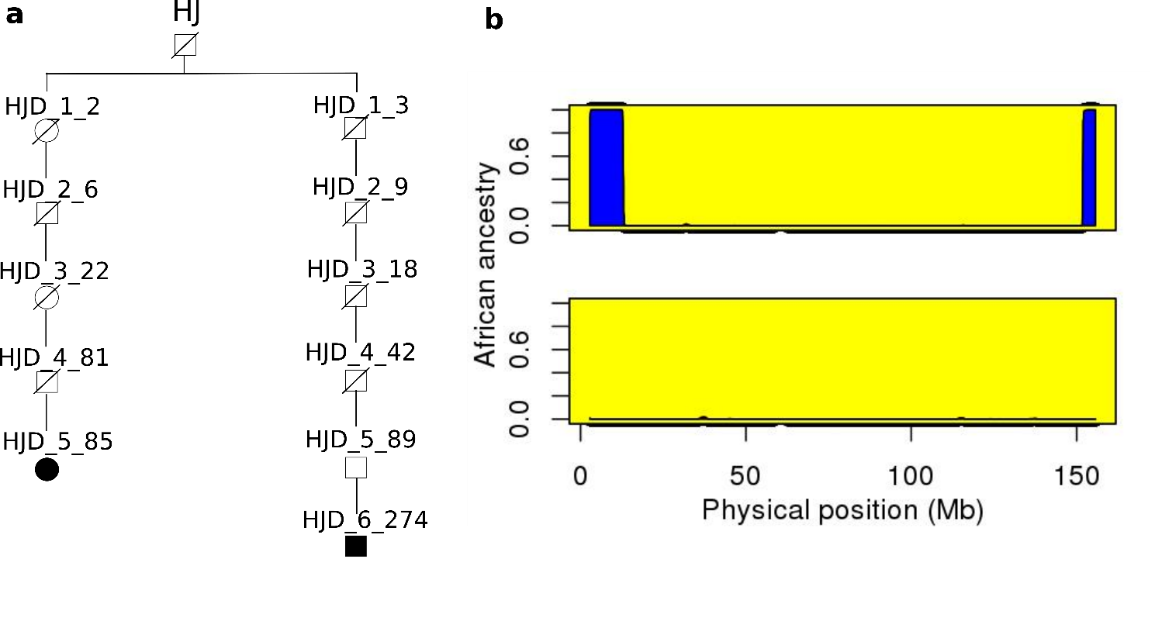
Supplementary Figure 9

Transmission of HJ’s X and Y chromosome.
(a) A genealogical tree showing the transmission of HJ’s X and Y chromosome. This tree represents a subset of the genealogy used in the study, with two different paths connecting a 5th descendant (HJD_5_85, represented by a filled circle), who carries part of HJ's X chromosome and a 6th generation descendant (HJD_6_274, represented by a filled square), who carries HJ's Y chromosome. (b) Beside this tree, the ancestry results as estimated by HAPMIX in the haploid mode, for the pair of X chromosomes from HJD_5_85 is shown.
The Y chromosome haplogroup of the direct male line descendant (HJD_6_274) was determined to be I2a2a3a2. Of the two X chromosome fragments in HJD_5_85, neither were shared with any of the 150,832 genotyped Icelanders who were not descendants of HJ. The longer 10.21 Mb fragment was carried by only HJD_5_85, while the smaller 3.86 Mb fragment was found to be shared with 3 other HJ’s descendants (two children and a grandchild of HJD_5_85). These two African fragments in HJD_5_85 are very likely to have been derived from HJ’s X chromosome. HJ’s Y chromosome is of European origin, while his maternal X chromosome seems to be of African origin, which agrees with the historical reports that his mother was African and his father European.

