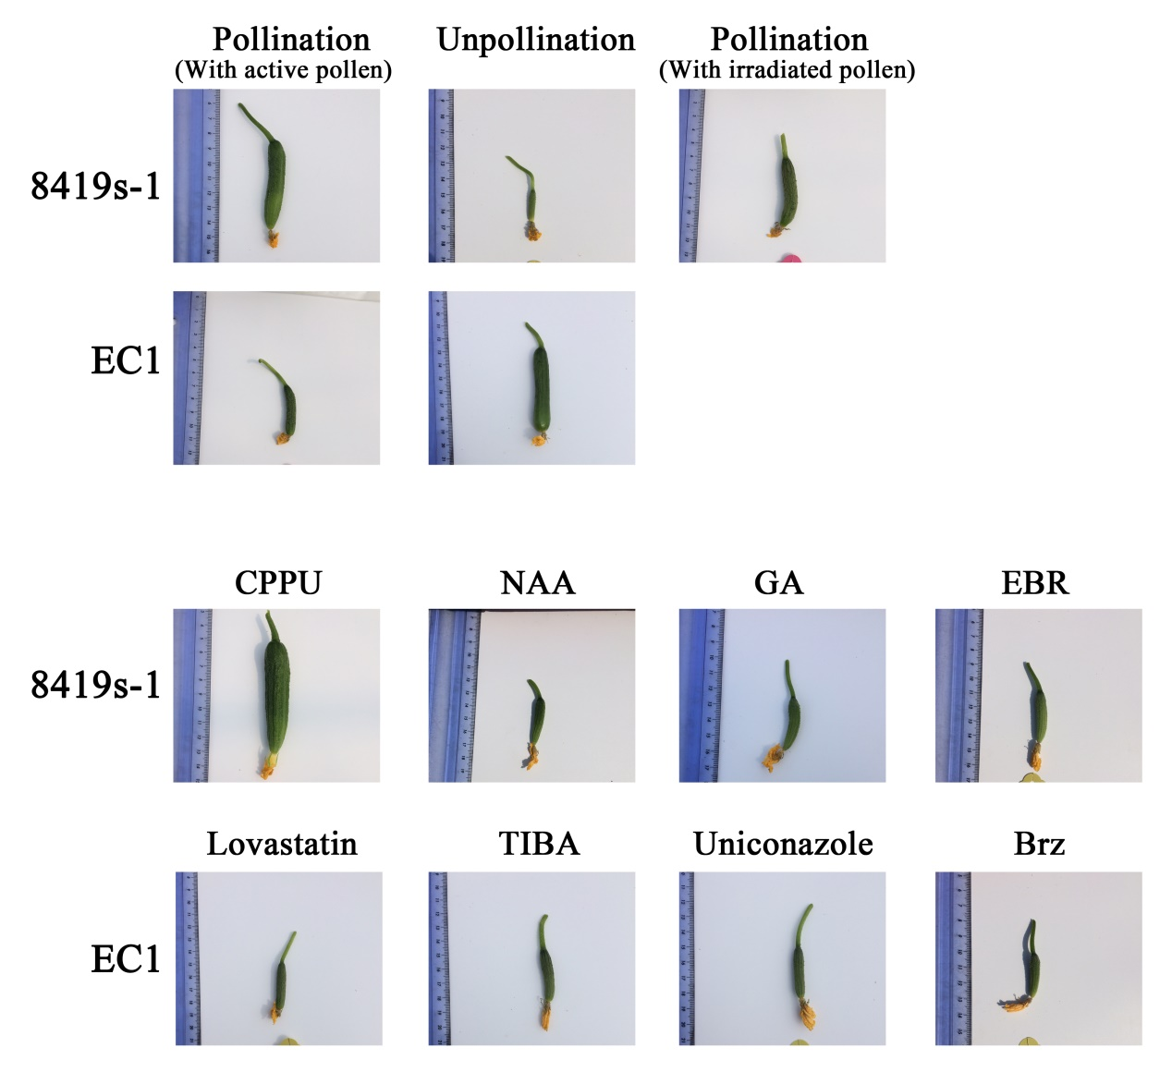
Additional file 1: Figure S1. The typical phenotypes of the treated ovaries of ‘EC1’ and ‘8419s-1’ at 4 dpa

