Supplementary information
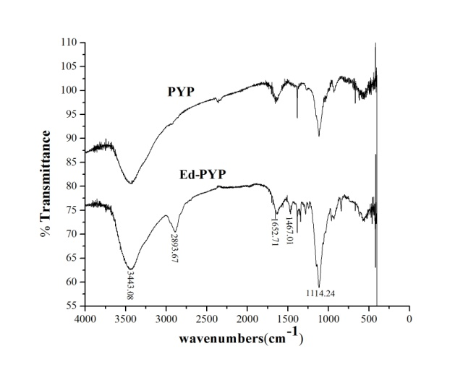
Figure 1
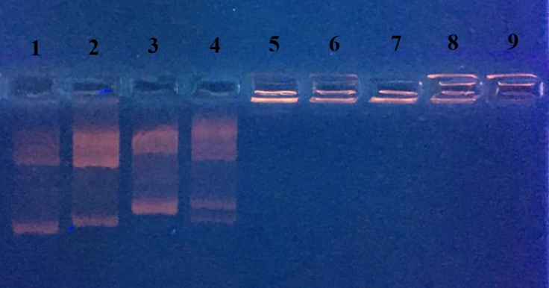
Figure 2
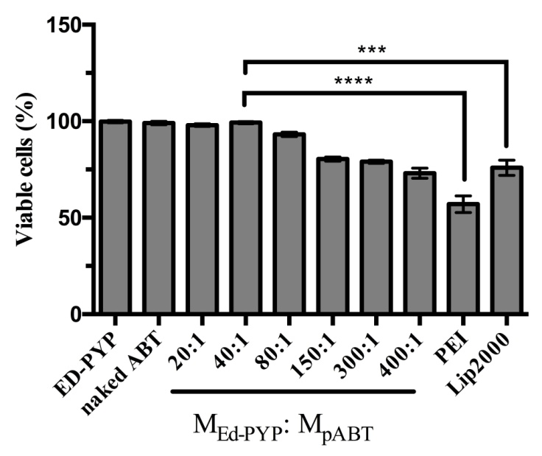
Figure 3
Figure 4
Nissl staining
- Induced 3T6 cells were washed with PBS for 3 times and then fixed with 4% paraformaldehyde at room temperature for 30 min.
- 0.5% toluidine blue was added into the plate and incubated for 40 min.
- Cells were washed with double distilled water and 70% ethanol for 30s respectively.
- Dehydration with absolute ethanol for 1min

Neural cells preparation
- Select 5 neonatal mice and killed.
- Put the bodies into iodine for 1.5 min followed by washing with 75% ethanol.
- Scissor the scalp and take out the brain with tweezers and wash the brain with cold PBS solution.
- Strip the meninx and scissors the brain into small pieces (about 2mm³ each) followed by washing them with cold PBS.
- Centrifuge the tissue (900rpm for 5 min) and eliminate the supernatant followed by adding collagenaes type 1 and digested in 37 ℃ for 20 min.
- Centrifuge again (900 rpm for 5 min) and eliminate the supernatant followed by adding cold PBS to resuspend the tissue.
- Filter the suspension with cell strainer (pore diameter=57μm).
- Centrifuge again (900 rpm for 5min) and eliminate the supernatant followed by adding serum-free medium (DMEM/F12 98ml, bFGF 20ng/ml, EGF 20ng/ml, B27 2ml, Penicillin-Streptomycin 100U/ml) to incubate.

