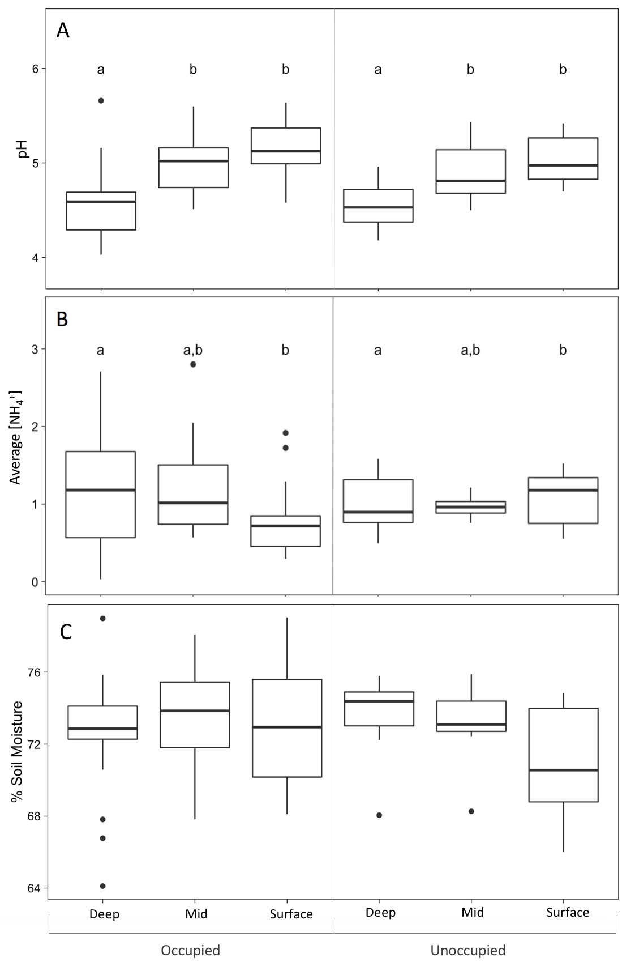

Figure S5- Soil pH (A), NH₄⁺ (ppm) (B), and moisture (C) between 18 occupied and 7 unoccupied burrows at deep, mid, and surface burrow soil represented by bar and whisker plots. Boxes represent upper and lower quartiles, whiskers depict maximum and minimum values, and points are outliers. Horizontal bars within each box represent the median. Soil pH was significantly lower in deep burrow soil (F= 19.120, p < 0.001). NH₄⁺ concentration was significantly higher in deep burrow soil compared to surface burrow soil ($χ$²= 7.861, p = 0.02). Soil moisture was similar between occupied and unoccupied burrows, and was similar at all soil depths (F = 0.332, p > 0.05). Burrow occupancy had no effect on soil pH (F = 0.008, p = 0.929)), NH₄⁺ (F = 0.543, p = 0.469), or soil moisture (F =0.377, p = 0.541).

