Additional File 1
Supplementary Table 1. Analysis of sustained CID events by previous treatment with a LABA and / or LAMA (ITT population)
Prior LABA or LAMA | AB/FF  400/12 µg | AB  400 µg | FF  12 µg | Placebo
Yes, n | 355 | 371 | 362 | 254
HR vs placebo | 0.55*** | 0.48*** | 0.74* | -
HR vs AB 400 µg | 1.16 | - | - | -
HR vs FF 12 µg | 0.75* | 0.65*** | - | -
No, n | 365 | 349 | 353 | 271
HR vs placebo | 0.48*** | 0.61*** | 0.58*** | -
HR vs AB 400 µg | 0.78 | - | - | -
HR vs FF 12 µg | 0.82 | 1.05 | - | -
*p<0.05, ***p<0.001
The risk of a sustained CID event was analyzed using a Cox-Proportional Hazard model including study, treatment group, and smoking status as covariates
AB, aclidinium bromide; CID, clinically important deterioration; FF, formoterol fumarate; HR, hazard ratio; LABA, long-acting β₂-agonist; LAMA, long-acting muscarinic antagonist

Supplementary Table 2. Analysis of sustained CID events by COPD severity at baseline (ITT population)
COPD at baseline | AB/FF  400/12 µg | AB  400 µg | FF  12 µg | Placebo
Moderateª, n | 418 | 411 | 436 | 293
HR vs placebo | 0.57*** | 0.50*** | 0.61*** | -
HR vs AB 400 µg | 1.13 | - | - | -
HR vs FF 12 µg | 0.94 | 0.83 | - | -
Severe^{b}, n | 301 | 306 | 278 | 231
HR vs placebo | 0.44*** | 0.60*** | 0.77* | -
HR vs AB 400 µg | 0.74* | - | - | -
HR vs FF 12 µg | 0.58*** | 0.78 | - | -
*p<0.05, ***p<0.001
ªPatients with ≥50% predicted post-bronchodilator FEV₁; ^{b}Patients with <50%predicted post-bronchodilator FEV₁
The risk of a sustained CID event was analyzed using a Cox-Proportional Hazard model including study, treatment group, and smoking status as covariates
AB, aclidinium bromide; CID, clinically important deterioration; COPD, chronic obstructive pulmonary disease; FF, formoterol fumarate; HR, hazard ratio; ITT population

Supplementary Table 3. Sensitivity analysis of the risk of first CID events for common visits over 24 weeks (ITT population)
 | AB/FF  400/12 µg  (n = 720) | AB  400 µg  (n = 720) | FF  12 µg  (n = 715) | Placebo  (n = 525)
Percentage of patients with  ≥1 CID during the studyª | 54.6 | 60.4 | 61.7 | 70.3
HR vs placebo | 0.61*** | 0.71*** | 0.74*** | -
HR vs AB 400 µg | 0.85* | - | - | -
HR vs FF 12 µg | 0.82** | 0.97 | - | -
*p<0.05, **p<0.01, ***p<0.001
ªWeeks 4, 12, and 24
The risk of a first CID event was analyzed using a Cox-Proportional Hazard model including study, treatment group, and smoking status as covariates
AB, aclidinium bromide; CID, clinically important deterioration; FF, formoterol fumarate; HR, hazard ratio; ITT, intent-to-treat

Supplementary Table 4. Sensitivity analysis of the risk of sustained CID events for common visits over 24 weeks (ITT population)
 | AB/FF  400/12 µg  (n = 720) | AB  400 µg  (n = 720) | FF  12 µg  (n = 715) | Placebo  (n = 525)
Percentage of patients with  ≥1 sustained CID during the studyª | 19.7 | 22.5 | 27.1 | 37.5
HR vs placebo | 0.47*** | 0.54*** | 0.66*** | -
HR vs AB 400 µg | 0.86 | - | - | -
HR vs FF 12 µg | 0.71** | 0.82 | - | -
**p<0.01, ***p<0.001
ªWeeks 4, 12, and 24
The risk of a sustained CID event was analyzed using a Cox-Proportional Hazard model including study, treatment group, and smoking status as covariates
AB, aclidinium bromide; CID, clinically important deterioration; FF, formoterol fumarate; HR, hazard ratio; ITT, intent-to-treat

Supplementary Table 5. Characterization of patients according to CID endpoints achieved (ITT population)
Number of CIDs, n (%) | AB/FF  400/12 µg  (n = 462) | AB  400 µg  (n = 511) | FF  12 µg  (n = 519) | Placebo  (n = 444) | Total  (n = 1936)
1ª | 258 (55.8) | 281 (55.0) | 234 (45.1) | 170 (38.3) | 943 (48.7)
2^{b} | 138 (29.9) | 152 (29.7) | 202 (38.9) | 173 (39.0) | 665 (34.3)
3^{c} | 60 (13.0) | 67 (13.1) | 74 (14.3) | 87 (19.6) | 288 (14.9)
4^{d} | 6 (1.3) | 11 (2.2) | 9 (1.7) | 14 (3.2) | 40 (2.1)
ªDeterioration in any CID component of trough FEV₁, TDI focal score, SGRQ total score, or exacerbation
^{b}Any two CIDs of trough FEV₁ + TDI focal score, trough FEV₁ + SGRQ total score, trough FEV₁ + exacerbation, TDI focal score + SGRQ total score, TDI focal score + exacerbation, or SGRQ total score + exacerbation
^{c}Any three CIDs of trough FEV₁ + TDI focal score + SGRQ total score, FEV₁ + TDI focal score + exacerbation, trough FEV₁ + SGRQ total score + exacerbation, TDI focal score + SGRQ total score + exacerbation
^{d}All four exacerbations, trough FEV₁ + TDI focal score + SGRQ total score + exacerbation
AB, aclidinium bromide; CID, clinically important deterioration; FEV₁, forced expiratory volume in 1 second; FF formoterol fumarate; ITT, intent-to-treat; SGRQ, St George’s Respiratory Questionnaire; TDI, Transition Dyspnea Index
Supplementary Table 6. List of ethics committees
Ethikkommission der Medizinischen, Universität Graz, Auenbruggerplatz 2, Graz, 8036, Austria
Ethisch Comité UZA, Wilrijkstraat 10, Edegem, 2650, Belgium
Ethics Committee for Multicenter Trials (ECMT), 5, ‘Sveta Nedelya’, Square 1000 Sofia, Bulgaria
Agency for Medicinal Product and Medical Devices of Croatia, Central Ethics Committee, Ksaverska cesta 4 Zagreb, 10000, Croatia
Multicentricka eticka komise Fakultni nemocnice u sv. Anny v Brne, Vystavni 17/19, Brno, 656 19, Czech Republic
De Videnskabsetiske Komitéer for Region Hovedstaden, Kongens Vænge 2, 3400, Hillerød, Denmark
Keski-Suomen sairaanhoitopiiri, Eettinen toimikunta, Sairaanhoitopiirin toimisto Rak. 6/2, Keskussairaalantie 19, 40620 Jyväskylä, Finland
Comité de Protection des Personnes Sud Ouest et Outre Mer III, Place Amélie Raba-Léon, Groupe Hospitalier Pellegrin – Service de Pharmacologie Clinique, Bât 1 A, Bordeaux Cedex, 33076, France
Landesärztekammer Rheinland-Pfalz, Place Amélie Raba-Léon, Groupe Hospitalier Pellegrin – Service de Pharmacologie Clinique, Bât 1 A, Bordeaux cedex, 33076, Germany
Egészségügyi Tudományos Tanács Klinikai Farmakológiai Etikai Bizottsága, Arany J. u. 6–8, Budapest, H-1051, Hungary
Comitato Etico Locale per la Sperim. Clin. dei Medicinali dell'Az. Osp.ra Univ.ria Senese di Siena, c/o Farmacia AOUS Viale Bracci, Siena, 53100, Italy
METC Catharina Ziekenhuis, Michelangelolaan 2, Eindhoven, 5623 EJ, Netherlands
Komisja Bioetyczna przy Instytucie Gruzlicy I Chorob Pluc, ul. Plocka 26, Warszawa, 01–138, Poland
Comisia Nationala de Etica, Str. Aviator Sanatescu Nr. 48, Bucuresti, Sector 1, 011478, Romania
Ethical Council at the MoH of RF, 3 Rakhmanovsky Pereulok, Moscow, 127994, Russia
Fakultná nemocnica s poliklinikou F.D. Roosevelta, Nám. L. Svobodu 1, 975 17 Banská Bystrica, Slovakia
CEIC Hospital Universitario Puerta de Hierro Majadahonda, Planta 1ª, Pasillo unidades, administrativas de servicios, c/ Manuel de Falla, 1, Majadahonda, 28222, Spain
Regionala Etikprövningsnämnden I Lund, Box 133, Östra Vallgatan 14/Östervångsvägen 1, Lund, 22100, Sweden
Central Ethics Commission of the Ministry of Health of Ukraine, 5, Narodnogo Opolchennya St., Kyiv, 03680, Ukraine
NRES Committee North, West-Greater Liverpool, Central, 3rd Floor, Barlow House, 4 Minshull Street, Manchester, M1 3DZ, United Kingdom

Supplementary Figure legend
Supplementary Figure 1. Analysis of the risk of CID events over 24 weeks, stratified by a) ICS use, b) previous treatment, c) symptoms defined by E-RS, and d) symptoms defined by BDI (ITT population)
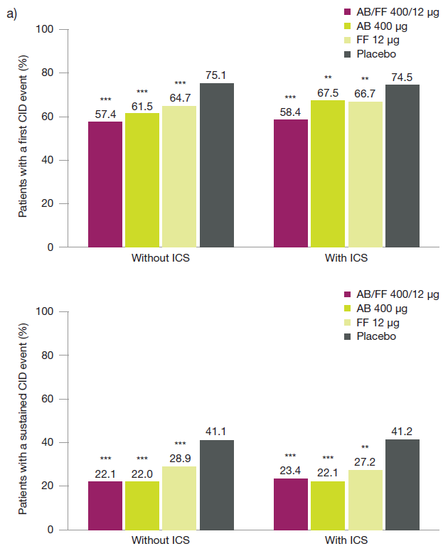
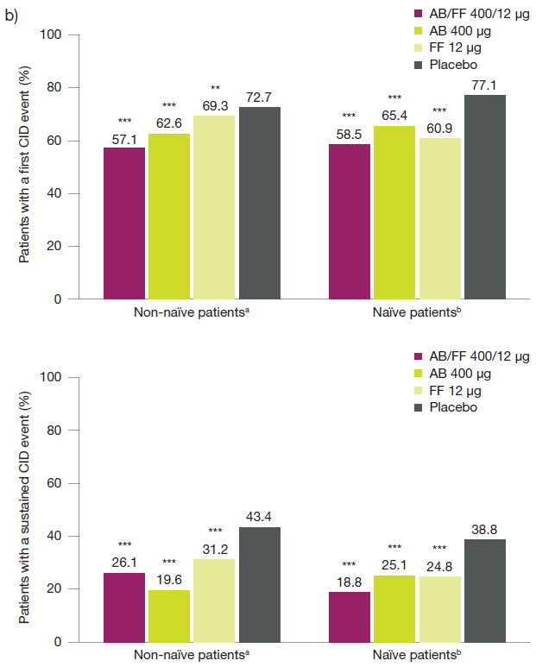
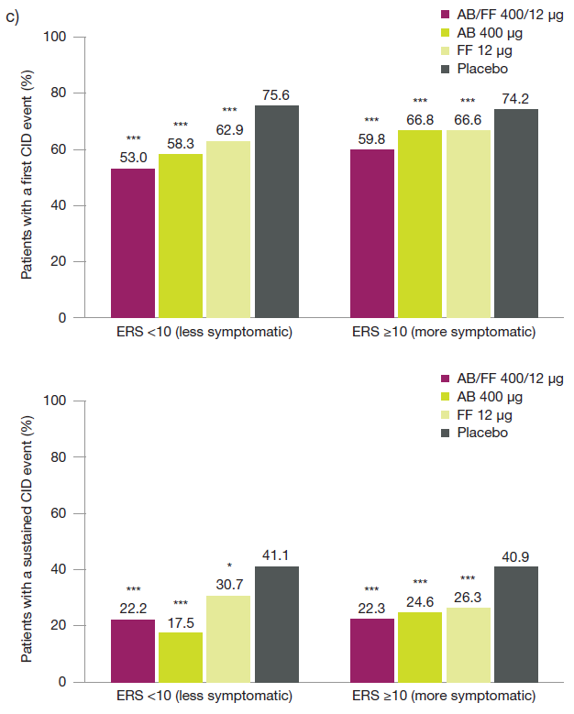

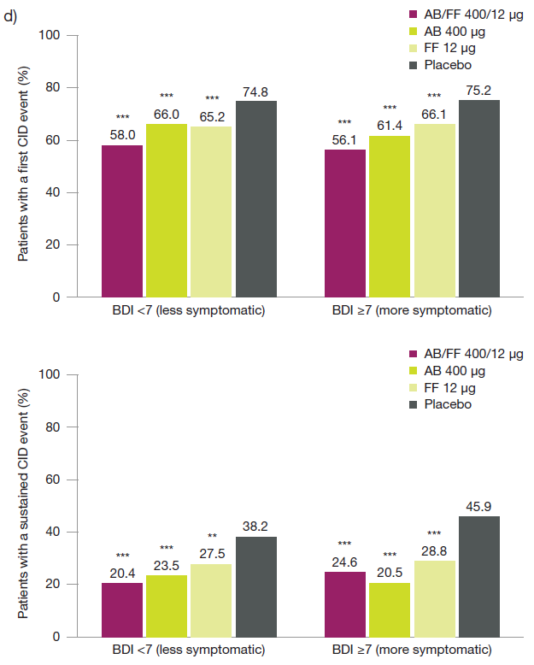
*p<0.05, **p<0.01, ***p<0.001 HR vs placebo
ªDefined as patients previously treated with LABAs and/or LAMAs, LABA/ICS combinations, or LABA/LAMA/ICS combinations or xanthines
^{b}Defined as patients who were not previously treated with SABAs and/or SAMAs or with other medications (ICS, leukotriene antagonists, systemic corticosteroids, oxygen or influenza vaccine) not in accordance with GOLD guidelines [1].
Risk of first or sustained CID events and each individual component were analyzed using a Cox-Proportional Hazard model including study, treatment group, and smoking status as covariates
AB, aclidinium bromide; BDI, baseline dyspnea index; CID, clinically important deterioration; E-RS, Evaluating Respiratory Symptoms; FF, formoterol fumarate; GOLD, Global initiative for chronic Obstructive Lung Disease; HR, hazard ratio; ICS, inhaled corticosteroid; ITT, intent-to-treat; LABA, long-acting β₂-agonist; LAMA, long-acting muscarinic antagonist; SABA, short-acting β₂-agonist; SAMA, short-acting muscarinic antagonist

References
1. Global Initiative for Chronic Obstructive Lung Disease. Global strategy for the diagnosis, management, and prevention of chronic obstructive pulmonary disease 2017. [http://goldcopd.org/gold-2017-global-strategy-diagnosis-management-prevention-copd/]. Accessed 1 Mar 2017.

