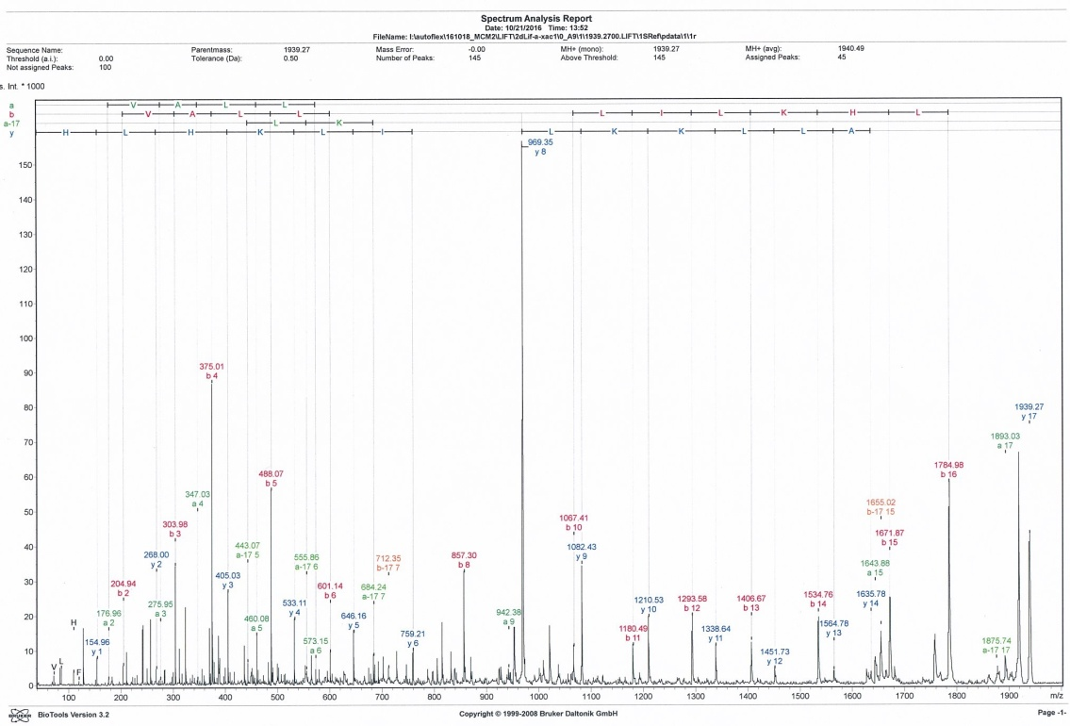
Additional file 1. MS/MS analysis of Xac-1.

