Why do aftershocks occur? –Relationship between mainshock rupture and aftershock sequence based on highly resolved hypocenter and focal mechanism distributions–

Additional File 2

Yohei Yukutake, Yoshihisa Iio

Earth, Planets and Space

Validation for the thickness of aftershock distribution by using the observed differential arrival times
To confirm validity of the thickness of aftershock distribution based on the double-difference method, we investigated the differential arrival times for the small earthquake cluster shown in Figure A3. Considering the result of the DD method, these events occurred at almost same depth (around a depth of 7km), and are aligned perpendicular to the strike of Fault1 within a range of 1 km. We show the waveform traces around P-wave onsets of these earthquakes at wt34 station in Figure A4. wt34 station is located in the direction perpendicular to the strike of Fault1, and the epicentral distances from these events are approximately 6 km. Since the ray paths between the source region and wt34 station are similar, the difference in the travel times for two events can be attributed to the spatial offset in the direction perpendicular to the fault plane between the events. The relation between the distance from the hypocenter to Fault1 and the differential arrival time relative to Even3991 that located at the easternmost place in the cluster is also shown in Figure A5.
The spatial offsets among these events can be almost explained by considering the observed differential arrival times. For example, the differential arrival time of -0.14 sec between Events 3991 and 4000 corresponds to the spatial offset of 0.89km that is consistent with the locations by the DD method, when we assume the P-wave velocity of 6.23 km/sec at a depth of 7km based on the velocity structure estimated by Shibutani et al. (2005). The thickness of aftershock distribution is supported by the observation of differential arrival times and this result suggests that many aftershocks do not distribute along to the mainshock fault plane.

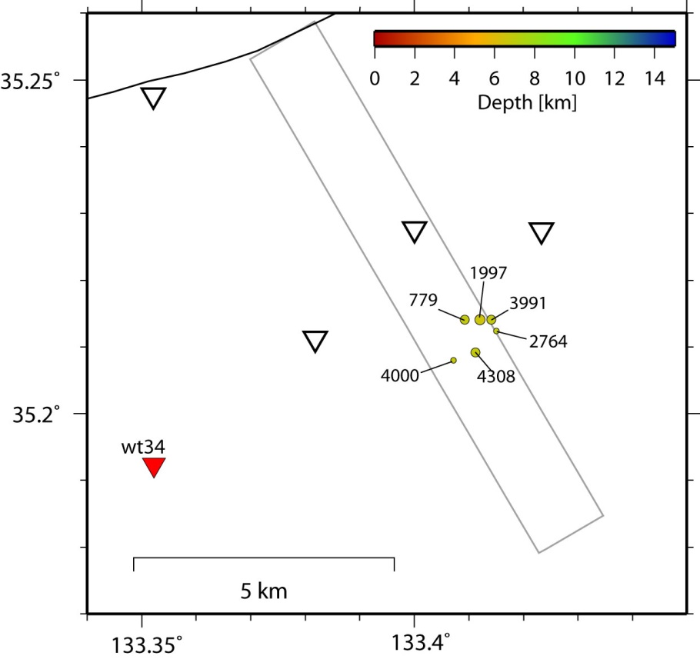
Figure A3. The hypocenter distribution of earthquake cluster. The gray rectangle shows the position of the best-fit plane (Fault 1). The red triangle indicates the location of wt34 station. Number corresponds to the index number of earthquake.
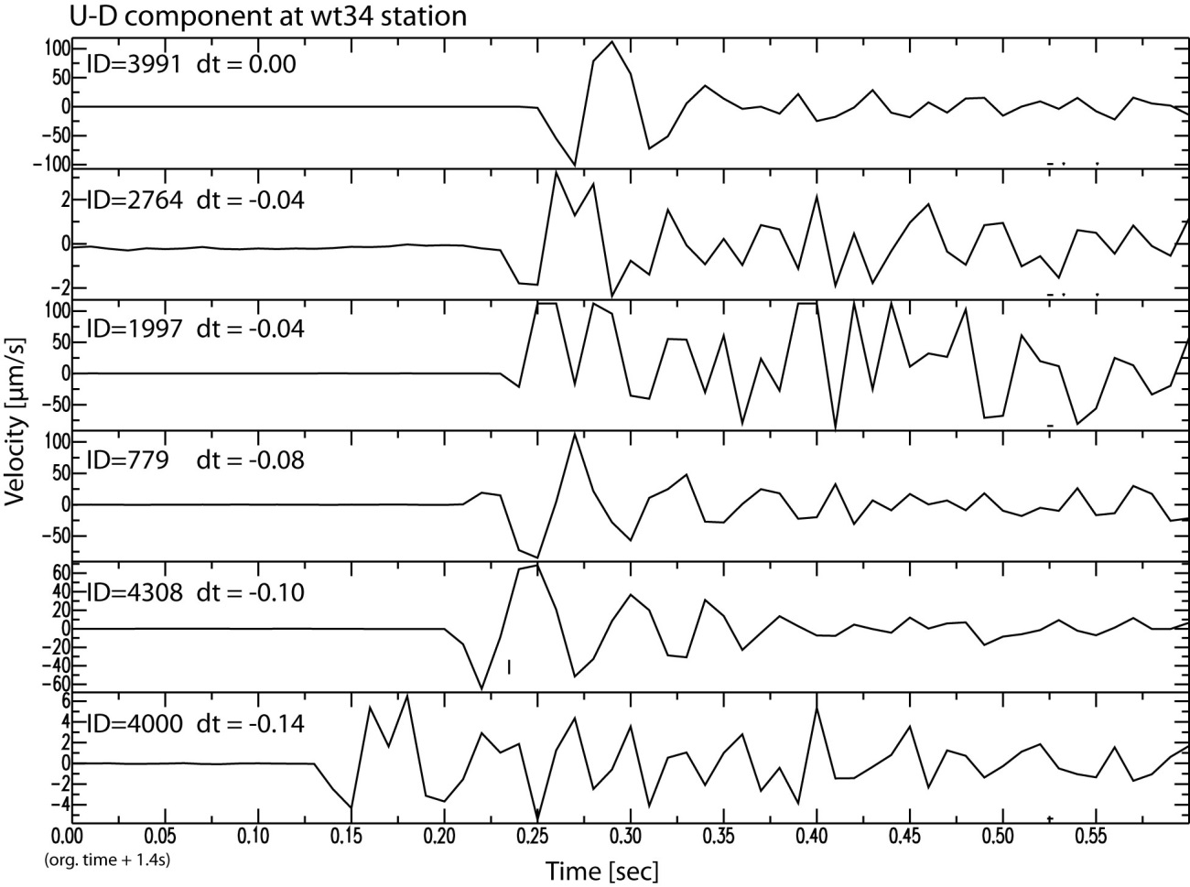
Figure A4. U-D component velocity waveforms at wt34 station. Index number in each trace corresponds to that in Figure A3. dt is the differential arrival time relative to Event 3991, obtained by manually picked arrival times. The waveform traces are aligned with their origin times and in the order of epicentral distance from wt34 station.

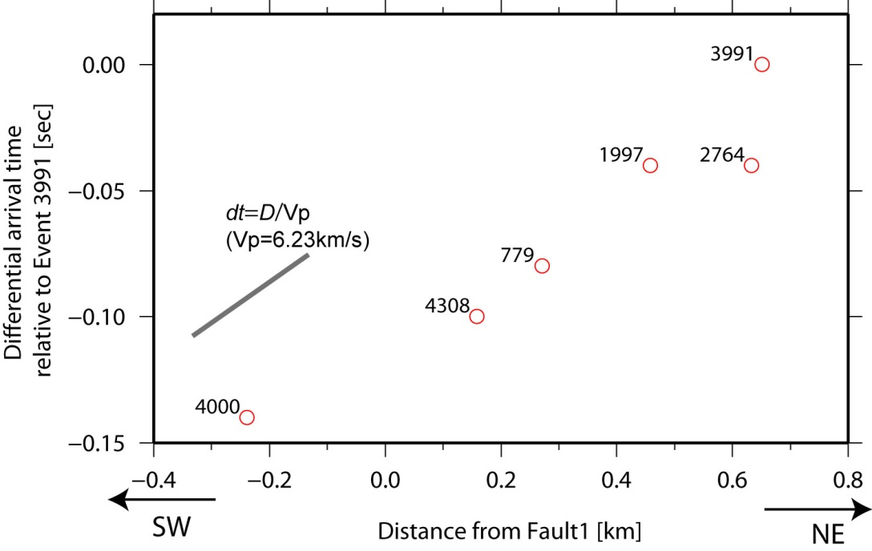
Figure A5. Relation between the distance (D) from each hypocenter to Fault1 and the differential arrival time relative to Event3991. Index number in each trace corresponds to that in Figure A3. Slope of a gray line indicates theoretical relation between dt and the distance (D), when we assume Vp of 6.23 km/s.

