*Supporting Information*

Enhanced Photoelectrochemical Behavior of H-TiO2 Nanorods Hydrogenated by Controlled and Local Rapid Thermal Annealing

Xiaodan Wang,†,‡,* Sonia Estradé,# Yuanjing Lin,$ Feng Yu, †,‡ Lluis Lopez-Conesa,# Hao Zhou, †,‡ Sanjeev Kumar Gurram,§ Francesca Peiró,# Zhiyong Fan,$ Hao Shen,§,&,* Lothar Schaefer,§ Guenter Braeuer,§ Andreas Waag†,‡,*

†Institute for Semiconductor Technology, TU Braunschweig, Hans-Sommer-Strasse 66, 38106 Braunschweig, Germany

‡Laboratory for Emerging Nanometrology (LENA), TU Braunschweig, Langer Kamp 6, 38106 Braunschweig, Germany

#Department d’Electrònica, Universitat de Barcelona, c/Martí Franquès 1, 08028 Barcelona, Spain

$Department of Electronic and Computer Engineering, The Hong Kong University of Science and Technology, Clear Water Bay, Kowloon, Hong Kong SAR, China.

§Fraunhofer Institute for Surface Engineering and Thin Films, Bienroder Weg 54E, 38108 Braunschweig, Germany

&School of Chemistry and Chemical Engineering, Jiangsu University, Xuefu Road 301, 212013 Zhenjiang, China

*Corresponding authors: w.xiaodan@tu-bs.de; hshen678@126.com; a.waag@tu-bs.de

**Table S1.** Donor density (Nd), flat band potential (Vfb) and depletion region width (W) of pristine TiO2 and H-TiO2 nanorods calculated from the Mott-Schottky plots.

**Figure S1.** (a) Optical absorption spectra of pristine TiO2 and H-TiO2 nanorods. (b) Tauc plots of optical absorption curves for pristine TiO2 and H-TiO2 nanorods.

**Figure S2.** Photoconversion efficiency of pristine TiO2 and H-TiO2 nanorods.

**Figure S3.** The O/Ti ratio distribution along the nanorod diameter (a) pristine TiO2 and (b) H-TiO2 nanorods treated at 400oC. The O/Ti ratio is estimated using EELS spectra taken from a cross-line shown in the TEM image.

**Table S1**

|  |  |  |  |
| --- | --- | --- | --- |
| Samples | Nd (cm-3) | Vfb (V vs. Ag/AgCl) | W (nm) at 0.23 V vs. Ag/AgCl |
| As-prepared | 1.50 x 1017 | -0.95 | 295 |
| 350 oC | 5.19 x 1017 | -0.95 | 160 |
| 400 oC | 2.15 x 1018 | -0.97 | 78 |
| 450 oC | 2.98 x 1017 | -0.71 | 187 |

Since it is difficult to get the real active area of 3D H-TiO2 nanorods, we followed the suggestion from Fabrega’s work and assigned a donor density (1.50 x 1017 cm-3) to the as-prepared sample. The equation to calculate the depletion region width is given as-followed:

$$W=\sqrt{\frac{2ε_{0}ε_{r}\left|ϕ_{SC}\right|}{e_{0}N_{d}}}$$

Where Nd is the donor density, e0 is the electron charge, εr is the dielectric constant of TiO2 nanorods, ε0 is the permittivity of vacuum, ϕSC ≡ V − Vfb is the maximum potential drop in the depletion layer.

**Figure S1**



(a)



(b)

**Figure S2**



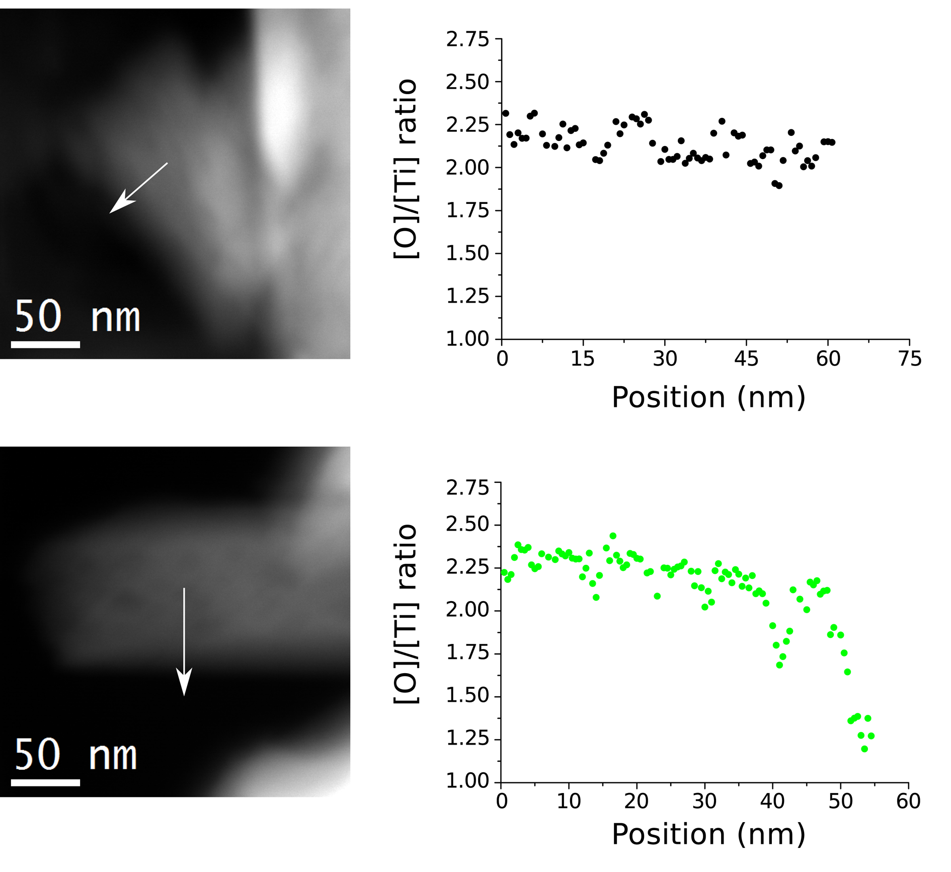**Figure S3**

(a)

(b)