Additional file 1

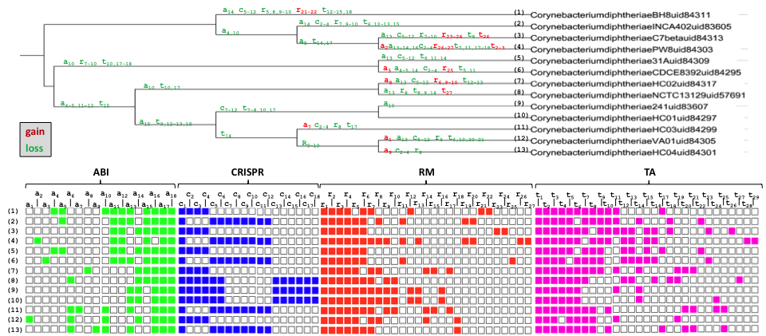
Figure S1. Gains and losses in ATGC068-Corynebacterium
Gene descriptions can be found in supplementary table 7

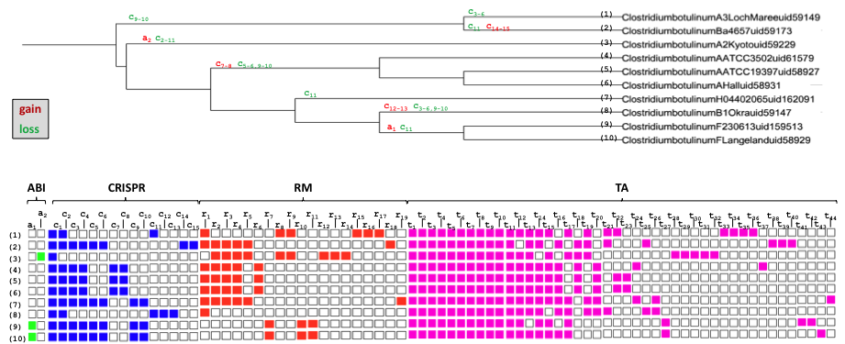
Figure S2. Gains and losses in ATGC081-Clostridium
Gene descriptions can be found in supplementary table 7

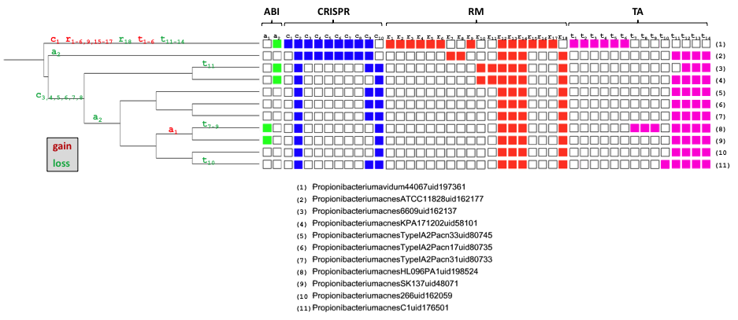

Figure S3. Gains and losses in ATGC159-Propionibacterium
Gene descriptions can be found in supplementary table 7

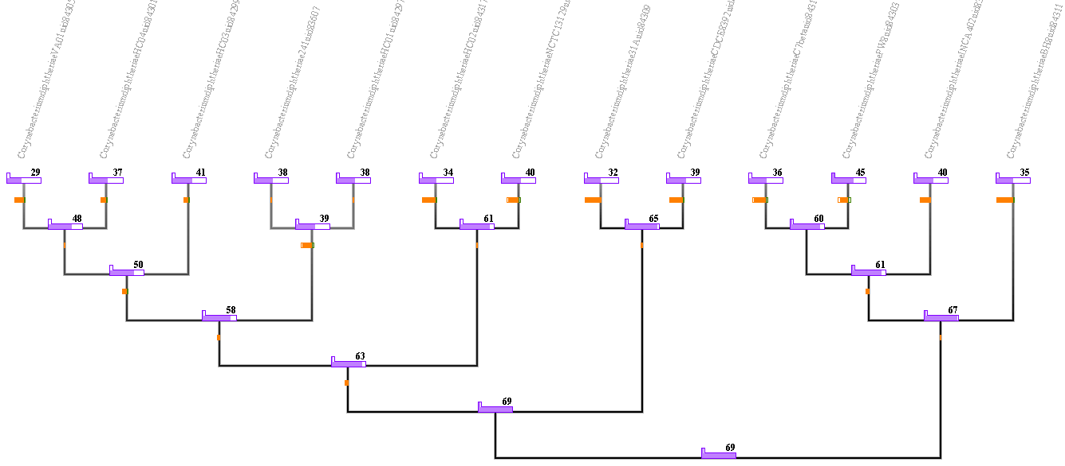

Figure S4. Count output for ATGC068-Corynebacterium
Numbers and purple bars correspond to the real (at the tips) and estimated (in the branches) number of DS genes. Green and orange bars correspond to gain and loss of genes.

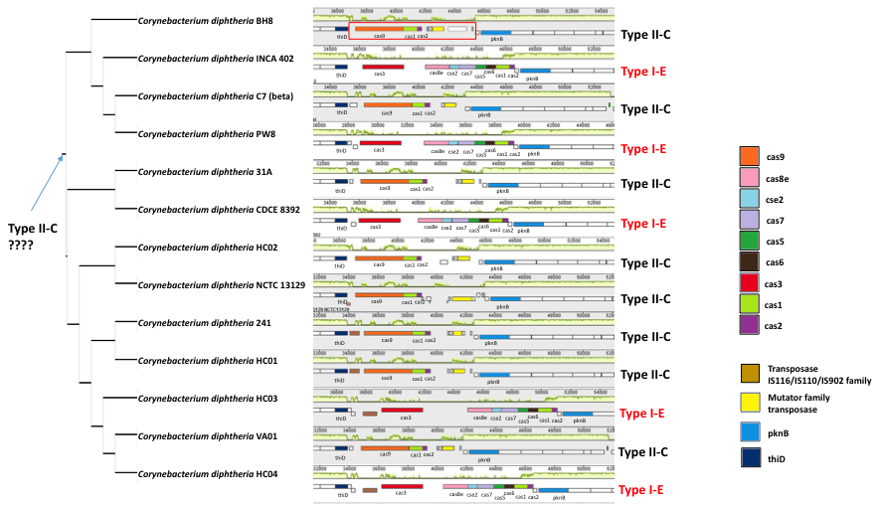
Figure S5. Example of multiple independent substitutions of CRISPR-Cas system type II-C to type I-E
The species tree for the ATGC068-Corynebacterium, reconstructed from concatenated alignments of nucleotide sequences of common orthologs [1], is shown on the left. Defense system loci are shown on the right. Homologous genes are highlighted in matching colors.

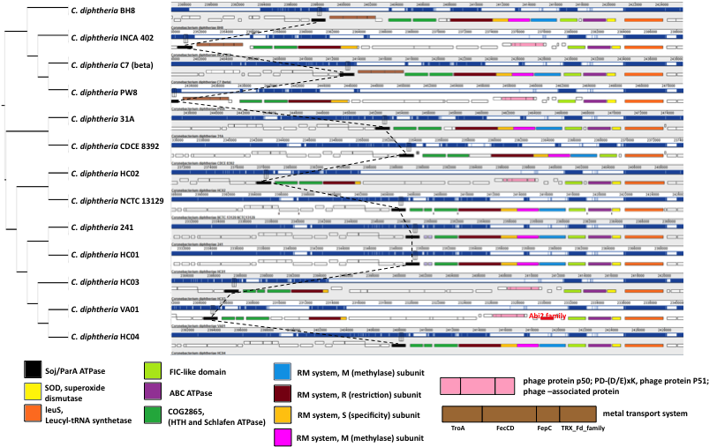
Figure S6. Example of predicted gain by COUNT of Abi2 gene in a large loci with multiple gains and losses
The species trees for the ATGC068-Corynebacterium, reconstructed from concatenated alignments of nucleotide sequences of common orthologs [1], is shown on the left. Defense system loci are shown on the right. Homologous genes are highlighted in matching colors.

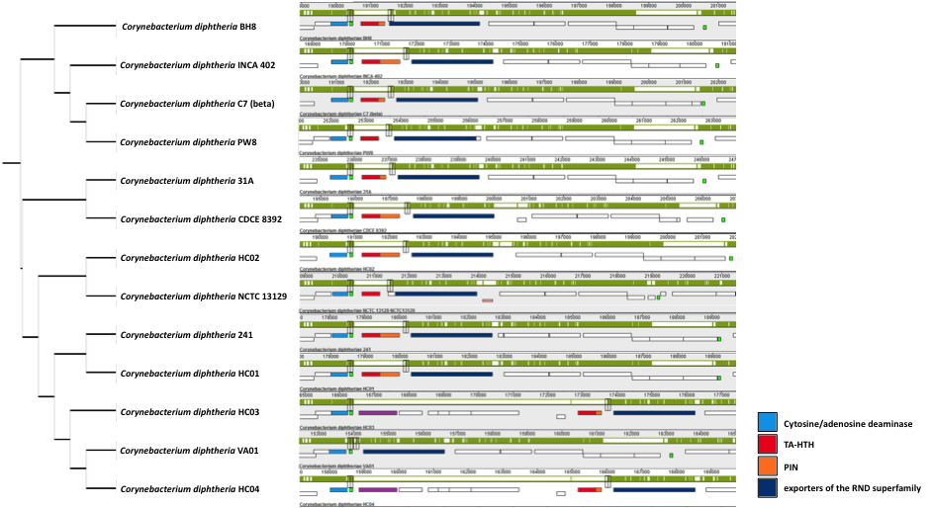
Figure S7. Example of TA gene loss
The species trees for the ATGC068-Corynebacterium, reconstructed from concatenated alignments of nucleotide sequences of common orthologs [1], is shown on the left. Defense system loci are shown on the right. Homologous genes are highlighted in matching colors.

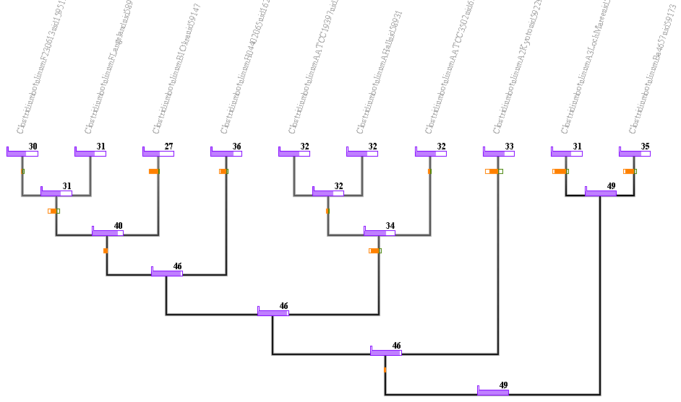
Figure S8. Count output for ATGC081-Clostridium
Numbers and purple bars correspond to the real (at the tips) and estimated (in the branches) number of DS genes. Green and orange bars correspond to gain and loss of genes.
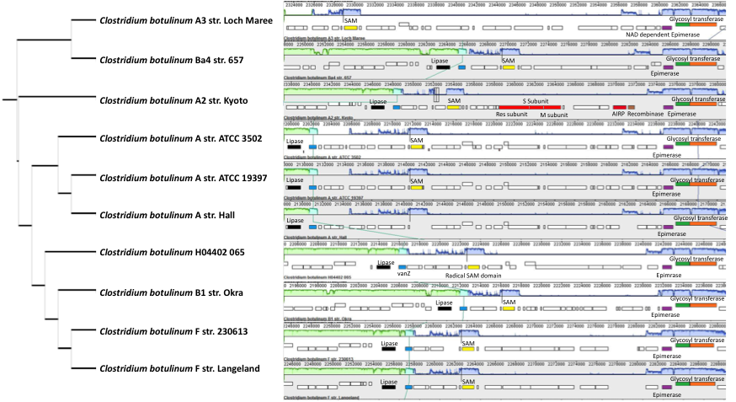
Figure S9. Example of gain of four DS genes in Clostridium botulinum A2 str Kyoto
The species trees for the ATGC081-Clostridium, reconstructed from concatenated alignments of nucleotide sequences of common orthologs [1], is shown on the left. Defense system loci are shown on the right. Homologous genes are highlighted in matching colors. Locus description for Clostridium botulinum A2 str. Kyoto in supplementary table 8
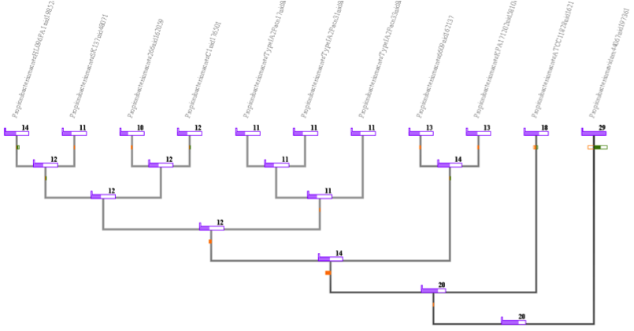

Figure S10. Count output for ATGC159-Propionibacterium
Numbers and purple bars correspond to the real (at the tips) and estimated (in the branches) number of DS genes. Green and orange bars correspond to gain and loss of genes.

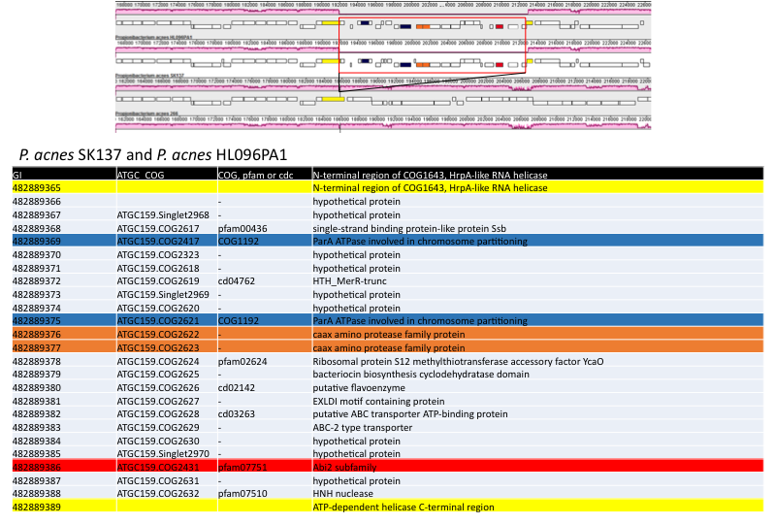
Figure S11. Locus details for Figure 7c

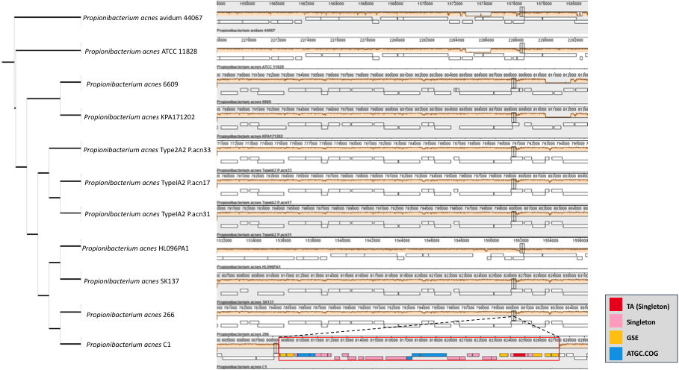
Figure S12. Example of TA gene gain (within a large locus) in Propionibacterium acnes C1
The species trees for the ATGC159-Propionibacterium, reconstructed from concatenated alignments of nucleotide sequences of common orthologs [1], is shown on the left. Defense system loci are shown on the right. TA gene highlighted in red, the rest of genes of P. acne C1 are highlighted according ATGC descriptors (COGs in blue, GSE in yellow and singletons in pink). Full Locus description for P. acne C1 in supplementary table S9.
Homologous genes are highlighted in matching colors.

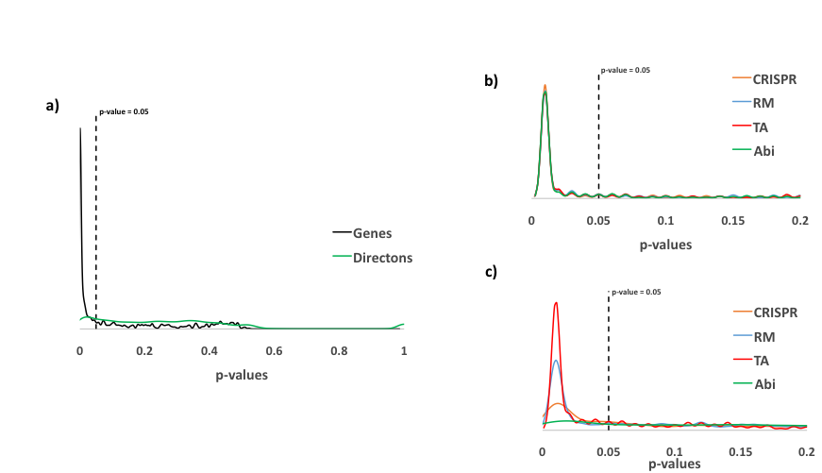
Figure S13. Density distribution of p-values from the randomization test
a) P-values from the randomization test of all genes (black line) and directons (green line)
b) P-values from the randomization test of genes (CRISPR, orange line; RM, blue line; TA, red line; Abi, green line)
c) P-values from the randomization test of directons (CRISPR, orange line; RM, blue line; TA, red line; Abi, green line)
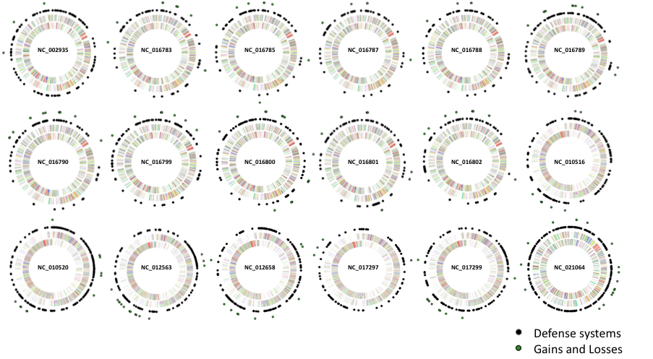
Figure S14. Distribution of defense systems and dynamic events in 18 genomes.
P-values are included in supplementary table S10.

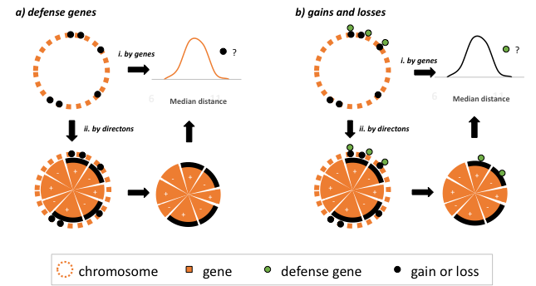

Figure S15. Scheme of the methodology used to test randomness in the distribution defense genes and dynamic events in the chromosome
- Defense genes. (i) Randomness in defense genes is assessed through comparison of the median distance between closest defense genes and a random distribution. This distribution is created by randomly sampling as many genes as defense genes and then calculate the median distance between genes (10,000 replications). (ii) Same procedure, but genes are previously grouped together in directons (see Methods).
b) Gains and losses. In this case, the median distance is calculated between closest gains or losses and compared to a random distribution calculated from defense genes; same procedure as in (a).

Table S1. Distribution of defense systems COGs in ATGCs

ATGC | Genera | N_SP | N_COGs | Abi | CRISPR | RM | RM_DND | TA | Unknown
ATGC149 | Acinetobacter | 14 | 6457 | 4 | 14 | 21 | 1 | 26 | 35
ATGC014 | Bacillus | 31 | 16679 | 16 | 33 | 43 | 4 | 93 | 44
ATGC015 | Bacillus | 24 | 9243 | 4 | 6 | 26 | 1 | 29 | 20
ATGC104 | Bifidobacterium | 11 | 4353 | 11 | 23 | 26 | 0 | 53 | 40
ATGC105 | Bifidobacterium | 10 | 2019 | 0 | 18 | 5 | 1 | 19 | 14
ATGC144 | Borrelia | 11 | 1922 | 0 | 0 | 4 | 0 | 1 | 42
ATGC136 | Brucella-Ochrobactrum | 19 | 6014 | 3 | 4 | 11 | 0 | 35 | 44
ATGC088 | Burkholderia | 13 | 13383 | 5 | 13 | 34 | 0 | 45 | 53
ATGC089 | Burkholderia | 12 | 14542 | 12 | 19 | 32 | 4 | 119 | 97
ATGC143 | Campylobacter | 11 | 2638 | 2 | 5 | 17 | 0 | 23 | 15
ATGC044 | Candidatus-Rickettsia | 40 | 4456 | 2 | 5 | 12 | 0 | 91 | 20
ATGC021 | Chlamydia | 45 | 1218 | 0 | 2 | 2 | 0 | 2 | 7
ATGC022 | Chlamydia-Chlamydophila | 21 | 1536 | 0 | 2 | 0 | 0 | 2 | 8
ATGC001 | Enterobacteria | 109 | 24846 | 25 | 40 | 89 | 6 | 159 | 142
ATGC081 | Clostridium | 10 | 5992 | 4 | 32 | 19 | 0 | 44 | 20
ATGC067 | Corynebacterium | 18 | 3255 | 2 | 25 | 13 | 0 | 16 | 9
ATGC068 | Corynebacterium | 13 | 3560 | 19 | 25 | 28 | 0 | 31 | 21
ATGC002 | Enterobacter-Klebsiella | 11 | 10803 | 12 | 28 | 46 | 2 | 71 | 69
ATGC138 | Francisella | 18 | 3253 | 3 | 9 | 19 | 0 | 14 | 11
ATGC050 | Helicobacter | 51 | 4569 | 9 | 8 | 78 | 0 | 22 | 27
ATGC056 | Lactobacillus | 10 | 4894 | 5 | 21 | 19 | 1 | 21 | 23
ATGC184 | Legionella | 10 | 4588 | 15 | 19 | 14 | 0 | 38 | 36
ATGC108 | Listeria | 31 | 5835 | 7 | 21 | 25 | 0 | 21 | 24
ATGC024 | Mycobacterium | 32 | 7294 | 14 | 34 | 19 | 0 | 124 | 33
ATGC032 | Mycoplasma | 11 | 884 | 0 | 4 | 3 | 0 | 0 | 4
ATGC137 | Neisseria | 18 | 4345 | 3 | 23 | 35 | 0 | 42 | 31
ATGC159 | Propionibacterium | 11 | 3486 | 2 | 12 | 21 | 0 | 14 | 17
ATGC071 | Pseudomonas | 12 | 11390 | 10 | 17 | 36 | 1 | 96 | 80
ATGC120 | Shewanella | 14 | 8091 | 13 | 29 | 50 | 3 | 80 | 75
ATGC052 | Staphylococcus | 42 | 4846 | 3 | 17 | 23 | 2 | 24 | 64
ATGC003 | Streptococcus | 22 | 4480 | 10 | 6 | 29 | 0 | 38 | 18
ATGC004 | Streptococcus | 22 | 3747 | 4 | 15 | 13 | 0 | 23 | 42
ATGC005 | Streptococcus | 16 | 3467 | 7 | 12 | 27 | 0 | 31 | 26
ATGC093 | Sulfolobus | 12 | 4472 | 5 | 87 | 13 | 0 | 84 | 24
ATGC134 | Xanthomonas | 13 | 9817 | 7 | 22 | 41 | 2 | 72 | 65
ATGC127 | Yersinia | 19 | 8289 | 3 | 16 | 24 | 0 | 78 | 52

* N_COGs = Number of COGs (including all genes) in the ATGC; N_SP = Number of species in the ATGC

Table S2. Number of the defense systems normalized by the total number of genes (COGs)

ATGC | Abi | CRISPR | RM | RM_DND | TA | Unknown | p-value (chi-test)
ATGC001 | 0.101 | 0.161 | 0.358 | 0.024 | 0.640 | 0.572 | 0.2243
ATGC002 | 0.111 | 0.259 | 0.426 | 0.019 | 0.657 | 0.639 | 0.2243
ATGC003 | 0.223 | 0.134 | 0.647 | 0.000 | 0.848 | 0.402 | 0.2243
ATGC004 | 0.107 | 0.400 | 0.347 | 0.000 | 0.614 | 1.121 | 0.2243
ATGC005 | 0.202 | 0.346 | 0.779 | 0.000 | 0.894 | 0.750 | 0.2243
ATGC014 | 0.096 | 0.198 | 0.258 | 0.024 | 0.558 | 0.264 | 0.2243
ATGC015 | 0.043 | 0.065 | 0.281 | 0.011 | 0.314 | 0.216 | 0.2243
ATGC021 | 0.000 | 0.164 | 0.164 | 0.000 | 0.164 | 0.575 | 0.2851
ATGC022 | 0.000 | 0.130 | 0.000 | 0.000 | 0.130 | 0.521 | 0.2851
ATGC024 | 0.192 | 0.466 | 0.260 | 0.000 | 1.700 | 0.452 | 0.2243
ATGC032 | 0.000 | 0.452 | 0.339 | 0.000 | 0.000 | 0.452 | 0.2851
ATGC044 | 0.045 | 0.112 | 0.269 | 0.000 | 2.042 | 0.449 | 0.2243
ATGC050 | 0.197 | 0.175 | 1.707 | 0.000 | 0.482 | 0.591 | 0.2243
ATGC052 | 0.062 | 0.351 | 0.475 | 0.041 | 0.495 | 1.321 | 0.2243
ATGC056 | 0.102 | 0.429 | 0.388 | 0.020 | 0.429 | 0.470 | 0.2424
ATGC067 | 0.061 | 0.768 | 0.399 | 0.000 | 0.492 | 0.276 | 0.2243
ATGC068 | 0.534 | 0.702 | 0.787 | 0.000 | 0.871 | 0.590 | 0.2243
ATGC071 | 0.088 | 0.149 | 0.316 | 0.009 | 0.843 | 0.702 | 0.2243
ATGC081 | 0.067 | 0.534 | 0.317 | 0.000 | 0.734 | 0.334 | 0.2243
ATGC088 | 0.037 | 0.097 | 0.254 | 0.000 | 0.336 | 0.396 | 0.2243
ATGC089 | 0.083 | 0.131 | 0.220 | 0.028 | 0.818 | 0.667 | 0.2243
ATGC093 | 0.112 | 1.945 | 0.291 | 0.000 | 1.878 | 0.537 | 0.2243
ATGC104 | 0.253 | 0.528 | 0.597 | 0.000 | 1.218 | 0.919 | 0.2243
ATGC105 | 0.000 | 0.892 | 0.248 | 0.050 | 0.941 | 0.693 | 0.2243
ATGC108 | 0.120 | 0.360 | 0.428 | 0.000 | 0.360 | 0.411 | 0.2424
ATGC120 | 0.161 | 0.358 | 0.618 | 0.037 | 0.989 | 0.927 | 0.2243
ATGC127 | 0.036 | 0.193 | 0.290 | 0.000 | 0.941 | 0.627 | 0.2243
ATGC134 | 0.071 | 0.224 | 0.418 | 0.020 | 0.733 | 0.662 | 0.2243
ATGC136 | 0.050 | 0.067 | 0.183 | 0.000 | 0.582 | 0.732 | 0.2243
ATGC137 | 0.069 | 0.529 | 0.806 | 0.000 | 0.967 | 0.713 | 0.2243
ATGC138 | 0.092 | 0.277 | 0.584 | 0.000 | 0.430 | 0.338 | 0.2243
ATGC143 | 0.076 | 0.190 | 0.644 | 0.000 | 0.872 | 0.569 | 0.2243
ATGC144 | 0.000 | 0.000 | 0.208 | 0.000 | 0.052 | 2.185 | 0.2627
ATGC149 | 0.062 | 0.217 | 0.325 | 0.015 | 0.403 | 0.542 | 0.2243
ATGC159 | 0.057 | 0.344 | 0.602 | 0.000 | 0.402 | 0.488 | 0.2243
ATGC184 | 0.327 | 0.414 | 0.305 | 0.000 | 0.828 | 0.785 | 0.2243
MEAN | 0.107 | 0.355 | 0.432 | 0.008 | 0.713 | 0.636 | NA

* Chi-test between normalized values and the mean

Table S3. Genome dynamics in defense systems, including gain, loss, expansion and reduction: (a) total number of events; (b) events relative to the number of COGs and (c) events relative to the number of COGs and genomes. Defense systems with less than 10 genes or less than 10 events are left empty.

ATGC | Genera | LS | (a) Events (N) |  |  |  |  | (b) N / COG |  |  |  |  | (c) N / COG / Genomes
 |  |  | A | C | R | T | U | A | C | R | T | U | A | C | R | T | U
ATGC149 | Acinetobacter | FL |  | 37 | 55 | 114 | 99 |  | 2.6 | 2.6 | 4.4 | 2.8 |  | 0.19 | 0.19 | 0.31 | 0.20
ATGC014 | Bacillus | FL | 125 | 116 | 102 | 435 | 137 | 7.8 | 3.5 | 2.4 | 4.7 | 3.1 | 0.25 | 0.11 | 0.08 | 0.15 | 0.10
ATGC015 | Bacillus | FL |  |  | 108 | 83 | 27 |  |  | 4.2 | 2.9 | 1.3 |  |  | 0.17 | 0.12 | 0.06
ATGC104 | Bifidobacterium | FHA | 22 | 30 | 64 | 93 | 60 | 2.0 | 1.3 | 2.4 | 1.8 | 1.5 | 0.18 | 0.12 | 0.22 | 0.16 | 0.14
ATGC105 | Bifidobacterium | FHA |  | 19 | 0 | 26 | 12 |  | 1.1 |  | 1.3 | 0.9 |  | 0.11 |  | 0.14 | 0.09
ATGC144 | Borrelia | FHA |  |  |  |  | 131 |  |  |  |  | 3.1 |  |  |  |  | 0.28
ATGC136 | Brucella-Ochrobactrum | FHA |  |  |  | 54 | 45 |  |  |  | 1.5 | 1.0 |  |  |  | 0.08 | 0.05
ATGC088 | Burkholderia | FL |  | 28 | 101 | 108 | 99 |  | 2.2 | 3.0 | 2.4 | 1.9 |  | 0.17 | 0.23 | 0.19 | 0.14
ATGC089 | Burkholderia | FL | 26 | 19 | 57 | 260 | 167 | 2.2 | 1.0 | 1.8 | 2.2 | 1.7 | 0.18 | 0.08 | 0.15 | 0.18 | 0.14
ATGC143 | Campylobacter | FHA |  |  | 54 | 59 | 41 |  |  | 3.2 | 2.6 | 2.7 |  |  | 0.29 | 0.23 | 0.25
ATGC044 | Candidatus-Rickettsia | P |  |  | 88 | 378 | 49 |  |  | 7.3 | 4.2 | 2.5 |  |  | 0.18 | 0.10 | 0.06
ATGC021 | Chlamydia | P
ATGC022 | Chlamydia-Chlamydophila | P
ATGC081 | Clostridium | FL |  | 79 | 44 | 81 | 47 |  | 2.5 | 2.3 | 1.8 | 2.4 |  | 0.25 | 0.23 | 0.18 | 0.24
ATGC067 | Corynebacterium | FL |  | 53 | 26 | 24 |  |  | 2.1 | 2.0 | 1.5 | 0.0 |  | 0.12 | 0.11 | 0.08
ATGC068 | Corynebacterium | FL | 48 | 111 | 105 | 131 | 41 | 2.5 | 4.4 | 3.7 | 4.2 | 1.9 | 0.20 | 0.34 | 0.29 | 0.32 | 0.15
ATGC002 | Enterobacter-Klebsiella | FHA | 20 | 63 | 89 | 175 | 143 | 1.6 | 2.2 | 1.9 | 2.5 | 2.1 | 0.15 | ` | 0.18 | 0.22 | 0.19
ATGC001 | Enterobacteria | FHA | 200 | 356 | 865 | 1647 | 1643 | 8.0 | 8.9 | 9.7 | 10.4 | 11.6 | 0.07 | 0.08 | 0.09 | 0.10 | 0.11
ATGC138 | Francisella | FHA |  |  | 50 | 40 | 25 |  |  | 2.6 | 2.9 | 2.3 |  |  | 0.15 | 0.16 | 0.13
ATGC050 | Helicobacter | FHA |  |  | 787 | 135 | 297 |  |  | 10.1 | 6.1 | 11.0 |  |  | 0.20 | 0.12 | 0.22
ATGC056 | Lactobacillus | FL |  | 24 | 35 | 37 | 46 |  | 1.1 | 1.8 | 1.7 | 2.0 |  | 0.11 | 0.18 | 0.17 | 0.20
ATGC184 | Legionella | FHA | 54 | 41 | 26 | 92 | 83 | 3.6 | 2.2 | 1.9 | 2.4 | 2.3 | 0.36 | 0.22 | 0.19 | 0.24 | 0.23
ATGC108 | Listeria | FL |  | 145 | 136 | 104 | 69 |  | 6.9 | 5.5 | 4.9 | 2.9 |  | 0.22 | 0.18 | 0.16 | 0.09
ATGC024 | Mycobacterium | FHA | 38 | 70 | 51 | 316 | 69 | 2.7 | 2.1 | 2.7 | 2.5 | 2.1 | 0.09 | 0.06 | 0.08 | 0.08 | 0.07
ATGC032 | Mycoplasma | FHA
ATGC137 | Neisseria | FHA |  | 45 | 95 | 120 | 65 |  | 1.9 | 2.7 | 2.9 | 2.1 |  | 0.11 | 0.15 | 0.16 | 0.12
ATGC159 | Propionibacterium | FL |  | 13 | 25 | 16 | 23 |  | 1.1 | 1.2 | 1.2 | 1.3 |  | 0.10 | 0.11 | 0.11 | 0.12
ATGC071 | Pseudomonas | FL |  | 26 | 76 | 244 | 167 |  | 1.5 | 2.1 | 2.5 | 2.1 |  | 0.13 | 0.18 | 0.21 | 0.17
ATGC120 | Shewanella | FL | 57 | 80 | 170 | 205 | 142 | 4.4 | 2.7 | 3.4 | 2.6 | 1.9 | 0.31 | 0.20 | 0.24 | 0.18 | 0.14
ATGC052 | Staphylococcus | FL |  | 110 | 162 | 134 | 319 |  | 6.5 | 7.0 | 5.6 | 5.0 |  | 0.15 | 0.17 | 0.13 | 0.12
ATGC003 | Streptococcus | FL |  |  | 112 | 90 | 85 |  |  | 3.9 | 2.4 | 4.7 |  |  | 0.18 | 0.11 | 0.22
ATGC004 | Streptococcus | FL |  | 48 | 42 | 94 | 120 |  | 3.2 | 3.2 | 4.1 | 2.9 |  | 0.15 | 0.15 | 0.19 | 0.13
ATGC005 | Streptococcus | FL |  | 19 | 57 | 69 | 69 |  | 1.6 | 2.1 | 2.2 | 2.7 |  | 0.10 | 0.13 | 0.14 | 0.17
ATGC093 | Sulfolobus | FL |  | 310 | 29 | 200 | 50 |  | 3.6 | 2.2 | 2.4 | 2.1 |  | 0.30 | 0.18 | 0.20 | 0.17
ATGC134 | Xanthomonas | FHA |  | 44 | 109 | 155 | 182 |  | 2.0 | 2.7 | 2.2 | 2.8 |  | 0.16 | 0.21 | 0.17 | 0.22
ATGC127 | Yersinia | FHA |  | 23 | 52 | 216 | 129 |  | 1.4 | 2.2 | 2.8 | 2.5 |  | 0.07 | 0.11 | 0.15 | 0.13
* LS: Life style; A: abortive infection; R: restriction modification; C: CRISPR; T: toxin/antitoxin; U: unknown; FL: free living; P: intracellular parasite; FHA: facultative host associated

Table S4. Comparison of the genome dynamics in defense systems (relative to the dynamics in all genes) between life styles using the Welch Two Sample t-test implemented in R
Type of GDE | FL vs FHA | FL vs P | FHA vs P
 | p-value
Gain | 0.1539 | 0.06201 | 0.1185
Loss | 0.1229 | 0.2186 | 0.07436
Expansion | 0.3864 | 0.5983 | 0.3857
Reduction | 0.2365 | 0.5158 | 0.2067
* FL: free living; P: intracellular parasite; FHA: facultative host associated

Table S5. Comparison of the genome dynamics in defense systems (relative to the dynamics in all genes) between taxa using the Welch Two Sample t-test implemented in R
Type of GDE | Actinobacteria vs Firmicutes | Actinobacteria vs Proteobacteria | Firmicutes vs Proteobacteria
 | p-value
Gain | 0.7452 | 0.06858 | 0.05135
Loss | 0.3869 | 0.6053 | 0.7081
Expansion | 0.5738 | 0.8872 | 0.8084
Reduction | 0.7274 | 0.7366 | 0.4507

Table S6. Relative fluxes in defense systems.
ATGC | Phylum | Lifestyle | Flux (relative gene dynamics >75% = high; <25% = low) | Expanding (top 25% of gene gain rates) | Compressing (top 25% of gene loss rates)
ATGC024 | Actinobacteria | FHA | LOW | - | -
ATGC067 | Actinobacteria | FL | LOW | - | -
ATGC068 | Actinobacteria | FL | HIGH | - | -
ATGC104 | Actinobacteria | FHA | MEDIUM | - | -
ATGC105 | Actinobacteria | FHA | HIGH | - | -
ATGC159 | Actinobacteria | FL | LOW | EXPANDING | -
ATGC021 | Chlamydiae | P | LOW | - | -
ATGC022 | Chlamydiae | P | LOW | - | -
ATGC093 | Crenarchaeota | FL | MEDIUM | - | -
ATGC003 | Firmicutes | FL | LOW | EXPANDING | -
ATGC004 | Firmicutes | FL | MEDIUM | - | -
ATGC005 | Firmicutes | FL | MEDIUM | - | -
ATGC014 | Firmicutes | FL | LOW | - | -
ATGC015 | Firmicutes | FL | MEDIUM | - | -
ATGC052 | Firmicutes | FL | MEDIUM | - | -
ATGC056 | Firmicutes | FL | MEDIUM | - | -
ATGC081 | Firmicutes | FL | MEDIUM | - | COMPRESSING
ATGC108 | Firmicutes | FL | HIGH | - | COMPRESSING
ATGC001 | Proteobacteria | FHA | HIGH | - | COMPRESSING
ATGC002 | Proteobacteria | FHA | HIGH | - | COMPRESSING
ATGC044 | Proteobacteria | P | MEDIUM | - | -
ATGC050 | Proteobacteria | FHA | HIGH | EXPANDING | COMPRESSING
ATGC071 | Proteobacteria | FL | MEDIUM | - | -
ATGC088 | Proteobacteria | FL | LOW | EXPANDING | -
ATGC089 | Proteobacteria | FL | MEDIUM | - | -
ATGC120 | Proteobacteria | FL | MEDIUM | EXPANDING | -
ATGC127 | Proteobacteria | FHA | MEDIUM | - | -
ATGC134 | Proteobacteria | FHA | HIGH | - | COMPRESSING
ATGC136 | Proteobacteria | FHA | LOW | - | -
ATGC137 | Proteobacteria | FHA | MEDIUM | - | -
ATGC138 | Proteobacteria | FHA | MEDIUM | - | COMPRESSING
ATGC143 | Proteobacteria | FHA | HIGH | - | COMPRESSING
ATGC149 | Proteobacteria | FL | MEDIUM | EXPANDING | -
ATGC184 | Proteobacteria | FHA | HIGH | EXPANDING | COMPRESSING
ATGC144 | Spirochaetes | FHA | MEDIUM | - | -
ATGC032 | Tenericutes | FHA | MEDIUM | - | -
* LS: Life style; FL: free living; P: intracellular parasite; FHA: facultative host associated

Table S7. Description of genes in supplementary figures S1, S2 and S3
DS Type | Code | ATGC.COG | Annotation
Figure S1
ABI | a1 | ATGC068.Singlet3559 | pfam07751
ABI | a2 | ATGC068.Singlet3525 | pfam08843
ABI | a3 | ATGC068.Singlet3216 | pfam07751
ABI | a4 | ATGC068.COG2752.nosub | pfam08843
ABI | a5 | ATGC068.COG2498.nosub | pfam07751
ABI | a6 | ATGC068.COG2396.1 | COG4849
ABI | a7 | ATGC068.COG2115.singlet3 | COG4823
ABI | a8 | ATGC068.COG2115.singlet2 | COG4823
ABI | a9 | ATGC068.COG2115.singlet1 | COG4823
ABI | a10 | ATGC068.COG2115.1 | COG4823
ABI | a11 | ATGC068.COG2095.1 | COG1106
ABI | a12 | ATGC068.COG2093.1 | COG4849
ABI | a13 | ATGC068.COG2004.1 | pfam07751
ABI | a14 | ATGC068.COG1998.1 | pfam08843
ABI | a15 | ATGC068.COG1962.1 | COG1106
ABI | a16 | ATGC068.COG1801.1 | COG4861
ABI | a17 | ATGC068.COG1573.1 | COG4823
ABI | a18 | ATGC068.COG1371.1 | COG4823
CRISPR | c1 | ATGC068.COG1435.1 | COG1199
CRISPR | c2 | ATGC068.COG1928.1 | cd09643
CRISPR | c3 | ATGC068.COG1929.1 | cd09720
CRISPR | c4 | ATGC068.COG1930.1 | COG3512
CRISPR | c5 | ATGC068.COG1946.1 | pfam09344
CRISPR | c6 | ATGC068.COG1947.1 | cd09719
CRISPR | c7 | ATGC068.COG2206.1 | COG1203
CRISPR | c8 | ATGC068.COG2207.1 | cd09729
CRISPR | c9 | ATGC068.COG2208.1 | cd09731
CRISPR | c10 | ATGC068.COG2209.1 | cd09645
CRISPR | c11 | ATGC068.COG2210.1 | pfam08798
CRISPR | c12 | ATGC068.COG2211.1 | pfam09707
CRISPR | c13 | ATGC068.COG2460.nosub | cd09645
CRISPR | c14 | ATGC068.COG2461.nosub | cd09670
CRISPR | c15 | ATGC068.COG2462.nosub | cls000721
CRISPR | c16 | ATGC068.COG2463.nosub | cd09727
CRISPR | c17 | ATGC068.COG2464.nosub | COG1203
CRISPR | c18 | ATGC068.COG2465.nosub | pfam09707
RM | r1 | ATGC068.COG0008.1 | pfam12161
RM | r2 | ATGC068.COG0032.1 | COG1061
RM | r3 | ATGC068.COG1093.1 | COG1061
RM | r4 | ATGC068.COG1370.1 | COG1715
RM | r5 | ATGC068.COG1770.1 | COG1061
RM | r6 | ATGC068.COG1839.1 | COG0610
RM | r7 | ATGC068.COG1913.1 | COG2189
RM | r8 | ATGC068.COG2036.1 | COG0610
RM | r9 | ATGC068.COG2150.1 | COG2189
RM | r10 | ATGC068.COG2266.nosub | COG4096
RM | r11 | ATGC068.COG2410.nosub | COG0610
RM | r12 | ATGC068.COG2422.nosub | COG4889
RM | r13 | ATGC068.COG2434.nosub | COG0732
RM | r14 | ATGC068.COG2604.nosub | COG0610
RM | r15 | ATGC068.COG2632.nosub | COG2189
RM | r16 | ATGC068.COG2673.nosub | COG4889
RM | r17 | ATGC068.COG2880.nosub | COG3587
RM | r18 | ATGC068.COG2919.nosub | COG0286
RM | r19 | ATGC068.COG2923.nosub | pfam12161
RM | r20 | ATGC068.COG2924.nosub | COG0732
RM | r21 | ATGC068.Singlet3065 | pfam09019
RM | r22 | ATGC068.Singlet3070 | pfam10593
RM | r23 | ATGC068.Singlet3197 | pfam12161
RM | r24 | ATGC068.Singlet3198 | COG4096
RM | r25 | ATGC068.Singlet3231 | COG4889
RM | r26 | ATGC068.Singlet3479 | pfam10544
RM | r27 | ATGC068.Singlet3480 | COG1061
TA | t1 | ATGC068.COG0277.1 | pfam12728
TA | t2 | ATGC068.COG1399.1 | COG3311
TA | t3 | ATGC068.COG1671.1 | COG3177
TA | t4 | ATGC068.COG1747.1 | pfam12728
TA | t5 | ATGC068.COG1776.1 | COG3093
TA | t6 | ATGC068.COG1818.1 | COG3177
TA | t7 | ATGC068.COG1880.1 | COG1476
TA | t8 | ATGC068.COG1923.1 | COG4710
TA | t9 | ATGC068.COG2031.1 | COG2026
TA | t10 | ATGC068.COG2044.1 | COG3177
TA | t11 | ATGC068.COG2050.1 | COG4710
TA | t12 | ATGC068.COG2113.1 | pfam06114
TA | t13 | ATGC068.COG2118.1 | COG2856
TA | t14 | ATGC068.COG2146.1 | pfam13470
TA | t15 | ATGC068.COG2235.1 | pfam12728
TA | t16 | ATGC068.COG2363.1 | COG1476
TA | t17 | ATGC068.COG2500.nosub | COG2184
TA | t18 | ATGC068.COG2566.nosub | COG3654
TA | t19 | ATGC068.COG2596.nosub | COG3177
TA | t20 | ATGC068.COG2601.nosub | COG3550
TA | t21 | ATGC068.COG2602.nosub | pfam05534
TA | t22 | ATGC068.COG2711.nosub | COG3177
TA | t23 | ATGC068.COG2823.nosub | COG4710
TA | t24 | ATGC068.COG2860.nosub | COG4710
TA | t25 | ATGC068.COG2890.nosub | pfam12728
TA | t26 | ATGC068.Singlet3116 | pfam12728
TA | t27 | ATGC068.Singlet3441 | pfam12728
TA | t28 | ATGC068.Singlet3478 | COG3177
TA | t29 | ATGC068.Singlet3527 | COG3549
Figure S2
ABI | a1 | ATGC081.COG4600.nosub | pfam10592
ABI | a2 | ATGC081.Singlet4818 | pfam10592
CRISPR | c1 | ATGC081.COG0054.1 | COG1199
CRISPR | c2 | ATGC081.COG2537.1 | cd09652
CRISPR | c3 | ATGC081.COG3062.1 | COG1336
CRISPR | c4 | ATGC081.COG3138.1 | cd09679
CRISPR | c5 | ATGC081.COG3603.1 | cd09661
CRISPR | c6 | ATGC081.COG3605.1 | cd09748
CRISPR | c7 | ATGC081.COG3877.nosub | pfam09700
CRISPR | c8 | ATGC081.COG3903.nosub | cd09661
CRISPR | c9 | ATGC081.COG3939.nosub | cd09749
CRISPR | c10 | ATGC081.COG4015.nosub | cd09749
CRISPR | c11 | ATGC081.COG4016.nosub | COG1367
CRISPR | c12 | ATGC081.COG4289.nosub | cd09692
CRISPR | c13 | ATGC081.Singlet5369 | cd09680
CRISPR | c14 | ATGC081.Singlet5396 | cd09683
CRISPR | c15 | ATGC081.Singlet5694 | pfam09701
CRISPR | c16 | ATGC081.Singlet5695 | cd09657
RM | r1 | ATGC081.COG3128.1 | COG1061
RM | r2 | ATGC081.COG3176.1 | pfam12161
RM | r3 | ATGC081.COG3177.1 | COG0732
RM | r4 | ATGC081.COG3178.1 | COG4096
RM | r5 | ATGC081.COG3708.nosub | pfam10544
RM | r6 | ATGC081.COG3899.nosub | COG1061
RM | r7 | ATGC081.COG4047.nosub | pfam10593
RM | r8 | ATGC081.COG4117.nosub | COG4748
RM | r9 | ATGC081.COG4119.nosub | COG0732
RM | r10 | ATGC081.COG4599.nosub | COG0270
RM | r11 | ATGC081.COG4629.nosub | COG0270
RM | r12 | ATGC081.Singlet4813 | COG0610
RM | r13 | ATGC081.Singlet4814 | pfam12161
RM | r14 | ATGC081.Singlet4830 | COG0338
RM | r15 | ATGC081.Singlet5068 | COG0610
RM | r16 | ATGC081.Singlet5083 | COG3183
RM | r17 | ATGC081.Singlet5163 | pfam12161
RM | r18 | ATGC081.Singlet5678 | COG1743
RM | r19 | ATGC081.Singlet5939 | COG0338
TA | t1 | ATGC081.COG0577.1 | COG2337
TA | t2 | ATGC081.COG0677.1 | COG2856
TA | t3 | ATGC081.COG0848.1 | COG1393
TA | t4 | ATGC081.COG0971.1 | COG1476
TA | t5 | ATGC081.COG1466.1 | pfam12728
TA | t6 | ATGC081.COG1537.1 | COG2002
TA | t7 | ATGC081.COG1547.1 | COG1476
TA | t8 | ATGC081.COG1997.1 | COG1476
TA | t9 | ATGC081.COG2274.1 | COG2337
TA | t10 | ATGC081.COG2275.1 | COG0864
TA | t11 | ATGC081.COG2403.1 | COG2002
TA | t12 | ATGC081.COG2505.1 | COG1476
TA | t13 | ATGC081.COG2867.1 | pfam01909
TA | t14 | ATGC081.COG2914. | COG1476
TA | t15 | ATGC081.COG2992.1 | pfam04014
TA | t16 | ATGC081.COG3063.1 | COG1476
TA | t17 | ATGC081.COG3168.1 | COG1476
TA | t18 | ATGC081.COG3294.1 | COG3177
TA | t19 | ATGC081.COG3321.1 | COG2856
TA | t20 | ATGC081.COG3365.1 | COG1476
TA | t21 | ATGC081.COG3781.nosub | COG3654
TA | t22 | ATGC081.COG3833.nosub | COG1476
TA | t23 | ATGC081.COG4393.nosub | pfam12728
TA | t24 | ATGC081.COG4459.nosu | COG2002
TA | t25 | ATGC081.COG4494.nosub | COG1476
TA | t26 | ATGC081.COG4498.nosub | COG3654
TA | t27 | ATGC081.COG4590.nosub | COG1724
TA | t28 | ATGC081.Singlet4736 | COG1476
TA | t29 | ATGC081.Singlet4825 | COG1476
TA | t30 | ATGC081.Singlet4840 | COG1476
TA | t31 | ATGC081.Singlet4846 | COG1724
TA | t32 | ATGC081.Singlet4847 | pfam03681
TA | t33 | ATGC081.Singlet5006 | COG2002
TA | t34 | ATGC081.Singlet5010 | COG1476
TA | t35 | ATGC081.Singlet5010 | COG1476
TA | t36 | ATGC081.Singlet5108 | pfam12728
TA | t37 | ATGC081.Singlet5263 | COG1476
TA | t38 | ATGC081.Singlet5612 | pfam06114
TA | t39 | ATGC081.Singlet5644 | COG2856
TA | t40 | ATGC081.Singlet5708 | COG2856
TA | t41 | ATGC081.Singlet5781 | COG1476
TA | t42 | ATGC081.Singlet5822 | COG1476
TA | t43 | ATGC081.Singlet5840 | COG1476
TA | t44 | ATGC081.Singlet5949 | COG2856
Figure S3
ABI | a1 | ATGC159.COG2431.nosub | pfam07751
ABI | a2 | ATGC159.COG2383.nosub | COG4823
CRISPR | c1 | ATGC159.Singlet3297 | COG0640
CRISPR | c2 | ATGC159.COG0695.1 | COG1199
CRISPR | c3 | ATGC159.COG2588.nosub | cd09719
CRISPR | c4 | ATGC159.COG2587.nosub | pfam08798
CRISPR | c5 | ATGC159.COG2585.nosub | pfam09344
CRISPR | c6 | ATGC159.COG2584.nosub | cd09731
CRISPR | c7 | ATGC159.COG2583.nosub | cd09729
CRISPR | c8 | ATGC159.COG2582.nosub | cd09641
CRISPR | c9 | ATGC159.COG2140.1 | pfam09707
CRISPR | c10 | ATGC159.COG1956.1 | cd09719
RM | r1 | ATGC159.Singlet3411 | COG1715
RM | r2 | ATGC159.COG2549 | COG1061
RM | r3 | ATGC159.Singlet3316 | COG4889
RM | r4 | ATGC159.Singlet3315 | COG4889
RM | r5 | ATGC159.Singlet3308 | COG0610
RM | r6 | ATGC159.Singlet3305 | COG4889
RM | r7 | ATGC159.Singlet3236 | COG2852
RM | r8 | ATGC159.Singlet2927 | COG4748
RM | r9 | ATGC159.Singlet2926 | COG4748
RM | r10 | ATGC159.GSE2688 | pfam12161
RM | r11 | ATGC159.COG2548.nosub | COG2189
RM | r12 | ATGC159.COG0602.1 | COG1061
RM | r13 | ATGC159.COG0354.1 | COG1061
RM | r14 | ATGC159.COG0119.1 | COG2852
RM | r15 | ATGC159.COG0005.singlet4 | COG2852
RM | r16 | ATGC159.COG0005.singlet3 | COG2852
RM | r17 | ATGC159.COG0005.singlet1 | COG2852
RM | r18 | ATGC159.COG0005.1 | COG2852
TA | t1 | ATGC159.Singlet3398 | COG3177
TA | t2 | ATGC159.Singlet3326 | COG1476
TA | t3 | ATGC159.Singlet3306 | pfam02604
TA | t4 | ATGC159.Singlet3269 | pfam12728
TA | t5 | ATGC159.Singlet3199 | COG3654
TA | t6 | ATGC159.Singlet3197 | COG2856
TA | t7 | ATGC159.Singlet3021 | COG3514
TA | t8 | ATGC159.Singlet2987 | COG2026
TA | t9 | ATGC159.Singlet2986 | xls000612
TA | t10 | ATGC159.Singlet2956 | COG2184
TA | t11 | ATGC159.COG1928.1 | COG4710
TA | t12 | ATGC159.COG1804.1 | COG4691
TA | t13 | ATGC159.COG1750.1 | pfam05534
TA | t14 | ATGC159.COG1615.1 | pfam06114

Table S8. Locus description of supplementary figure S9
GI | ATGC_COG | COG, pfam or CDC | Function
226949361 | ATGC081.COG1442 | COG2108 | Radical SAM superfamily
226949362 | ATGC081.COG3446 |  | hypothetical protein
226949363 | ATGC081.COG3447 |  | hypothetical protein
226949364 | Singlet4808 |  | Serine Recombinase family, fragment
226949365 | Singlet4809 |  | hypothetical protein
226949366 | Singlet4810 |  | N-acetylmuramoyl-L-alanine amidase
226949367 | ATGC081.COG3309 | pfam05105 | Phage holin
226949368 | Singlet4811 |  | hypothetical protein
226949369 | Singlet4812 |  | hypothetical protein
226949370 | ATGC081.COG0145 | COG4443 | ssDNA binding protein PC4
226949371 | Singlet4813 | COG0610 | HsdR Res subunit
226949372 | ATGC081.COG4119 | COG0732 | Type I restriction modification DNA specificity domain
226949373 | Singlet4814 | COG0286 | type I restriction endonuclease subunit M
226949374 | Singlet4815 |  | hypothetical protein
226949375 | Singlet4816 | COG1204 | Helicase
226949376 | Singlet4817 |  | HEPN domain containing protein, yhm subfamily
226949377 | Singlet4818 |  | AIPR
226949378 | ATGC081.COG4120 | COG1961 | Serine Recombinase (SR) family
226949379 | ATGC081.COG1443 | COG0451 | UDP-N-acetylglucosamine 4-epimerase

Table S9. Locus description of supplementary figure S12
GI | ATGC_COG | COG, pfam or CDC | Function
407935118 |  | COG2267 | Lysophospholipase (disrupted)
407935119 | ATGC159.GSE2674 | pfam13340 | hypothetical protein
407935120 | ATGC159.GSE2675 | pfam13586 | transposase for insertion sequence element
407935121 | ATGC159.Singlet2939 | - | single-stranded DNA-binding protein
407935122 | ATGC159.COG2417 | COG1192 | CobQ/CobB/MinD/ParA nucleotide binding domain-containing protein
407935123 | ATGC159.COG2323 | - | hypothetical protein
407935124 | ATGC159.Singlet2940 | COG1430 | hypothetical protein
407935125 | ATGC159.Singlet2941 | - | hypothetical protein
407935126 | ATGC159.Singlet2942 | - | hypothetical protein
407935127 | ATGC159.Singlet2943 | COG3464 | transposase
407935128 | ATGC159.Singlet2944 | - | hypothetical protein
407935129 | ATGC159.Singlet2945 | - | hypothetical protein
407935130 | ATGC159.Singlet2946 | - | hypothetical protein
407935131 | ATGC159.Singlet2947 | COG0798 | Arsenite efflux pump ACR3
407935132 | ATGC159.Singlet2948 | COG1249 | pyridine nucleotide-disulfide oxidoreductase Lpd
407935133 | ATGC159.COG2607 | cd00090 | arsR family transcriptional regulator
407935134 | ATGC159.COG2608 | pfam06953 | arsenic resistance operon repressor ArsD
407935135 | ATGC159.COG2609 | pfam02374,cd02035 | arsenite-activated ATPase ArsA
407935136 | ATGC159.Singlet2949 | pfam01695 | IstB domain-containing protein ATP-binding protein
407935137 | ATGC159.Singlet2950 | - | hypothetical protein
407935138 | ATGC159.Singlet2951 | - | hypothetical protein
407935139 | ATGC159.Singlet2952 | - | hypothetical protein
407935140 | ATGC159.Singlet2953 | COG4300 | cadmium resistance transporter CadD
407935141 | ATGC159.Singlet2954 | cd00090 | regulatory protein ArsR
407935142 | ATGC159.GSE2681 | cd03768 | resolvase
407935143 | ATGC159.Singlet2955 | cd11586 | VbhA antitoxin to VbhT toxin
407935144 | ATGC159.Singlet2956 | COG2184 | Fic/DOC family
407935145 | ATGC159.Singlet2957 | - | hypothetical protein
407935146 | ATGC159.Singlet2958 | - | hypothetical protein
407935147 | ATGC159.GSE2681 | cd03768,cd00569 | resolvase
407935148 | ATGC159.GSE2674 | pfam13340 | Putative transposase of IS4/5 family
407935149 | ATGC159.GSE2675 | pfam13586 | transposase for insertion sequence element
407935150 |  | COG2267 | Lysophospholipase (disrupted)

Table S10. P-values of supplementary figure S14
Genomes | DS (by genes) | DS (by directons) | GL (by genes) | GL (by directons)
NC_002935 | <0.001 | 0.008 | 0.197 | 0.148
NC_016783 | <0.001 | 0.219 | 0.441 | 0.269
NC_016785 | <0.001 | <0.001 | 0.347 | 0.129
NC_016787 | <0.001 | 0.373 | 0.339 | 0.41
NC_016788 | <0.001 | 0.425 | 0.087 | 0.074
NC_016789 | <0.001 | 0.01 | <0.001 | 0.047
NC_016790 | 0.002 | 0.452 | 0.003 | 0.154
NC_016799 | <0.001 | 0.09 | 0.024 | 0.103
NC_016800 | <0.001 | 0.31 | <0.001 | 0.265
NC_016801 | <0.001 | 0.049 | <0.001 | 0.53
NC_016802 | <0.001 | <0.001 | <0.001 | 0.147
NC_010516 | <0.001 | 0.426 | 0.075 | 0.017
NC_010520 | <0.001 | 0.851 | <0.001 | 0.111
NC_012563 | <0.001 | 0.001 | 0.001 | 0.003
NC_012658 | <0.001 | 0.126 | 0.436 | 0.196
NC_017297 | 0.009 | 0.256 | 0.39 | 0.37
NC_017299 | <0.001 | 0.148 | 0.072 | 0.034
NC_021064 | <0.001 | 0.599 | 0.171 | 0.343
* DS = Defense systems; GL = Gains and losses

REFERENCES

1. Novichkov PS, Ratnere I, Wolf YI, Koonin EV, Dubchak I: ATGC: a database of orthologous genes from closely related prokaryotic genomes and a research platform for microevolution of prokaryotes. Nucleic Acids Res 2009, 37(Database issue):D448-454.

