Effect of temperature on a miniaturized microbial fuel cell (MFC) (supplementary material)
Hao Ren, Chenming Jiang and Junseok Chae
School of Electrical, Computer and Energy Engineering, Arizona State University, Tempe, Arizona, U.S.A.
*To whom correspondence should be addressed. E-mail: hren12@asu.edu
Figure S1 Current density versus time during the start-up process of the miniaturized MFC at 314 K. It takes approximately 7.5 days for the miniaturized MFC to finish the start-up process.
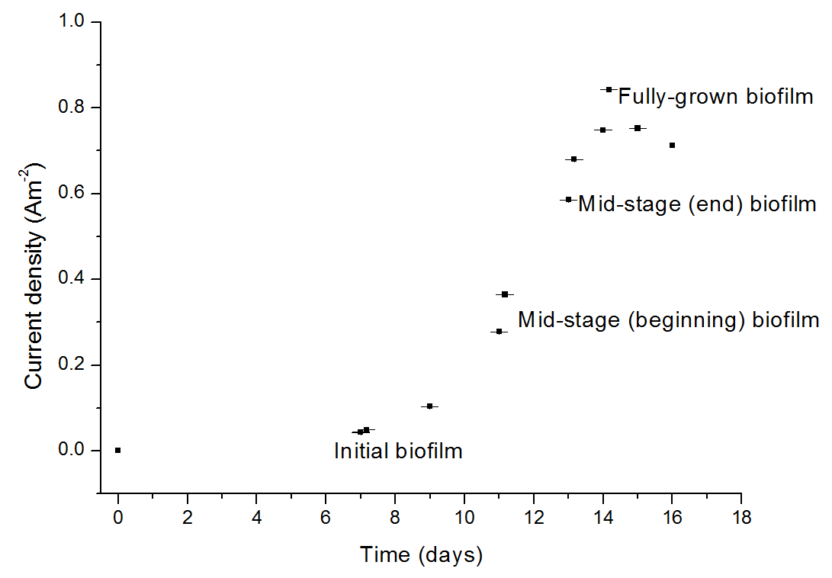
Figure S2 Current density versus time during the start-up process of the miniaturized MFC at 294 K. It takes approximately 14 days for the miniaturized MFC to finish the start-up process at 294 K. The initial biofilm, mid-stage (beginning) biofilm, mid-stage (end) biofilm and fully-grown biofilm are marked in the Figure. Please note that because the MFC was operated at a much lower temperature compared with Figure S1 (294 K vs. 314 K), the maximum current density is lower than Figure S1, and the start-up process is longer than Figure S1, due to the slow reaction kinetics low temperature.

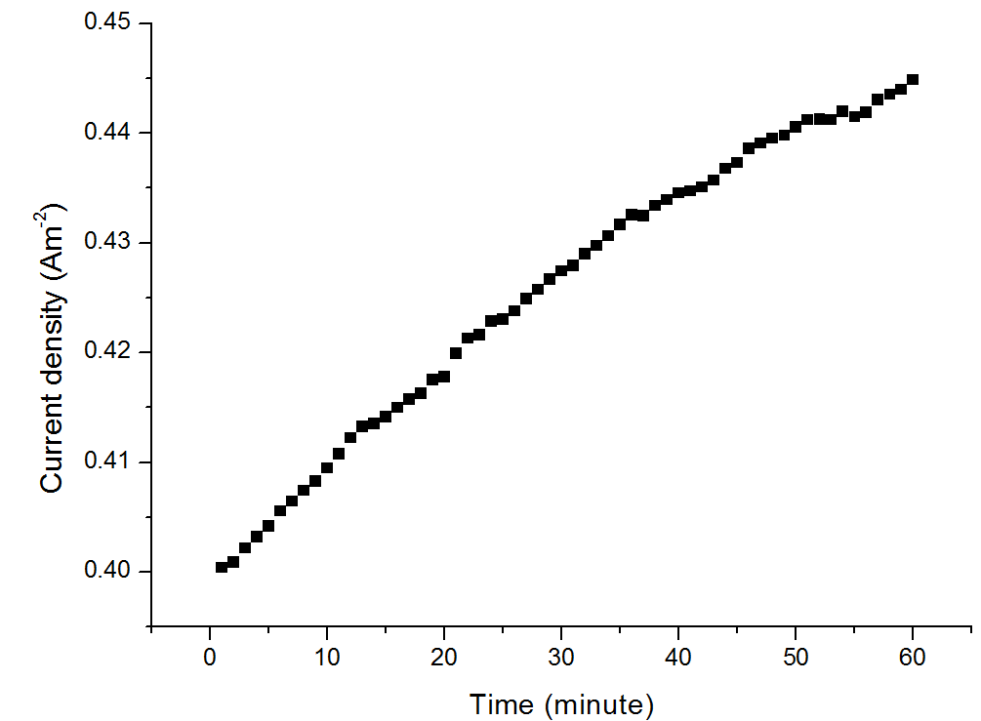
Figure S3 Increase of current density versus time during a 60-minute period in the start-up process at 314 K. We can see that during 60 minutes, the current density increased only 10%, and in 5 minute the current density only increase 1.28%, which can be negligible for the calculation in the activation energy.

First-order calculation of the miniaturized MFC temperature increase in 5-7 minutes:
Volumetric heat capacity of the glass: 2.1 J/cm³/K
Volumetric heat capacity of the water: 4.18 J/cm³/K
Volume of two glass slides: 2*4.6*2.6*0.1=2.392 cm³
Volume of anolyte and catholyte: 2*100 µL=0.2 cm³
As a result, the heat for the miniaturized MFC (glass slides, anolyte and catholyte) to increase 1 K is
2.1*2.392+4.18*0.2=5.8592 Jole.
For an increment of 4 K, 23.4368 Jole is needed.

According to “R.R. Tummala, Fundamentals of Microelectronic Packaging, 1st edition, chapter 6, Fundamentals of Thermal Management”, the heat transfer flux can be described as:
q_{rad}=σ(T₁⁴-T₂⁴)/(1/ξ₁+1/ξ₂-1)
where T₁ and T₂ are the temperature of the radiating elements: oven and the MFC, respectively (T₁=548K and T₂=294K). σ is the Stefan-Boltzmann constant (5.67x10⁻⁸W/m²/K), and ξ₁, ξ₂ are the emissivity of the radiating element of oven and the MFC, respectively (ξ₁= ξ₂=0.02). We can compute the radiation heat transfer rate to MFC is Q_{rad}=qA=0.0618 W (here A is the surface area of the MFC). In 5 minutes, the heat transferred to the MFC is 0.0618*300=18.54 Jole
Let us consider the heat transfer by convection. The heat transfer coefficient is 15 W/m²/K for natural heat convection in air. ΔT of 4K, we can calculate the convention heat transfer rate as: Q_{con}=15*2A*4=0.1436W. Thus, in 5 minutes, the heat transferred to the MFC by natural convection in air is 0.1436*300=43.08 Jole.
This first-order hand calculation shows we need to wait ~ 2.7 minutes to increase the temperature of MFC by 4K in our setting. There are, obviously, other methods to control the temperature of MFC, yet we took 5-7 minutes to accommodate the heat transfer rate of oven to MFC in our setting.

