Supplementary figure

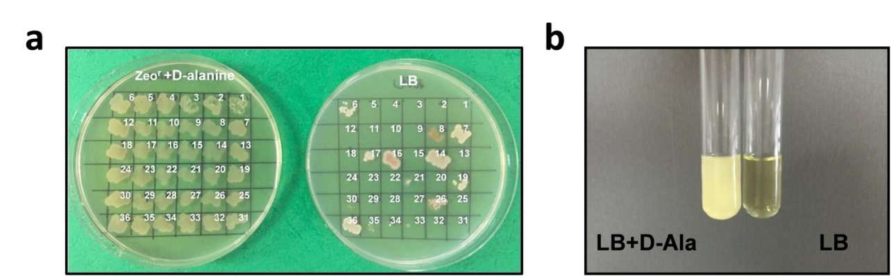

Figure S1 The isolation of B. subtilis 1A751D1. a The transformants with zeocin-resistant phenotype was replica-plated on LB agar plate and LB agar plate with zeocin and D-alanine. b B. subtilis 1A751D1 was inoculated into liquid LB medium and liquid LB medium with zeocin and D-alanine.
Table S1
Strains and plasmids used in this study

Strains | Genotype and/or relevant characteristic(s) | Source
E. coli DH5α | F⁻∆lacU169(Ø80d lacZ∆M15) supE44 hsdR17 recA1 gyrA96 endA1 thi-1 relA1 | Invitrogen
B. subtilis 168 | trpC2 | Lab stock
B. subtilis 1A751 | eglS∆102 bglT/bglS∆EV aprE nprE his | BGSCª
1A751R | 1A751 containing pMA5-RDPE; Km^{r} | Lab stock
1A751D1 | 1A751 with integration of lox71-zeo-lox66 (dal:: lox71-zeo-lox66); Zeo^{r} | This work
1A751D1C | 1A751D1 containing p148-cre; Km^{r} | This work
1A751D2 | 1A751 with integration of loxP (dal::loxP) | This work
1A751D2C | 1A751D2 containing pMA5-DAL; Km^{r} | This work
1A751D2R | 1A751D2 containing pMA5-DAL -RDPE; Km^{r} | This work
Plasmids
pET-RDPE | pET-28a derivative, rdpe; Ap^{r} | Lab stock
pMA5 | E. coli/B. subtilis shuttle vector, P_{HpaⅡ}; Ap^{r}, Km^{r} | Lab stock
pMA5-RDPE | pMA5 derivative, rdpe | Lab stock
p7Z6 | pMD18-T containing lox71-zeo-lox66 cassette | Lab stock
p148-cre | Ap^{r}, Km^{r}, P_{spac}-cre expression cassette | Lab stock
pMA5-DAL | pMA5 derivative, neo::dal, Zeo^{r} | This work
pMA5-DAL-RDPE | pMA5-DAL derivative, rdpe | This work

ª BGSC, Bacillus Genetic Stock Center, USA
Table S2
Primers used in this study

Prmier | Sequence(5’-3’)
UP-F | CTGGCACAAAAAGCCGTCTCTGTAC
UP-R | TACGACACTTCCTAGCTTTTATTCAATATC
DN-F | TAACTTACCTAAATGGAGAATTCATAAAACAG
DN-R | CTTTTAGTGTGTCAGTCCACAGTTGG
lox-F | GATATTGAATAAAAGCTAGGAAGTGTCGTATACCGTTCGTATAGCAT
lox-R | CTGTTTTATGAATTCTCCATTTAGGTAAGTTATACCGTTCGTATAATGT
YZ-F1 | ACCATCGAGACAGGGAGTGAGC
YZ-F2 | TTTCATACACTTGGTCAGTCAGCTG
pMA5-F1 | CCTTTATTGCAGGTAAATATAAGCAATTAATGAACGATGACCTCTAATAATTGTTAATC
pMA5-R1 | CTCTGTAAAAAGGTTTTGTGCTCATTACGACACTTCCTAGCTTTTATTCA
dal-F | TGAATAAAAGCTAGGAAGTGTCGTAATGAGCACAAAACCTTTTTACAGAG
dal-R | GATTAACAATTATTAGAGGTCATCGTTCATTAATTGCTTATATTTACCTGCAATAAAGG
YZ-F2 | AGCTGAATAAGAACGGTGCTCTCC
YZ-R2 | CCTTTATTCCGTTAATGCGCCATG
pMA5-F2 | GTAAAACATGTATTTGAAGTCTAAGGATCCTCTAGAGTCGAGCTCAAG
pMA5-R2 | AAGCGTAATAAATACCATATTTCATATGTAAATCGCTCCTTTTTAGGT
RDPE-F | ACCTAAAAAGGAGCGATTTACATATGAAATATGGTATTTATTACGCTT
RDPE-R | CTTGAGCTCGACTCTAGAGGATCCTTAGACTTCAAATACATGTTTTAC
YZ-F3 | AACGGACAAAATAAAAATTGGCAAG
YZ-R3 | ATTGCGAATAATAATTTTTTCACGTTG

