**Supplementary material**

An energy functional is defined in terms of a contour and two fitting functions that approximate the image intensities inside and outside the contour. The energy is then used into a variational level set formulation (see equation 7) with a arc length term (a) which is used for maintaining the regularity of the contour and a level set regularization term (b) that serves in maintaining the regularity of the level set function. Subsequently, a curve evolution equation is derived so as to minimize the associated energy functional. Intensity information in local regions at a certain scale is used to compute the two fitting functions ( and) and thereby progressively adapt the contour toward the LV bone boundaries. The energy criterion is as follows:

 (1)

where λ1 > 0, λ2 > 0, ν > 0, μ > 0 are fixed parameters,  is the level set function,  is the smoothed Dirac function given by the following formula:

,  (2)

and  and  are given by the following formulas:

  (3)

is a Gaussian kernel defined as:

 (4)

 and approximate image intensities outside and inside the active contour and are given by the following equations:

,  (5)

 are the intensities used for the fitting energy, and  is a regularised version of the Heaviside function:

 (6)

Minimization of the energy functional can be obtained by solving the evolution problem:

 (7)

(a) (b)

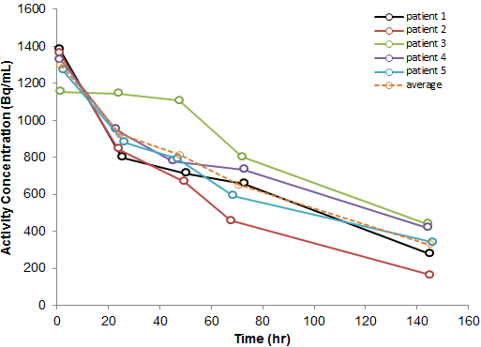

Supplemental figure: Non-decay corrected bone marrow time-activity curves (TAC). The dashed line shows the average TAC with values of 1300 Bq/mL at 1hr to 330 Bq/mL at 145hr, post-injection. This can be translated to a half-life of 73 hr which means that the compound decays slightly faster than its physical decay (78.41 hr).