Supporting Information
Synthesis of gold nanoparticles with buffer-dependent variations of size and morphology in biological buffers
Syed Rahin Ahmed^{1,‡}, Sangjin Oh^{2,‡}, Rina Baba³, Hongjian Zhou⁴, Sungu Hwang⁵, Jaebeom Lee^{2,}*, and Enoch Y. Park^{1,6,*}
¹ Research Institute of Green Science and Technology, Shizuoka University, 836 Ohya Suruga-ku, Shizuoka, 422-8529, Japan
² Department of Cogno-Mechatronics Engineering, Pusan National University, Busan, 46279, Korea
³ Department of Applied Biological Chemistry, Shizuoka University, 836 Ohya Suruga-ku, Shizuoka 422-8529, Japan
⁴ Institute of Solid State Physics, Chinese Academy of Sciences, Hefei, 230031, P. R. China
⁵ Department of Nanomechatronics Engineering, Pusan National University, Miryang 627-706, Korea
⁶ Graduate School of Science and Technology, Shizuoka University, 836 Ohya Suruga-ku, Shizuoka 422-8529, Japan.

Keywords: Gold nanoparticles, Good’s buffer, Synthesis route, MD simulation, Cell viability

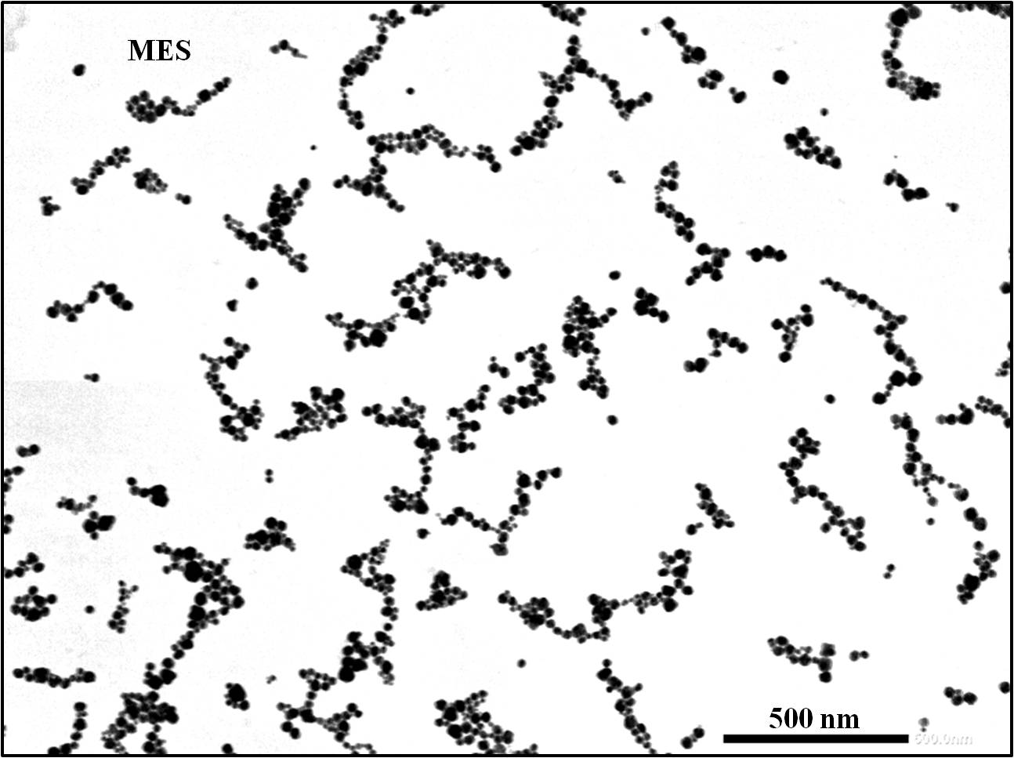
Figure S1: Far View TEM image of Au NPs synthesized by MES buffer.
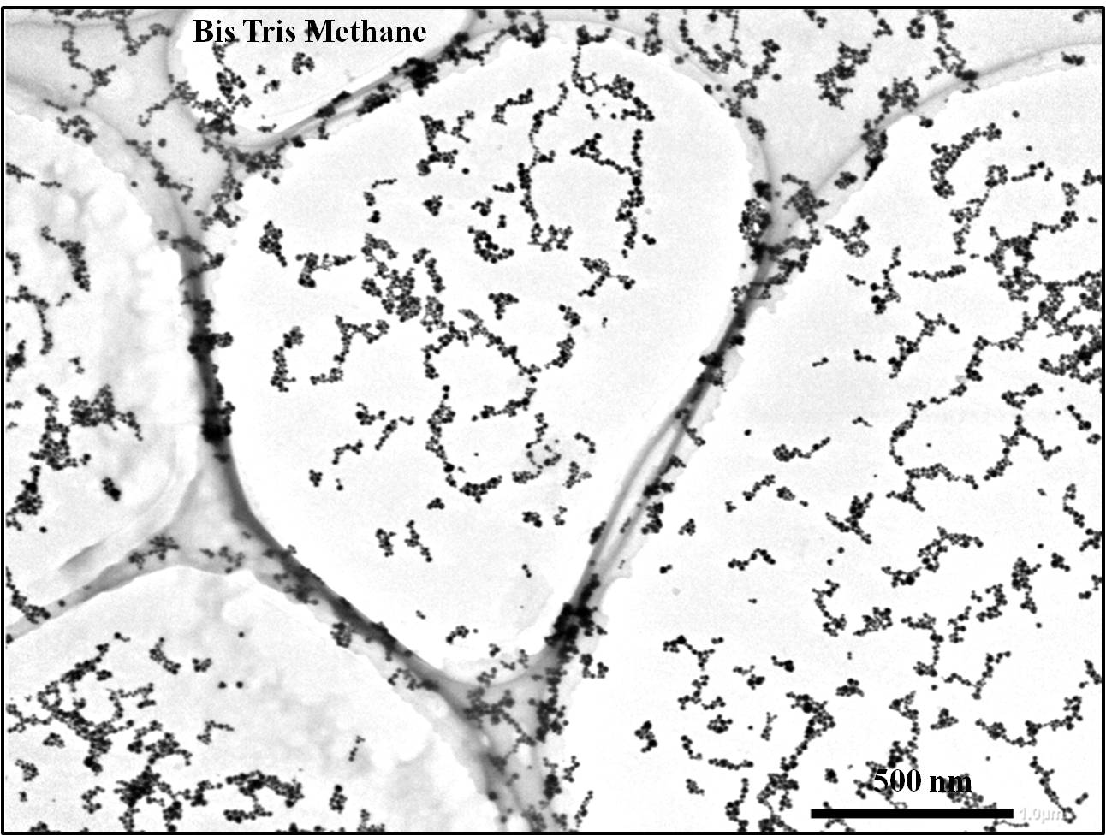
Figure S2: Far View TEM image of Au NPs synthesized by Bis Tris Methane buffer.
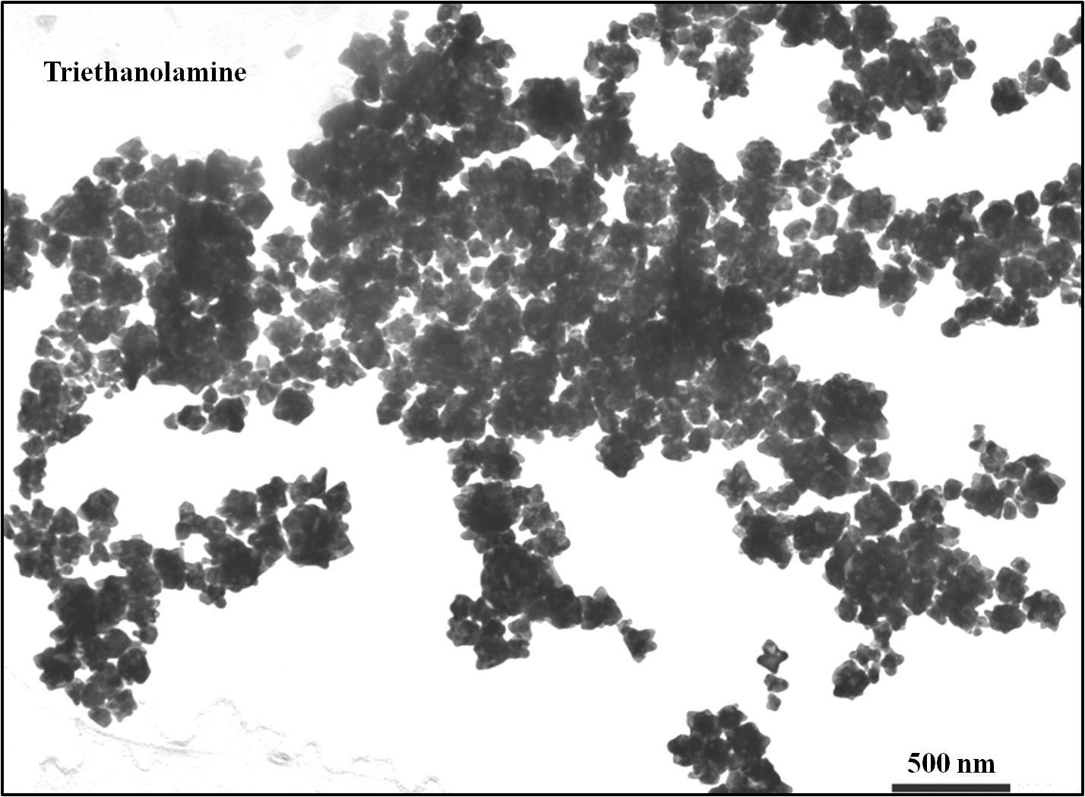
Figure S3: Far View TEM image of Au NPs synthesized by Triethanolamine buffer.

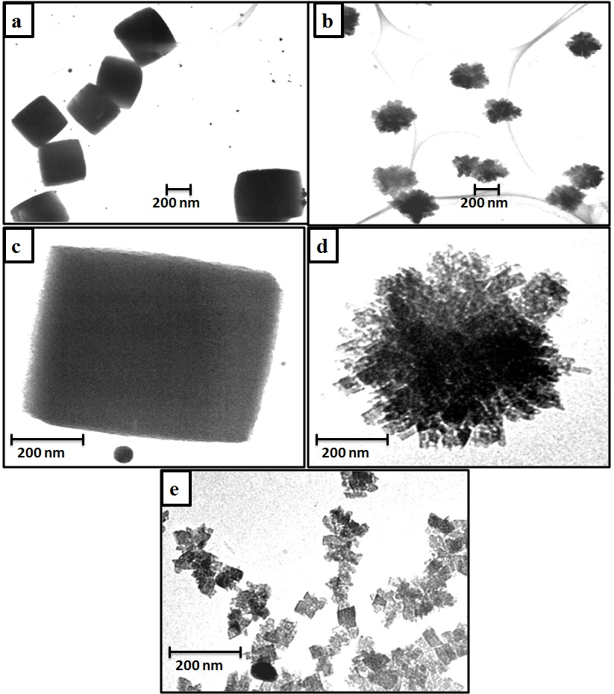
Figure S4: TEM images of unreacted buffer salts.

*Corresponding authors: jaebeom@pusan.ac.kr (JL), park.enoch@shizuoka.ac.jp (EYP) ‡Both contributed equally.

