One-Pot Method for Multifunctional Yolk Structured Nanocomposites with N-doped Carbon Shell Using Polydopamine as Precursor
Yanwei Zhang, Min Zhang,* Lei Ding, Yongtao Wang, Jingli Xu*
College of Chemistry and Chemical Engineering, Shanghai University of Engineering Science, Shanghai 201620, China. E-mail: zhangmin@sues.edu.cn; xujingli@sues.edu.cn

Synthesis of Fe₃O₄ NPs and Fe₃O₄@void@Carbon yolk-shell:
The magnetic Fe₃O₄ were prepared according to the published literature. FeCl₃.6H₂O (1.08 g), NaOAc (4.0 g) were dissoved in EG (14 mL) and DEG (26 mL) under magnetic stirring. The obtained homogeneous yellow solution was transferred into a Teflon-lined stainless-steel autoclave. The autoclave was maintained at 200 °C for 15 h and cooled to room temperature. The Fe₃O₄ was collected by magnetic separation and washed with deionized water and ethanol several times and then dried under vacuum for 12 h. The Fe₃O₄@SiO₂@pdop and Fe₃O₄@void@Cwere obtained in a similar manner with the synthesis procedures of Au@SiO₂@pdop and Au@void@C.
Synthesis of ellipsoid-shaped α-Fe₂O₃ and α-Fe₂O₃ @ void@Carbon yolk-shell:
The α-Fe₂O₃ spindles were synthesized by aging a solution containing 680 mg of FeCl₃.6H₂O and 10 mg of NaH₂PO₄ dissolved in 80 mL of deionized water, then the solution was transferred into a Teflon-lined stainless-steel autoclave. The autoclave was maintained at 180 °C for 6 h. Then α-Fe₂O₃ spindles was collected by centrifuging and washed with deionized water and ethanol several times and air-dried at 50 °C for 5 h. The α-Fe₂O₃@SiO₂@Pdop and α-Fe₂O₃@void@C were obtained in a similar manner with the synthesis procedures of Au@SiO₂@Pdop and Au@void@C.
Synthesis of Ag NWs and Ag NWs@ void@Carbon yolk-shell
Ag NWs were synthesized according to the method reported previously. First, 2.93 g of PVP (K30) and 95 mL of glycerol were added into the flask. The composites were heated at 90 °C, when the PVP fully dissolved and the solution was cooled down to 50 °C. Then, 0.79 g AgNO₃ powder was added. Subsequently, a solution containing 5 mL of glycerol, 29.5 mg of NaCl and 0.25 mL of H₂O was added into the above solution and the solution temperature was raised from 50 °C to 210 °C in 25 min under gentle stirring (70 rpm). When the solution temperature reached 210 °C, the heating was stopped and the obtained gray-green solution was transfer immediately into a beaker. When the solution temperature returned to room temperature 100 mL deionized water was added. After stabilized for one week, upper layer solution was poured out to remove silver nanoparticles (Ag NPs) and a layer of sediment at the bottom of the beaker was collected and washed with ethanol three times to remove the rest PVP, and the Ag NWs were collected and dispersed into an aqueous solution of 10 mg/mL. Ag NWs@SiO₂@pdop and Ag NWs@void@C were obtained in a similar manner with the synthesis procedures of Au@SiO₂@pdop and Au@ void@C.
Synthesis of CNTs/Fe₃O₄ and CNTs/Fe₃O₄@void@Carbon yolk-shell
Briefly, 80mg CNTs, 120 mg of the iron precursor Fe(acac)₃ and 30 mL triethylene glycol were added to the flask. The solution was sonicated for 30 min. Then, the mixed solution was heated to 278 °C under vigorous stirring and N₂ protection and kept at reflux for 30 min. After cooling to room temperature, 30 mL ethanol was added to dilute the solution. Then the obtained composites were magnetically separated by a commercial magnet, which was washed with ethanol several times and air-dried at 50 °C for 5 h. CNTs/Fe₃O₄@SiO₂@Pdop and CNTs/Fe₃O₄@void@C were obtained in a similar manner with the synthesis procedures of Au@SiO₂@pdop and Au@ void@C.

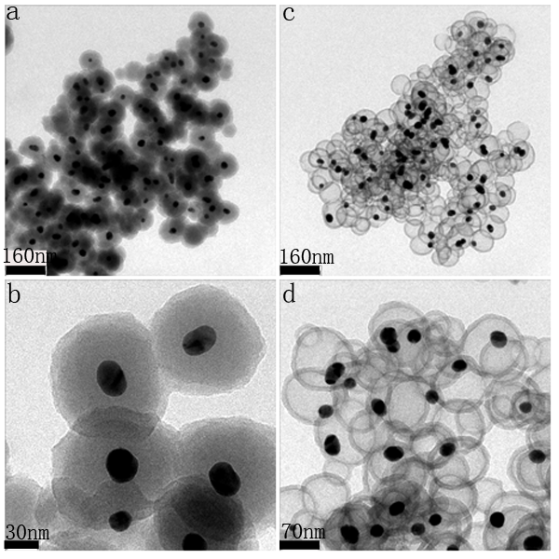
Figure S1 The TEM images of core–shell Au@SiO₂@Pdop (a, b) and Au@void@C(c, d) in the ratio of ethanol and water(10:1)
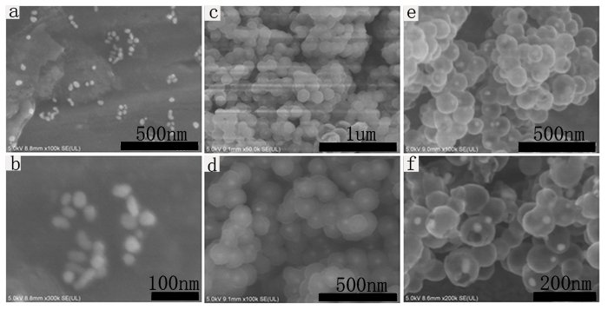

Figure S2 The SEM imagines of Au(a,b), Au@SiO₂@Pdop(c,d), Au@void@C(e,f),
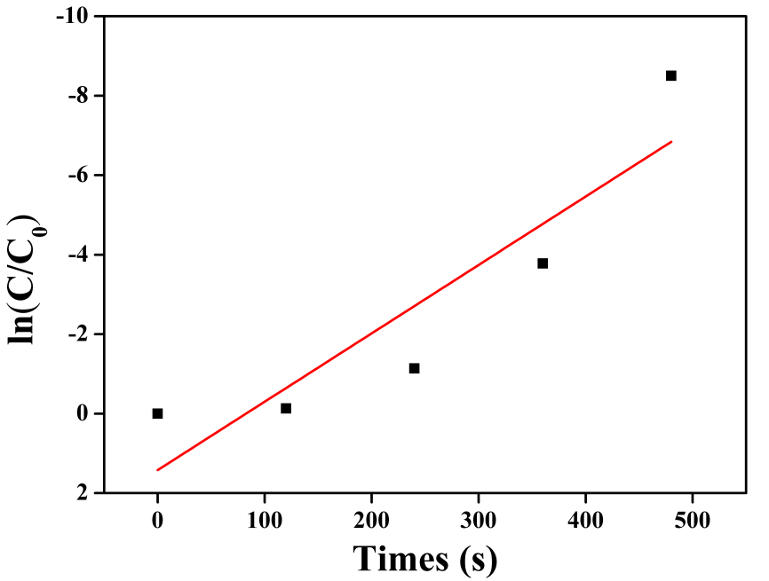
Figure S3 ln (C/C₀) versus time for the reduction of MB

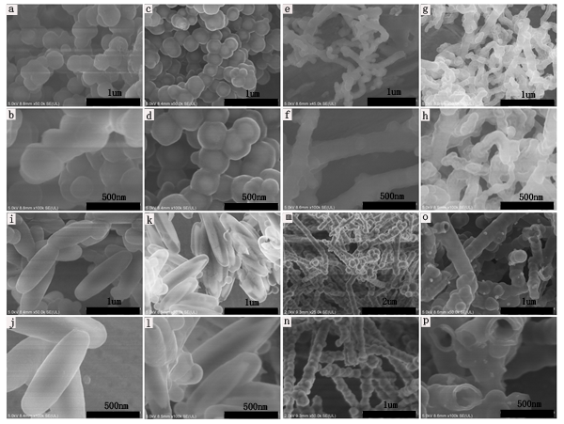

Figure S4 The SEM imagines of Fe₃O₄@SiO₂@Pdop(a,b), Fe₃O₄@void@C(c,d), CNTs@Fe₃O₄@SiO₂@Pdop(e,f), CNTs@Fe₃O₄@void@C(g,h), α-Fe₂O₃@SiO₂@Pdop(I,j), α-Fe₂O₃@void@C(k,l), Ag@SiO₂@Pdop(m,n), Ag@void@C(o,p) at different magnetification

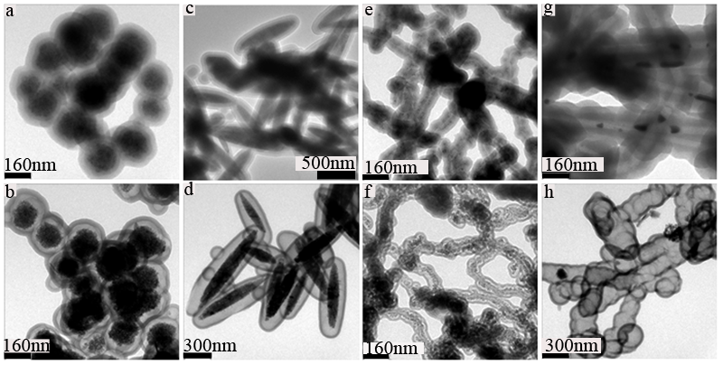
Figure S5 The TEM imagines of Fe₃O₄@SiO₂@Pdop(a), Fe₃O₄@void@C(b), α-Fe₂O₃@SiO₂@Pdop(c), α-Fe₂O₃@void@C(d), CNTs@Fe₃O₄@SiO₂@Pdop(e), CNTs@Fe₃O₄@void@C(f), Ag@SiO₂@Pdop(g), Ag@void@C(h) at higher magnetification

