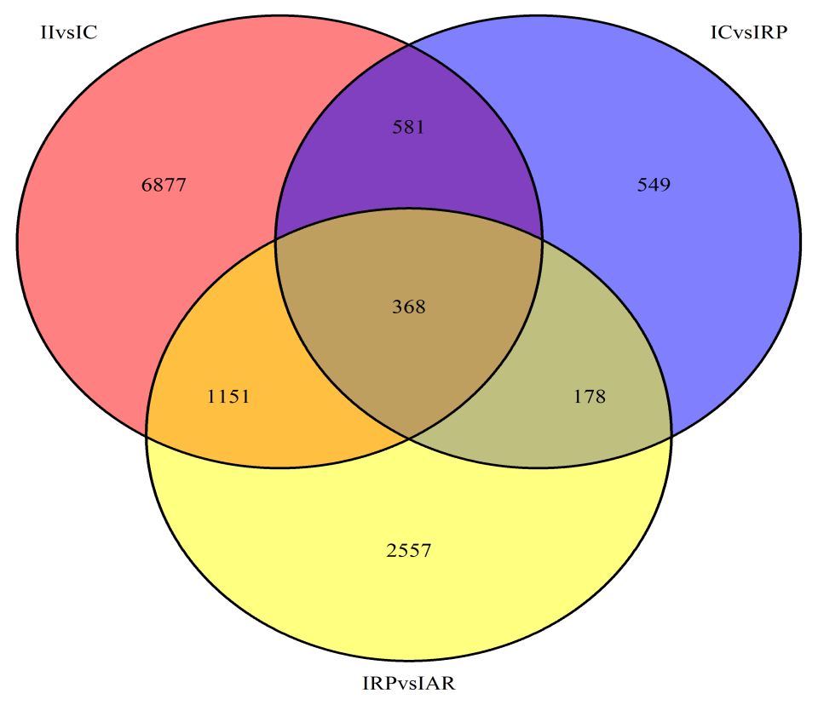
Additional file 5 Venn diagrams of unigenes showing differential expression in pairwise comparisons of developmental stages in the IBA treatment.

