Additional file 1

Cancer cells increase endothelial cell tube formation and survival
by activating the PI3K/Akt signalling pathway

Hao-Wei Cheng, Yi-Fang Chen, Jau-Min Wong, Chia-Wei Weng, Hsuan-Yu Chen, Sung-Liang Yu, Huei-Wen Chen, Ang Yuan, and Jeremy J.W. Chen

Correspondence: Associate Professor Ang Yuan, E-mail: navyyuan@ntu.edu.tw or Professor Jeremy J.W. Chen, E-mail: jwchen@dragon.nchu.edu.tw

Table S1. Pathway analysis of the differentially expressed genes in HUVECs with cancer cell co-culture.
Significant Pathways | Total | Found | p-Value
Neuroactive ligand-receptor interaction | 277 | 141 | 3.6E-10
PI3K-Akt signalling pathway | 345 | 153 | 5.1E-6
Insulin secretion | 85 | 46 | 9.1E-5
Jak-STAT signalling pathway | 145 | 69 | 2.5E-4
Rap1 signalling pathway | 210 | 94 | 2.8E-4
Aldosterone synthesis and secretion | 81 | 43 | 2.8E-4
Cytokine-cytokine receptor interaction | 229 | 101 | 3.1E-4
Calcium signalling pathway | 175 | 80 | 3.8E-4
Glutamatergic synapse | 114 | 56 | 4.0E-4
Cell adhesion molecules (CAMs) | 142 | 67 | 4.3E-4

Note:
- The differentially expressed genes were defined as the genes with a fold change greater than 2.5 between HUVECs with and without cancer cell co-culture.
- The top 10 pathways were determined by the DAVID programme.

Table S2. The differentially expressed gene changes in microarray data and QPCR validation.
Array probe ID | Gene symbol | Array ratio¹ | QPCR fold change²
211579_at | ITGB3 | 7.25 | 2.04
242876_at | AKT3 | 5.63 | 1.58
237401_at | ACTN1 | 5.62 | 3.02
202859_x_at | CXCL8 | 5.44 | 10.59
211506_s_at | CXCL8 | 4.82 | 10.59
241325_at | PIK3R3 | 4.57 | 1.86
204369_at | PIK3CA | 3.67 | 1.87
202351_at | ITGAV | 3.40 | 2.31
203868_s_at | VCAM1 | 2.92 | 7.93
1567457_at | RAC1 | 2.54 | 2.13
212239_at | PIK3R1 | 2.45 | 2.42
1554997_a_at | PTGS2 | 1.82 | 3.25
202638_s_at | ICAM1 | 1.65 | 3.76
201533_at | CTNNB1 | 1.65 | 2.71
Note:
- Array ratio = expression of co-cultured HUVECs/expression of HUVECs alone.
- QPCR fold change = expression of co-cultured HUVECs/expression of HUVECs alone.

Table S3. Probes and gene list of cancer cell-stimulated gene signatures derived from endothelial cells.
Probe ID | Gene name | Cox coefficient |  | Hazard ratio
 |  | OS* | DFS* | OS | DFS
202351_at | ITGAV | 0.54833 | 0.50411 | 1.730 | 1.656
204369_at | PIK3CA | 1.08186 | 1.43882 | 2.950 | 4.216
241325_at | PIK3R3 | 1.15214 | 1.24444 | 3.165 | 3.471
242876_at | AKT3 | 0.91519 | 0.95833 | 2.497 | 2.607
1567457_at | RAC1 | 0.44776 | 0.15455 | 1.565 | 1.167
237401_at | ACTN1 | 0.12674 | 0.77845 | 1.135 | 2.178
203868_s_at | VCAM1 | 0.35977 | 0.37022 | 1.433 | 1.448
202859_x_at | CXCL8 | 0.74904 | 0.73972 | 2.115 | 2.095
211506_s_at | CXCL8 | 0.53920 | 0.51848 | 1.715 | 1.679
201533_at | CTNNB1 | 1.29538 | 0.85054 | 3.652 | 2.341
1554997_a_at | PTGS2 | 0.07447 | 0.05834 | 1.077 | 1.060
202638_s_at | ICAM1 | 0.01016 | -0.03042 | 1.010 | 0.970
* OS: overall survival; DFS: disease-free survival.
Note:
1. The risk score function of the 11-gene signature for overall survival = (0.55 × expression level of ITGAV) + (1.08 × expression level of PIK3CA) + (1.15 × expression level of PIK3R3) + (0.92 × expression level of AKT3) + (0.45 × expression level of RAC1) + (0.13 × expression level of ACTN1) + (0.36 × expression level of VCAM1) + (0.75 × expression level of CXCL8) + (0.54 × expression level of CXCL8) + (1.30 × expression level of CTNNB1) + (0.07 × expression level of PTGS2) + (0.01 × expression level of ICAM1).
2. The risk score function of the 11-gene signature for disease-free survival = (0.50 × expression level of ITGAV) + (1.44 × expression level of PIK3CA) + (1.24 × expression level of PIK3R3) + (0.96 × expression level of AKT3) + (0.15 × expression level of RAC1) + (0.78 × expression level of ACTN1) + (0.37 × expression level of VCAM1) + (0.74 × expression level of CXCL8) + (0.52 × expression level of CXCL8) + (0.85 × expression level of CTNNB1) + (0.06 × expression level of PTGS2) + (-0.03 × expression level of ICAM1).
3. The risk score function of the 5-gene signature for overall survival = (1.08 × expression level of PIK3CA) + (1.15 × expression level of PIK3R3) + (0.92 × expression level of AKT3) + (0.75 × expression level of CXCL8) + (0.54 × expression level of CXCL8) + (1.30 × expression level of CTNNB1).
4. The risk score function of the 5-gene signature for disease-free survival = (1.44 × expression level of PIK3CA) + (1.24 × expression level of PIK3R3) + (0.96 × expression level of AKT3) + (0.74 × expression level of CXCL8) + (0.52 × expression level of CXCL8) + (0.85 × expression level of CTNNB1).

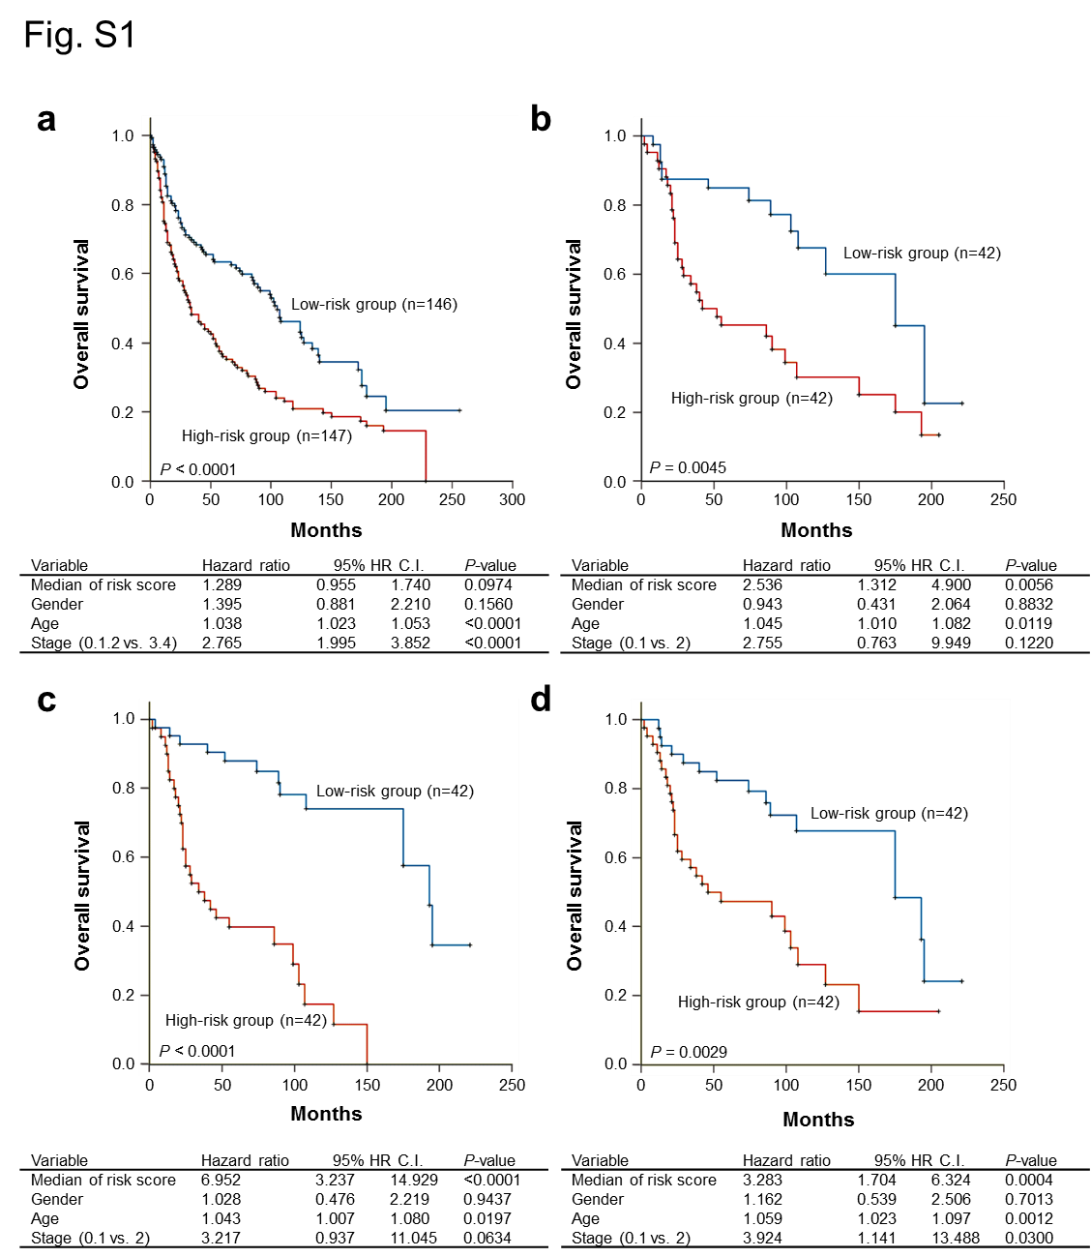

Fig. S1 Comparison of the endothelial cell derived gene signatures and the published prognostic gene signatures in the Kaplan–Meier estimates of NSCLC patient survival. (a) Kaplan-Meier estimates of overall survival (n = 293) of the subjects who were categorized based on the 8-gene signature (see ref. 46 in main text). (b) Kaplan-Meier estimates of overall survival (n = 84) of the early-stage lung adenocarcinoma subjects who were categorized based on the 7-gene signature (see ref. 47 in main text). (c, d) Kaplan-Meier estimates of overall survival (n = 84) of the early stage lung adenocarcinoma subjects who were categorized based on the 11-gene (c) and 5-gene (d) signatures derived from the differentially expressed genes of HUVECs co-cultured with cancer cells. The datasets were obtained from GSE30219. The risk score functions of all gene signatures were constructed according to our method as described in this study. The survival curve was estimated by the Kaplan-Meier method, and the log-rank test was performed to test the difference between the survival curves.

