Additional file 5. Multi-dimensional scaling (MDS) across five ethnic groups from 1000 genome project, 146 paediatric IBD cases and 126 non-IBD controls.

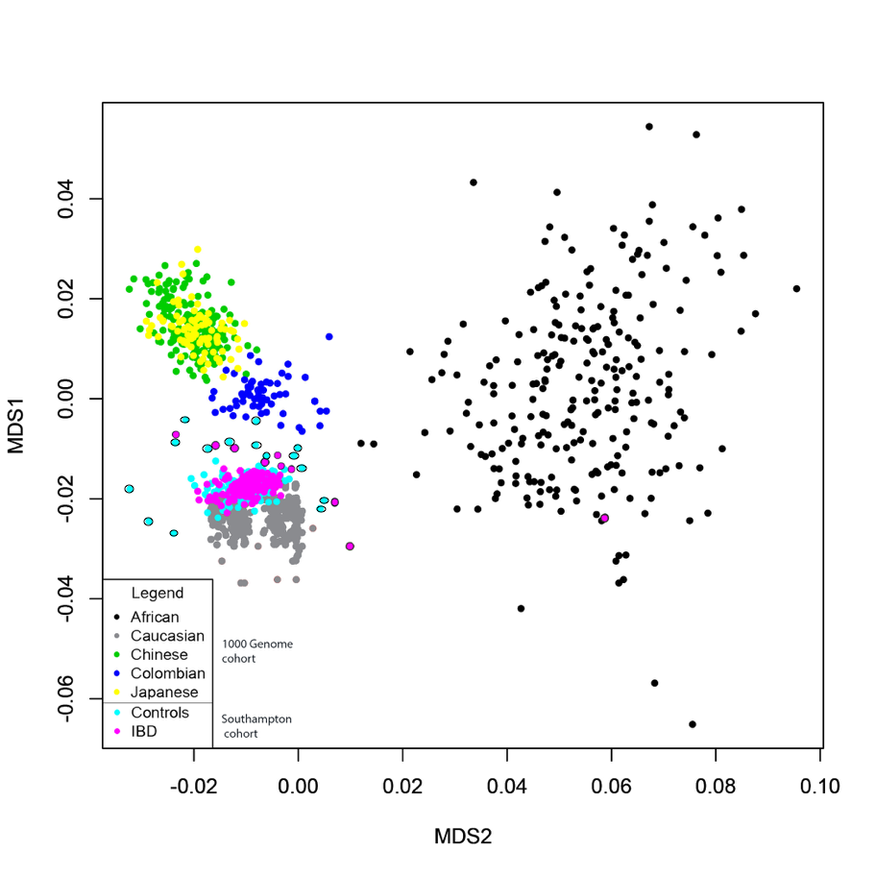

The five ethnic groups from 1000 Genome are colored as indicated. The Southampton IBD cohort and controls are in pink and light blue respectively. Southampton IBD samples excluded from the SKAT-O test because of ethnic status are represented with a black outline.

