Additional file 4
Figure S4A-F. Sanger traces of each of the four variants of interest found across six pedigrees. Genotypic state was confirmed in all available family members.
Figure S4A. Sanger trace for Pedigree 34
Mother
Homozygous reference

Father
Heterozygous

Proband
Heterozygous

Variant: HSPA1L:NM_005527:exon2:c.A1674T:p.Glu558Asp
Primers used: Forward ACTGCCCTGATAAAGCGCAA; Reverse GGGGCCTAGTTTTCCTGAGTC
Heterozygous status in proband and father (unaffected)

Figure S4B. Sanger trace for Pedigree 142
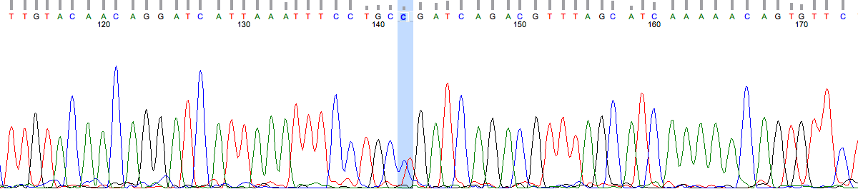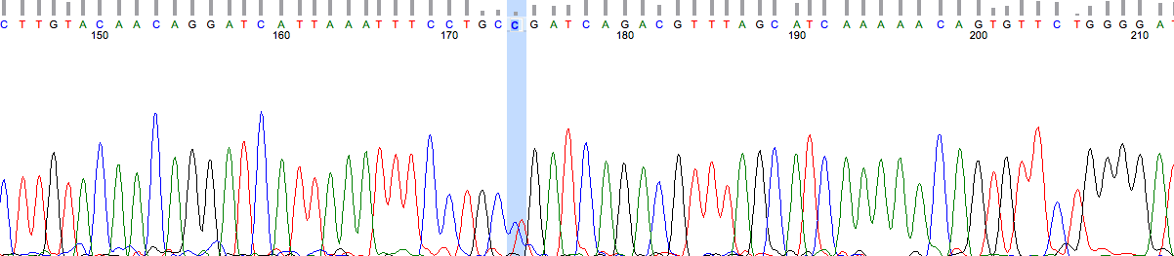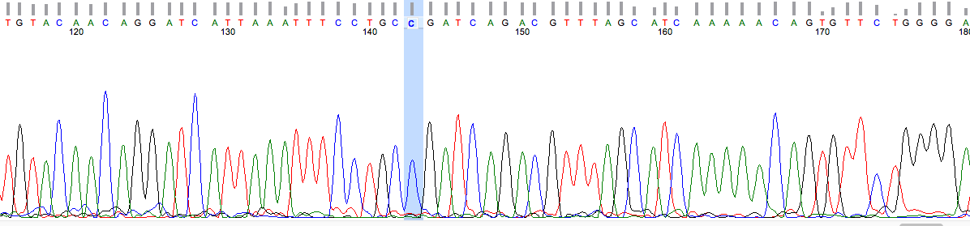
Mother
Homozygous reference

Father
Heterozygous

Proband
Heterozygous

Variant: HSPA1L:NM_005527:exon2:c.G229A:p.Gly77Ser
Primers used: Forward TTGACAACAGGCTTGTGAGC; Reverse AAATCGAGCTCTGGTGATGG
Heterozygous status in proband and father (unaffected)

Figure S4C. Sanger trace for Pedigree 151
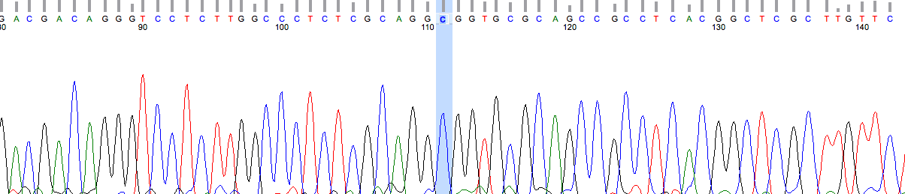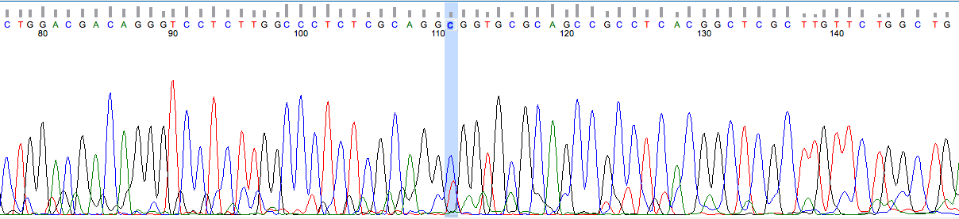
Proband
Heterozygous

Father
Homozygous reference
Mother
Heterozygous

Variant :HSPA1L:NM_005527:exon2:c.G802A:p.Ala268Thr
Primers used: Forward TTGACAACAGGCTTGTGAGC; Reverse AAATCGAGCTCTGGTGATGG
Heterozygous status in proband and mother (unaffected)

Figure S4D. Sanger trace for Pedigree 156
Proband
Heterozygous

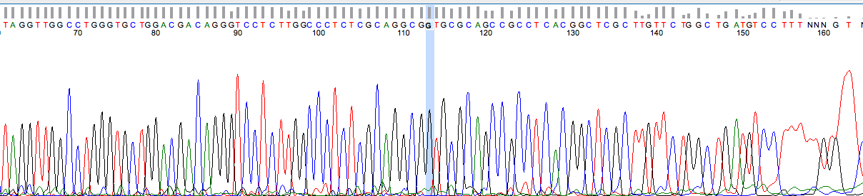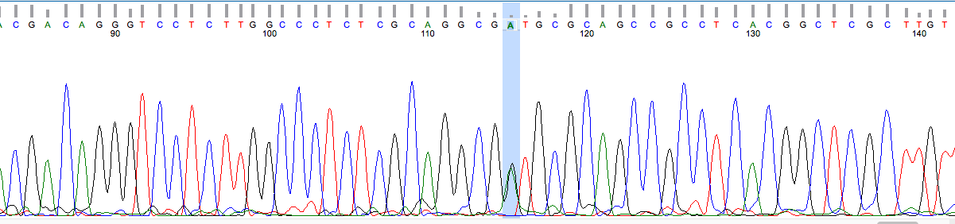
Mother
Heterozygous

Father
Homozygous reference

Variant: HSPA1L:NM_005527:exon2:c.C800T:p.Thr267Ile
Primer: Forward TTGACAACAGGCTTGTGAGC; Reverse AAATCGAGCTCTGGTGATGG
Heterozygous status in proband and mother (unaffected)

Figure S4E. Sanger trace for Pedigree 161
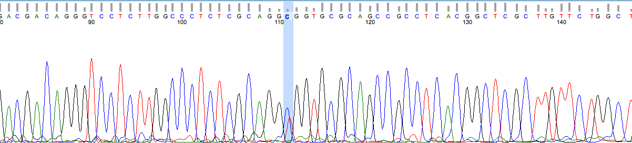
Proband
Heterozygous
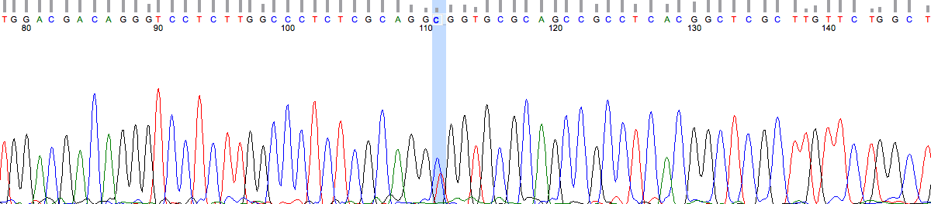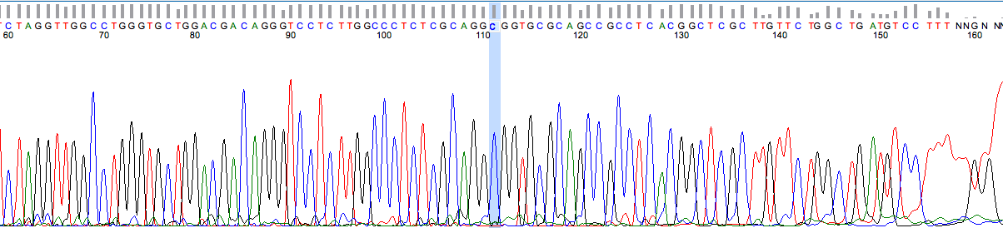
Mother
Homozygous reference
Father
Heterozygous
Sister
Heterozygous

Variant : HSPA1L:NM_005527:exon2:c.G802A:p.Ala268Thr
Primers used: Forward TTGACAACAGGCTTGTGAGC; Reverse AAATCGAGCTCTGGTGATGG
Heterozygous status in proband, unaffected father (unaffected) and sister (ulcerative colitis)

S4F. Sanger trace for Pedigree 244
Proband
Heterozygous

Mother
Homozygous reference

Variant: HSPA1L:NM_005527:exon2:c.515_517del:p.Leu172del
Primers used: Forward ACTGCCCTGATAAAGCGCAA; Reverse GGGGCCTAGTTTTCCTGAGTC
Heterozygous status in proband

Figure S4G. Pedigree Family A

Sanger trace for Family A is shown in Fig. 1A
Primers used: Forward TAGATGATGGGATTTTTGAGGTA; Reverse CTACTAAAACAATGTCATGGATTTT

