Additional file 1
Tree view and flowers of Lagesteromia speciosa (a) L. speciosa in full bloom (b) Flowers of L. speciosa
(a)
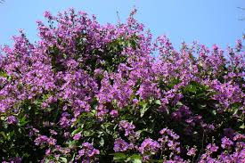
(b)
