Draft genomic sequence of a chromate- and sulfate-reducing Alishewanella with the ability to bioremediate Cr and Cd contamination
Xian Xia¹, Jiahong Li¹, Shuijiao Liao^{1, 2}, Gaoting Zhou^{1, 2}, Hui Wang¹, Liqiong Li¹, Biao Xu¹, Gejiao Wang¹*
¹ State Key Laboratory of Agricultural Microbiology, ² College of Basic Sciences, Huazhong Agricultural University, Wuhan, 430070, P. R. China
*Correspondence should be addressed to: Dr. Gejiao Wang, Tel: +86 27 87281261, Fax: +86 27 87280670, E-mail: gejiao@mail.hzau.edu.cn

Fig. S1 Phylogenetic relationships of Alishewanella sp. WH16-1 based on gyrB sequences. The analysis was performed by MEGA 6.0 [13] with NJ algorithm and 1,000 bootstrap repetitions were computed to estimate the reliability of the tree. The gyrB gene of strain WH16-1 is the gene sequence coding for AAY72_13600.
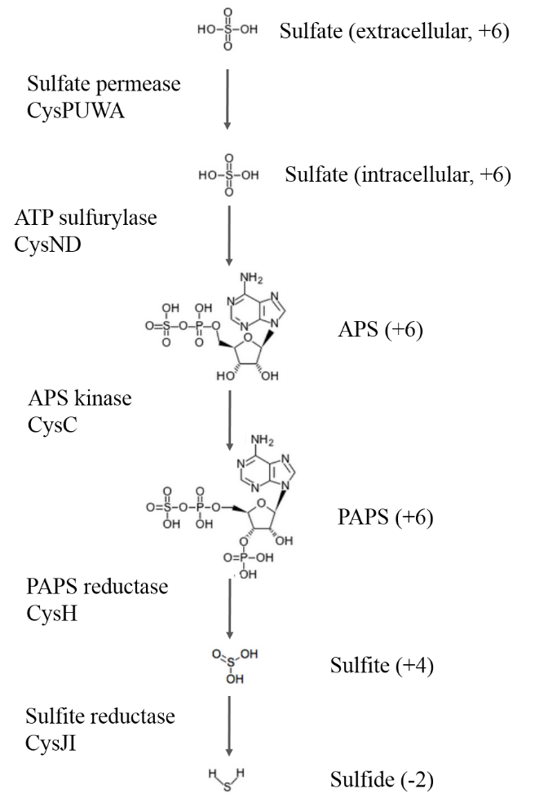
Fig. S2 The putative sulfate transport and reduction pathway in Alishewanella sp. WH16-1. APS stands for adenylylsulphate, PAPS stands for phosphoadenylylsulphate. The locus tag numbers of the predicted proteins (CysP, CysU, CysW, CysA, CysN, CysD, CysC, CysH CysJ and CysI) are AAY72_14890, AAY72_14885, AAY72_14880, AAY72_14875, AAY72_03865, AAY72_03870, AAY72_07290, AAY72_07265, AAY72_07255 and AAY72_07260, respectively.

