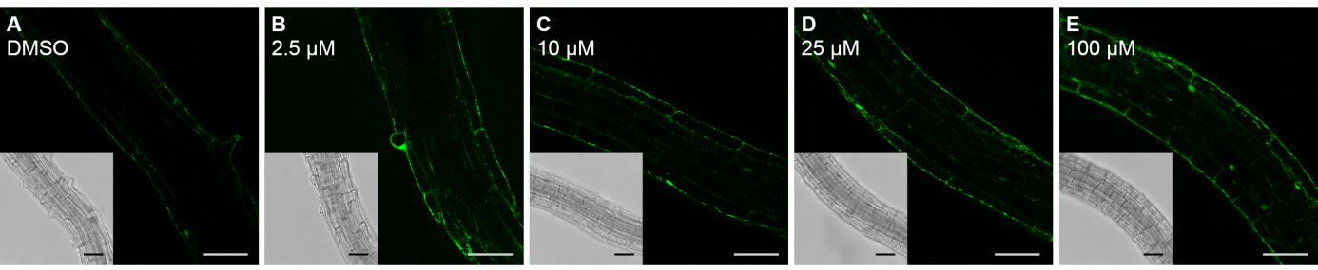Additional File 11. Optical sections of 4 day old Arabidopsis seedling roots incubated for 24 hours with 2.5 µM (b), 10 µM (c), 25 µM (d), and 100 µM (e) GalNAz, followed by labelling through a copper-catalysed click-reaction with Alexa Fluor® 488 alkyne. As a control, seedlings were treated with 0.01 % DMSO (a). Scale bars = 50 μm.

