Supplementary information
Figure S1. Differentially expressed proteins in liver of dairy goats fed HC and LC by two-dimensional gel electrophoresis analysis.

The differentially expressed proteins between LC and HC goats were spotted and numbered. pI, isoelectric point; Mr, molecular mass; Animals no. LC 2-4, HC 2-4.
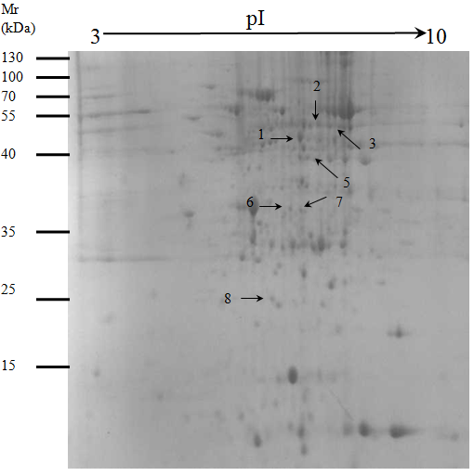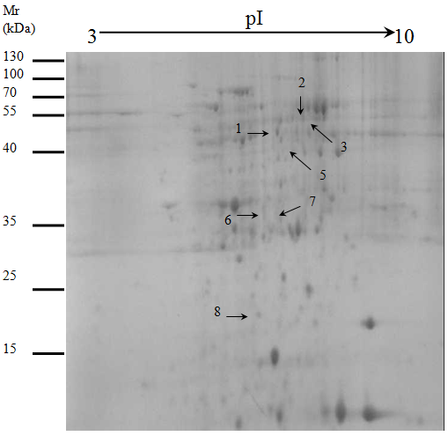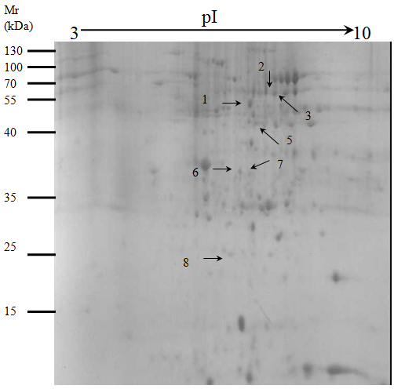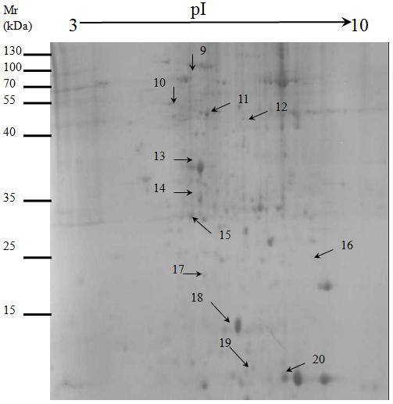
LC-2
LC-3
HC-2
LC-4

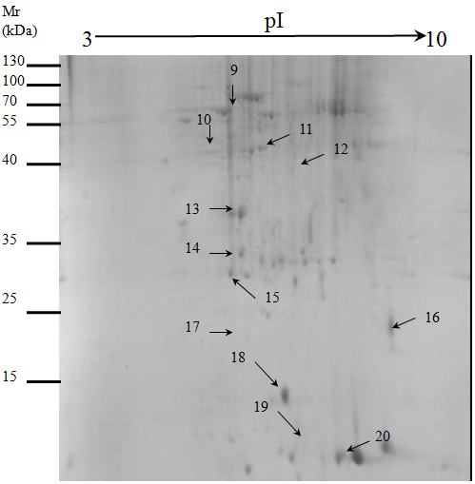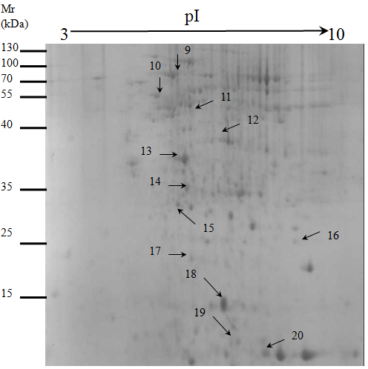
HC-4
HC-3

