Figure S1. Illustration of compound heterozygosity. (A) The state of possessing two identical mutations in a particular gene (homozygosity) may lead to a recessive phenotype. (B) The presence of two different mutations at the same gene locus, both inside coding regions, one on each chromosome (compound heterozygote), may lead to the same recessive phenotype. (C) An example of generalized CH, where the second mutation occurs inside a non-coding region.

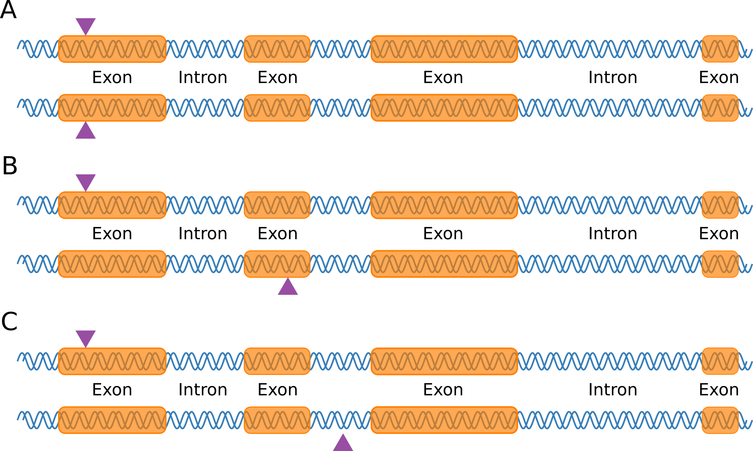

Algorithm S1. Genome shifting algorithm.
Input: bed_file_in (input bed file), k (window size)
Output: bed_file_out_1, bed_file_out_2, ..., bed_file_out_k
01: for each i in {sequence from 1 to k}:
02: stream1 <- open a reading stream on bed_file_in
03: stream2 <- open a reading stream on bed_file_in
04: stream1 skip the first 3 bytes
05: stream2 skip the first (3 + i * (number of bytes per SNP)) bytes
06: stream3 <- open a writing stream for bed_file_out_i
07: for each j in {sequence from 0 to (total number of SNPs - 1)}:
08: buffer_collapsed <- initialize a new byte array
09: buffer1 <- read genotypes of one SNP from stream1
10: if j >= (number_of_SNPs - i):
11: fill buffer_collapsed with NA
12: else:
13: buffer2 <- read genotype of one SNP from stream2
14: for each genotypes_byte1 in buffer1, each genotypes_byte2 in buffer2:
15: coerce genotypes_byte1 and genotypes_byte2 into integers
16: collapsed_byte <- look up collapsing_byte_array at coordinates (genotypes_byte1, genotypes_byte2)
17: add collapsed_byte to buffer_collapsed
18: end for
19: end if
20: write buffer_collapsed to stream3
21: end for
22: close all streams
23: end for

