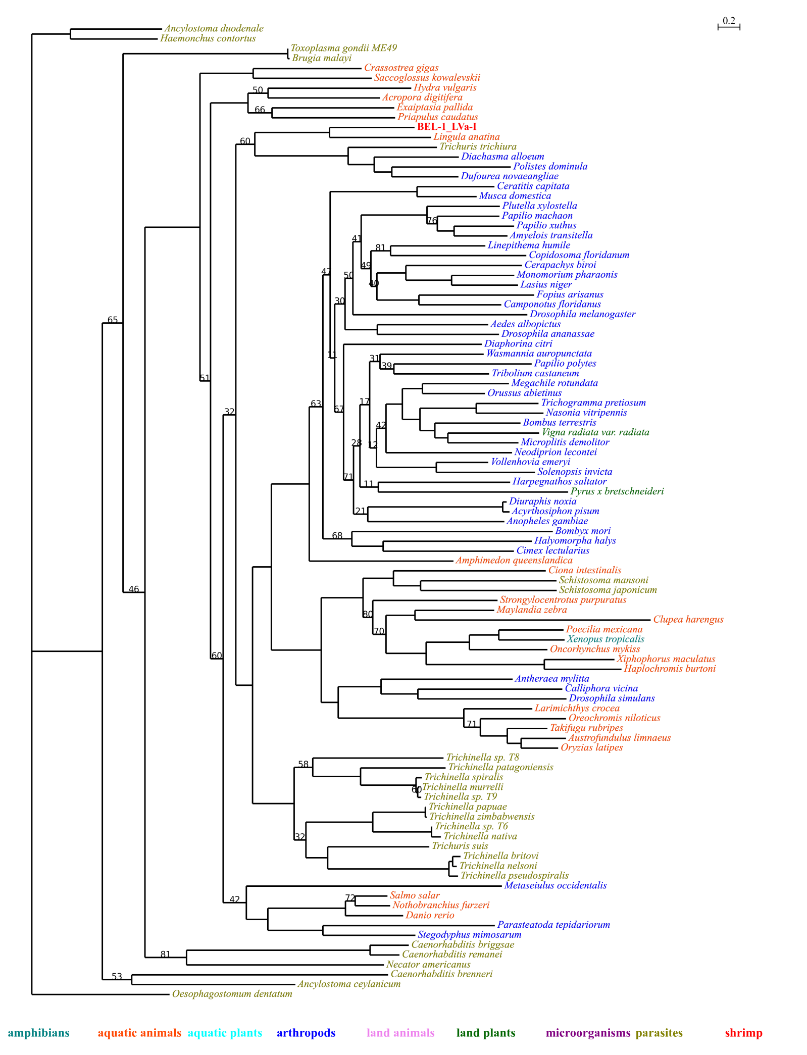
Fig. 1 Phylogenetic tree of BEL-1_LVa-I and its homologues. Only those bootstrap values below 90% were shown (100 replicates); the same below. The p-value of approximately unbiased (AU) test is 0.729.

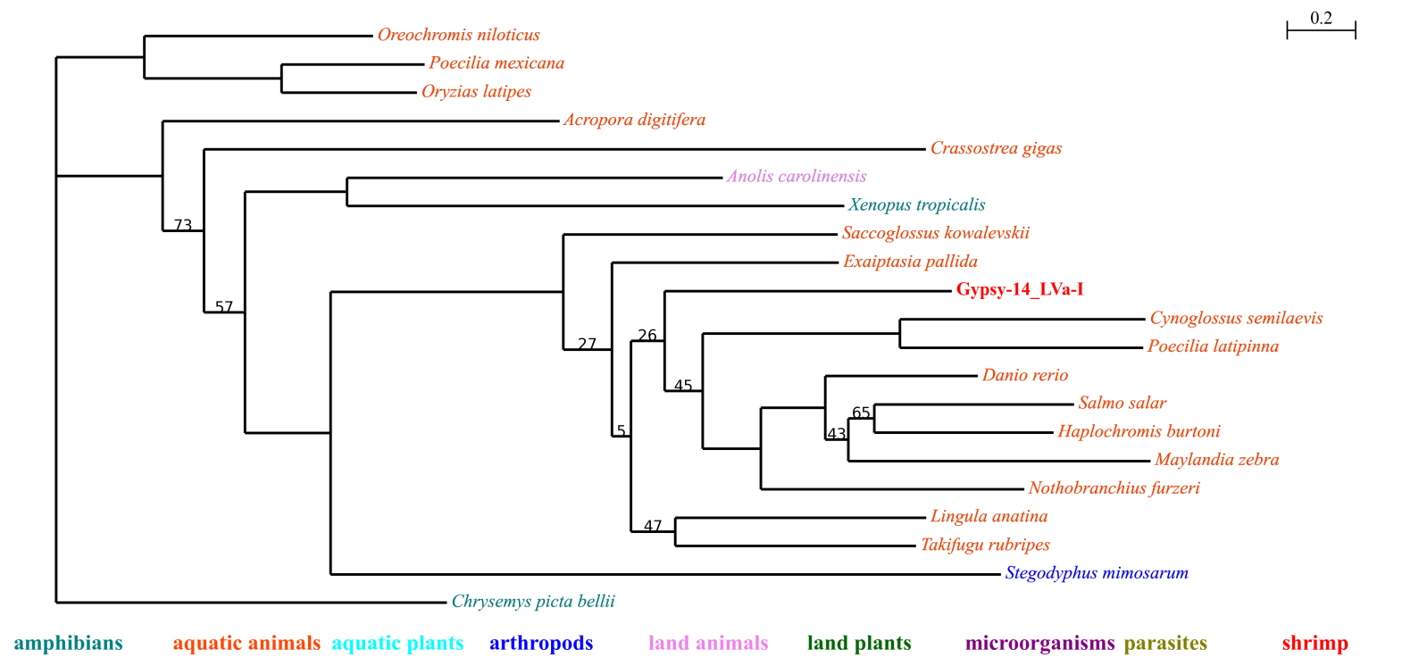
Fig. 2 Phylogenetic tree of Gypsy-14_LVa-I and its homologues. The p-value of AU test is 0.770.

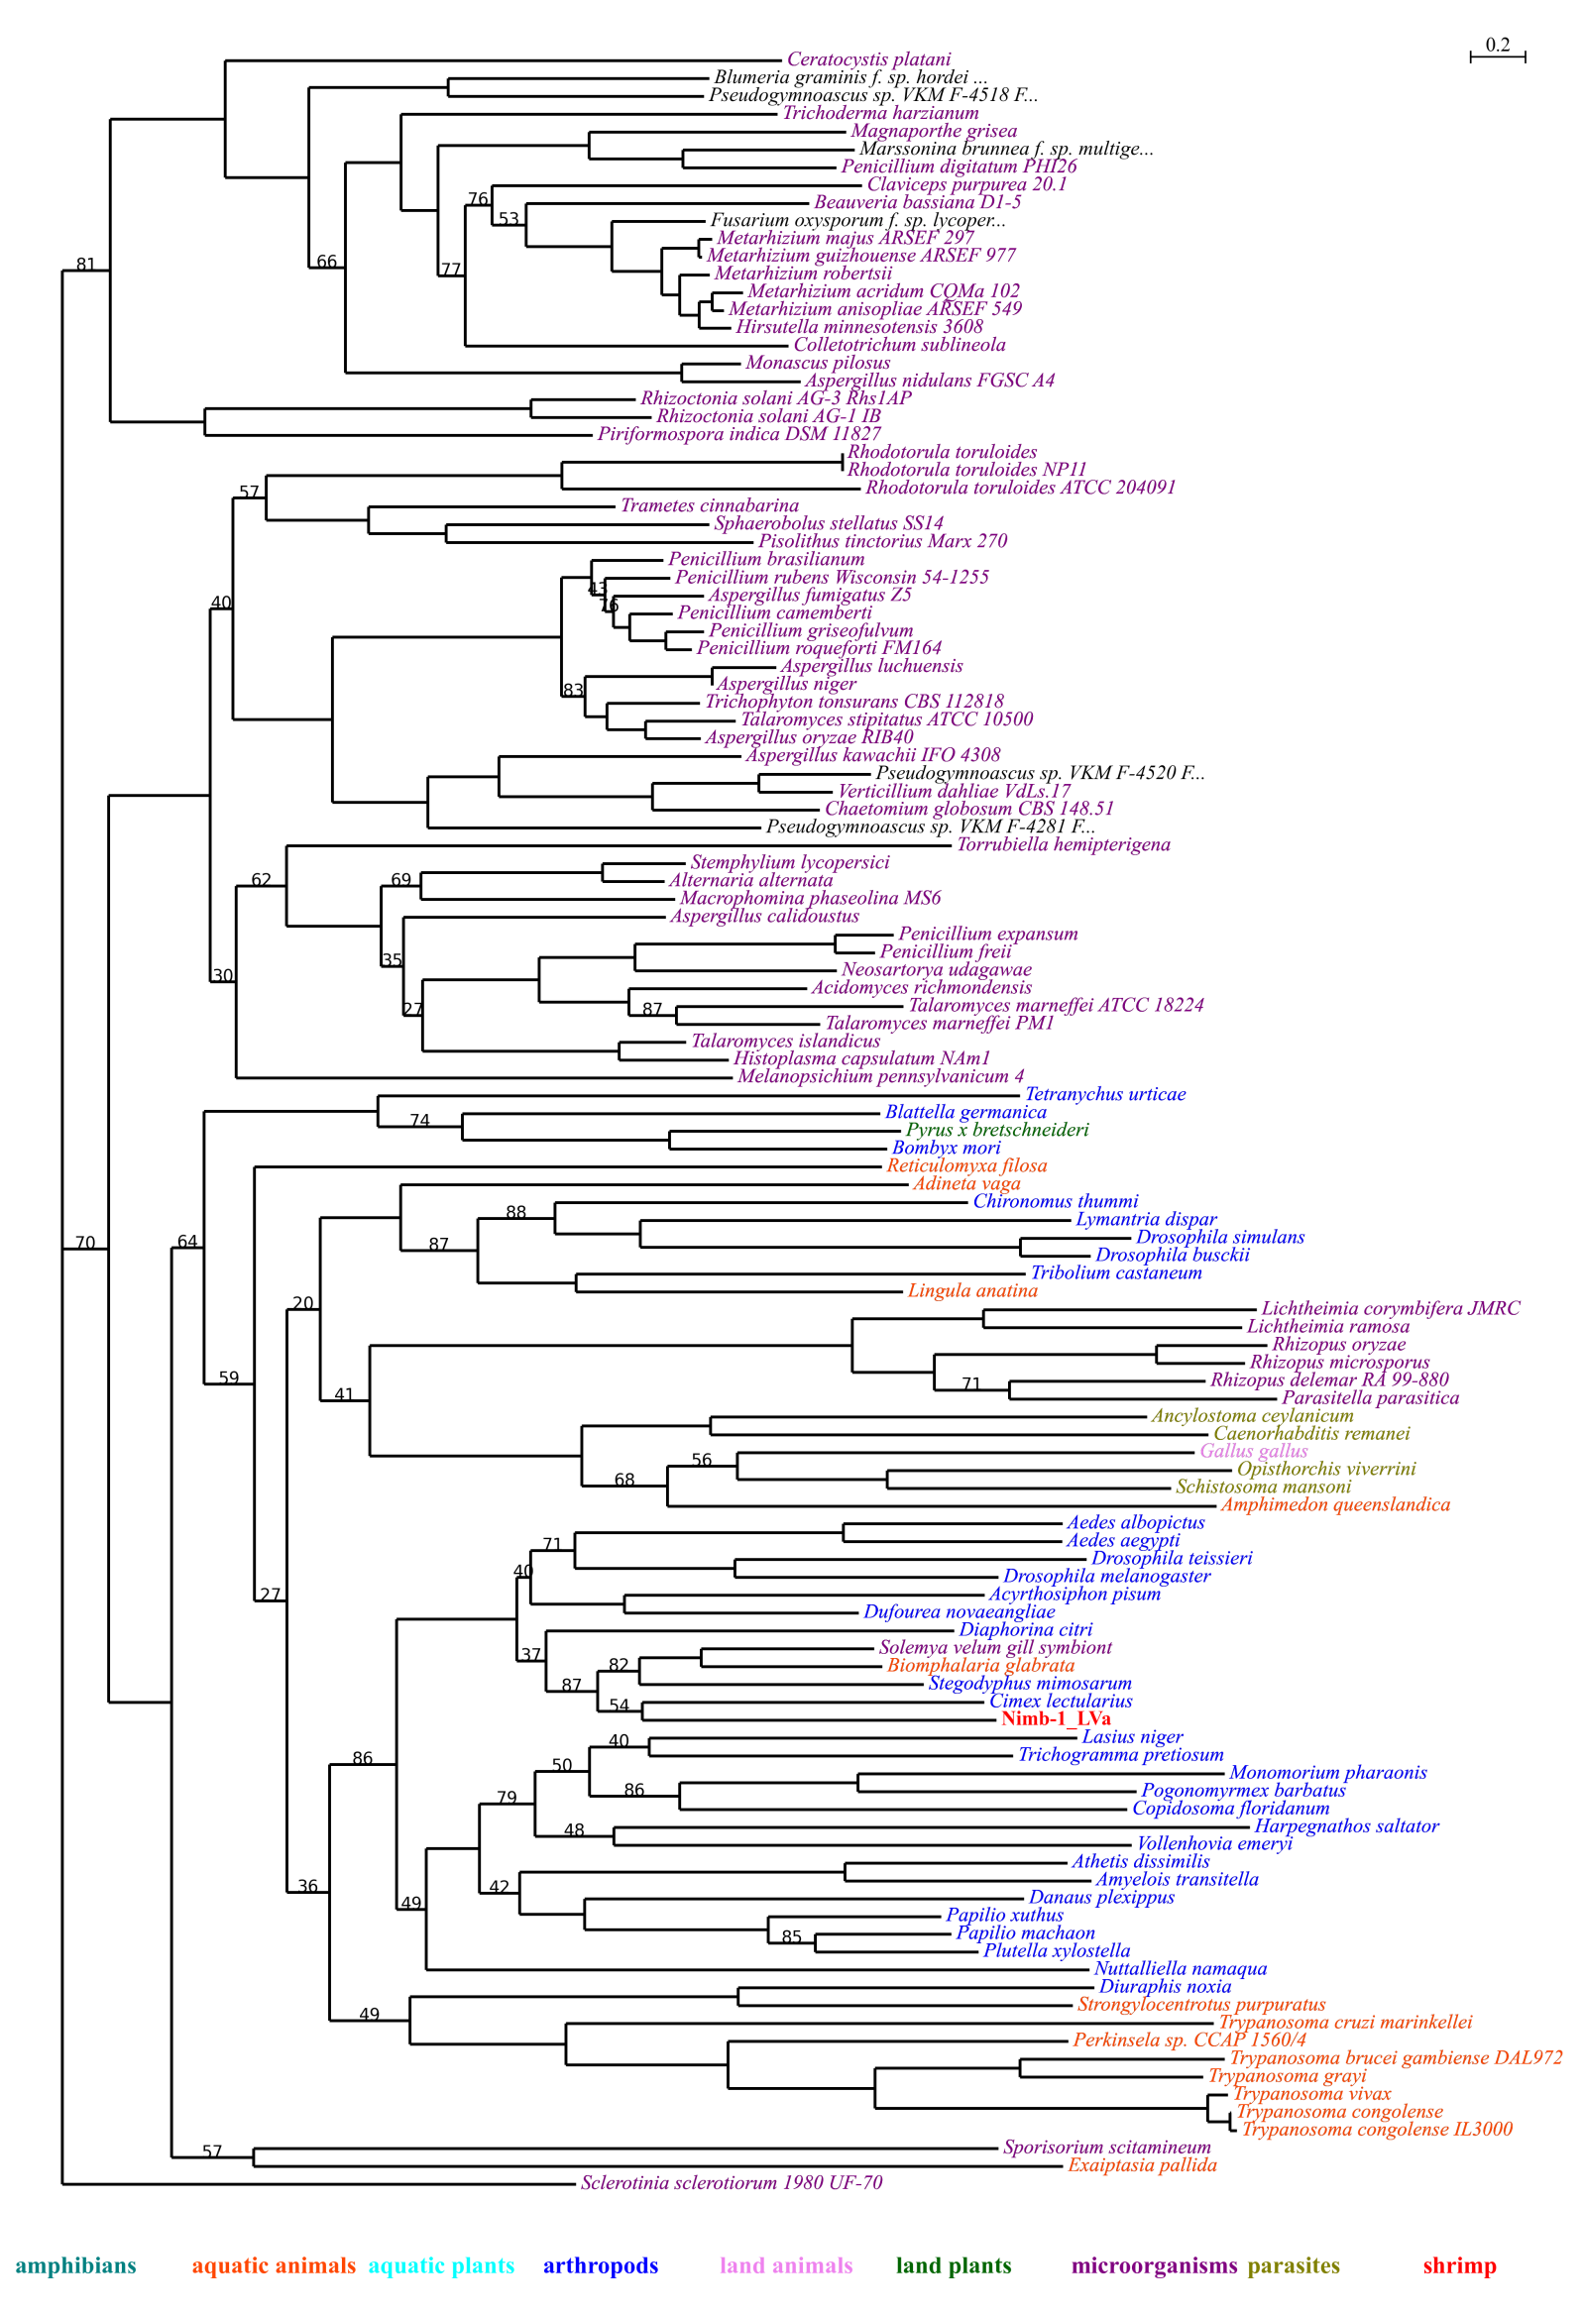
Fig. 3 Phylogenetic tree of Nimb-1_LVa and its homologues. The p-value of AU test is 0.760.

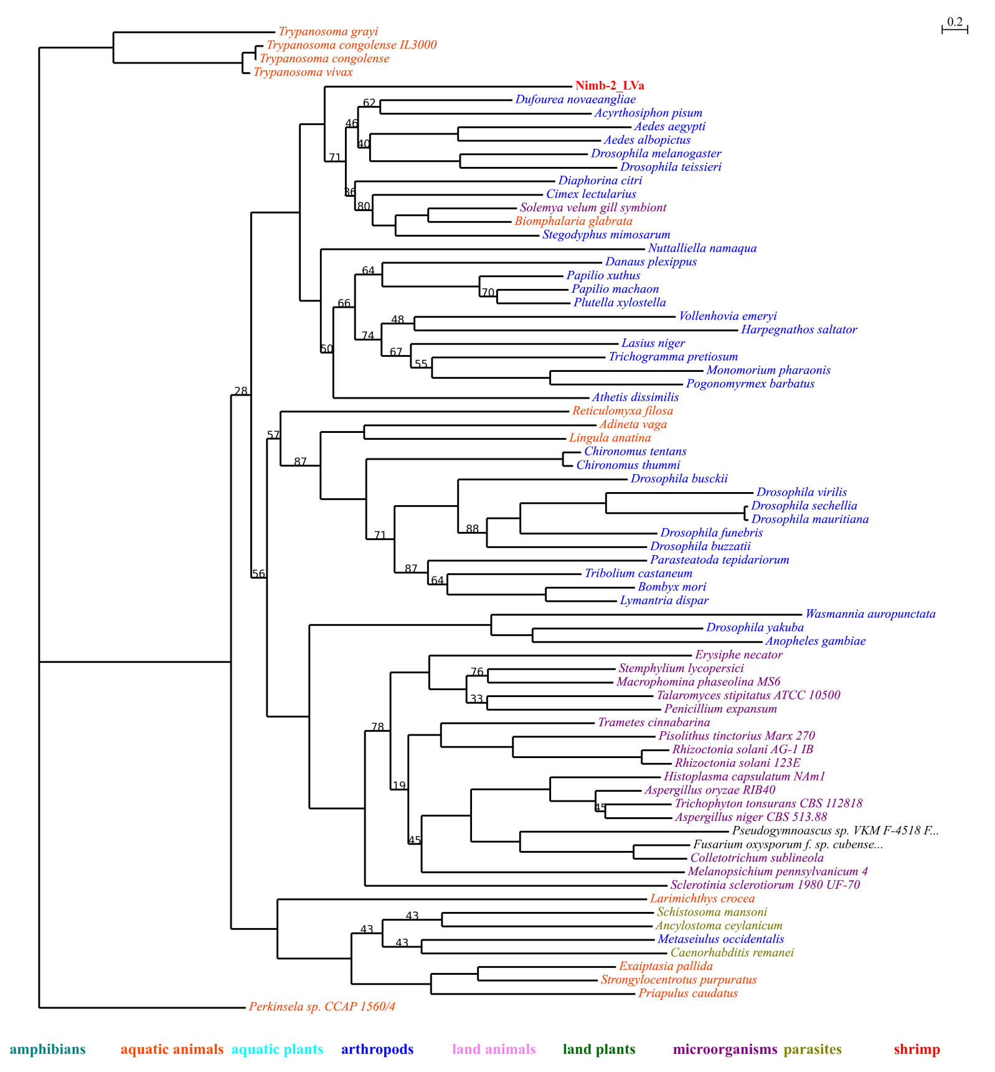
Fig. 4 Phylogenetic tree of Nimb-2_LVa and its homologues. The p-value of AU test is 0.899.

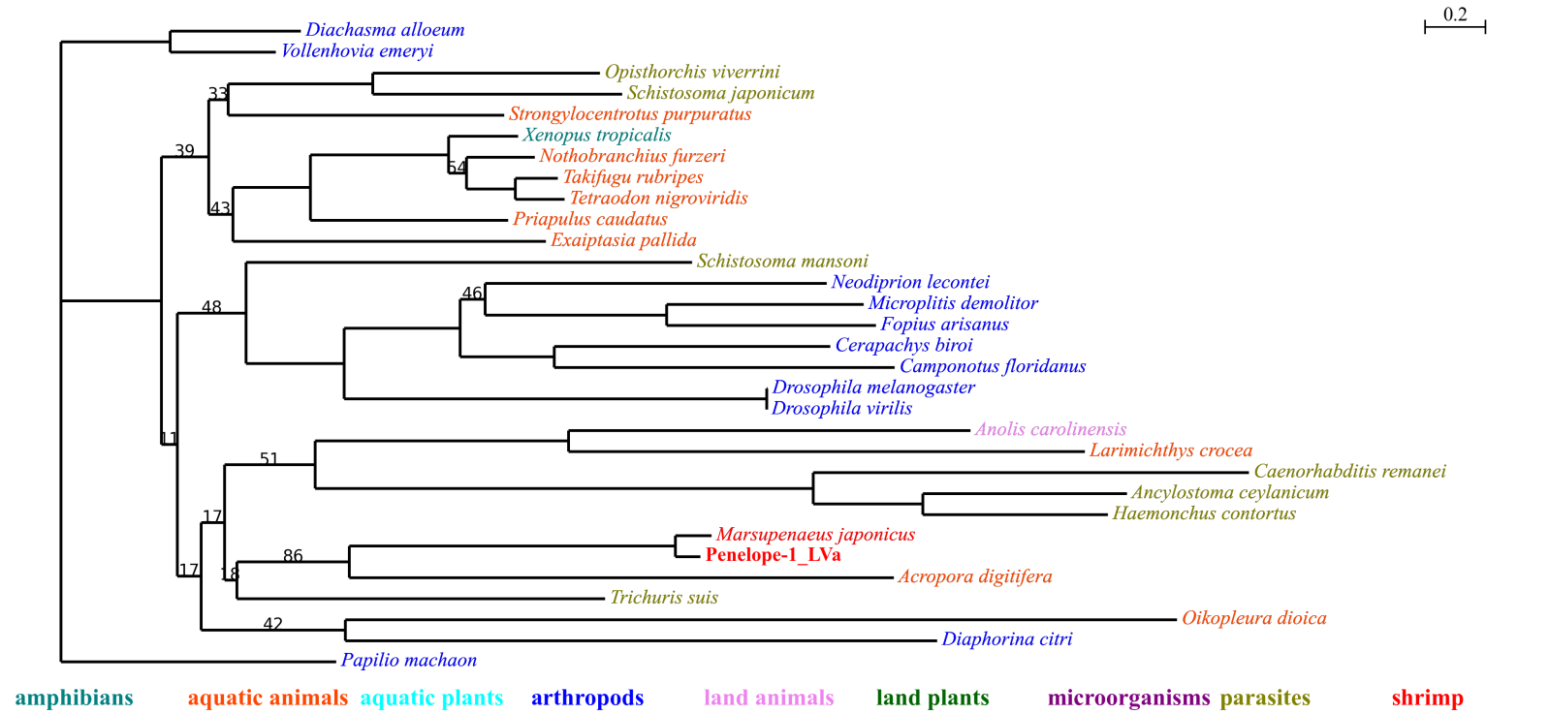
Fig. 5 Phylogenetic tree of Penelope-1_LVa and its homologues. The p-value of AU test is 0.926.

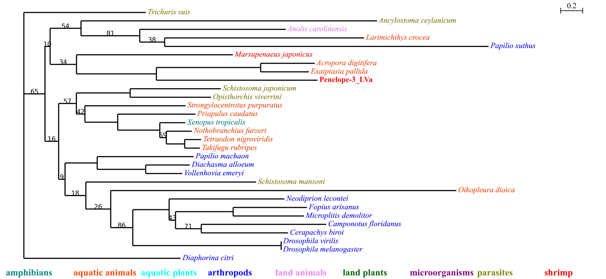
Fig. 6 Phylogenetic tree of Penelope-3_LVa and its homologues. The p-value of AU test is 0.875.

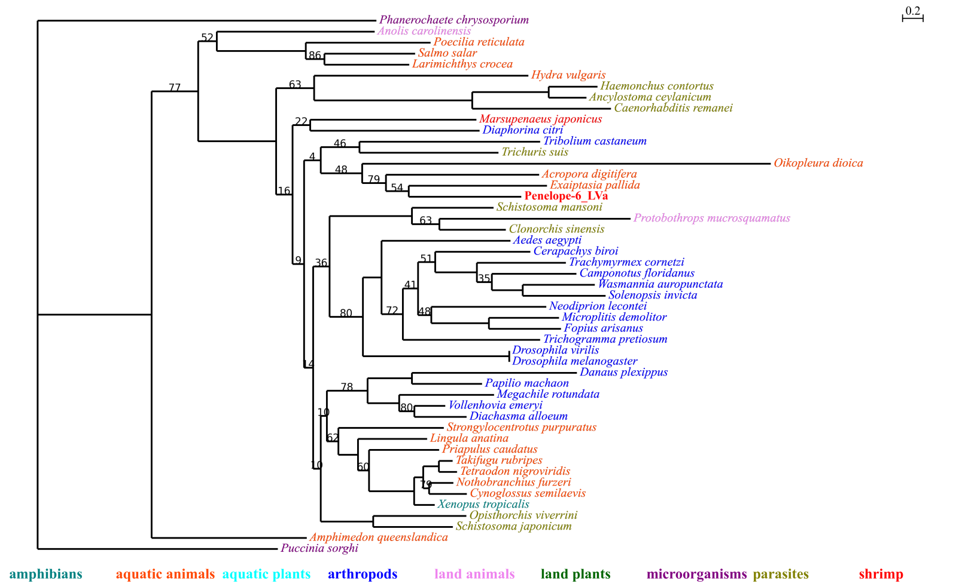
Fig. 7 Phylogenetic tree of Penelope-6_LVa and its homologues. The p-value of AU test is 0.812.

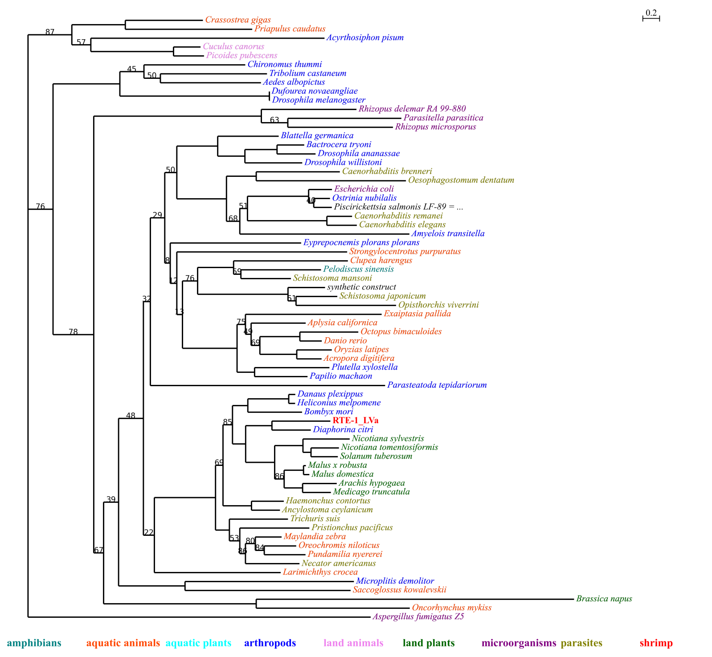
Fig. 8 Phylogenetic tree of RTE-1_LVa and its homologues. The p-value of AU test is 0.893.

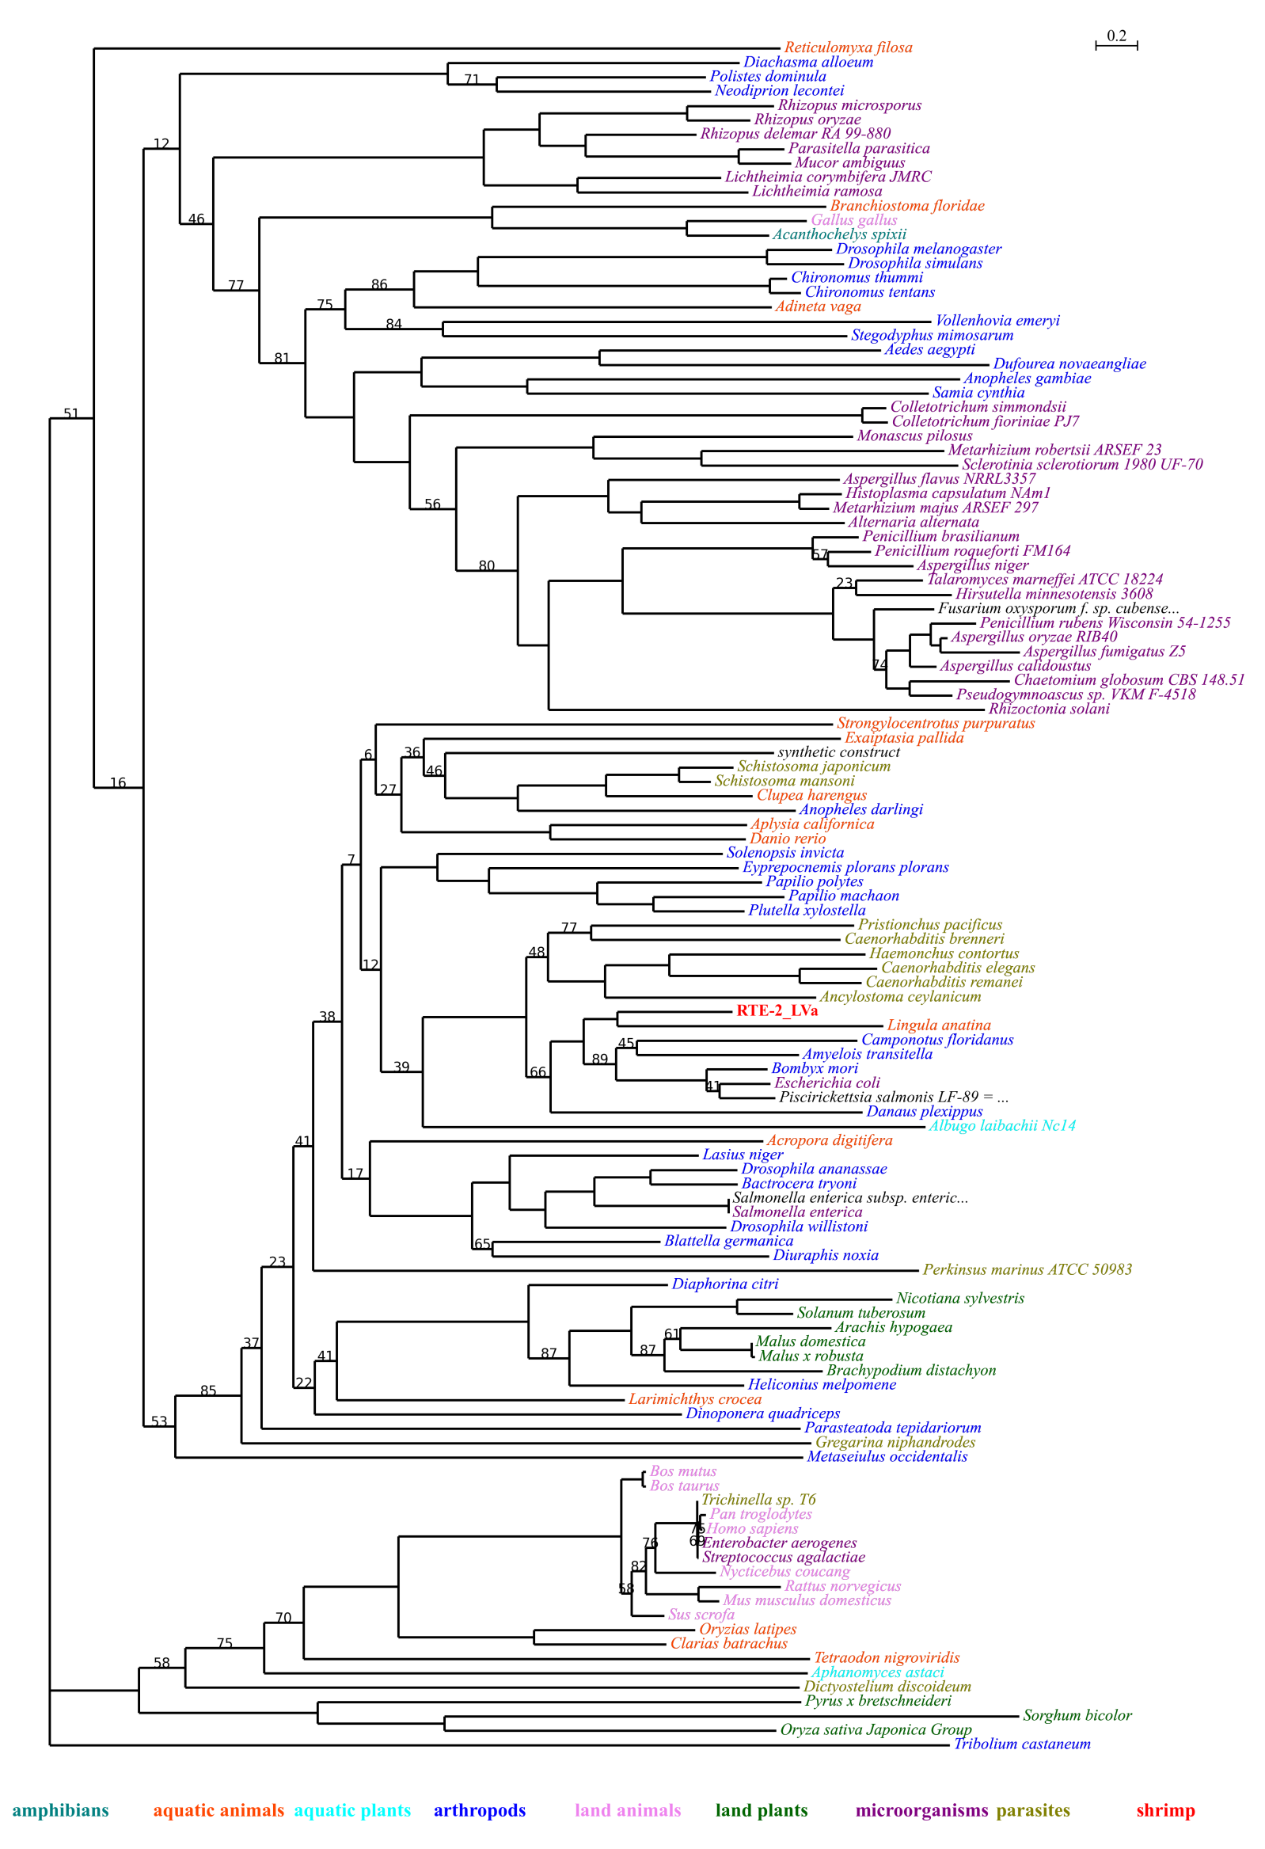
Fig. 9 Phylogenetic tree of RTE-2_LVa and its homologues. The p-value of AU test is 0.805.

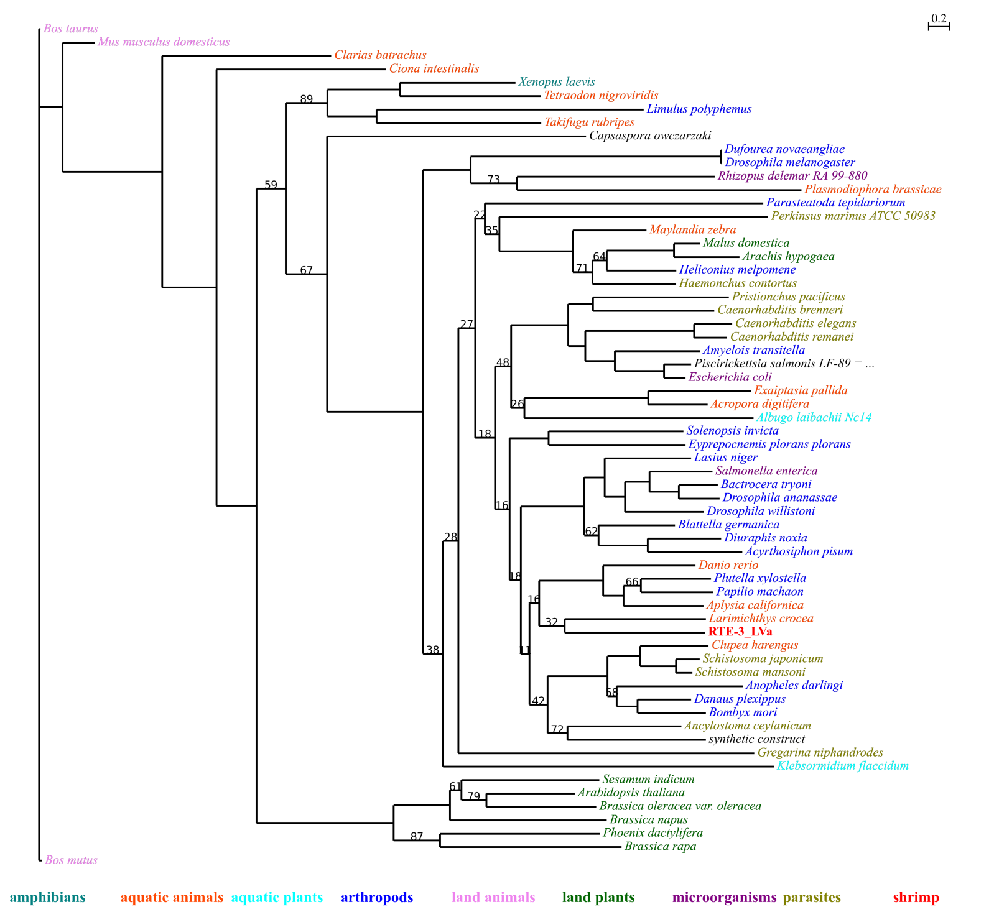
Fig. 10 Phylogenetic tree of RTE-3_LVa and its homologues. The p-value of AU test is 0.813.

