Second Delphi iteration; consensus on rural and remote populations where PHC services should be provided by resident service providers*
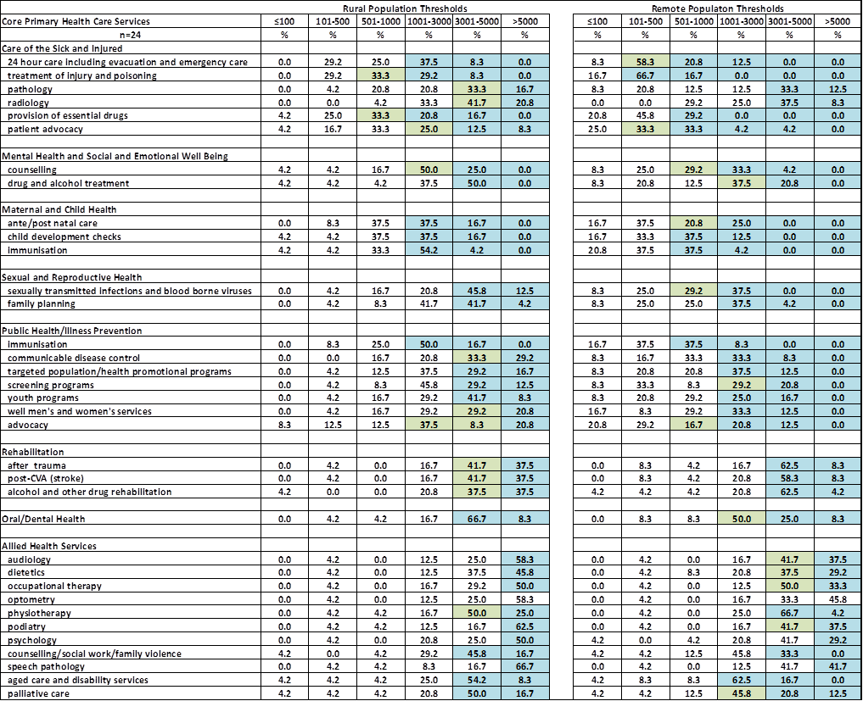
*survey results prior to face to face discussion

