Additional file 1
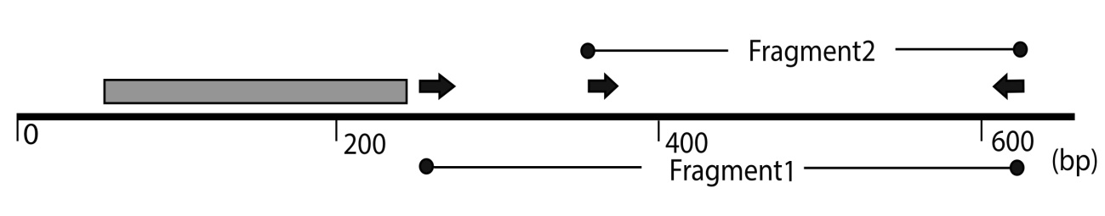
Figure S1. Schematic representation of PaWOX2 coding sequence. The gray box indicates the homeodomain. The black arrows indicate the location of the primers used for the preparation of the RNAi construct. Primer sequences are presented in table S1.

