Additional file 2: Scree plot and Parallel analyses of the final 5 items retained in the ‘Internal Reliability and Factor Structure Study’

a) Scree Plot
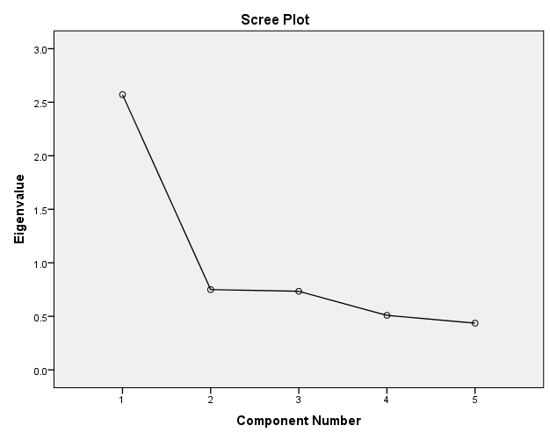
b) Parallel Analyses
