Table S1. Number of 16S rRNA and Wide Genome Sequences generated per sample. This table shows the number of raw (unprocessed) reads and the number of reads remaining after analytical processing of 18 samples from children fed with the habitual diet and plus the addition of RS.
Sample | 16S  Raw reads | 16S  Processed reads | WGS  Raw reads | WGS  Processed reads
1-Habitual diet + RS | 23394 | 10178 | 59972804 | 57553091
1-Habitual diet | 26843 | 12454 | 81142976 | 77930772
10-Habitual diet + RS | 7609 | 2432 | 66749696 | 63606275
10-Habitual diet | 23505 | 3166 | 88327146 | 83875032
11-Habitual diet + RS | 21706 | 4013 | 66799364 | 55827755
11-Habitual diet | 6179 | 2427 | 57758720 | 55989508
12-Habitual diet + RS | 23997 | 11091 | 86694566 | 83419038
12-Habitual diet | 19493 | 7913 | 86546104 | 82763383
13-Habitual diet + RS | 20582 | 9822 | 63719632 | 32290308
13-Habitual diet | 18267 | 7907 | 53038048 | 50717179
14-Habitual diet + RS | 16568 | 7353 | 60586322 | 58014951
14-Habitual diet | 22399 | 9614 | 44303156 | 42855352
15-Habitual diet + RS | 16654 | 7110 | 64685132 | 62260902
15-Habitual diet | 26739 | 11767 | 70064590 | 67872672
16-Habitual diet + RS | 15542 | 6074 | 78052286 | 68286852
16-Habitual diet | 21439 | 9251 | 52316668 | 50179787
17-Habitual diet + RS | 16789 | 6597 | 75984110 | 72912521
17-Habitual diet | 26850 | 11388 | 66680578 | 63966340
19-Habitual diet + RS | 20081 | 9039 | 71923114 | 68590855
19-Habitual diet | 31193 | 15090 | 66961080 | 64441495
2-Habitual diet + RS | 60510 | 31518 | 45017938 | 43555978
2-Habitual diet | 25078 | 10131 | 44841504 | 43445905
20-Habitual diet + RS | 23718 | 10486 | 27762094 | 26898029
20-Habitual diet | 20905 | 8941 | 73666034 | 70576237
3-Habitual diet + RS | 12577 | 5983 | 93683200 | 89724336
3-Habitual diet | 24671 | 10409 | 60288892 | 58330277
4-Habitual diet + RS | 17652 | 7268 | 97604256 | 93246922
4-Habitual diet | 32864 | 14043 | 66098988 | 64003636
5-Habitual diet + RS | 22441 | 10704 | 66133196 | 63366012
5-Habitual diet | 16236 | 7229 | 60820688 | 58541559
6-Habitual diet + RS | 10358 | 4554 | 76949718 | 73824058
6-Habitual diet | 28451 | 11812 | 45084442 | 43660948
7-Habitual diet + RS | 28514 | 13222 | 75444412 | 72118858
7-Habitual diet | 17151 | 7007 | 36624288 | 35539941
8-Habitual diet + RS | 24345 | 4385 | 68298134 | 65675186
8-Habitual diet | 5042 | 1501 | 62222912 | 59511292
Table S2. Comparison of the number of reads obtained by V1-V3 and V3-V5 sequencing.

Region | Total Samples | Paired Samples | Failed Samples (<1000 reads) | Average  # reads per sample
V1-V3 | 47 | 32 | 5 | 5639
V3-V5 | 47 | 35 | 0 | 3489

Figure S1. Venn diagram showing the degree of overlap for genera captured with the V1-V3 and V3-V5 regions. While the majority of taxa are captured by both sets of primers, the fact that a significant subset were captured by only one primer set made the use of both sets more valuable.
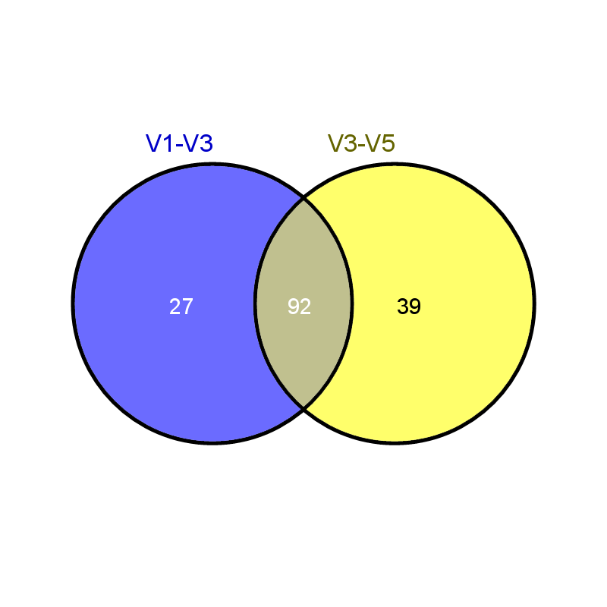

Figure S2. LEfse rank plot of differentially abundant genes in gut microbiomes initial samples vs. final samples. LDA scores were given for different abundance of genes before (habitual diet:GREEN) and after the resistant starch was added to the habitual diet (habitual diet + RS:RED).

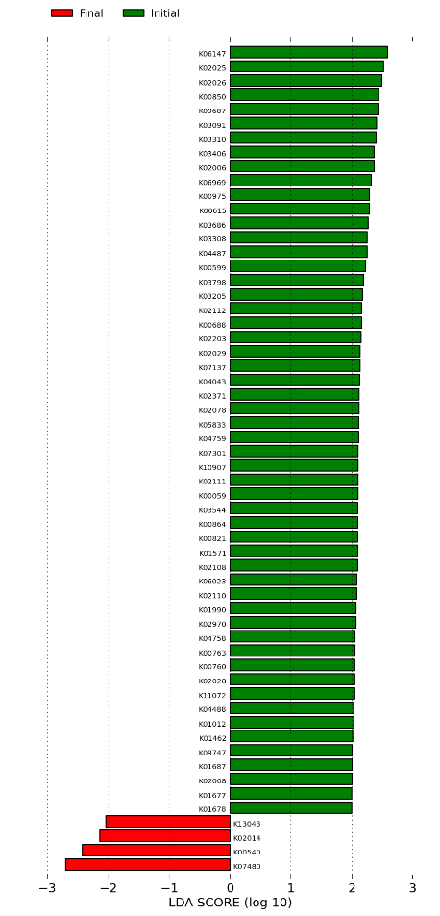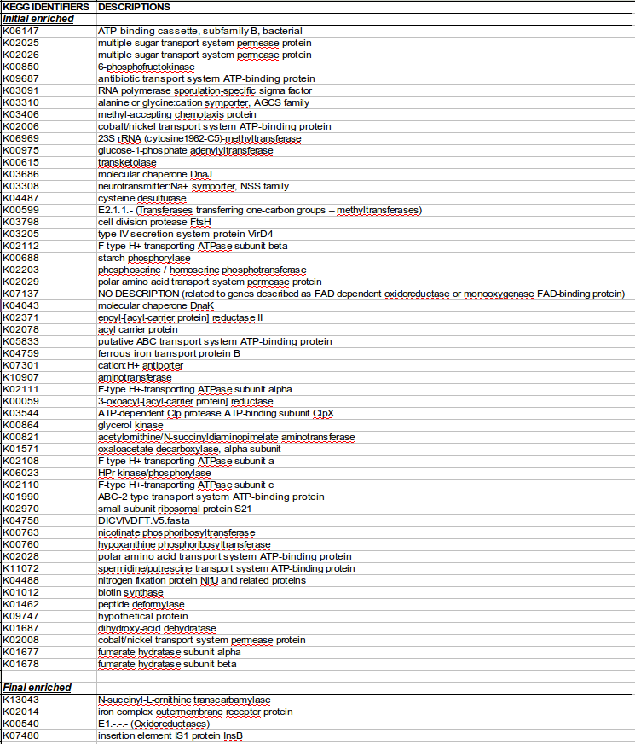

Habitual Diet + RS

Habitual Diet

Figure S3. Principal Component Analysis (PCA) plot showing the differential clustering of metabolites in fecal samples collected before (blue - habitual diet) and after (red - habitual diet plus RS) the diet supplementation with RS. Brown circles represent replicate analyses of the pooled quality control (QC) fecal samples. The tight clustering of these QC replicate analyses indicates the high reproducibility and low amount of drift associated with the GC/MS-based fecal metabolomic profiling analyses conducted over several hours while the individual fecal extracts are analyzed at the same time, under identical GC/MS conditions, and on the same GC/MS instrument.
