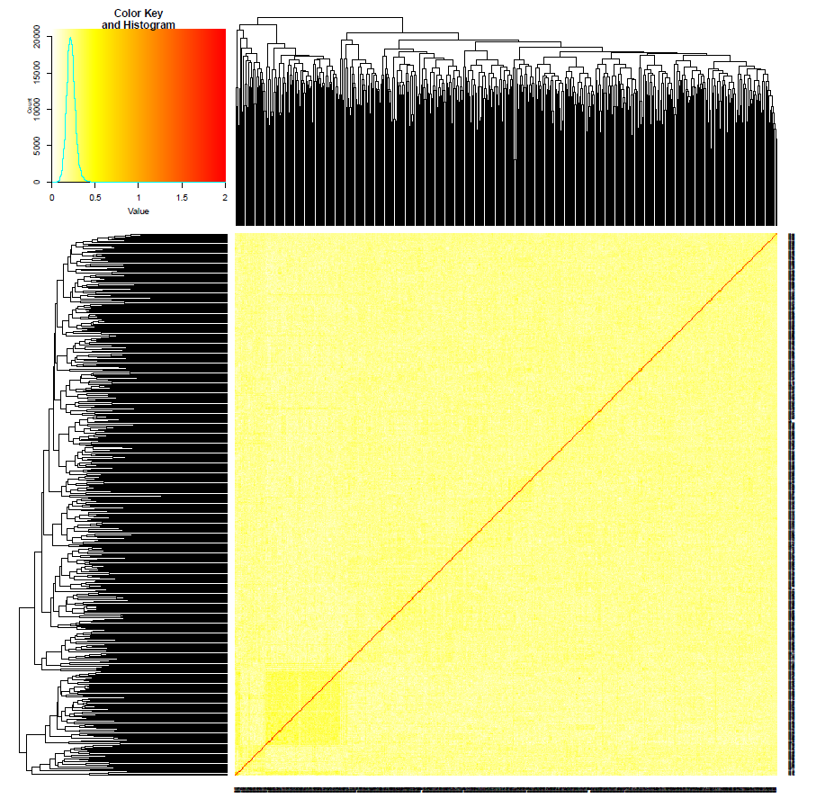
Additional file 4. Kinship matrix among the 547 RILs of Upland cotton MAGIC population using GBS-based SNP and SSR marker.

