Holistic View of the Seascape Dynamics and Environment Impact on Macro-scale Genetic Connectivity of Marine Plankton Populations
Romuald Laso-Jadart^{1,4*}, Michael O’Malley², Adam Sykulski², Christophe Ambroise³, Mohammed-Amin Madoui^{1,4*}
¹Génomique Métabolique, Genoscope, Institut François Jacob, CEA, CNRS, Univ Evry, Université Paris-Saclay, Evry, France.
³LaMME, CNRS, Univ Evry, Université Paris-Saclay, Evry, France
⁶Research Federation for the study of Global Ocean Systems Ecology and Evolution, FR2022/Tara Oceans GO-SEE, 3 rue Michel-Ange, 75016 Paris, France
*Corresponding authors. Emails: rlasojad@genoscope.cns.fr&amadoui@genoscope.cns.fr

Table of contents
Supplementary Figure S1: Occurrence of species. Species are noted “MVS” for metavariant species. 3
Supplementary Figure S2: Distributions of pairwise-F_{ST} by species 4
Supplementary Figure S3: Lagrangian estimates matrices 5
Supplementary Figure S4: Lagrangian trajectories for stations of Southern Ocean. 6
Supplementary Figure S5: SNPs clustering with metaVaR 9
Supplementary Figure S6: Overview of the taxonomic assignment procedure 10
Supplementary Figure S7: Environmental parameters maps 11
Supplementary Figure S8: Principal component analysis of the contribution of environmental parameters to the genomic differentiation of plankton species 14
Supplementary Table S2: Species assigned to Bathycoccus 15

Supplementary Figure S1: Occurrence of species.
The y axis corresponds the number of species noted “MVS” for Metavariant species.

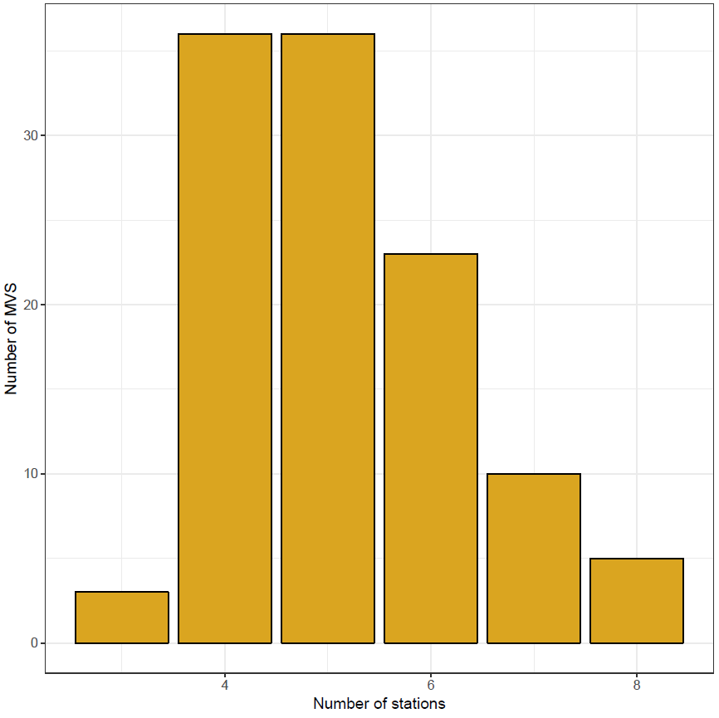

Supplementary Figure S2: Distributions of pairwise-F_{ST} by species
Each plot corresponds to the distribution of the pairwise-FST for one species. The color of the violin is linked to the taxonomy, and the background color of species’ ID stands for the size fractions; red, blue, green and yellow for 0.8-5µm, 5-20µm, 20-180µm and 180-2000µm respectively.

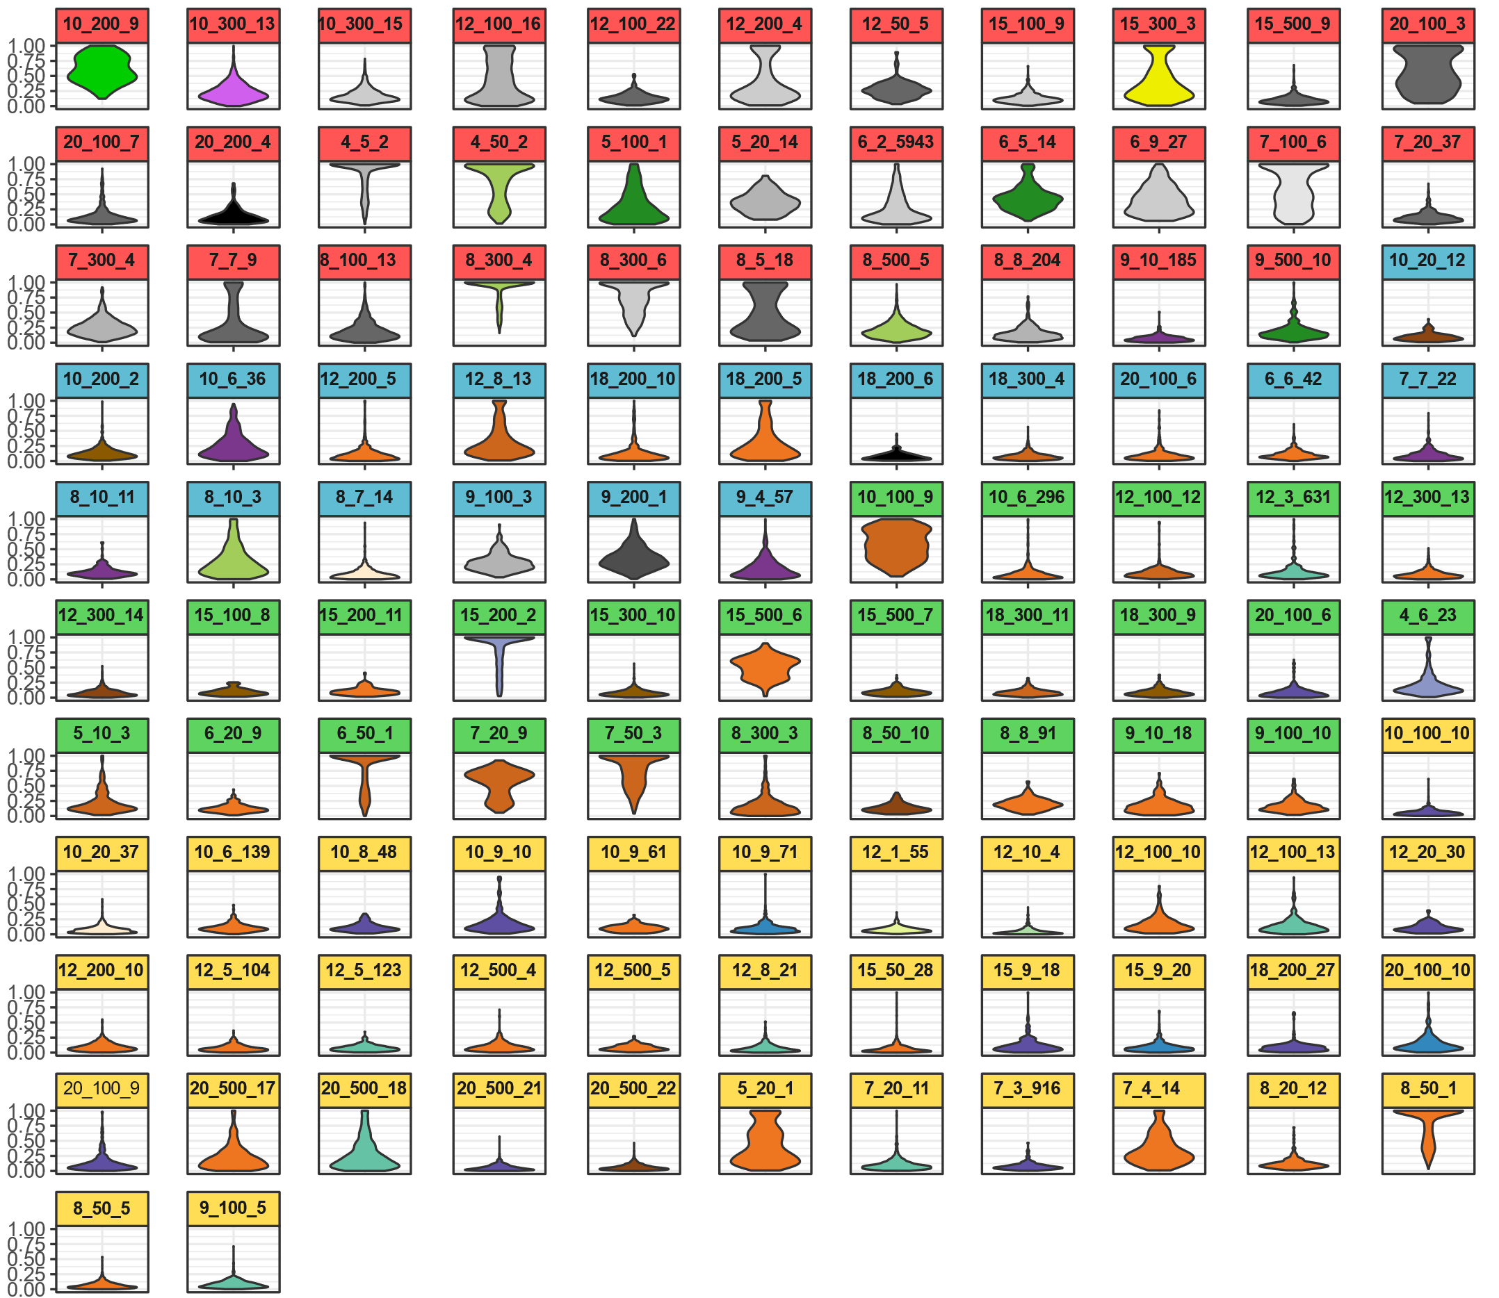

Supplementary Figure S3: Lagrangian estimates matrices
Results of Lagrangian travel time computations. A) Asymmetric times between the 35 stations. Because of the important difference in travel times between Mediterranean Sea stations and the rest, we also present the Lagrangian estimates between B) Mediterranean Sea stations, C) Atlantic and Southern Oceans stations. Based on recorded drifter motion throughout the oceans, we computed Lagrangian travel time estimates between the 35 Tara stations, and observed three clear patterns, distinguishing the MED, NAO and SAO/SO. These results showed the relative proximity from TARA_66 to 76 (SAO) and to other NAO stations. We noted a relatively high water masses connectivity from SO stations to TARA_66 and 70 compared to their large geographic distance. The station TARA_145 was isolated to the rest of NAO stations. The Mediterranean stations TARA_7, 9 and 11 were also isolated to the other Mediterranean stations

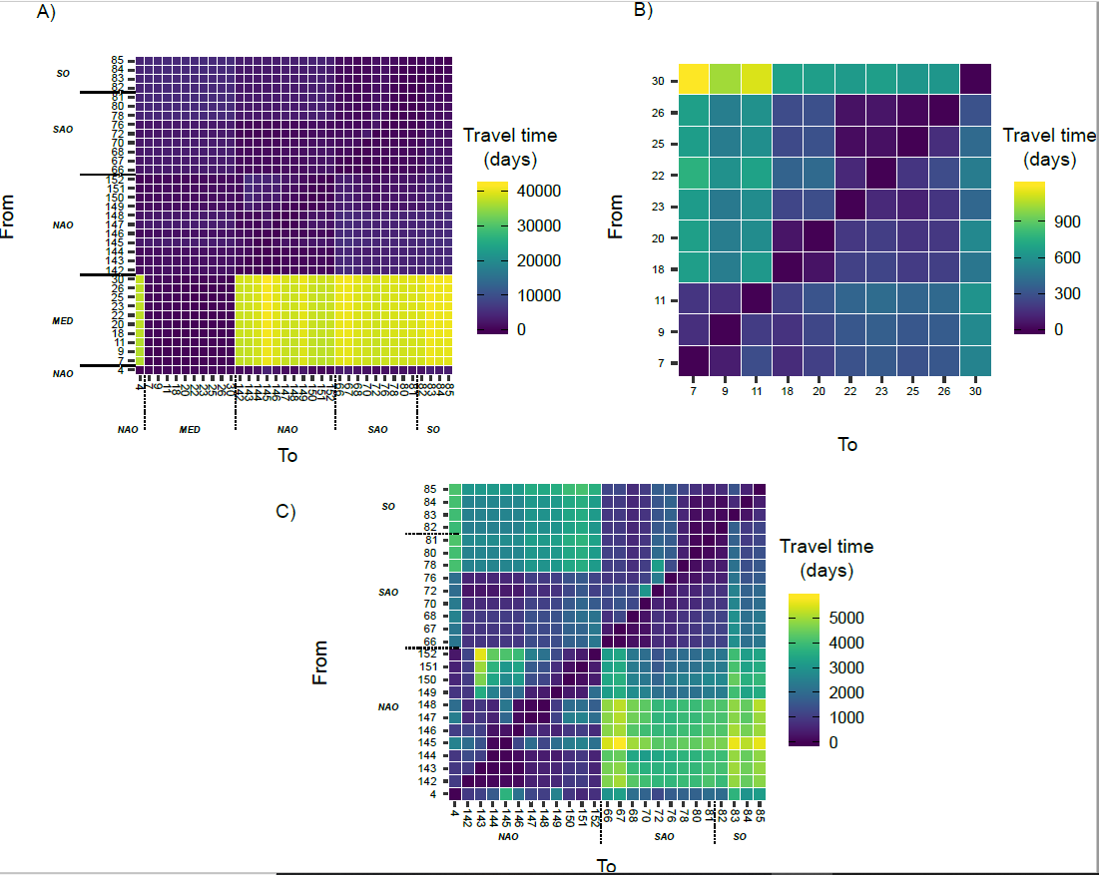

Supplementary Figure S4: Lagrangian trajectories for stations of Southern Ocean.
For each pair of stations; the two upper plots are the drifters trajectories with the fastest and the slowest tracks in blue and red respectively and the lower plots picture the distribution of Lagrangian travel times estimated after bootstrap for the corresponding trajectory.
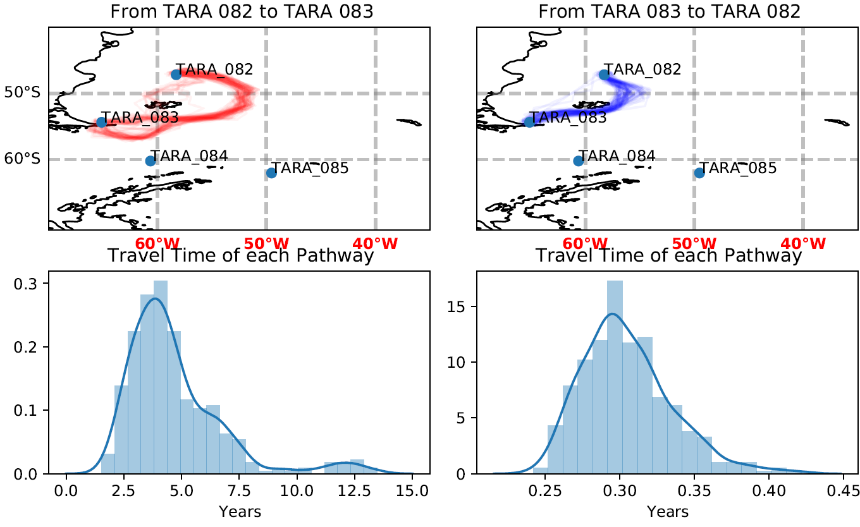
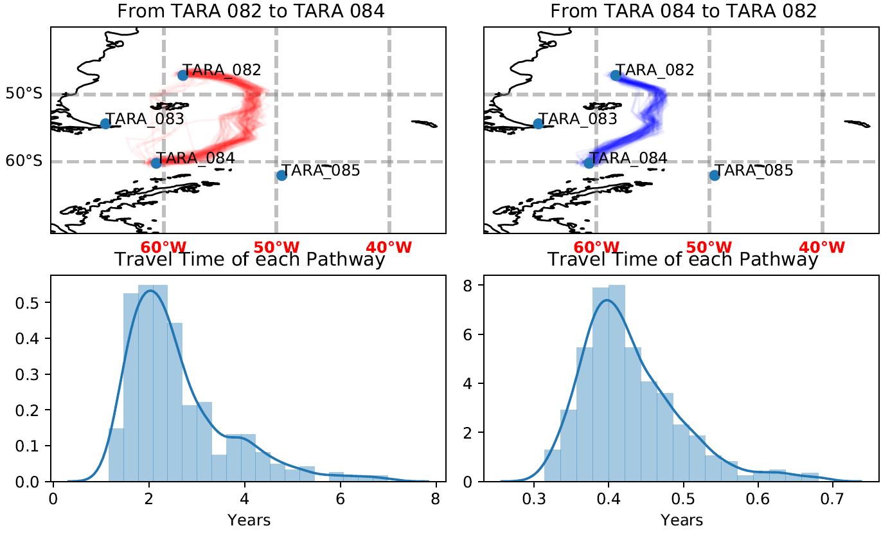

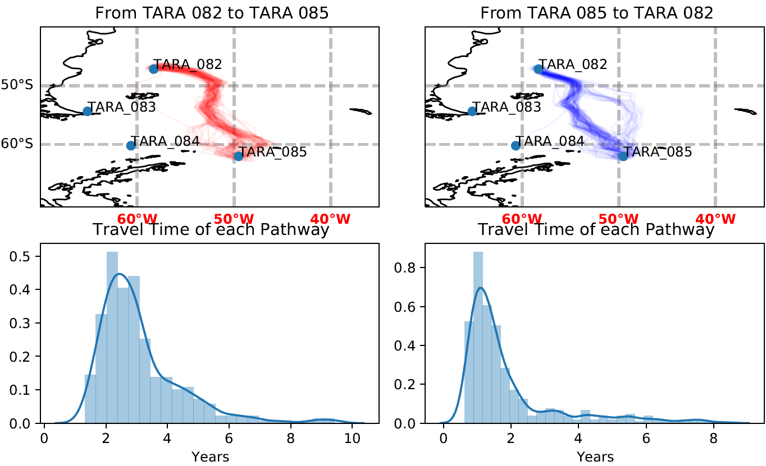
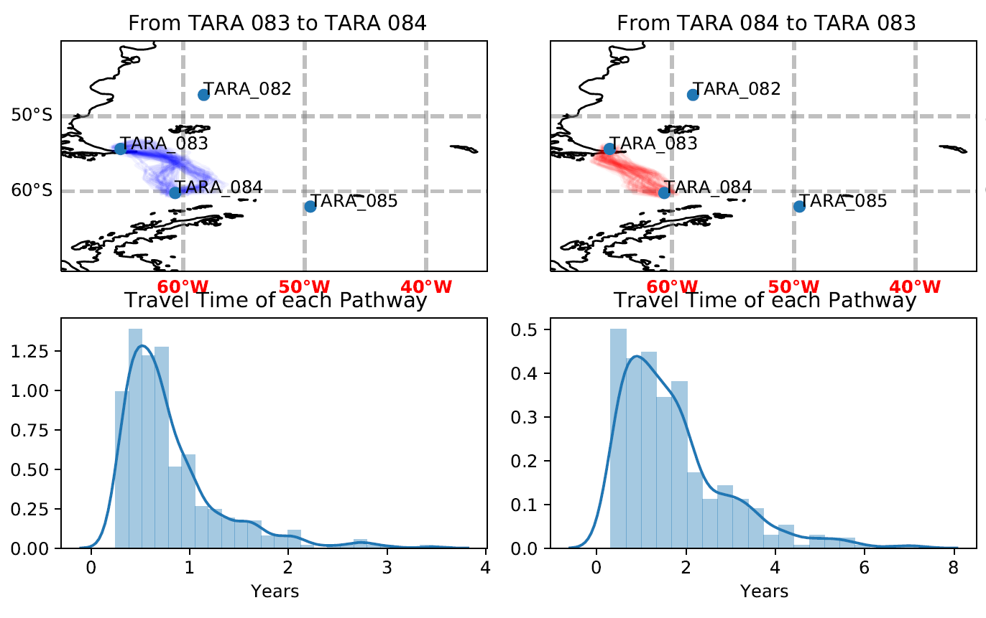

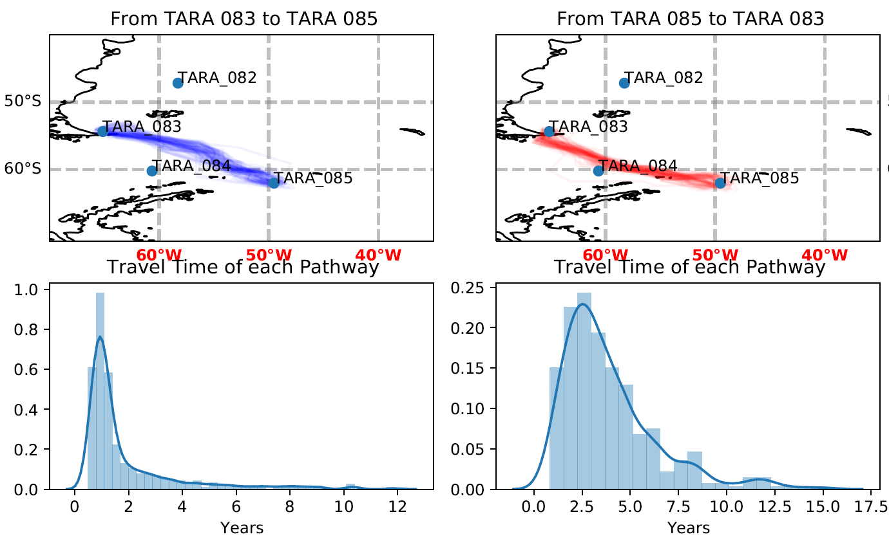
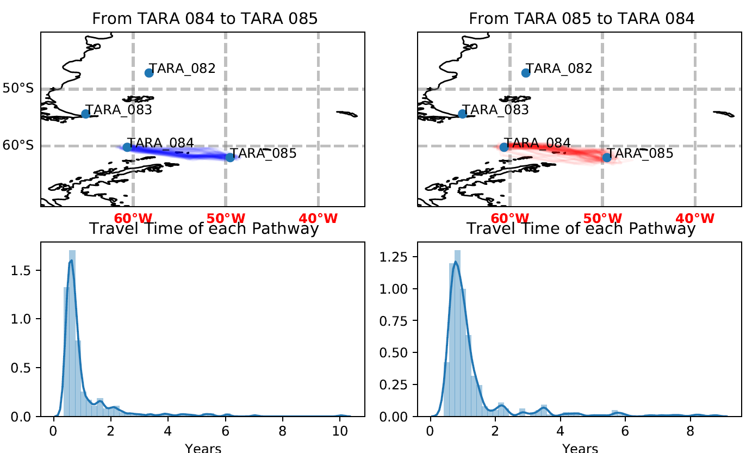

Supplementary Figure S5: SNPs clustering with metaVaR
Number of cluster of SNPs (called MVC) found for each dataset, and for each couple of dbscsan parameters ε and minimum points (MinPts). In blank, no cluster was found for the corresponding parameters.

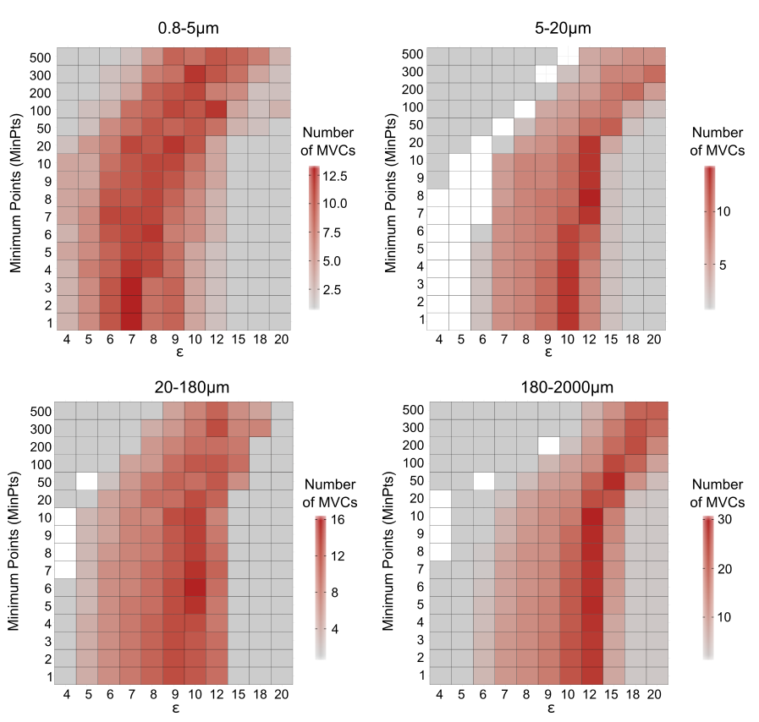

Supplementary Figure S6: Overview of the taxonomic assignment procedure
Pipeline describing how each species (called MVS) was assigned to a taxonomic group.
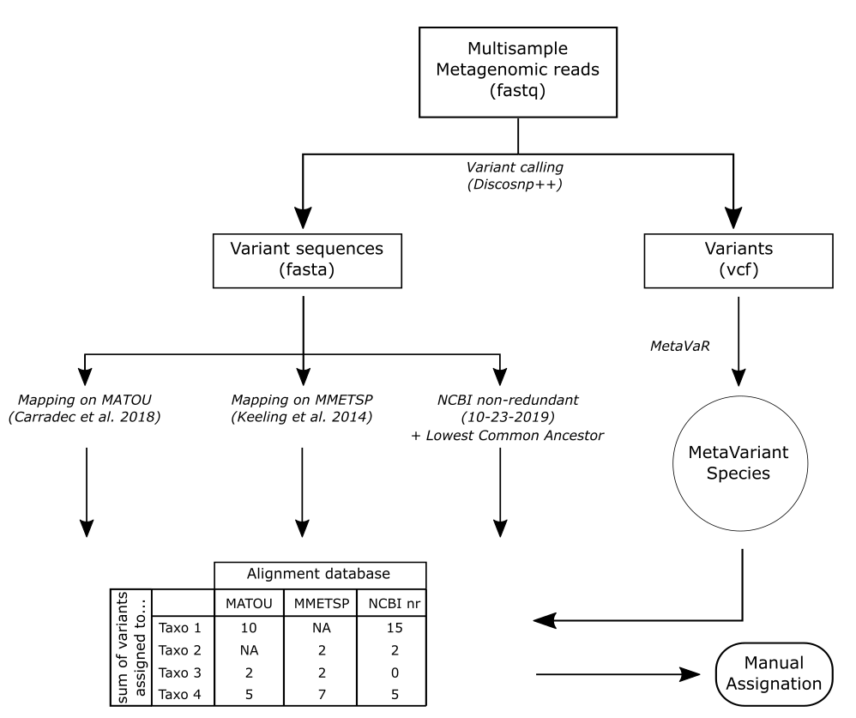

Supplementary Figure S7: Environmental parameters maps
Each dot corresponds to a Tara station.
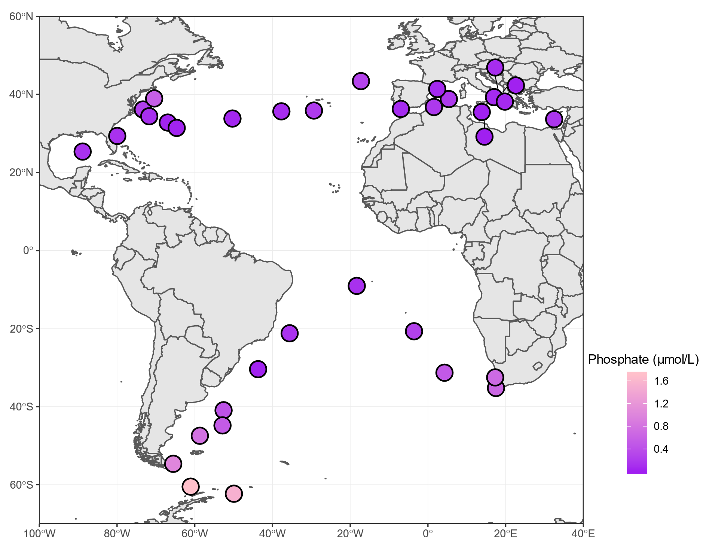

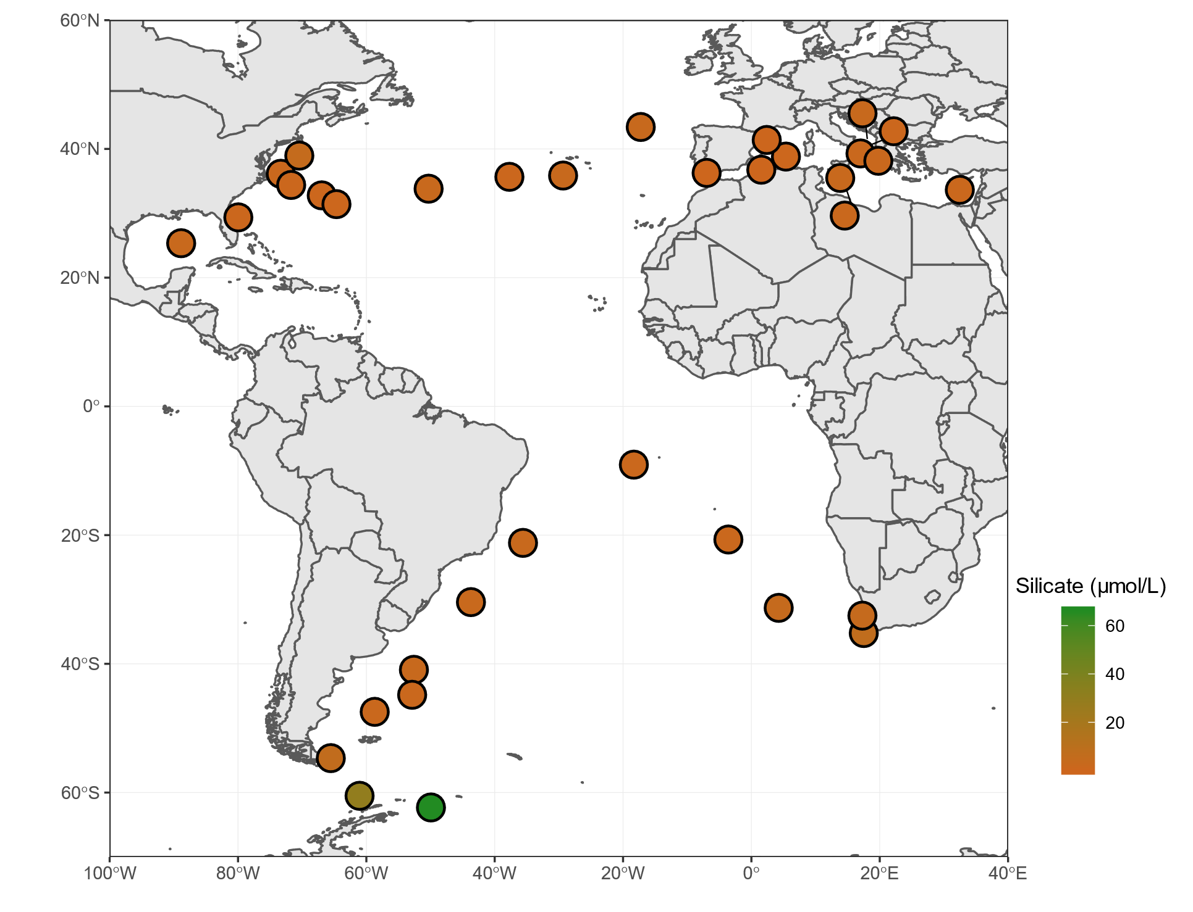
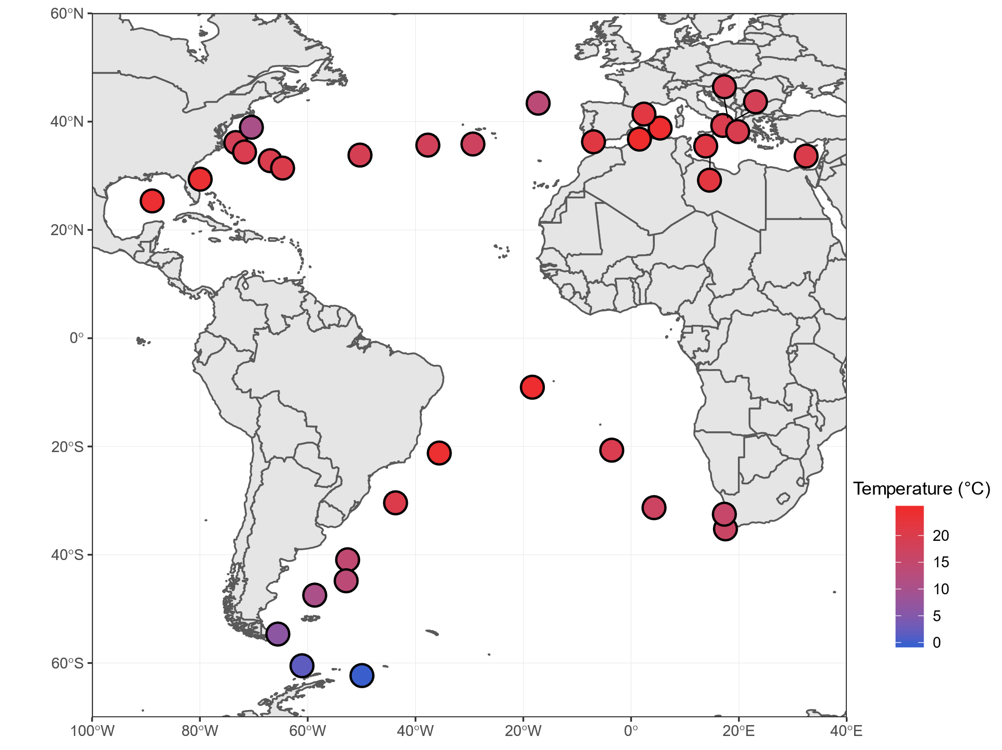

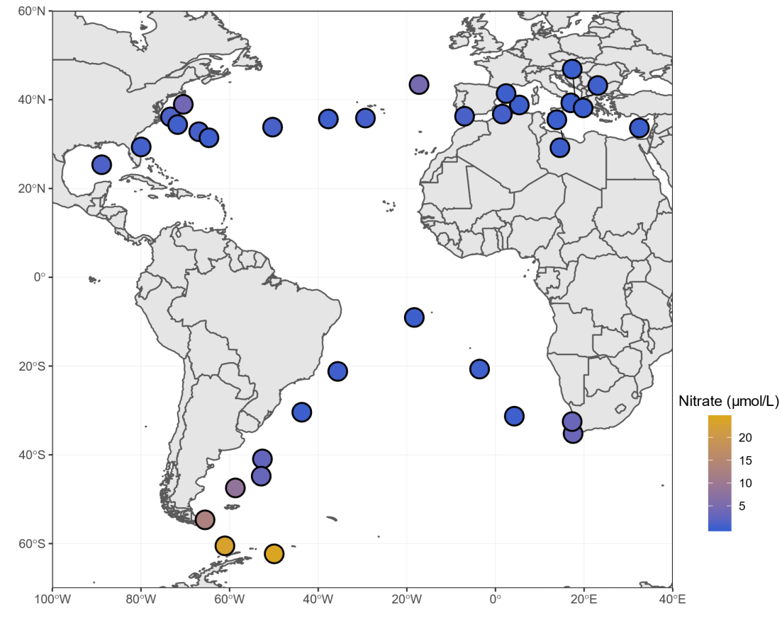

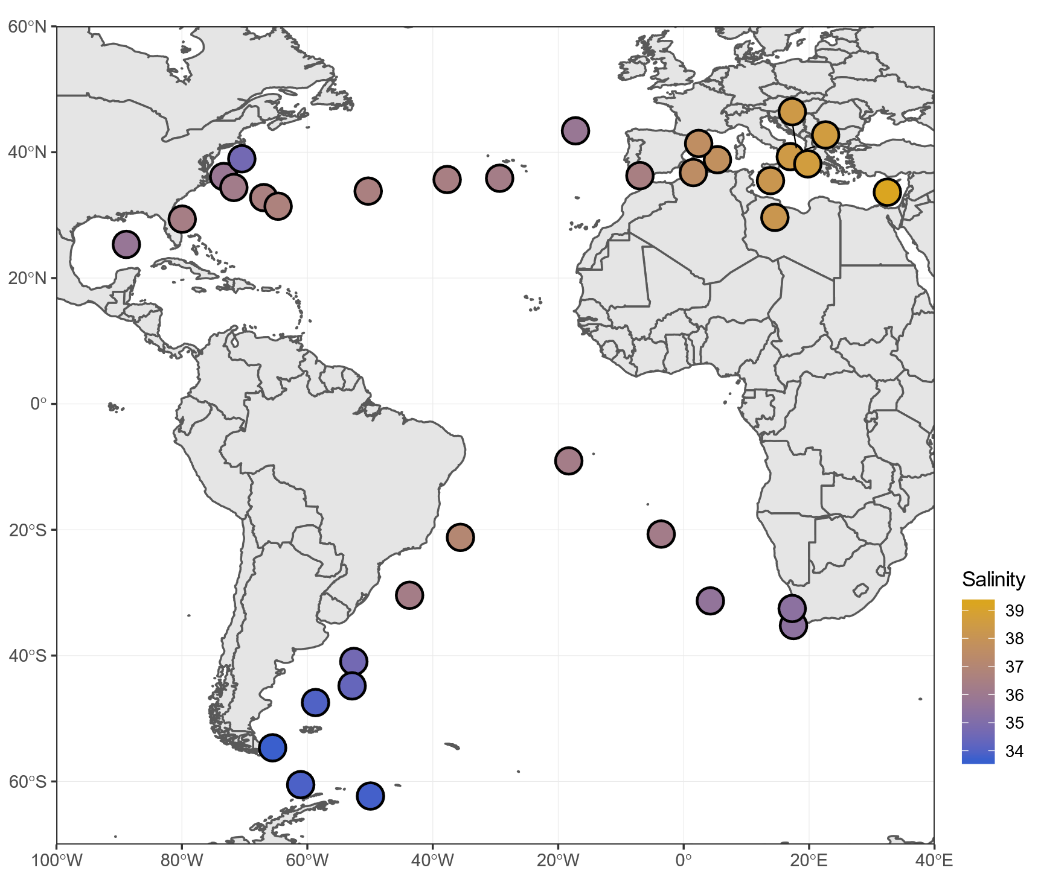

Supplementary Figure S8: Principal component analysis of the contribution of environmental parameters to the genomic differentiation of plankton species
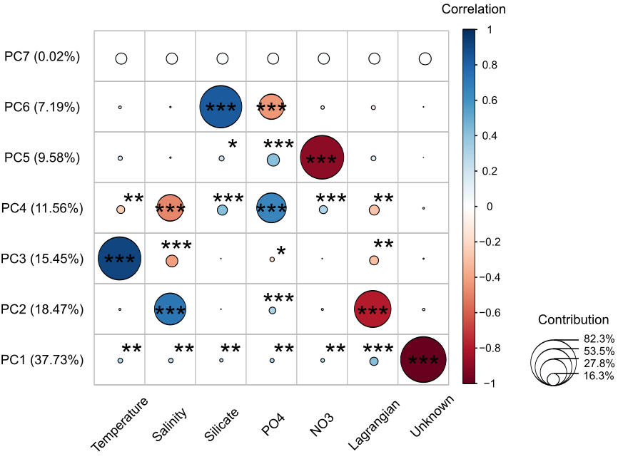

Supplementary Table S2: Species assigned to Bathycoccus
The columns "Bathycoccus" species reflects the occurrences of the two MVSs identified as potential Bathycoccus in our dataset. The columns “Bathycoccus strains” are the percentage of metagenomic reads from each Tara stations matching the two reference genomes (data extracted from Leconte et al. 2020). Species 6_5_14 and 9_500_10 are present where Bathycoccusprasinos RCC1105 and Bathycoccus TOSAG39.1 are the most abundant, respectively.

 | "Bathycoccus" species |  | Bathycoccus strains
Tara stations | 6_5_14 | 9_500_10 | Bathycoccus prasinos RCC1105 | Bathycoccus TOSAG39.1
TARA_66 | Yes | No | 0.7600 | 0.1264
TARA_67 | Yes | No | 0.9098 | 0.0156
TARA_80 | Yes | Yes | 0.9215 | 0.3204
TARA_81 | Yes | No | 1.3416 | 0.0202
TARA_142 | No | No | 0.0005 | 0.0345
TARA_145 | Yes | No | 1.3493 | 0.1263
TARA_146 | No | Yes | 0.1010 | 1.8254
TARA_147 | No | Yes | 0.0906 | 0.8468
TARA_150 | No | Yes | 0.3085 | 0.2685
TARA_152 | Yes | No | 0.4797 | 0.0329

