Seasonal variation in activity and nearshore habitat use of Lake Trout in a subarctic lake

Paul J. Blanchfield^{1,2*}, Graydon McKee¹, Matthew M. Guzzo³, Andrew J. Chapelsky¹, Peter A. Cott⁴

Supplemental Information
SI Figures
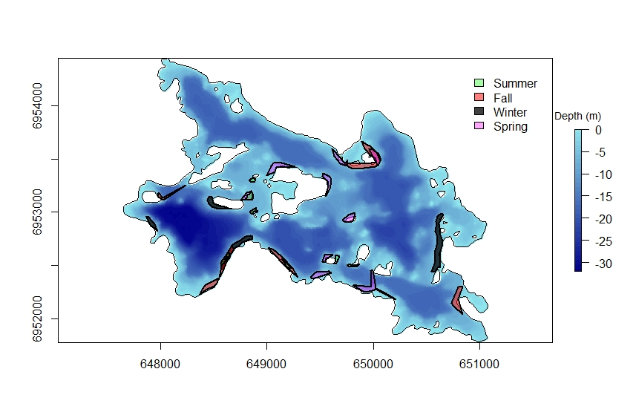
Fig. S1 Seasonal nearshore core home range areas (50% isopleth) of acoustically tagged Lake Trout in Alexie Lake

