Supplementary material for the manuscript:
Do beluga whales truly migrate? Testing a key trait of the classical migration syndrome
Authors: Luke Storrie, Lisa L. Loseto, Emma L. Sutherland, Shannon A. MacPhee, Greg O'Corry-Crowe, Nigel E. Hussey

Supplementary Material 3: Additional maps showing HMM-decoded states and corresponding dive profiles.

- Additional HMM-decoded locations and corresponding dive profiles

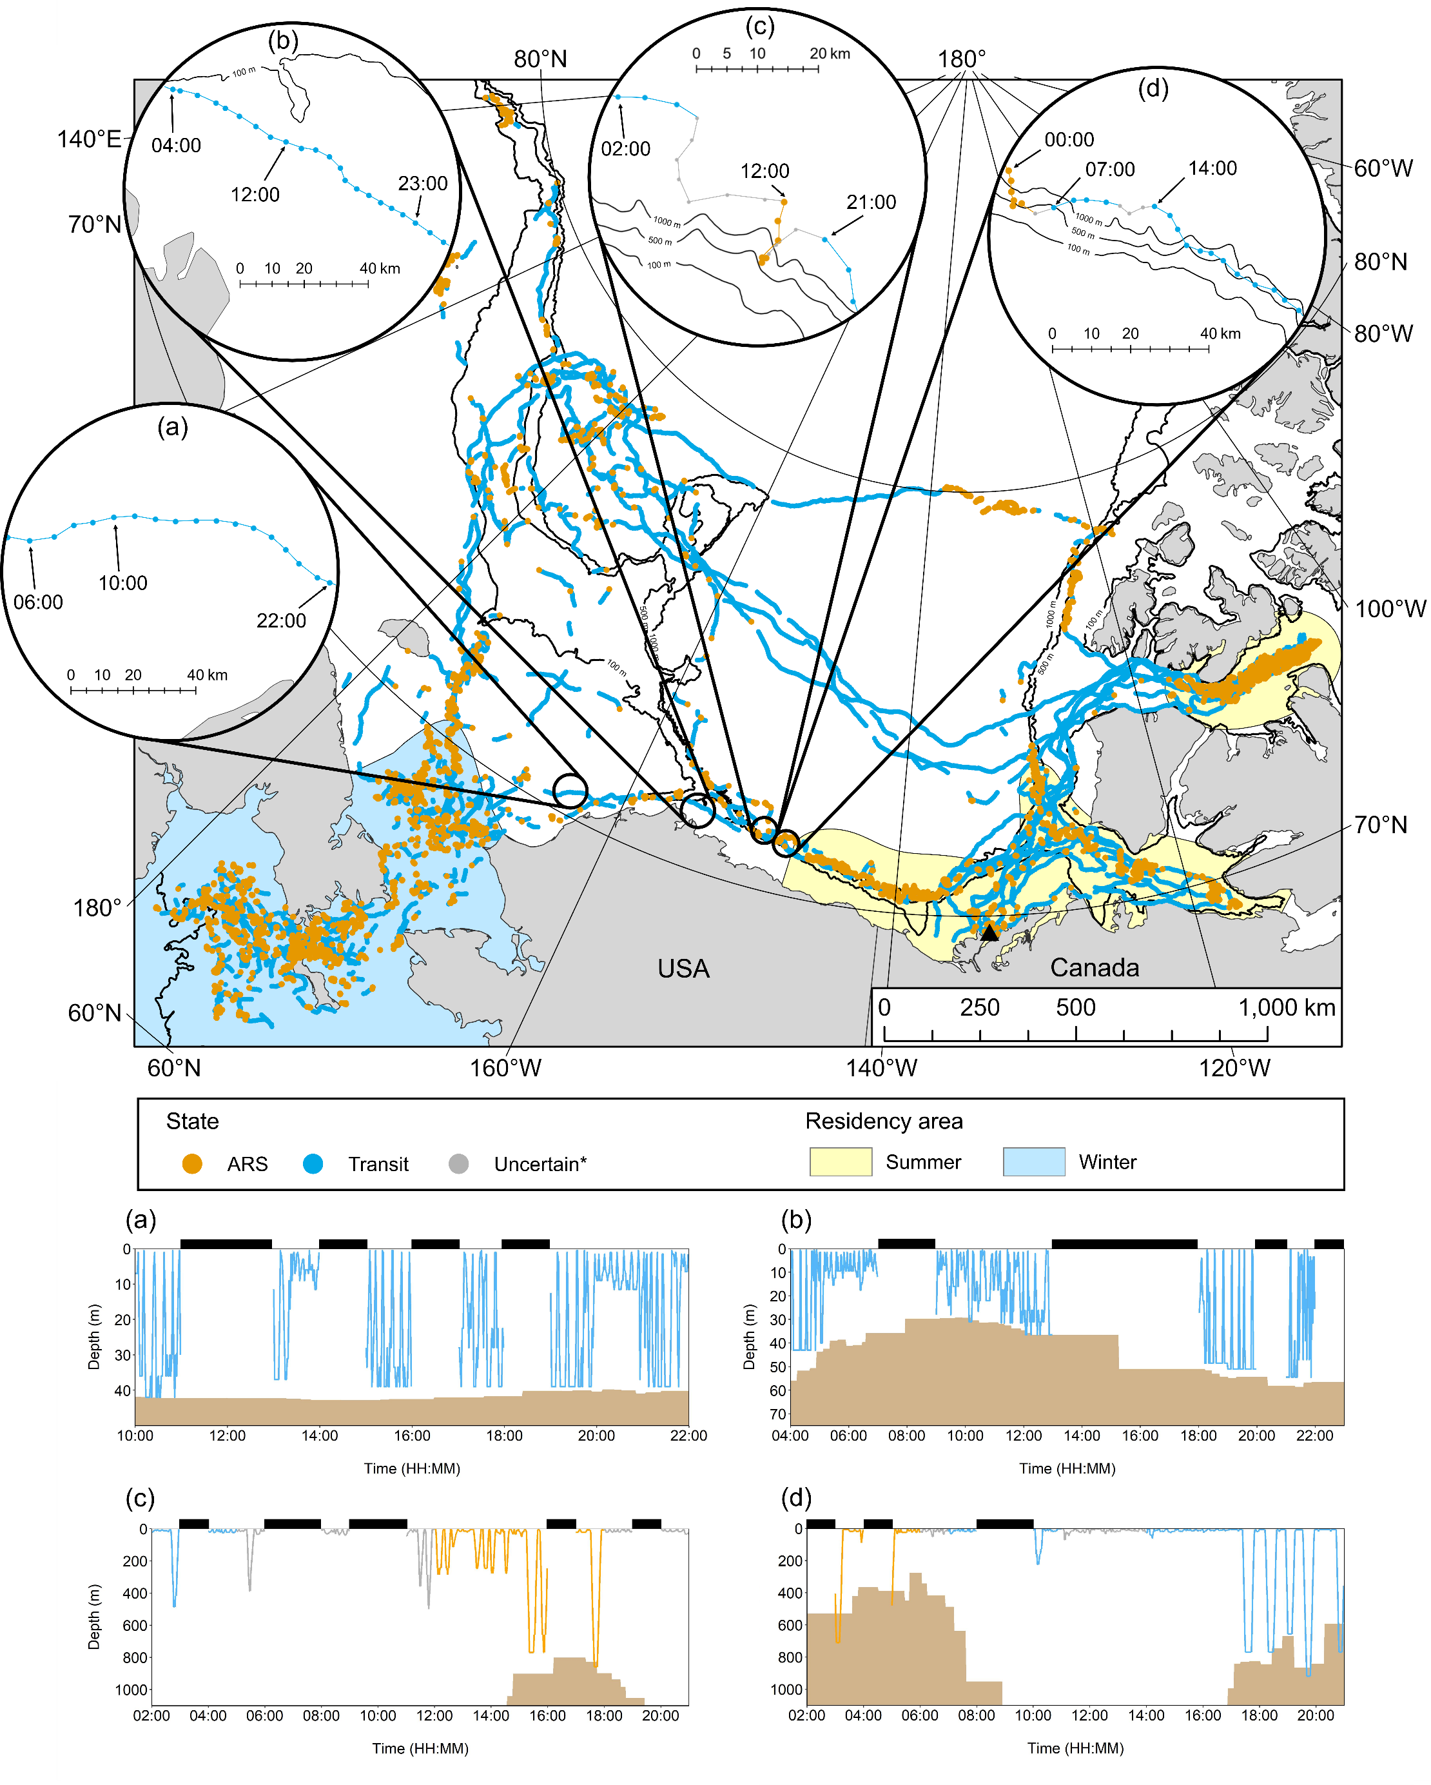
Figure 1: State-decoded locations recorded by belugas between July 2018 and June 2019. The long-distance movement phase analysed includes all locations not bounded by the summer or winter residency area polygons. ‘Uncertain*’ locations (probability of < 0.9 of being in ARS or Transit) shown in zoomed inset panels a-d only. Zoomed inset panels a-d show examples of state-decoded beluga tracks, with the corresponding dive profiles colour-coded by state shown in the lower panels. (a) beluga LC2018#2 15th May 2019 at 06:00-22:00 UTC (note, depth data unavailable for several hours prior to 10:00, (b) beluga LC2018#6 29th April 2019 at 04:00 UTC to 30th April 2019 at 01:00 UTC, (c) beluga LC2018#4 1st May 2019 between 02:00-23:00 UTC, (d) beluga LC2018#2 22nd May 2019 at 00:00 UTC to 23rd May 2019 at 01:00 UTC. Black bars above dive profiles denote periods with missing data and the seafloor depth is shaded brown at the bottom. Note, zoomed inset panels only show the individual beluga referred to for that period. Note that the shallowest dives (up to 23 m) were not classified as foraging type dives.

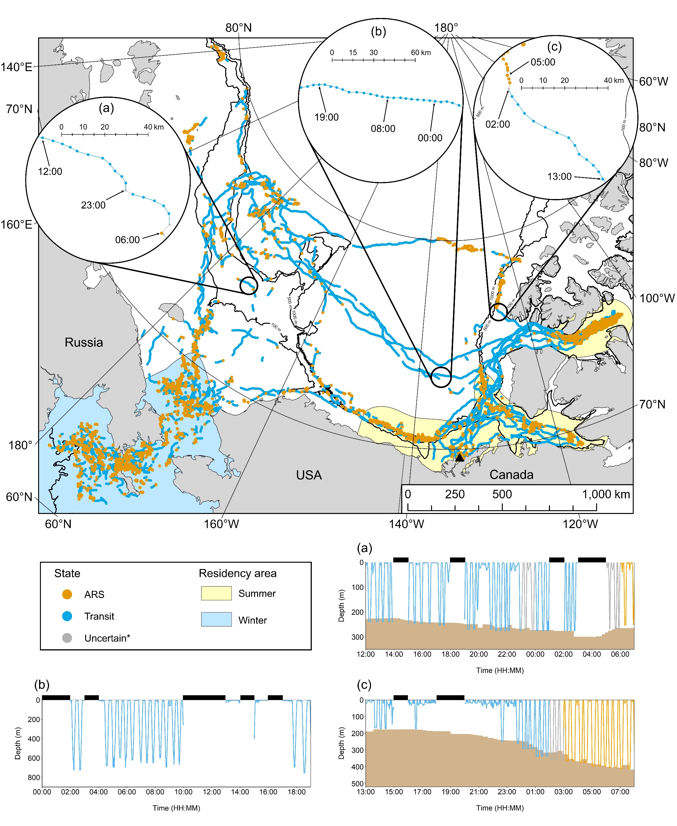
Figure 2: State-decoded locations recorded by belugas between July 2018 and June 2019. The long-distance movement phase analysed includes all locations not bounded by the summer or winter residency area polygons. ‘Uncertain*’ locations (probability of < 0.9 of being in ARS or Transit) shown in zoomed inset panels a-c only. Zoomed inset panels a-c show examples of state-decoded beluga tracks, with the corresponding dive profiles colour-coded by state shown in the lower panels. (a) beluga LC2018#1 12th November 2018 at 12:00 UTC to 13th November 2018 at 07:00 UTC, (b) beluga LC2018#3 26th August 2018 00:00-19:00 UTC, (c) beluga LC2018#4 24th August 2018 at 13:00 UTC to 25th August 2018 at 08:00 UTC. Black bars above dive profiles denote periods with missing data and the seafloor depth is shaded brown at the bottom. Note, zoomed inset panels only show the individual beluga referred to for that period. Note that the shallowest dives (up to 23 m) were not classified as foraging type dives.

Figure 3: State-decoded locations recorded by belugas between July 2018 and June 2019. The long-distance movement phase analysed includes all locations not bounded by the summer or winter residency area polygons. ‘Uncertain*’ locations (probability of < 0.9 of being in ARS or Transit) shown in zoomed inset panels a-c only. Zoomed inset panels a-c show examples of state-decoded beluga tracks, with the corresponding dive profiles colour-coded by state shown in the lower panels. (a) beluga LC2018#3 15th October 2018 at 06:00 UTC to 16th October 2018 at 01:00 UTC, (b) beluga LC2018#3 10th September 2018 at 09:00 UTC to 11th September 2018 at 04:00 UTC, (c) beluga LC2018#6 12th September at 01:00-19:00 UTC. Black bars above dive profiles denote periods with missing data and the seafloor depth is shaded brown at the bottom. Note, zoomed inset panels only show the individual beluga referred to for that period. Note that the shallowest dives (up to 23 m) were not classified as foraging type dives.

Figure 4: State-decoded locations recorded by belugas between July 2018 and June 2019. The long-distance movement phase analysed includes all locations not bounded by the summer or winter residency area polygons. ‘Uncertain*’ locations (probability of < 0.9 of being in ARS or Transit) shown in zoomed inset panels a-c only. Zoomed inset panels a-c show examples of state-decoded beluga tracks, with the corresponding dive profiles colour-coded by state shown in the lower panels. (a) beluga LC2018#3 6th September 2018 at 13:00 UTC to 7th September 2018 at 08:00 UTC, (b) beluga LC2018#1 13th September 2018 at 13:00 UTC to 14th September 2018 at 07:00 UTC, (c) beluga LC2018#4 15th July between 03:00-22:00 UTC. Black bars above dive profiles denote periods with missing data and the seafloor depth is shaded brown at the bottom. Note, zoomed inset panels only show the individual beluga referred to for that period. Note that the shallowest dives (up to 23 m) were not classified as foraging type dives.

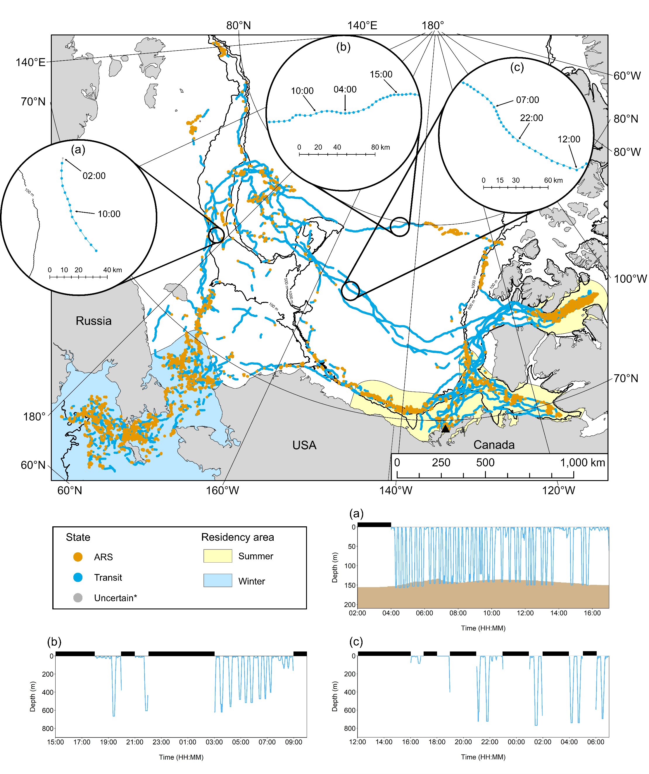
Figure 5: State-decoded locations recorded by belugas between July 2018 and June 2019. The long-distance movement phase analysed includes all locations not bounded by the summer or winter residency area polygons. ‘Uncertain*’ locations (probability of < 0.9 of being in ARS or Transit) shown in zoomed inset panels a-c only. Zoomed inset panels a-c show examples of state-decoded beluga tracks, with the corresponding dive profiles colour-coded by state shown in the lower panels. (a) beluga LC2018#1 10th November 2018 between 02:00-17:00 UTC, (b) beluga LC2018#4 15th September 2018 at 15:00 UTC to 16th September 2018 at 10:00 UTC, (c) beluga LC2018#8 25th August 2018 at 12:00 UTC to 26th August 2018 at 07:00 UTC. Black bars above dive profiles denote periods with missing data and the seafloor depth is shaded brown at the bottom. Note, zoomed inset panels only show the individual beluga referred to for that period. Note that the shallowest dives (up to 23 m) were not classified as foraging type dives.

References
1. Storrie L, Hussey NE, MacPhee SA, O’Corry-Crowe G, Iacozza J, Barber DG, et al. Year-Round Dive Characteristics of Male Beluga Whales From the Eastern Beaufort Sea Population Indicate Seasonal Shifts in Foraging Strategies. Front Mar Sci. 2022 Jan 3;8:715412.

