Additional file

Supplementary Table 1. Food categories within the Healthy Nordic Food Index (HNFI), consumption data segmented by index scores
 |  | HNFI segments
 | All | 1 | 2 | 3
Observations, n | 969 | 386 | 411 | 172
Food category:^{a, b}
Fish  grams/day  energy-adjusted | 19 (12, 28)  11 (7, 16) | 14 (9, 21)  8 (5, 11) | 21 (14, 29)  12 (8, 18) | 25 (19, 36)  15 (11, 20)
Cabbages  grams/day  energy-adjusted | 11 (4, 26)  6 (2, 15) | 4 (1, 11)  3 (1, 6) | 15 (7, 29)  9 (4, 16) | 30 (17, 58)  19 (10, 34)
Whole grain rye  grams/day  energy-adjusted | 56 (26, 78)  31 (18, 46) | 40 (21, 63)  22 (12, 35) | 58 (33, 88)  34 (21, 48) | 65 (55, 88)  40 (31, 53)
Whole grain oats  grams/day  energy-adjusted | 17 (1, 72)  11 (0, 43) | 1 (0, 25)  1 (0, 15) | 28 (1, 73)  13 (1, 47) | 56 (22, 155)  36 (14, 82)
Apples and pears  grams/day  energy-adjusted | 83 (37, 131)  47 (21, 87) | 41 (18, 83)  26 (11, 57) | 90 (42, 156)  54 (28, 100) | 122 (86, 230)  82 (53, 122)
Root vegetables  grams/day  energy-adjusted | 18 (7, 37)  9 (3, 23) | 7 (3, 18)  4 (2, 9) | 18 (7, 50)  12 (5, 12) | 37 (27, 73)  27 (15, 41)
ªValues presented as medians and interquartile ranges.
^{b}Energy-adjusted values in grams/day*1000 kcal⁻¹.

Supplementary Table 2. Food categories within the Baltic Sea Diet Score (BSDS), consumption data segmented by index scores
 |  | BSDS segments
 | All | 1 | 2 | 3 | 4 | 5
Observations, n | 969 | 131 | 240 | 170 | 226 | 202
Food category:^{a, b}
Fruits and berries  grams/day  energy-adjusted | 90 (46, 161)  55 (26, 96) | 40 (21, 65)  22 (11, 44) | 63 (35, 115)  34 (21, 63) | 89 (46, 142)  57 (30, 95) | 120 (63, 180)  68 (39, 100) | 138 (104, 238)  100 (63, 145)
Vegetables  grams/day  energy-adjusted | 67 (35, 116)  38 (19, 73) | 31 (14, 56)  18 (8, 33) | 45 (26, 84)  27 (15, 45) | 62 (38, 108)  39 (22, 70) | 78 (48, 129)  45 (27, 77) | 117 (78, 193)  76 (45, 118)
Cereals  grams/day  energy-adjusted | 97 (56, 163)  58 (35, 94) | 48 (24, 86)  29 (15, 46) | 75 (45, 123)  43 (27, 63) | 88 (50, 125)  51 (35, 76) | 121 (82, 196)  69 (47, 111) | 155 (103, 238)  95 (66, 136)
Low-fat milk  grams/day  energy-adjusted | 198 (76, 402)  125 (51, 219) | 59 (18, 198)  34 (11, 113) | 178 (47, 404)  102 (23, 209) | 209 (97, 402)  128 (66, 231) | 213 (136, 416)  130 (80, 223) | 269 (178, 452)  180 (118, 256)
Fish  grams/day  energy-adjusted | 19 (12, 28)  11 (7, 16) | 14 (6, 21)  8 (4, 12) | 17 (9, 26)  10 (6, 13) | 17 (12, 25)  11 (7, 15) | 21 (14, 29)  12 (8, 17) | 22 (16, 35)  15 (9, 21)
Meat products  grams/day  energy-adjusted | 73 (52, 100)  44 (33, 58) | 95 (65, 134)  57 (42, 73) | 81 (61, 116)  48 (37, 62) | 69 (50, 92)  43 (33, 56) | 71 (50, 88)  41 (31, 54) | 60 (45, 84)  38 (28, 48)
ªValues presented as medians and interquartile ranges.
^{b}Energy-adjusted values in grams/day*1000 kcal⁻¹.

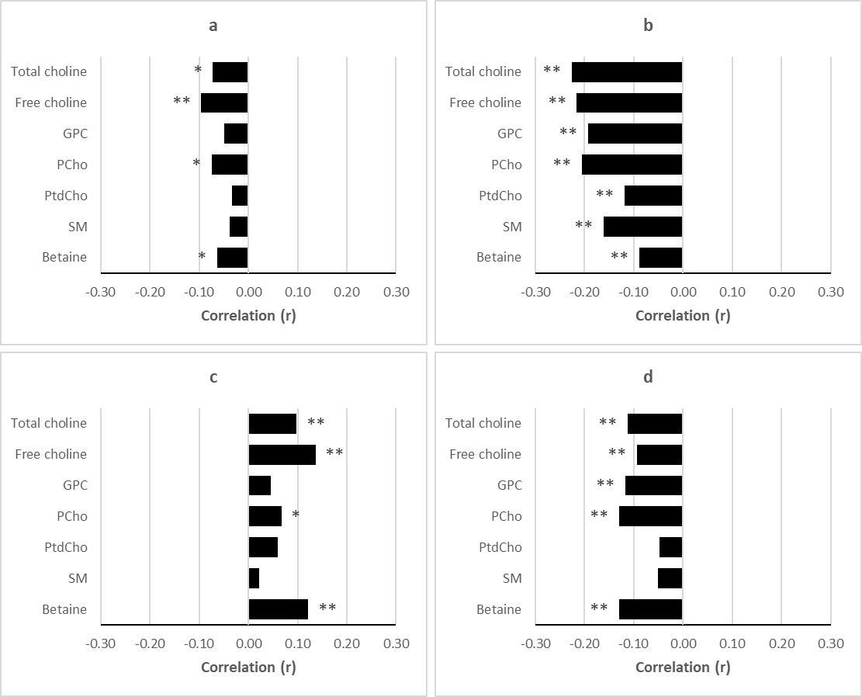
Supplementary Figure 1. Pearson correlation coefficients. Dietary choline and betaine intake (g/d*1000 kcal⁻¹) vs. plasma metabolite concentrations.
Legend: a - Choline. b - Betaine. c - Serine. d - Total homocysteine. * P<0.05. ** P<0.01.

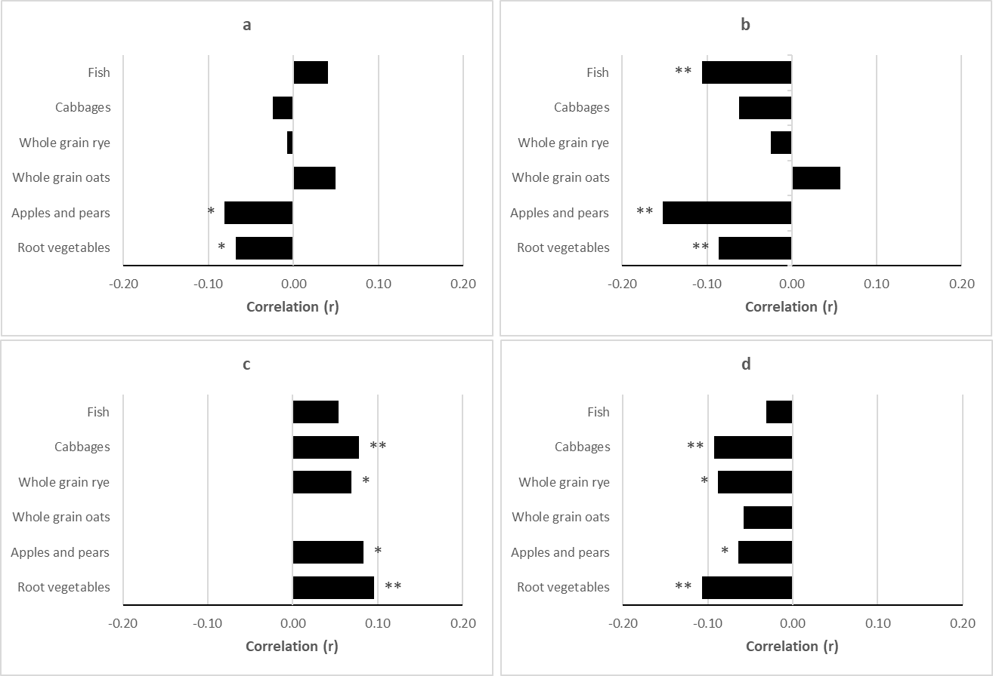
Supplementary Figure 2. Pearson correlation coefficients. HNFI food components (g/d*1000 kcal⁻¹) vs. plasma metabolite concentrations.
Legend: a - Choline. b - Betaine. c - Serine. d - Total homocysteine. * P<0.05. ** P<0.01.
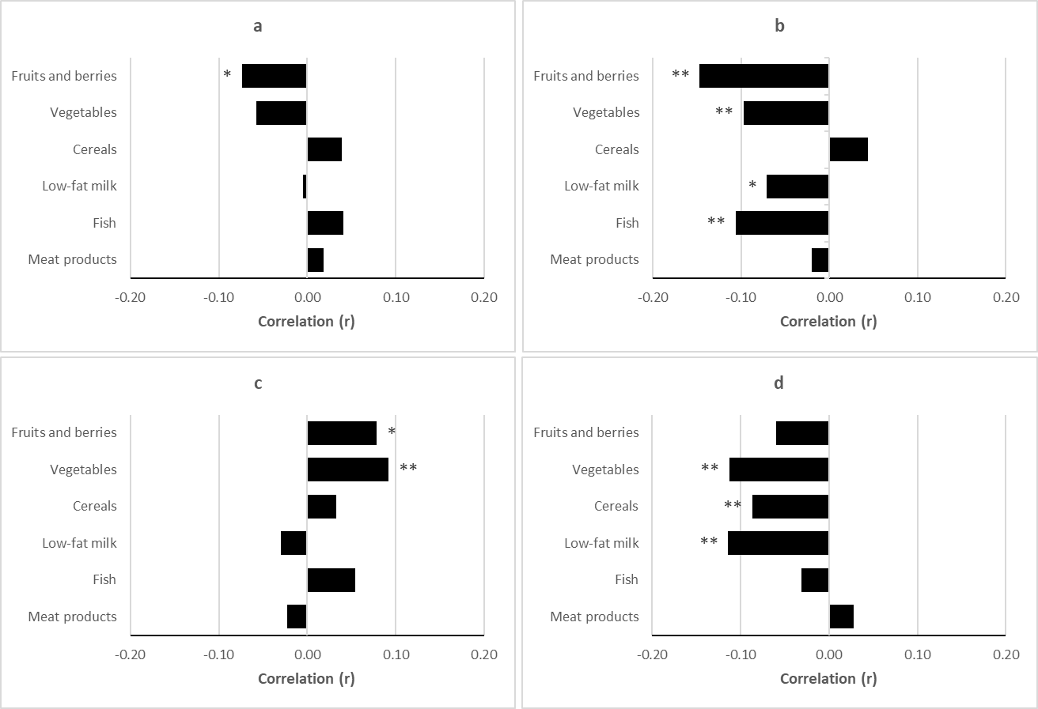
Supplementary Figure 3. Pearson correlation coefficients. BSDS food components (g/d*1000 kcal⁻¹) vs. plasma metabolite concentrations.
Legend: a - Choline. b - Betaine. c - Serine. d - Total homocysteine. * P<0.05. ** P<0.01.

