Supplementary Information: Transport by circulating myeloid cells drives liposomal accumulation in inflamed synovium
Joke Deprez^{1,2}, Rein Verbeke^{1,2}, Sofie Meulewaeter^{1,2}, Ilke Aernout^{1,2}, Heleen Dewitte^{1,2}, Tine Decruy^{2,3}, Julie Coudenys^{2,3}, Julie Van Duyse^{4,5}, Gert Van Isterdael^{4,5}, Dan Peer^{6,7,8,9}, Roy van der Meel¹⁰, Stefaan C. De Smedt^{1,2}, Peggy Jacques³, Dirk Elewaut^{2,3*}, Ine Lentacker^{1,2*}
¹Laboratory of General Biochemistry and Physical Pharmacy, Ghent Research Group on Nanomedicine, Ghent University, Ghent, Belgium
²Cancer Research Institute Ghent (CRIG), Ghent, Belgium
³Unit Molecular Immunology and Inflammation, VIB Centre for Inflammation Research, Ghent University and Department of Rheumatology, Ghent University Hospital, Ghent, Belgium
⁴VIB Flow Core, VIB Center for Inflammation Research, Ghent, Belgium
⁵Department of Biomedical Molecular Biology, Ghent University, Ghent, Belgium.
⁶Laboratory of Precision Nanomedicine, Shmunis School of Biomedicine and Cancer Research, George S. Wise Faculty of Life Sciences, Tel Aviv University, Tel Aviv, Israel.
⁷Department of Materials Sciences and Engineering, Iby and Aladar Fleischman Faculty of Engineering, Tel Aviv University, Tel Aviv, Israel.
⁸Center for Nanoscience and Nanotechnology, Tel Aviv University, Tel Aviv, Israel.
⁹Cancer Biology Research Center, Tel Aviv University, Tel Aviv, Israel.
¹⁰Laboratory of Chemical Biology, Department of Biomedical Engineering and Institute for Complex Molecular Systems, Eindhoven University of Technology, Eindhoven, The Netherlands
*Equal contribution

Content
Flow cytometry gating strategy (panel A) 3
Flow cytometry gating strategy (panel B) 4
Stability of liposomes in serum 5
In vivo biodistribution of DIR labelled liposomes 1 hour after injection in healthy and CIA DBA/1 mice. 5
Liposome uptake in different myeloid immune cells in the knee synovium of CIA DBA/1 mice 7
FACS sorting gating strategy of blood and ankle synovium prior to ImageStream® 8
ImageStream® gating strategy 9
ImageStream® images of liposome engulfment by (CD45⁺CD11b⁺Ly6C^{hi}Ly6G^{lo}) monocytes 10
ImageStream® images of liposome engulfment by (CD45⁺CD11b⁺Ly6C^{lo-med}Ly6G^{hi}) neutrophils 11
Flow cytometry gating strategy with extended flow cytometric panel. 12
DSPC:Chol:PEG liposome uptake in non-CD45+ cells. 13
In vivo biodistribution of fluorescently labelled liposomes in control and CIA C57BL/6 mouse 4 and 24 hours after injection 14
Comparison of the absolute number of different immune cells between blood and synovium from healthy and CIA C57BL/6 mice 15
Uptake profile of different liposome types in immune cells in blood and ankle synovium of CIA C57BL/6 at hours after injection of the liposomes. 16
Mean fluorescence intensity of liposome uptake in myeloid immune cells in blood and ankle synovium of CIA C57BL/6 mice at 4 and 24 hours after liposome injection. 17
Liposome uptake in different immune cell populations in the knee synovium of CIA C57BL/6 mice 18
Flow cytometry scatter plots of CD45.1 cells retrieved in respectively CIA CD45.1 harvested blood and blood and synovium of CIA induced CD45.2 after autologous transfusion with 7.6*10⁶ cells CD45.1 cells. 19
Flow cytometry scatter plots of CD45.1 cells retrieved in respectively CIA CD45.1 harvested blood and synovium of CIA induced CD45.2 after autologous transfusion with 12.5*10⁶ CD45.1 cells. 20
Impact of selective myeloid depletion with anti-GR-1 and anti-CCR2 antibodies on myeloid cell populations retrieved in ankle synovium and blood. 21
Comparison of liposome uptake in different immune cells in blood and ankle synovium of CIA C57BL/6 mice between PEGylated liposomes and LNPs. 22
In vivo biodistribution and transfection of LNPs 4 hours after i.v. injection Comparison of liposome uptake in myeloid cells in ankle synovium of CIA DBA/1 mice between PEGylated liposomes and LNPs. 23

Flow cytometry gating strategy (panel A)
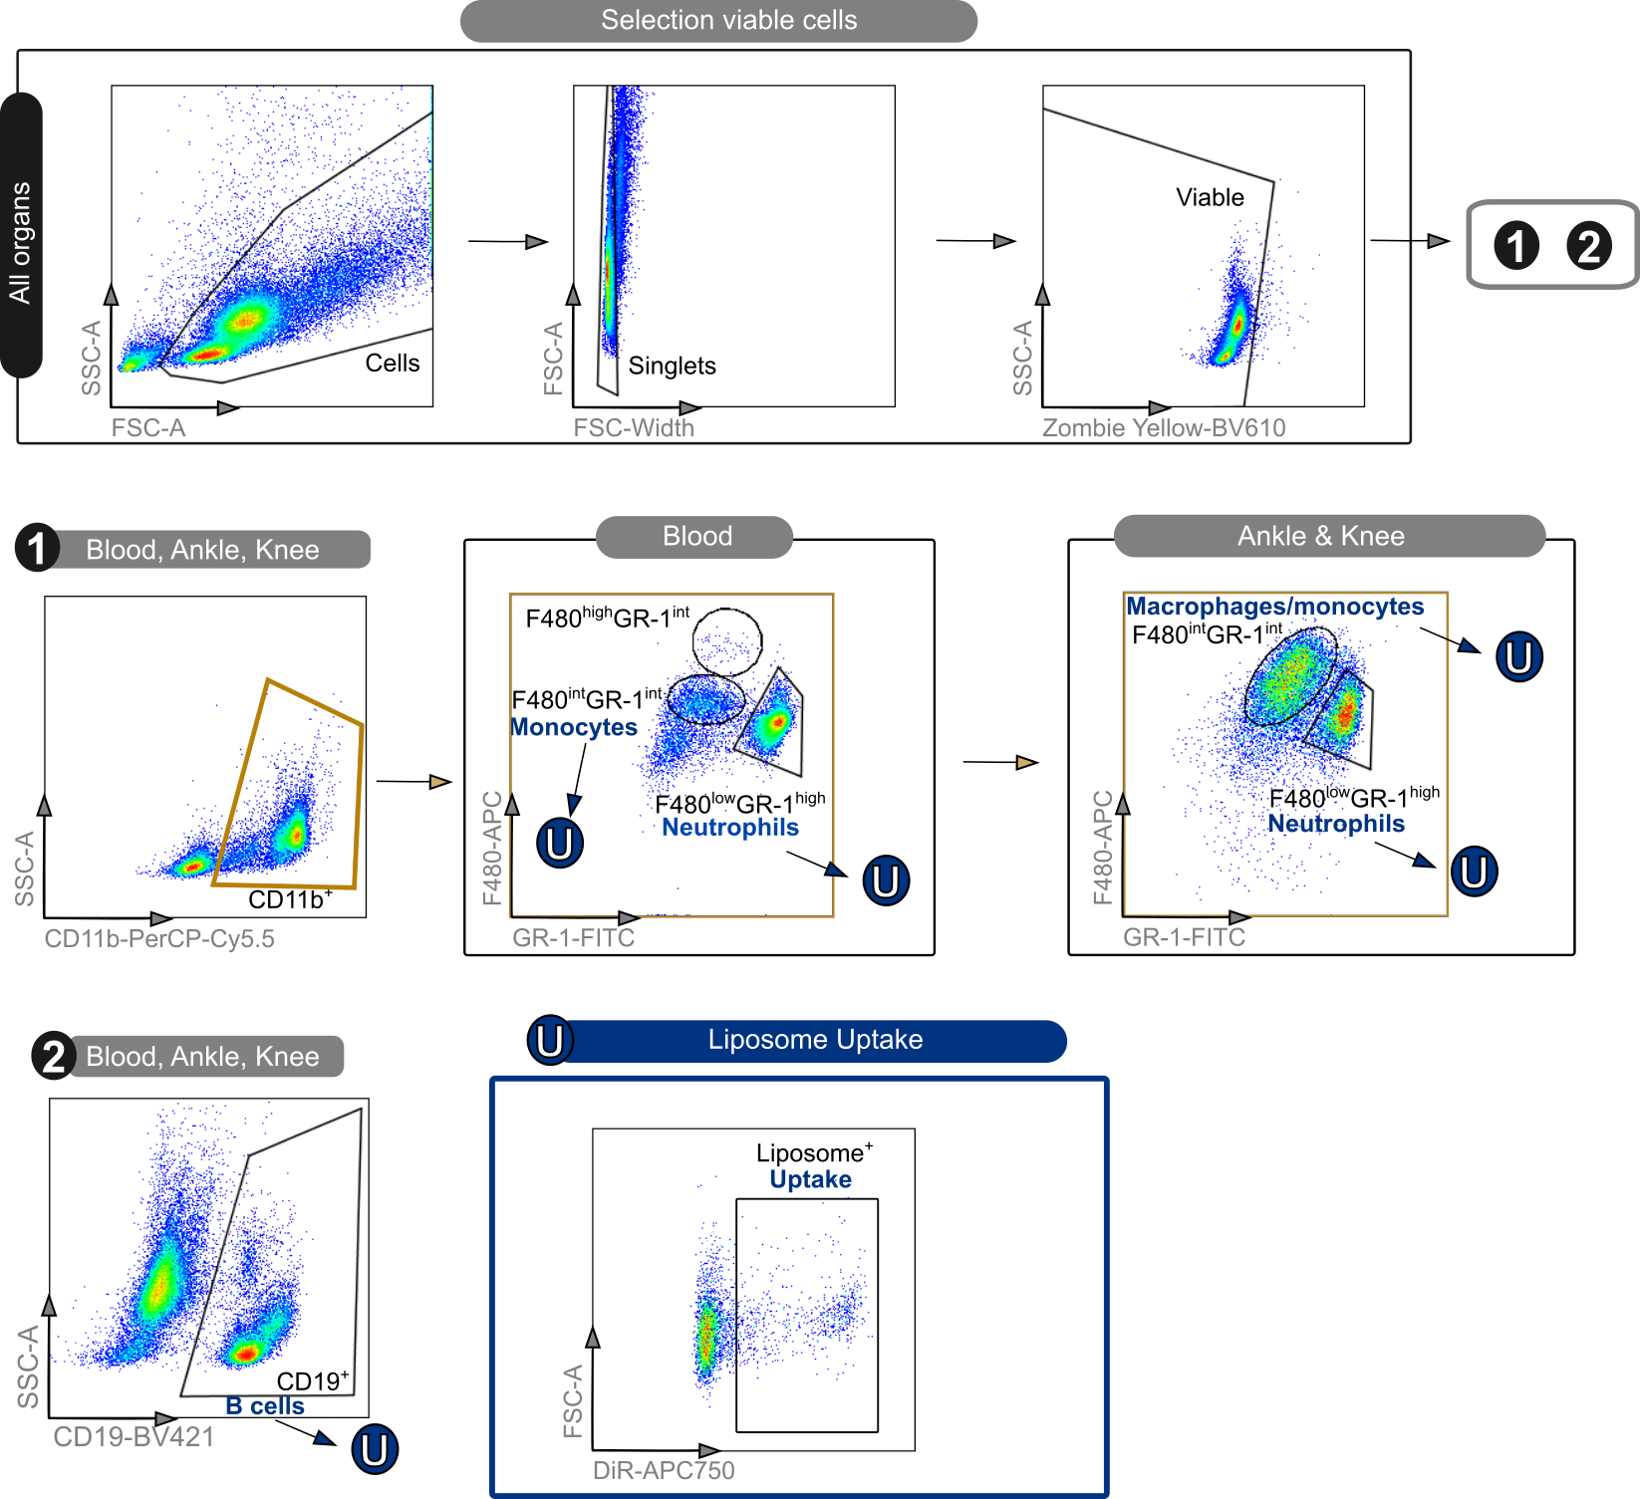
Supplementary Figure 1 | Gating strategy of exploratory flow panel A shown in Fig.1B. First the viable cells were selected by gating all cells, single cells and viable cells. Subsequently the cells were subdivided into different populations: Monocytes in blood (CD11b⁺F480^{lo}GR-1^{mid}), monocyte derived macrophages (MoMF) in synovium (CD11b⁺F480^{hi}GR-1^{mid}), neutrophils (CD11b⁺F480^{lo}GR-1^{hi}) and B-cells (CD19⁺) Finally, the liposome uptake (U) was defined for each individual cell type.

Flow cytometry gating strategy (panel B)

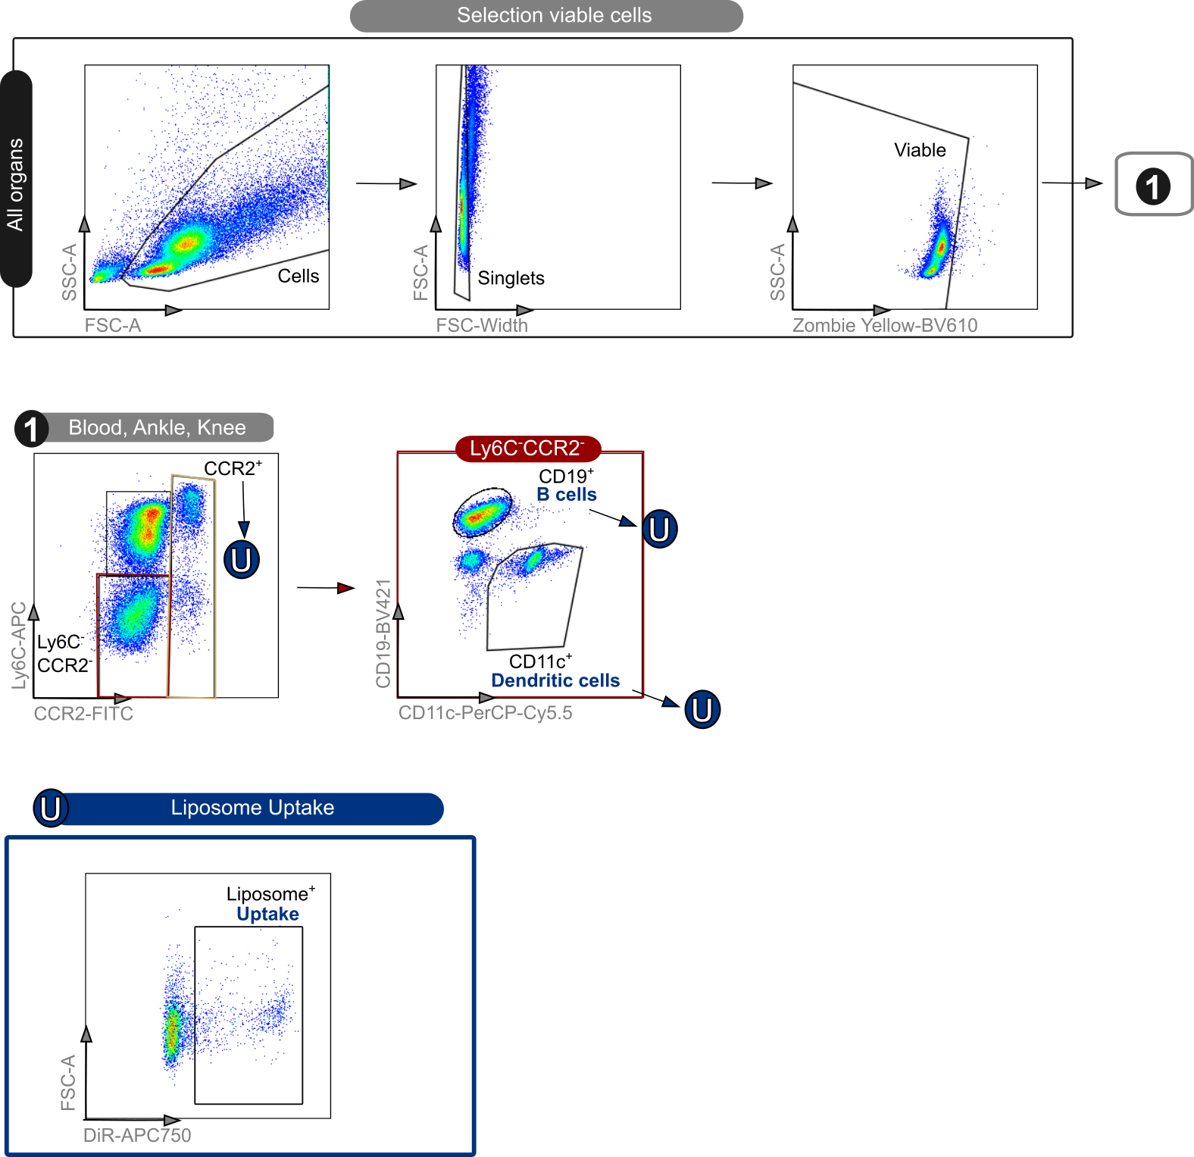
Supplementary Figure 2 | Gating strategy of exploratory flow panel B shown in Figure 1B. First the viable cells were selected by gating all cells, single cells, and viable cells. Subsequently the cells were subdivided into different populations: CCR2⁺ cells, dendritic cells (CD11c⁺) and B-cells (CD19⁺). Finally, the liposome uptake (U) was defined for each individual cell type.

Stability of liposomes in serum

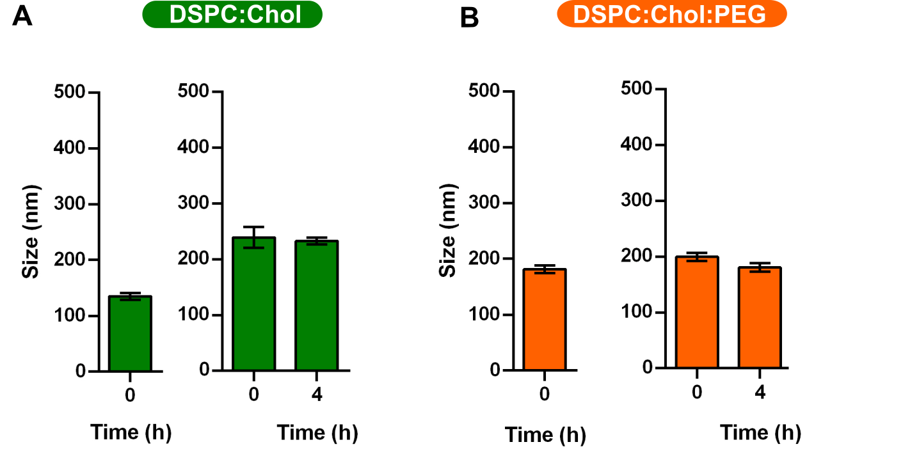
Supplementary Figure 3 | Mean size of the non-PEGylated and PEGylated liposomes over time after dilution in HEPES (left) and full serum (FBS) (right) as measured by Nanoparticle Tracking Analysis (Nanosight®). The near-neutral DSPC:Chol liposomes (A) increase about 100 nm in size after dilution in full serum. The PEGylated DSPC:Chol:PEG liposomes (B) retain their size after dilution in full serum. Data represent mean ± SEM. Total sample size (per condition: traced liposomes DSPC:Chol in HEPES 0h (N = 88), serum 0h (N = 131), serum 4h (N = 999) and traced liposomes DSPC:Chol:PEG in HEPES 0h (N = 112), serum 0h (N = 134), serum 4h (N = 113).

In vivo biodistribution of DIR labelled liposomes 1 hour after injection in healthy and CIA DBA/1 mice.
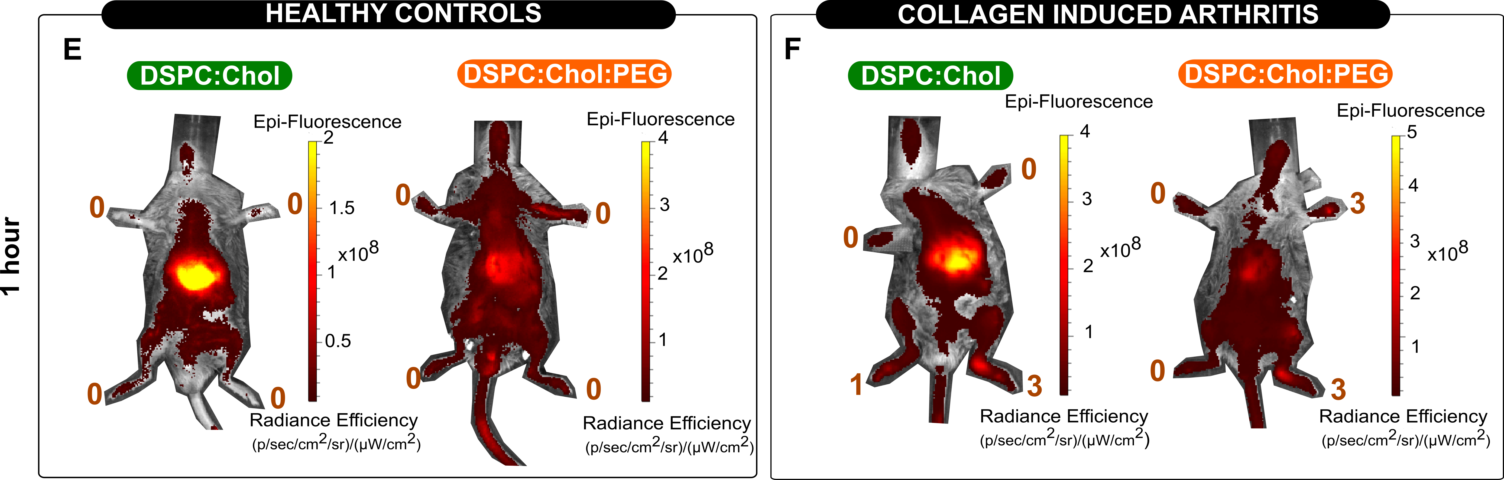
Supplementary Figure 4 | In vivo biodistribution of DIR labelled liposomes in control and CIA mice, 1 hour after intravenous injection. Representative images of the biodistribution of DiR liposomes in healthy (E) and CIA (F) DBA/1 mice at 1 hour after intravenous injection.
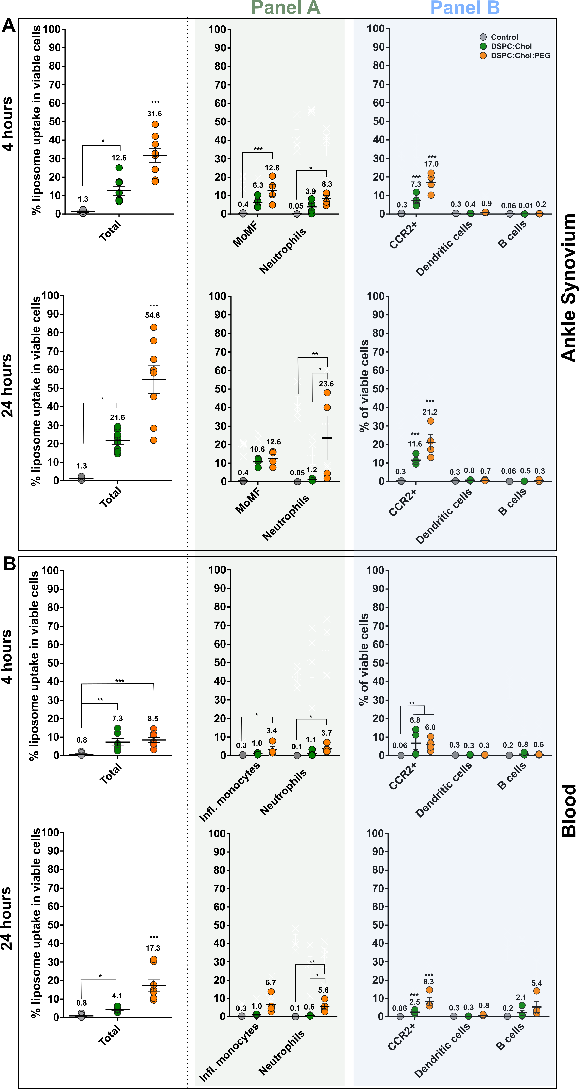
Supplementary Figure 5 | Liposome uptake in immune cells in the blood and ankle synovium following intravenous administration of non-PEGylated (green dots) and PEGylated liposomes (orange dots) in CIA DBA/1 mice using exploratory panel. Left from the dotted line: percentage of viable cells in the blood (A) and ankle (B) that engulfed liposomes, at respectively 4 and 24 hours after injection. Right from the dotted line: fraction of each immune cell type in liposome positive cells. Data represent mean ± SEM, Sample size (N=4) per condition, two-sided two-way ANOVA analysis with Tukey’s correction for multiple testing. Significance levels (A,B) are indicated with asterisks: *, ** and *** respectively represent adjusted p values of p < 0,05; p <0,01 and p <0.001.

Liposome uptake in different myeloid immune cells in the knee synovium of CIA DBA/1 mice

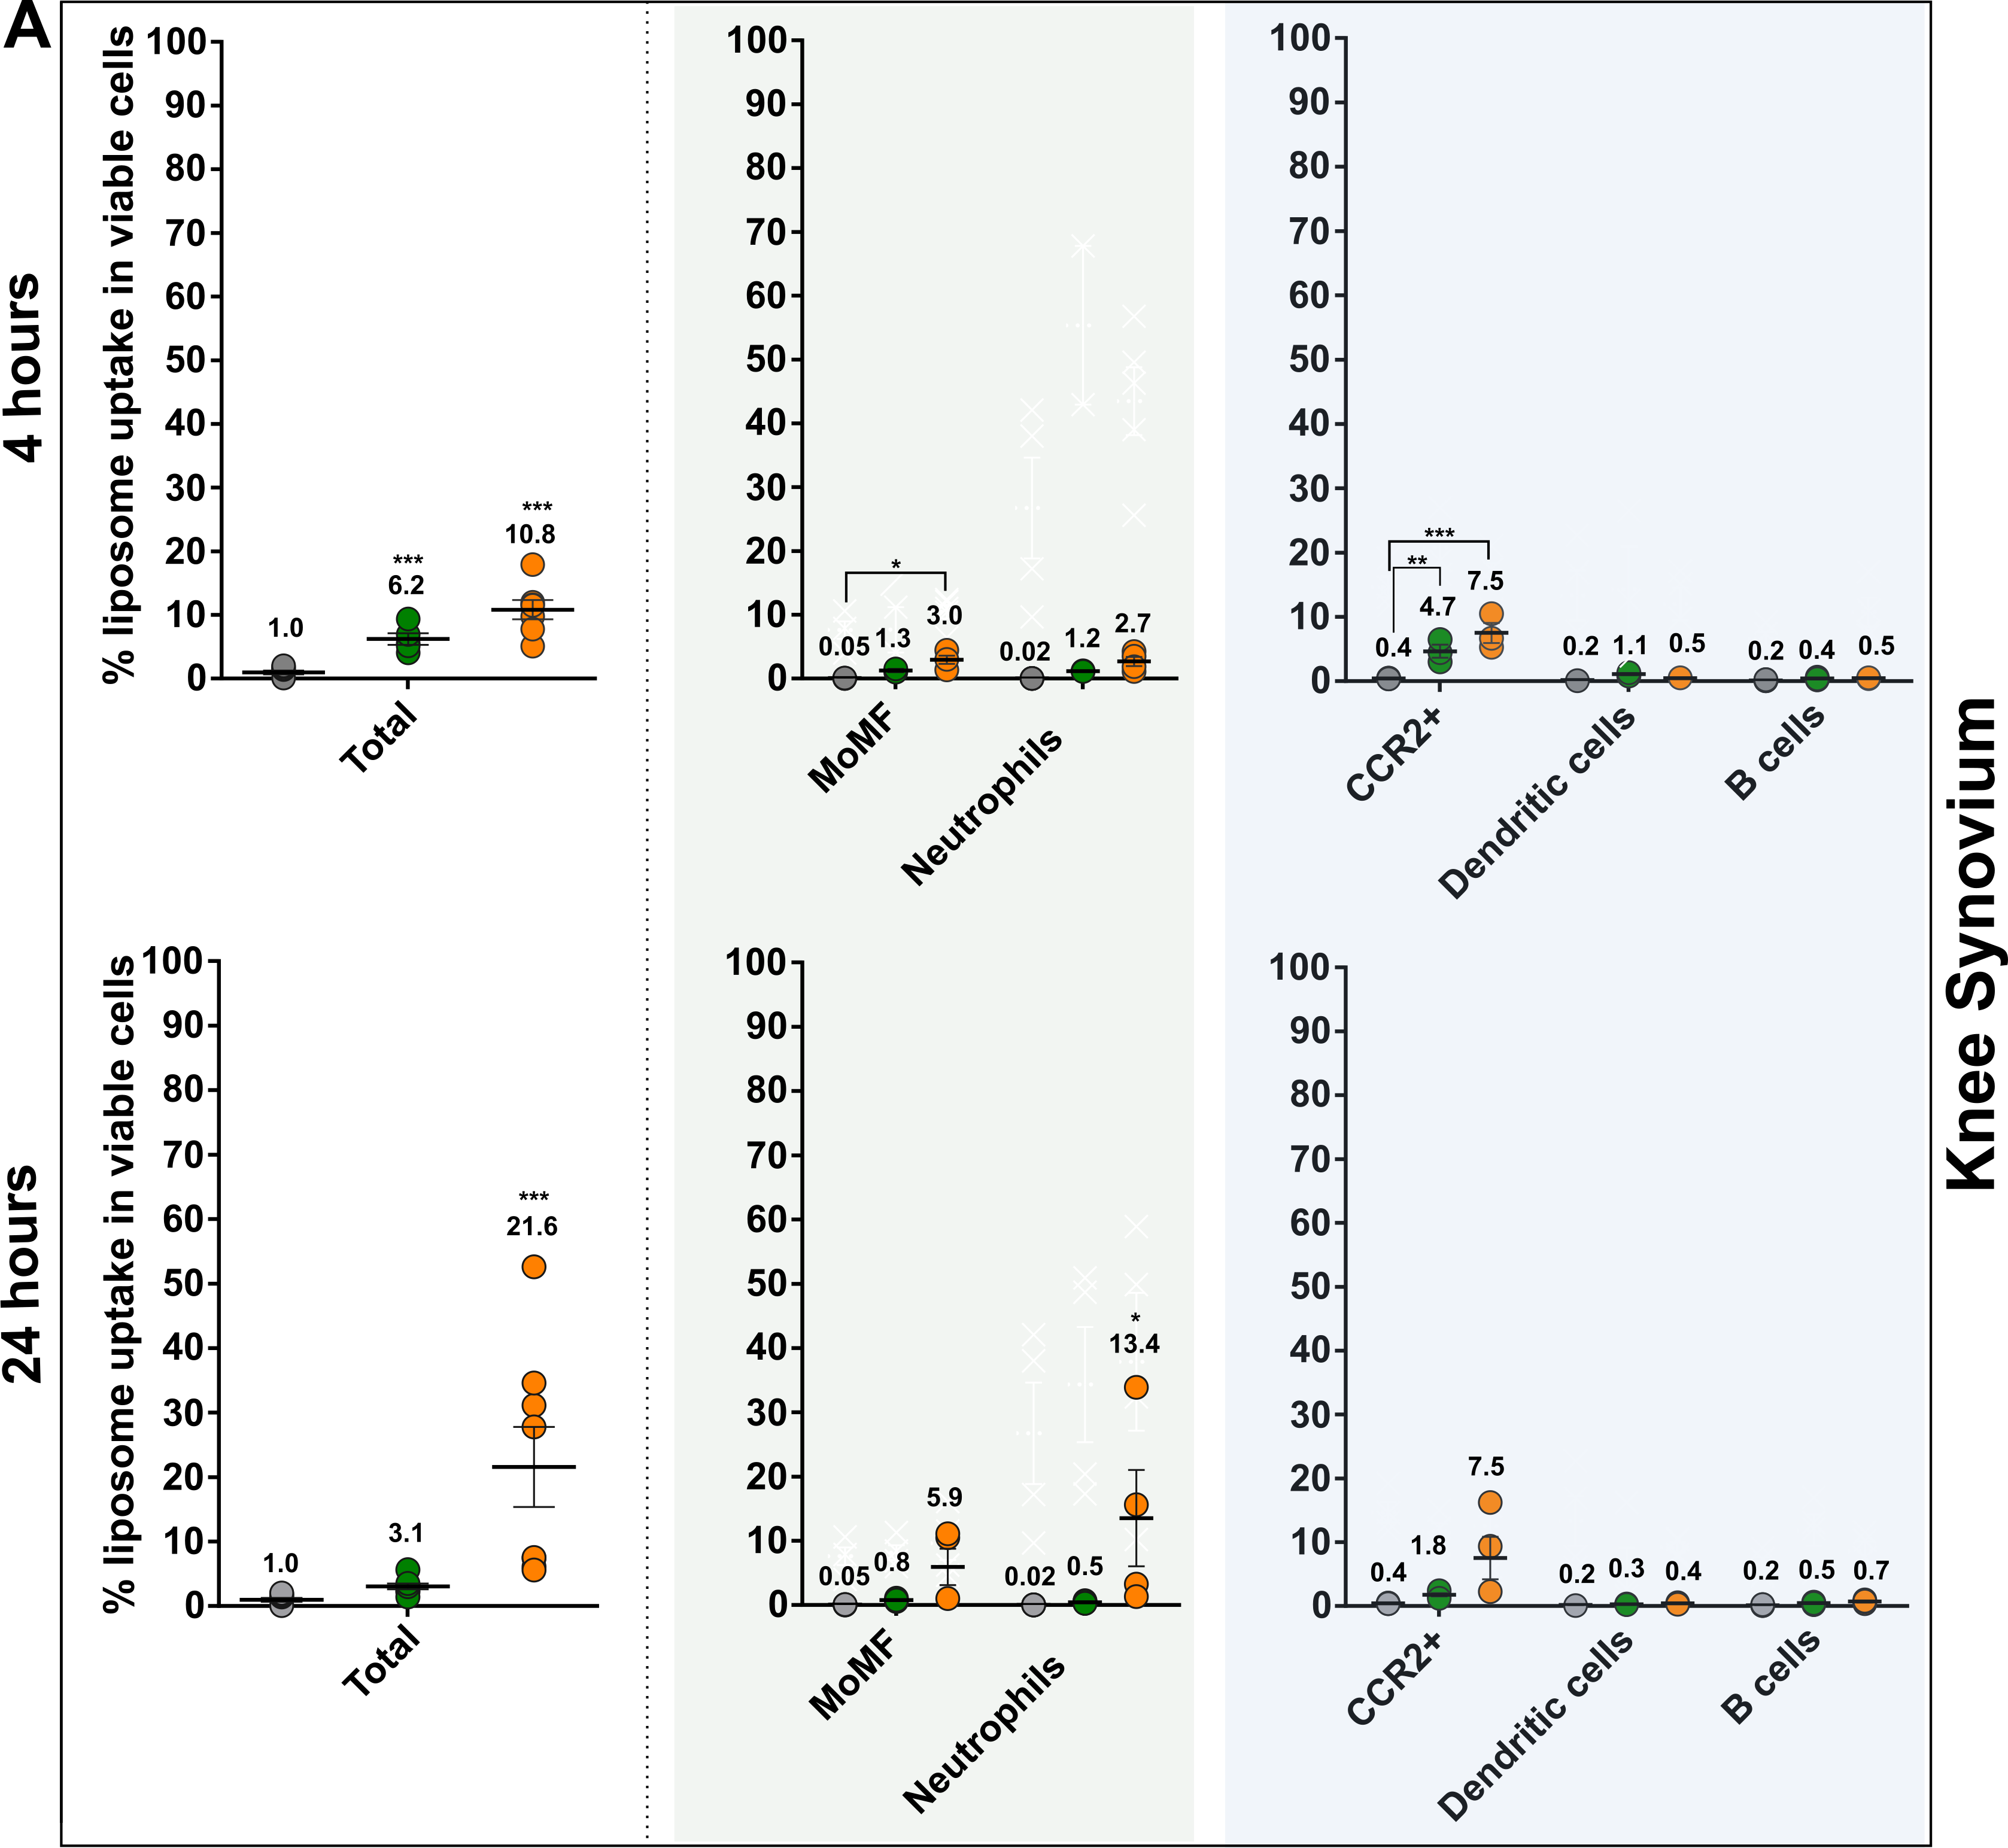
Supplementary Figure 6 | Liposome uptake in immune cells in the knee synovium following intravenous administration of liposomes in CIA DBA/1 mice using exploratory panel. Left from dotted line: percentage of viable immune cells in blood (A) and ankle (B) that engulfed liposomes, at respectively 4 and 24 hours after injection. Right from dotted line: contribution of each immune cell type in total liposome uptake (colored dots). Data represent mean ± SEM, Sample size (N=3) per condition, two-sided two-way ANOVA analysis with Tukey’s correction for multiple testing. Significance levels (A-B) are indicated with asterisks: *, ** and *** respectively represent adjusted p values of p < 0,05; p <0,01 and p <0.001.

FACS sorting gating strategy of blood and ankle synovium prior to ImageStream®
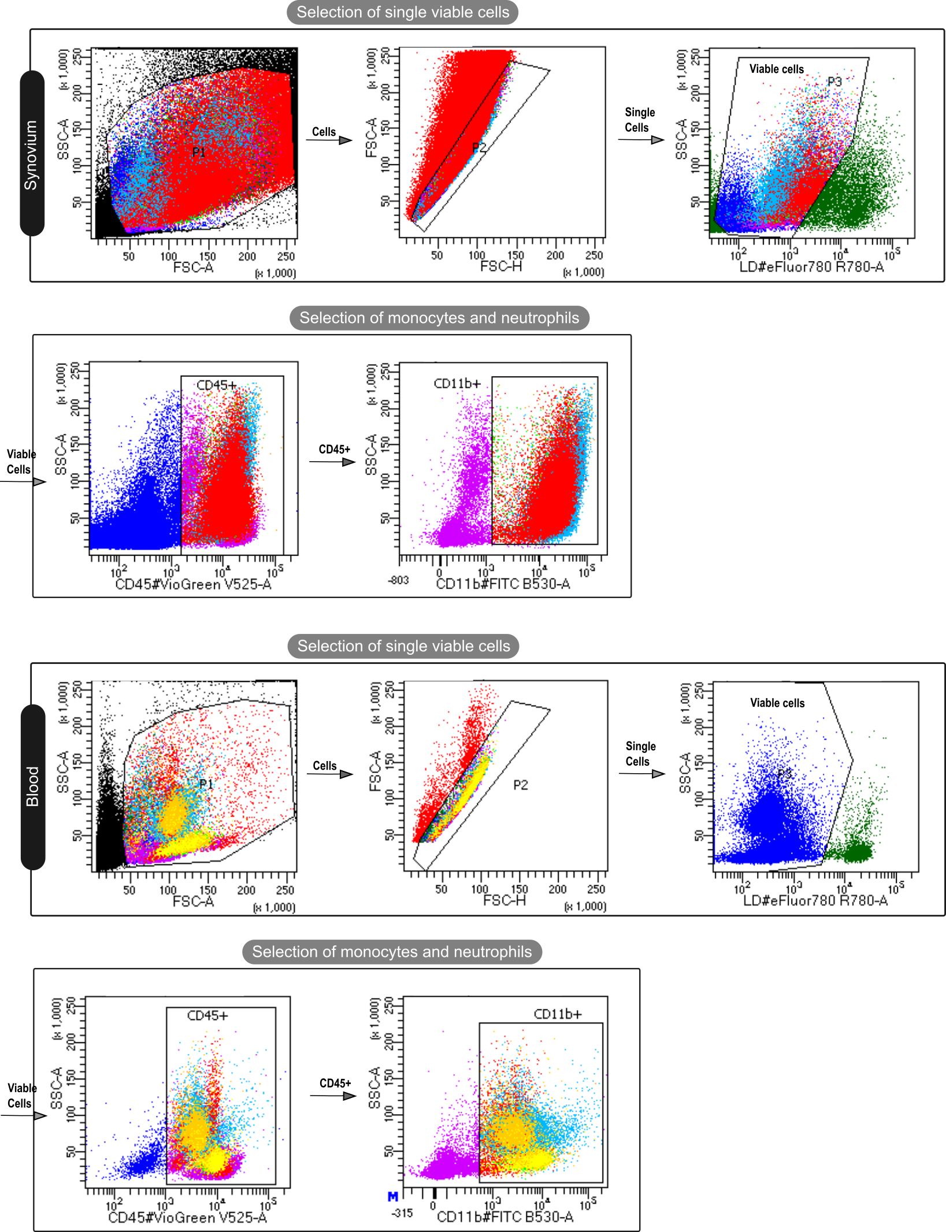
Supplementary Figure 7 | Gating strategy to sort myeloid cells from blood and ankle synovium prior to ImageStream®analysis. First the viable cells were selected by gating all cells, single cells, and viable cells. Subsequently the cells were consequently gated into myeloid cells (CD45⁺CD11b⁺) and were sorted for further analysis with the the ImageStream® to visualize and analyze liposoom engulfment at 24 hours post i.v. injection of PEGylated liposomes.

ImageStream® gating strategy
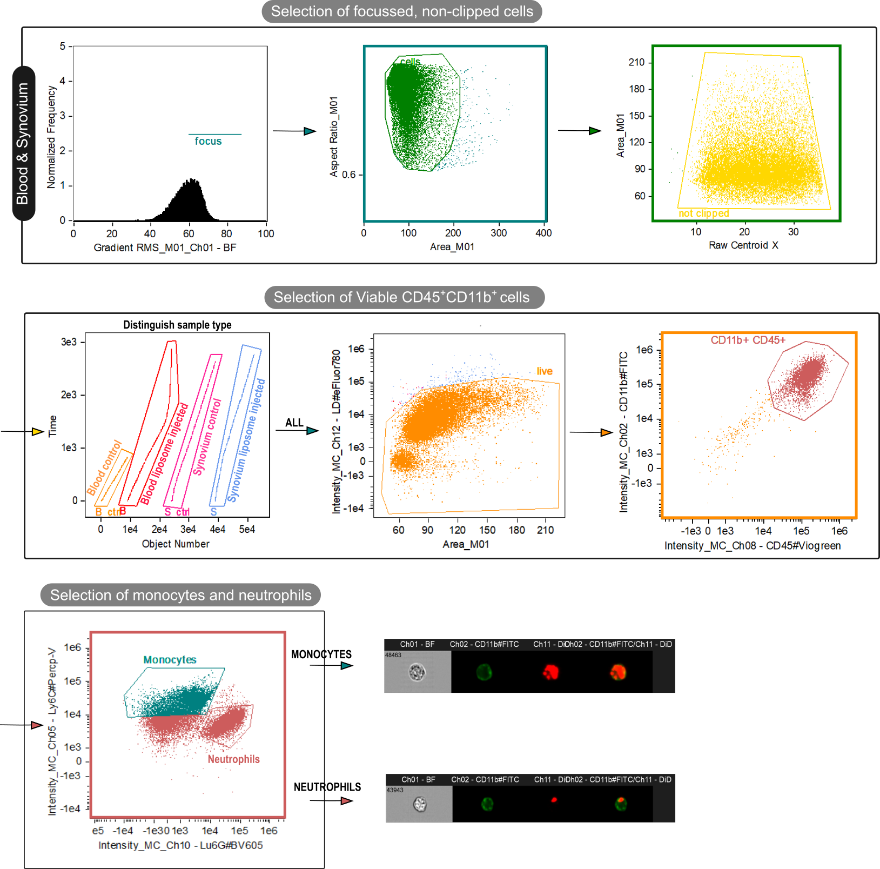
Supplementary Figure 8 | Gating strategy for Imagestream analysis at 24 hours post i.v. injection of PEGylated liposomes. First the well-focused, non-clipped cells were selected. Subsequently the cells from the different conditions were tagged to enable comparison. Finally, the viable myeloid immune cells were selected (CD45⁺ CD11b⁺).Within the myeloid cells, the monocytes (Ly6C^{hi}Ly6G^{lo}) and neutrophils (Ly6C^{lo-med}Ly6G^{hi}) were selected to identify the liposome uptake (DiD⁺) in images as displayed.

ImageStream® images of liposome engulfment by (CD45⁺CD11b⁺Ly6C^{hi}Ly6G^{lo}) monocytes

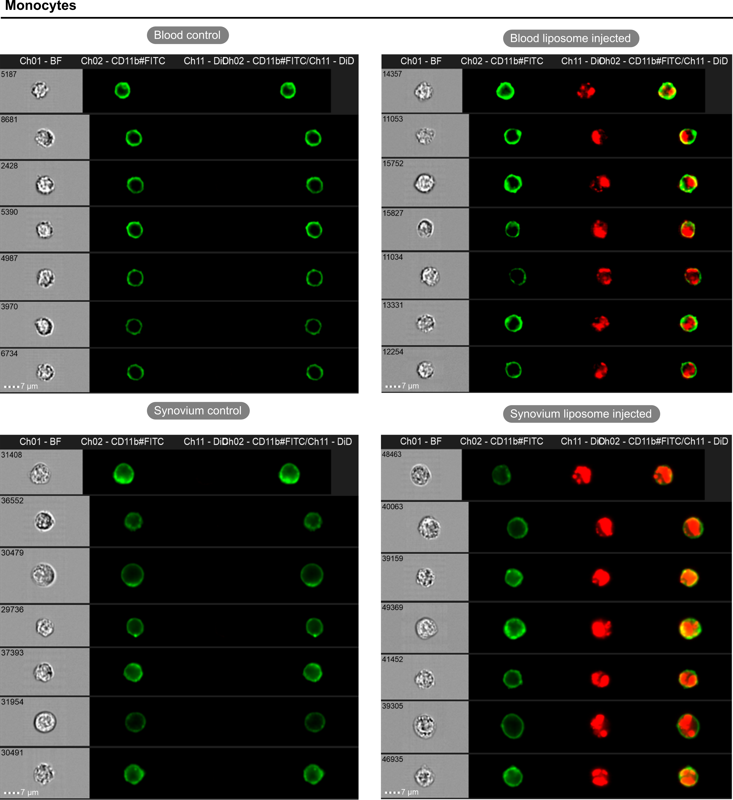
Supplementary Figure 9 | Liposome uptake in CD45⁺CD11b⁺Ly6C^{hi}Ly6G^{lo} monocytes in blood and ankle synovium. After selection of the monocytes within the sorted myeloid cells (as displayed in Supplementary Figure 10), a brightfield image of the cell, CD11b surface staining, DiD liposome signal and an overlay image is taken. Left: monocytes from blood and ankle synovium of non-liposome injected control mouse. Right: monocytes from blood and ankle synovium of liposome injected mouse.

ImageStream® images of liposome engulfment by (CD45⁺CD11b⁺Ly6C^{lo-med}Ly6G^{hi}) neutrophils

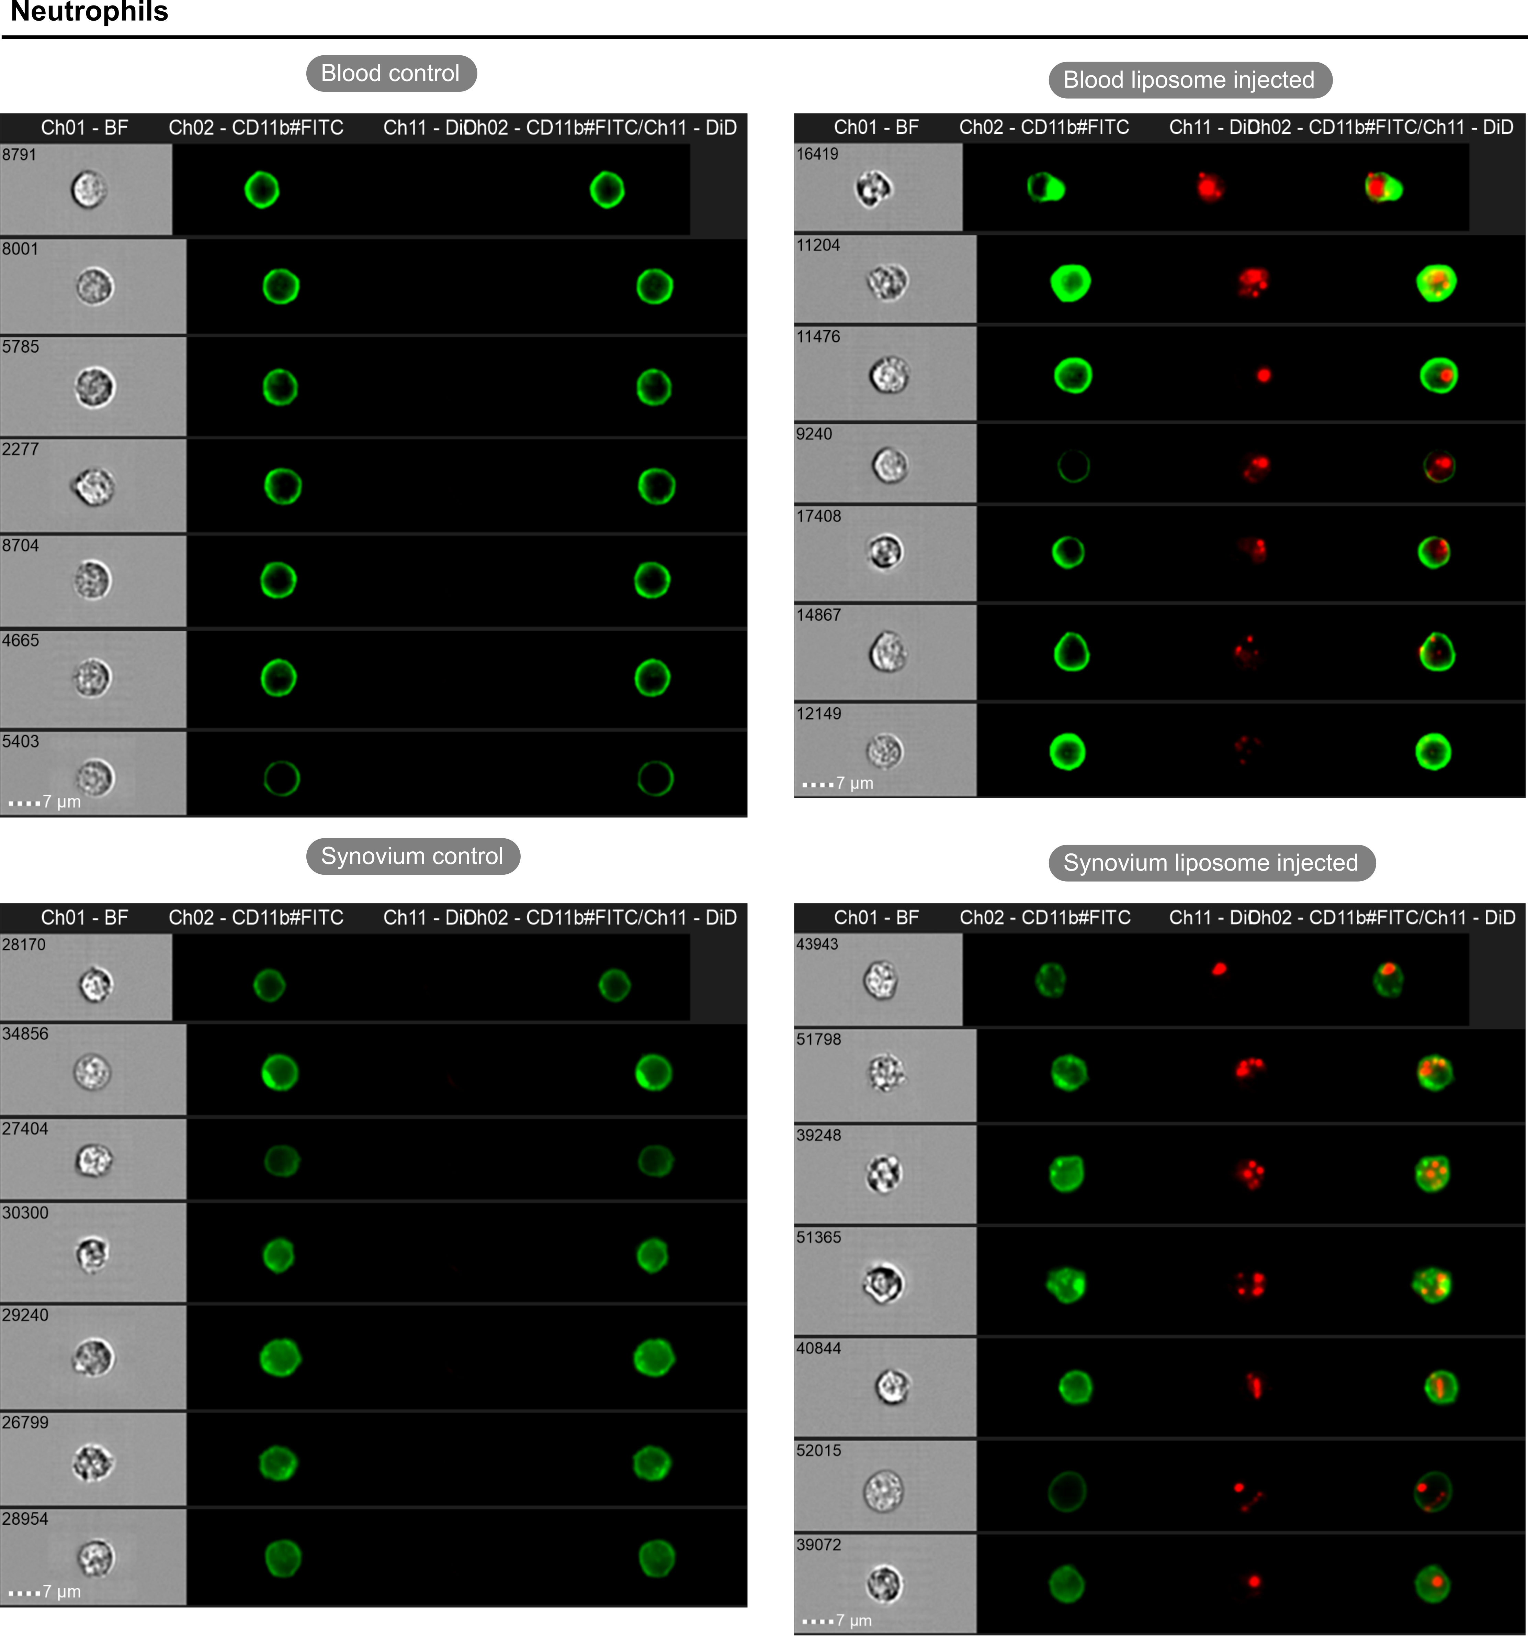
Supplementary Figure 10 | Liposome uptake in CD45⁺CD11b⁺Ly6C^{lo-med}Ly6G^{hi} neutrophils in blood and ankle synovium. After selection of the neutrophils within the sorted myeloid cells (as displayed in Supplementary Figure 10), a brightfield image of the cell, CD11b surface staining, DiD liposome signal and an overlay image is displayed. Left: neutrophils from blood and ankle synovium of non-liposome injected control mouse. Right: neutrophils from blood and ankle synovium of liposome injected mouse.

Flow cytometry gating strategy with extended flow cytometric panel.
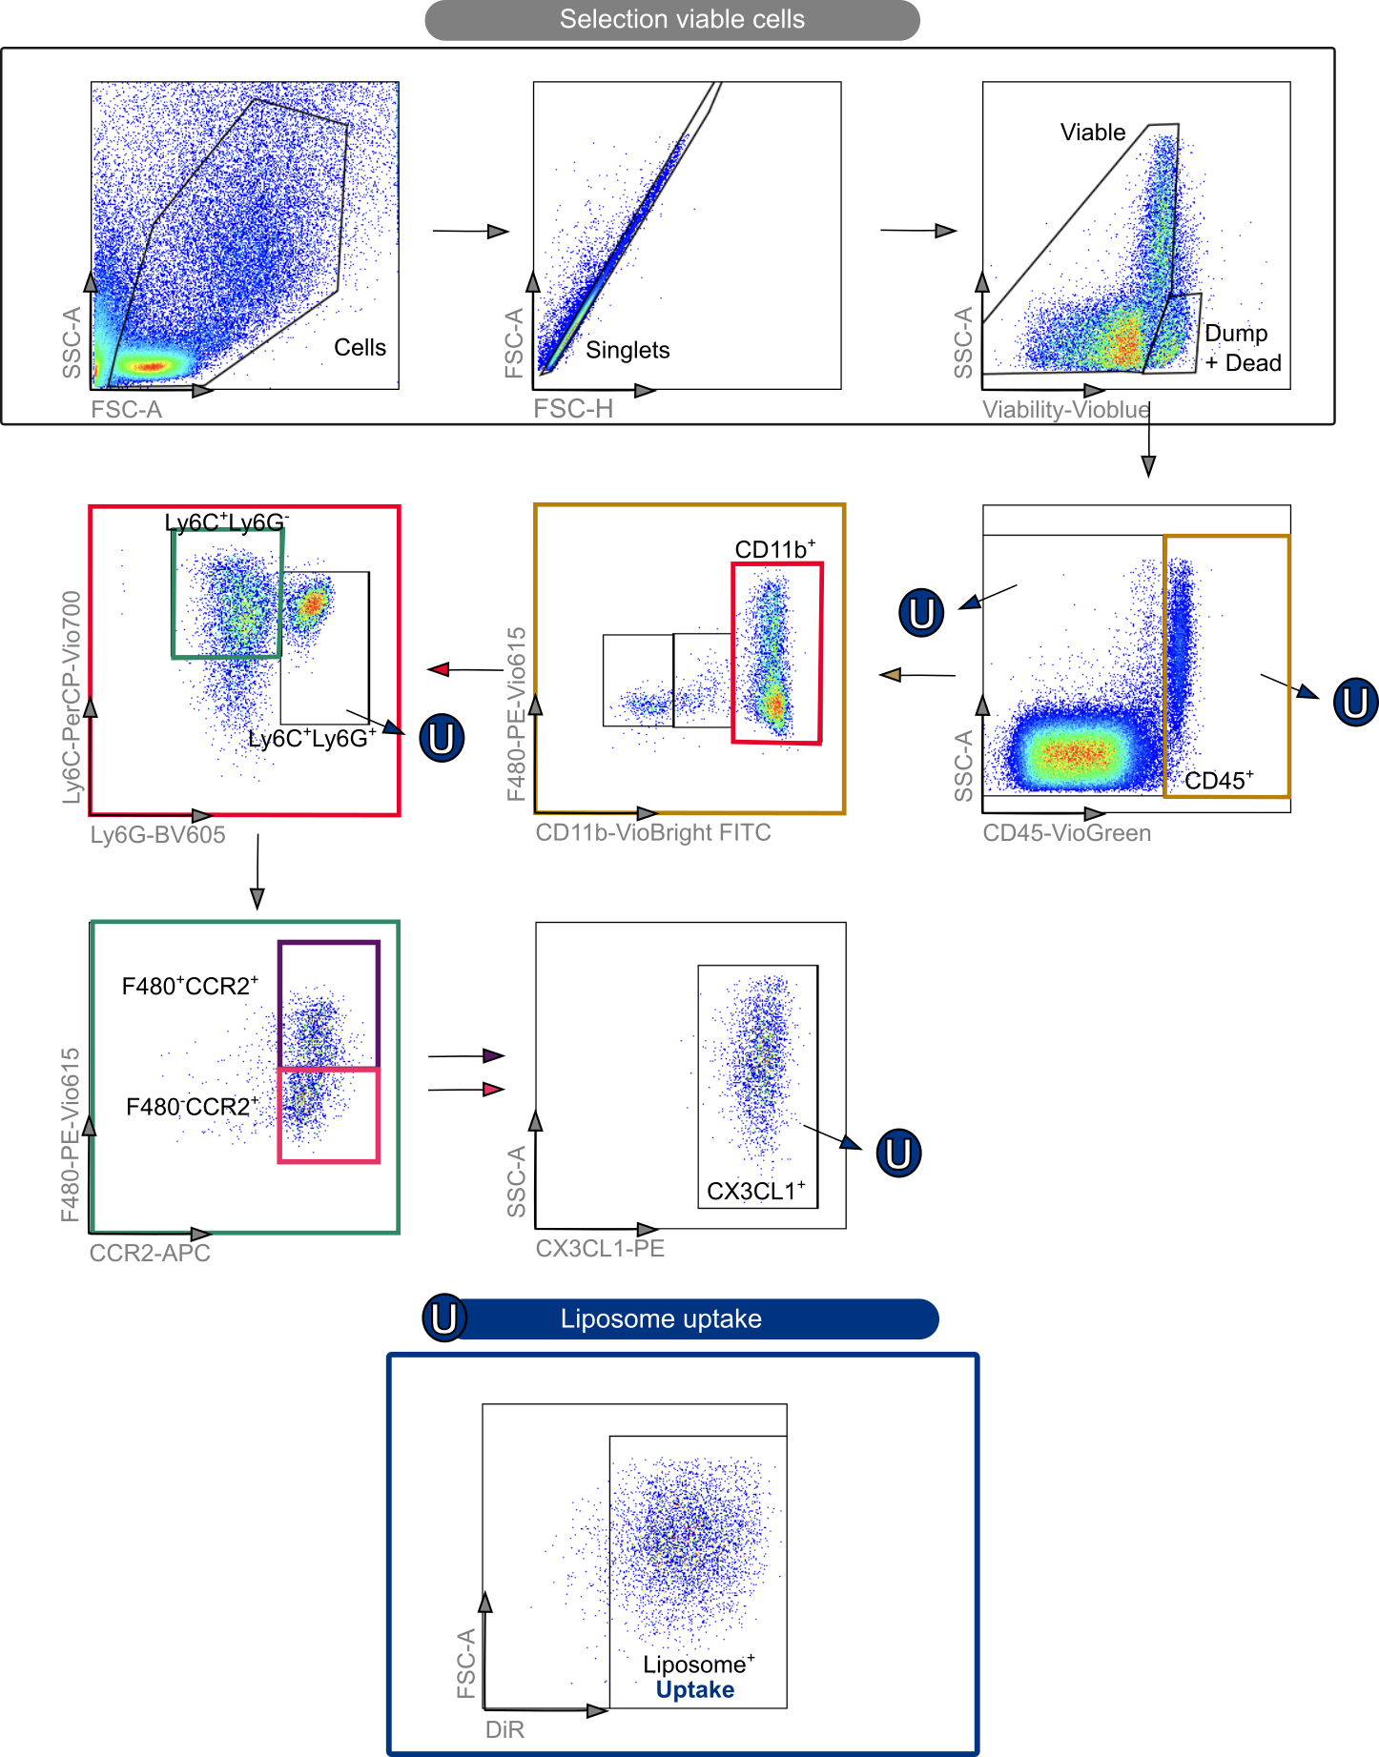
Supplementary Figure 11 | Gating strategy of extended myeloid cell flow cytometry panel. First the viable cells were selected by gating all cells, single cells and viable cells which excluded the dead cells and the dump channel containing the CD19, NK1.1 and CD3e markers. Subsequently the cells were subdivided into different populations: the monocytes CD45⁺CD11b⁺Ly6C⁺CCR2⁺CX3CR1⁺F480^{lo}, the monocyte-derived macrophages (MoMF) CD45⁺CD11b⁺Ly6C⁺CCR2⁺CX₃CR₁⁺
480^{hi} and the neutrophils (CD45⁺CD11b⁺Ly6C⁺Ly6G⁺). Finally, the liposome uptake (U) was defined for each individual cell type.

DSPC:Chol:PEG liposome uptake in non-CD45+ cells.
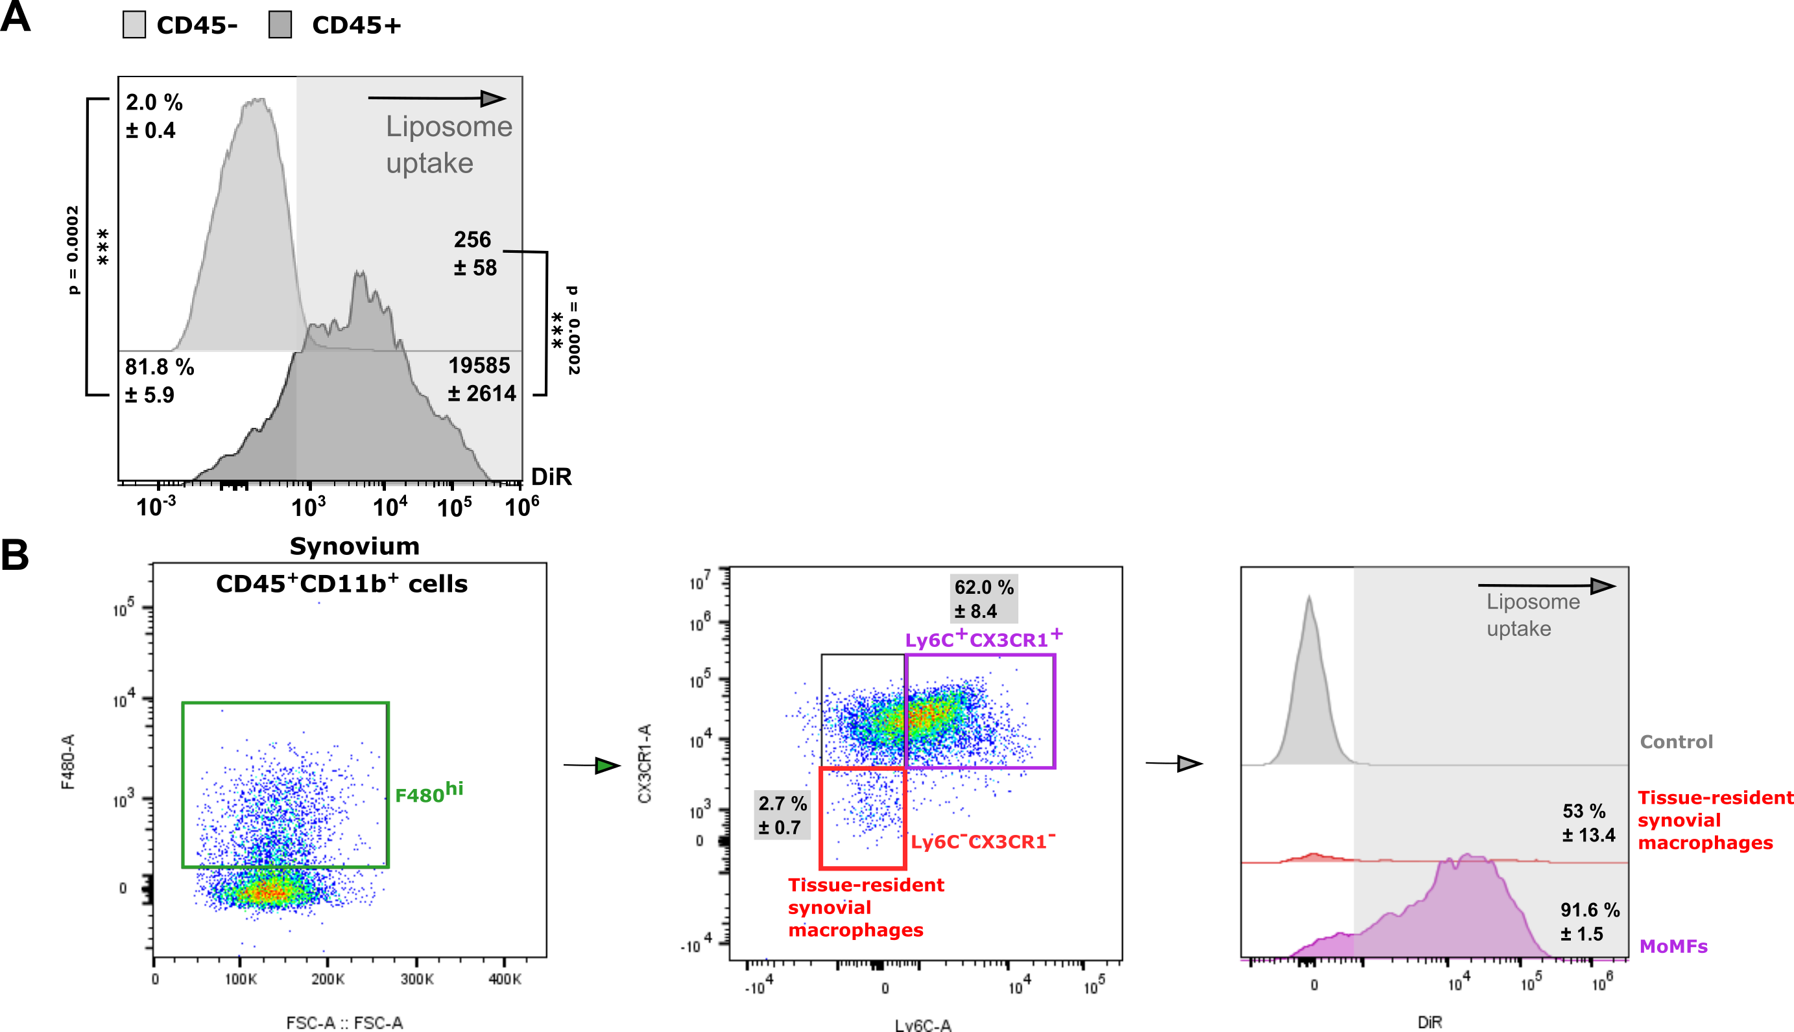
Supplementary Figure 12 | (A) Uptake of DSPC:Chol:PEG liposomes in non-immune cells (CD45-) and immune (CD45+) cells in ankle synovium. Data represent mean ± SD, Sample size (N=3) per condition, two-sided t-test. (B) Contribution of tissue-resident synovial macrophages to the retrieved macrophage (F480^{hi}) population in the synovium. After gating the macrophage (F480^{hi}) cells in the CD45⁺CD11b⁺ population (left), a further distinction was made based on the absence of specific monocyte markers such as Ly6C and CX3CR1 (middle). Finally, the liposome engulfment was determined between the tissue-resident synovial macrophages and the MoMFs (right). Although about half of the the tissue-resident synovial macrophages show liposome engulfment, the contribution of this macrophage subset to the liposome engulfment in the synovium is negligible compared to the infiltrating MoMFs.

In vivo biodistribution of fluorescently labelled liposomes in control and CIA C57BL/6 mouse 4 and 24 hours after injection
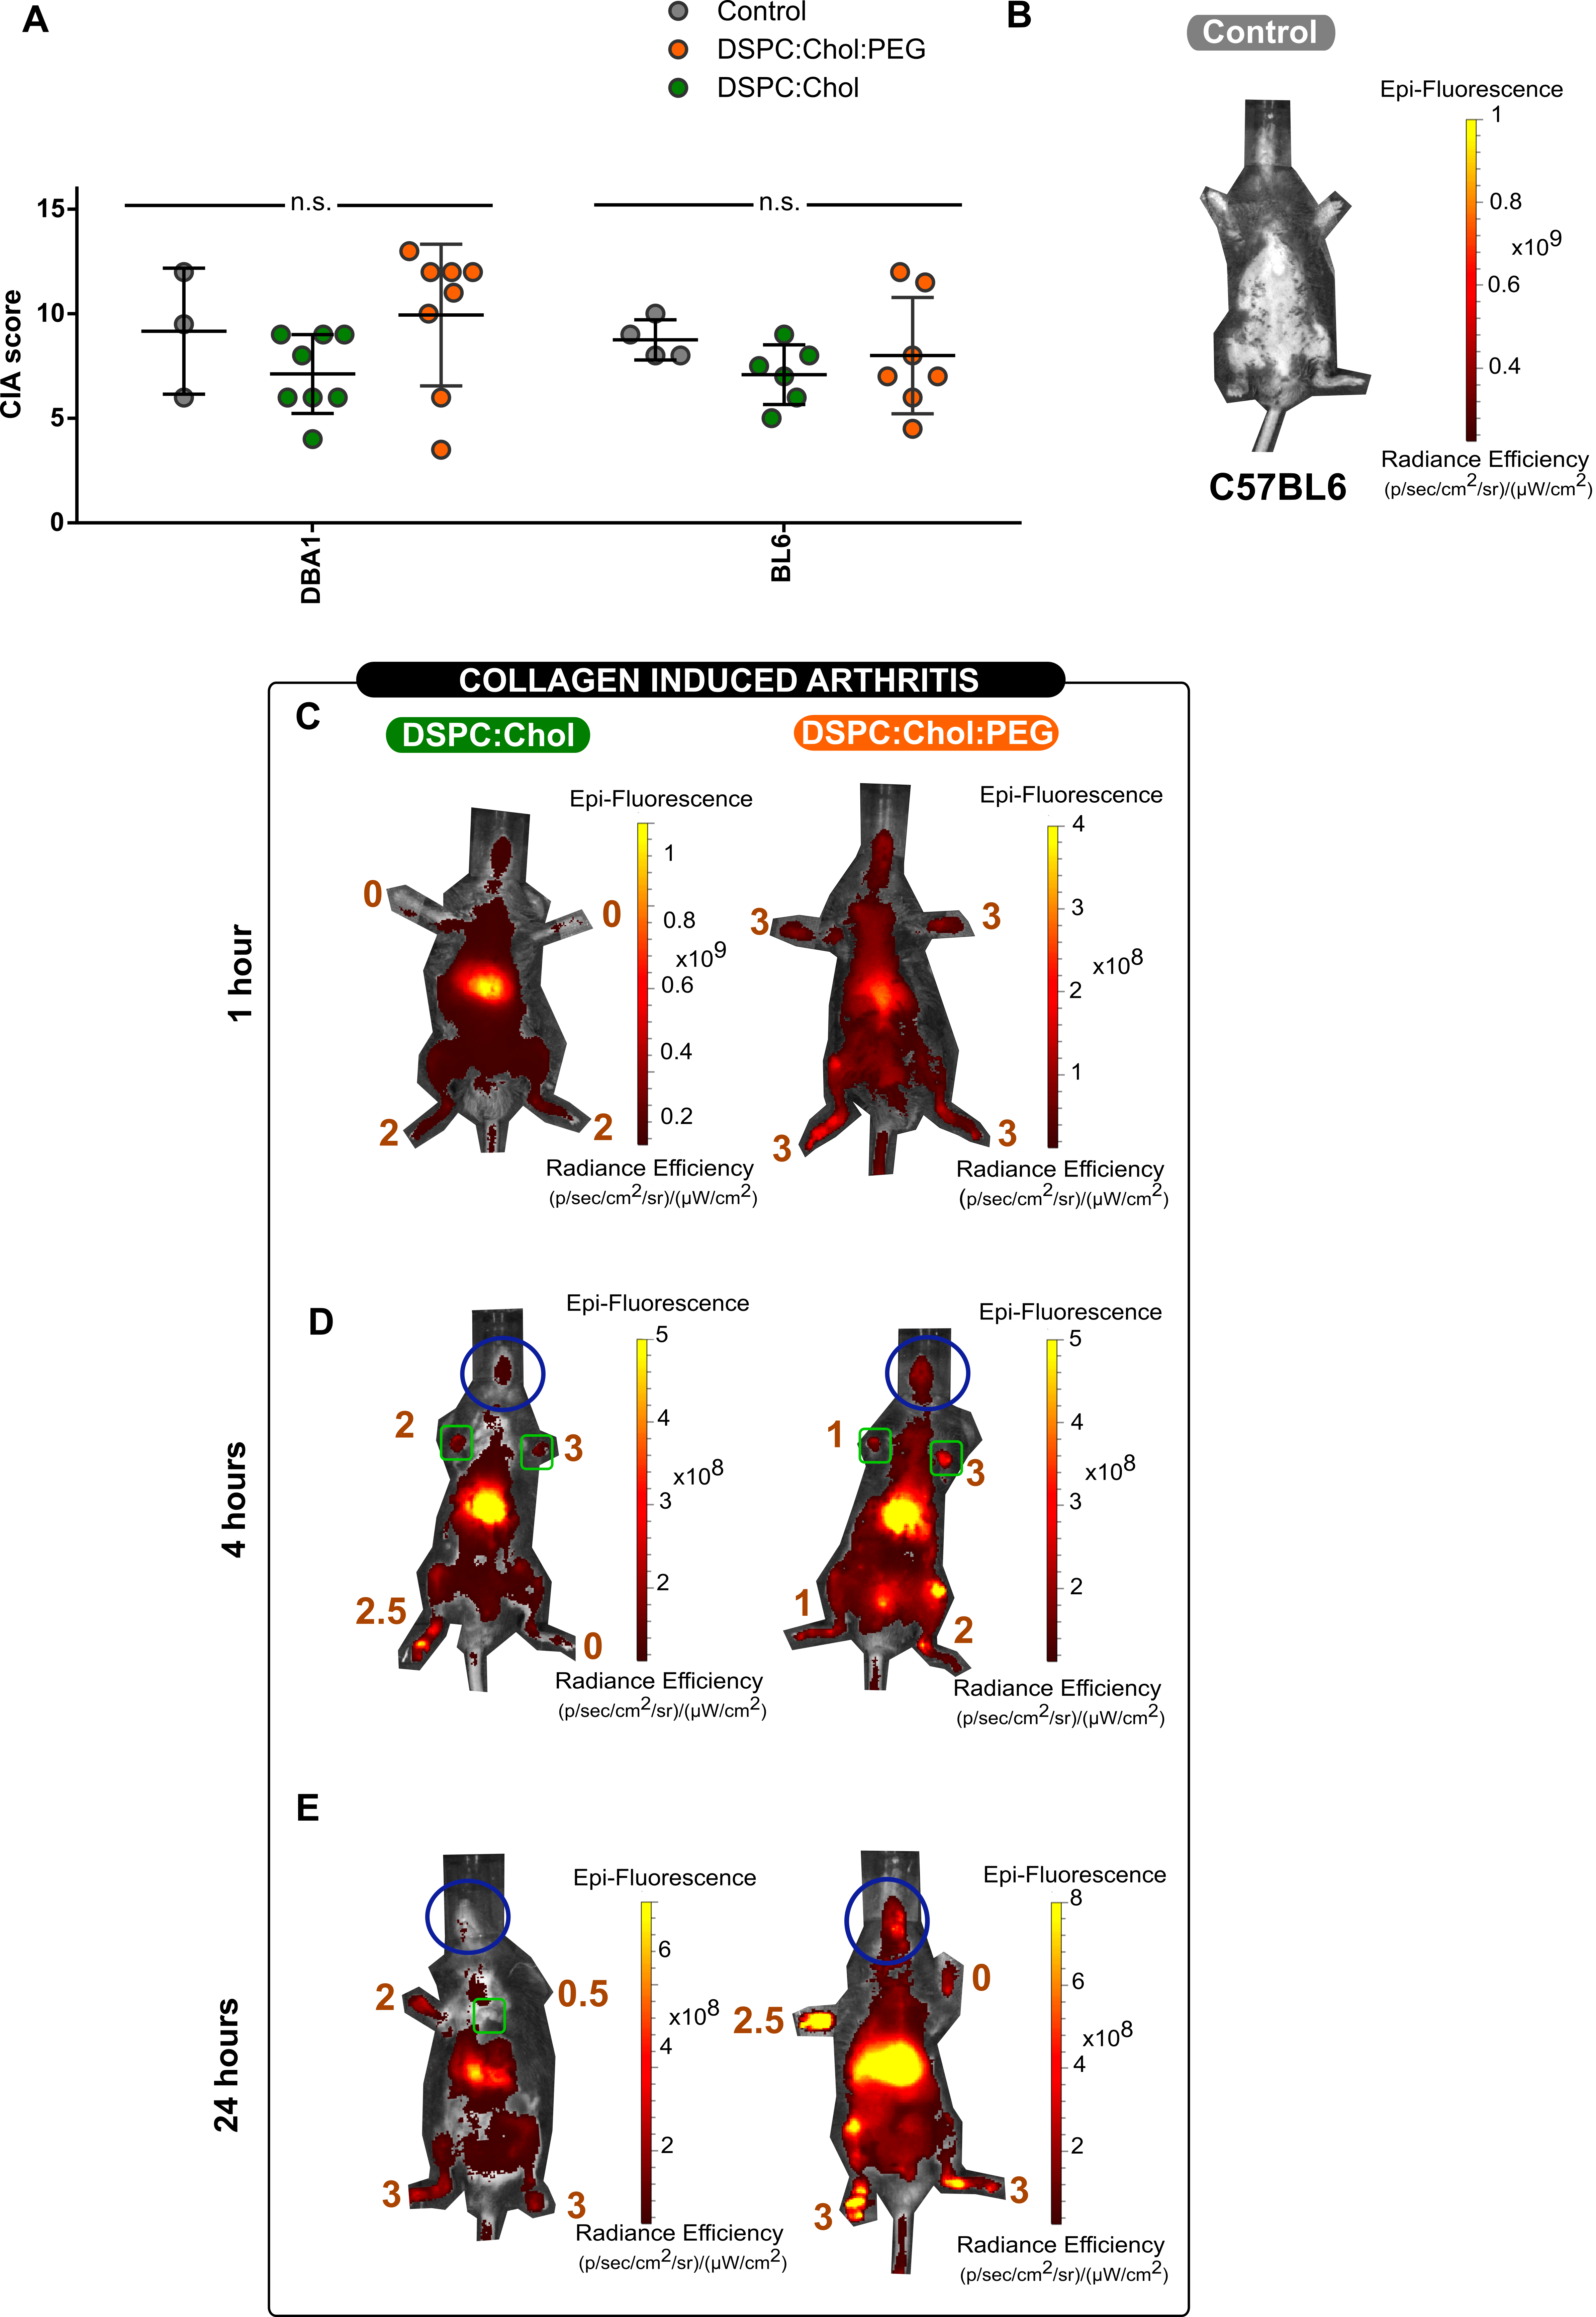
Supplementary Figure 13 | Biodistribution profile in healthy and CIA C57BL/6 mice at 4 and 24 hours after injection of the different Liposomes. (A) The differences in total CIA score (sum of individual scoring of the 4 limbs) between the two mice strains. Data represent mean ± SD, two-sided one-way ANOVA analysis, and adjusted p-values with correction for multiple testing (Tukey’s). (B) Representative whole body images of control C57BL/6. Representative images of the biodistribution of DiR labelled liposomes DSPC:Chol and DSPC:Chol:PEG liposomes in CIA mice at 1 hour (C), 4 hours (D) and 24 hours (E) after intravenous injection as measured with the IVIS in vivo imaging system. The blue circle indicates the neck-throat area; the fluorescence signal in this region allowed to estimate the blood-residence time of the liposomes.

Comparison of the absolute number of different immune cells between blood and synovium from healthy and CIA C57BL/6 mice

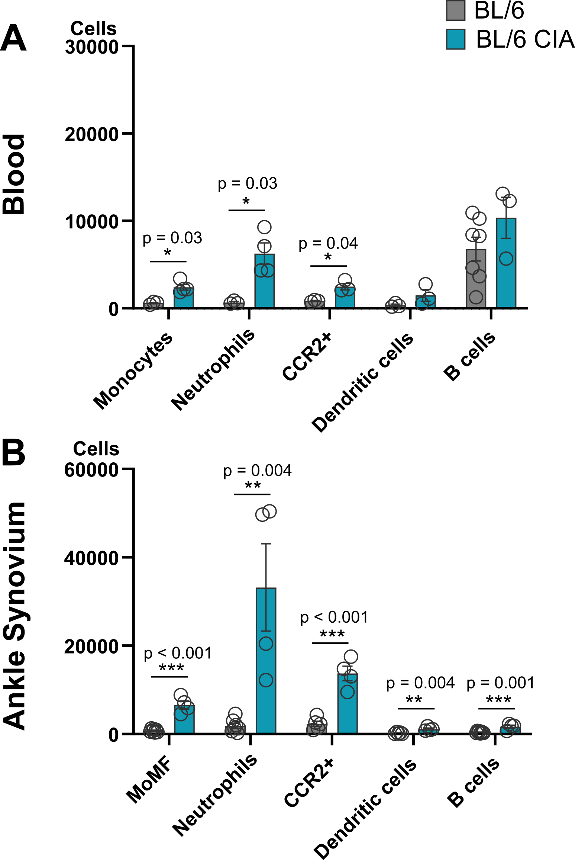
Supplementary Figure 14 | Absolute number of immune cells in healthy and CIA C57BL/6 mice. Cell counts per mouse in the blood sample (A) and ankle synovium (B) of healthy (grey bar) and CIA C57BL/6 mice (blue bar). Blood of 7 healthy and 4 CIA mice was analysed. The harvested ankle synovia were pooled per 3 healthy mice (N=12 mice in total, pooled into N=4 samples). For CIA mice, ankles contained enough cells to allow un-pooled analysis (N=4 mice) Data represent mean ± SEM and were analysed by a two-sided multiple t-test analysis with correction for multiple testing (Holm-Sidak). Significance levels (A-B) are indicated with asterisks: *, ** and *** respectively represent adjusted p values of p < 0,05; p <0,01 and p <0.001.

Uptake profile of different liposome types in immune cells in blood and ankle synovium of CIA C57BL/6 at hours after injection of the liposomes.
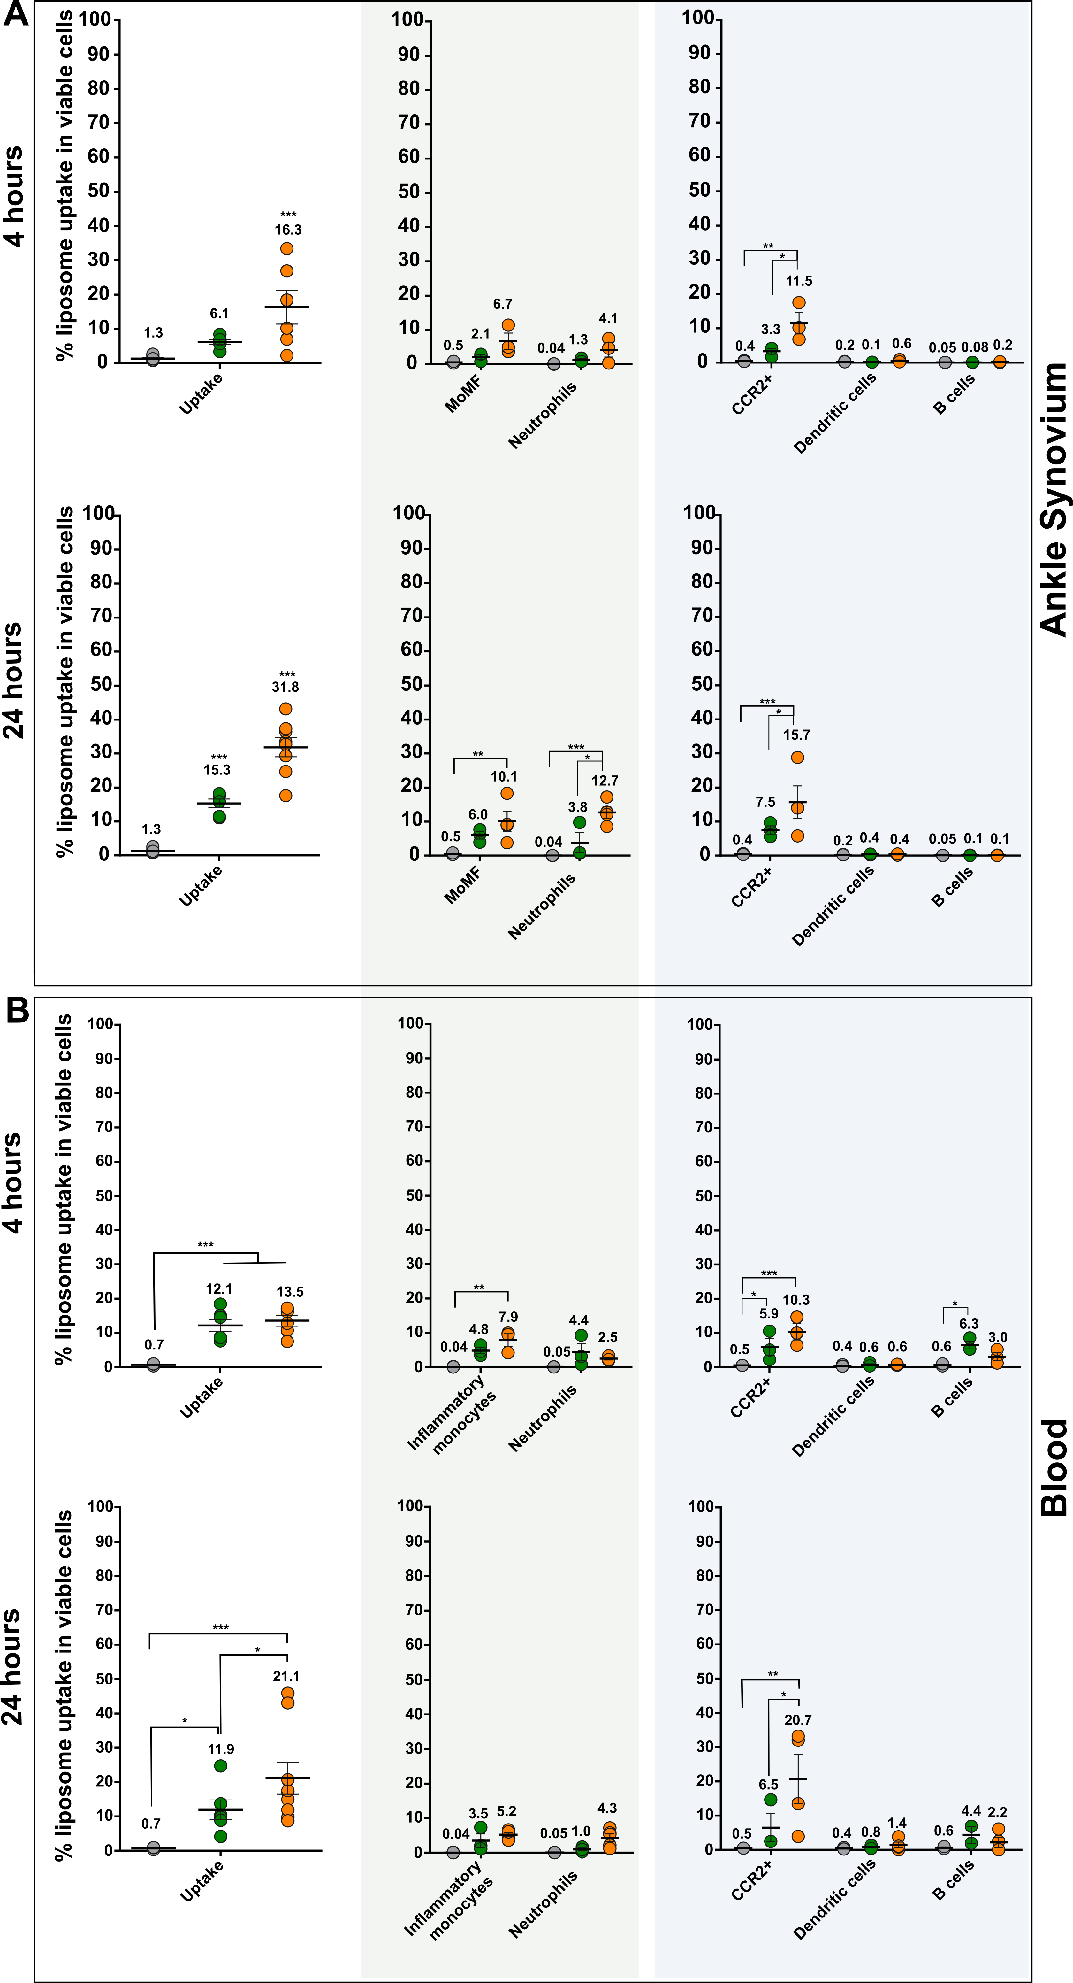
Supplementary Figure 15 | Liposome uptake in immune cells in the blood and ankle synovium following intravenous administration of liposomes in CIA C57BL/6 mice using exploratory panel. Left: percentage of viable immune cells in blood (A) and ankle (B) that engulfed liposomes, at respectively 4 and 24 hours after injection. Right: contribution of each immune cell type in total liposome uptake (colored dots). Data represent mean ± SEM, Sample size (N=3) per condition, two-sided two-way ANOVA analysis with Tukey’s correction for multiple testing. Significance levels (A,B) are indicated with asterisks: *, ** and *** respectively represent adjusted p values of p < 0,05; p <0,01 and p <0.001.

Mean fluorescence intensity of liposome uptake in myeloid immune cells in blood and ankle synovium of CIA C57BL/6 mice at 4 and 24 hours after liposome injection.

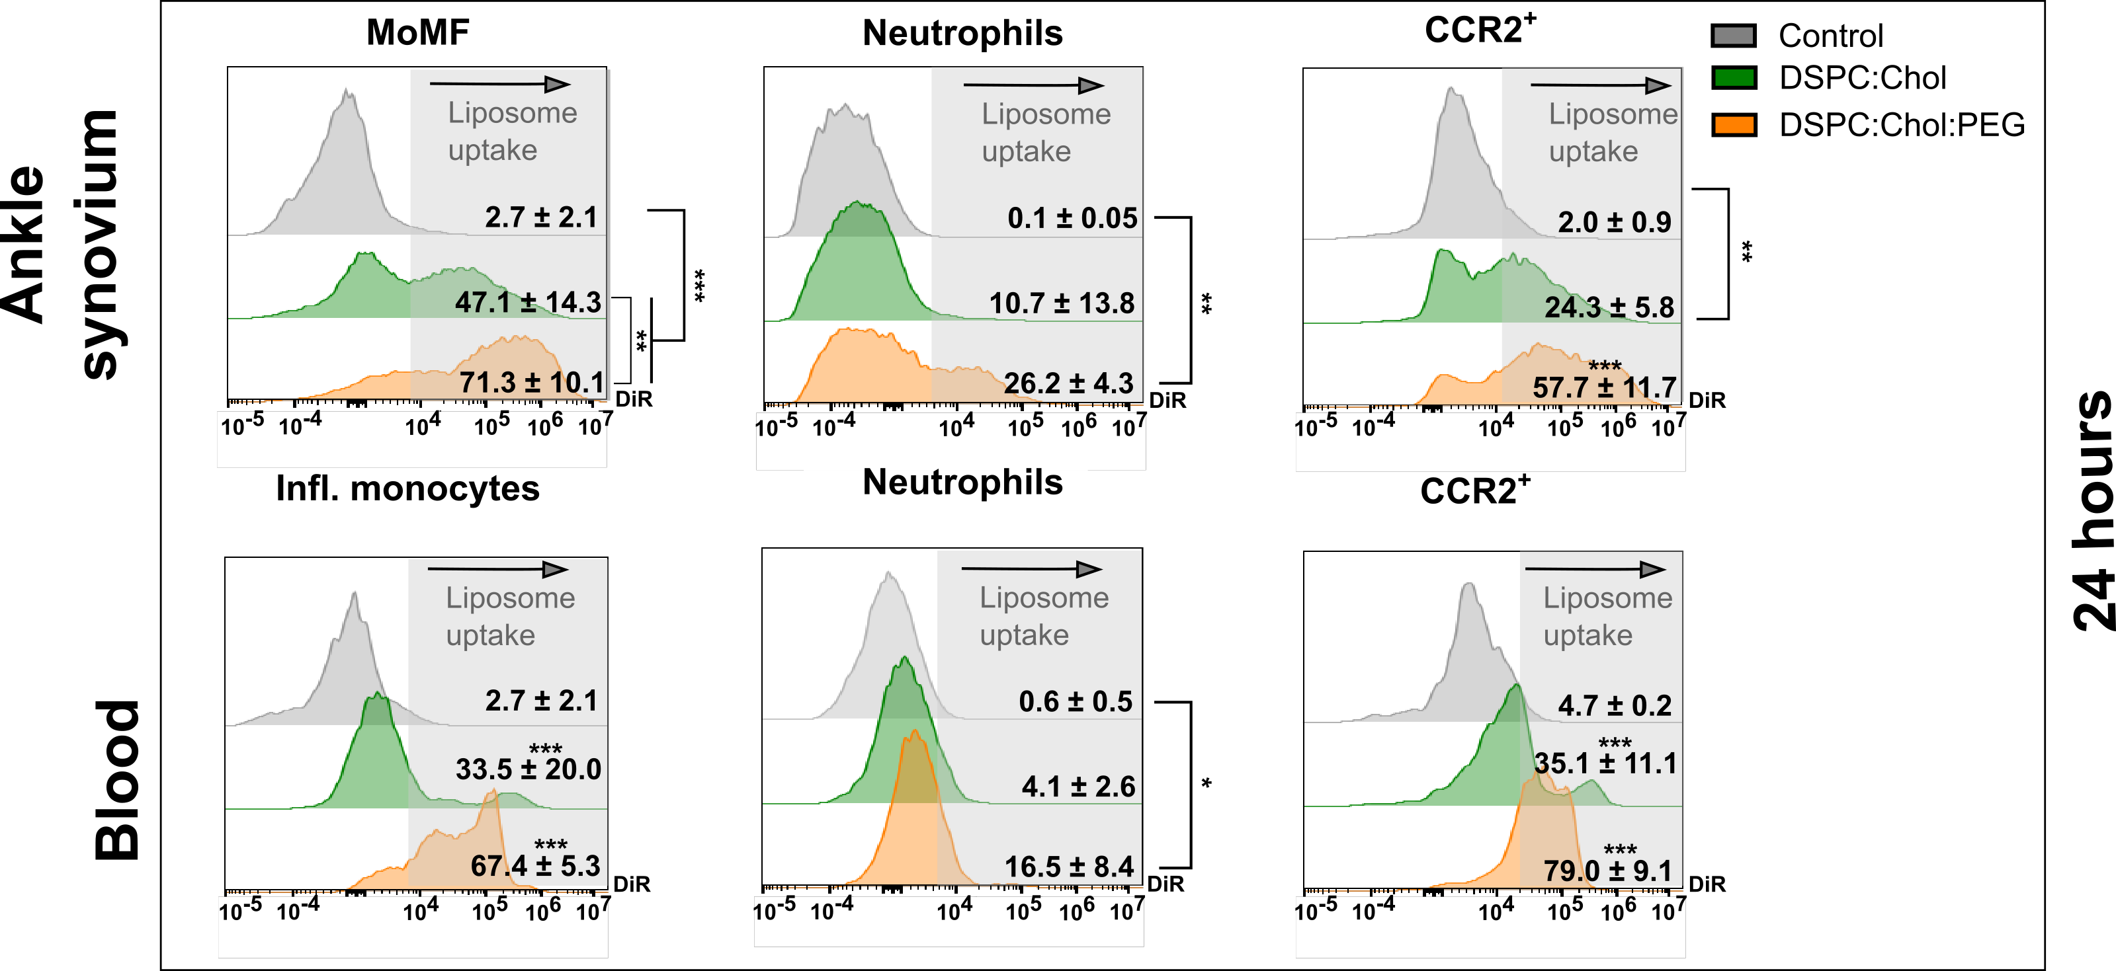
Supplementary Figure 16 | Liposome uptake in myeloid cells in C57BL/6 CIA mice 24 hours after i.v. injection using exploratory panel. Representative flow cytometry histograms for liposome uptake in the most relevant myeloid cells. Data represent mean ± SD, Sample size (N=3) per condition, two-sided one-way ANOVA analysis with correction for multiple testing (Tukey). Significance levels are indicated with asterisks: *, ** and *** respectively represent adjusted p values of p < 0,05; p <0,01 and p <0.001.

Liposome uptake in different immune cell populations in the knee synovium of CIA C57BL/6 mice
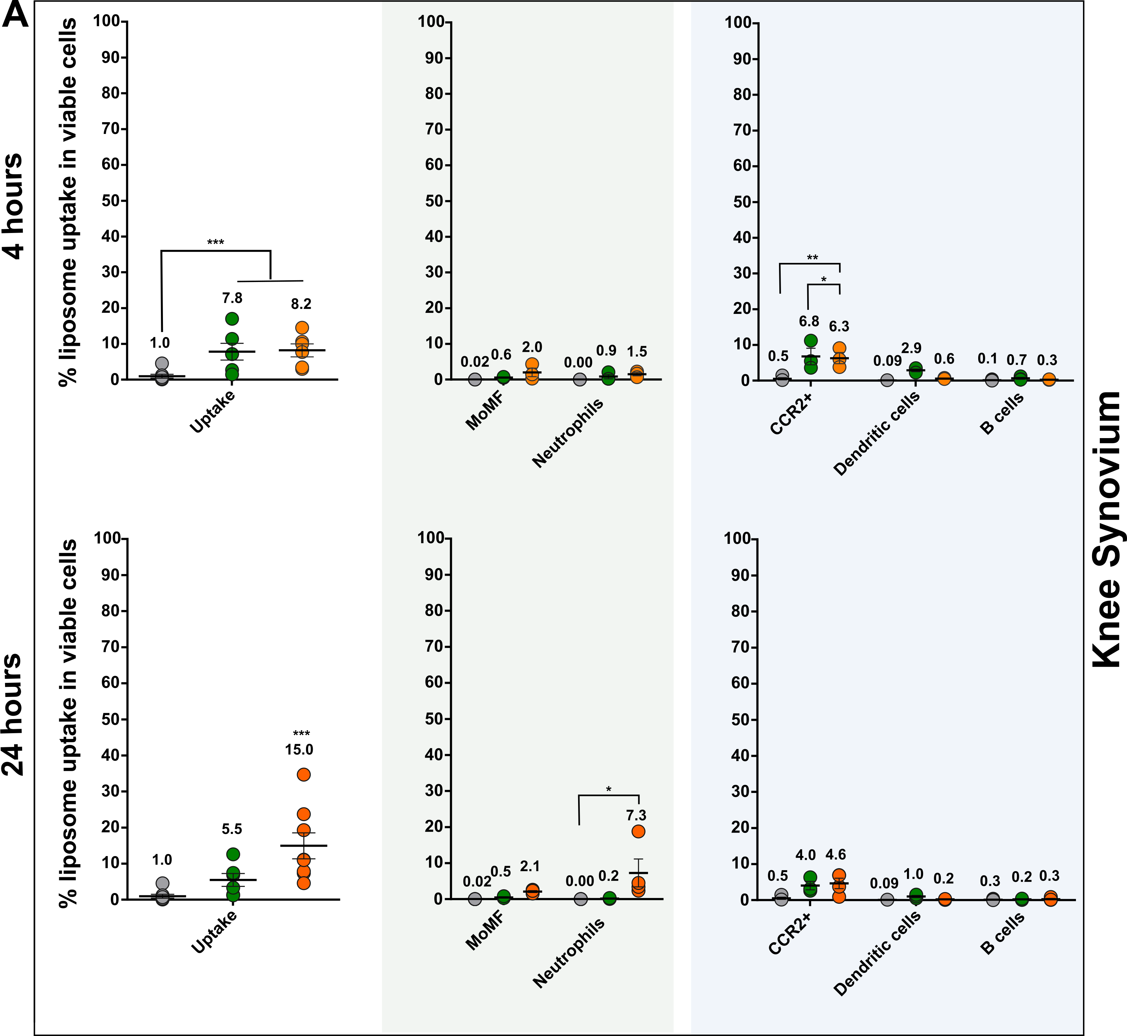
Supplementary Figure 17 | Liposome uptake in immune cells in the knee synovium following intravenous administration of liposomes in CIA C57BL/6 mice using exploratory panel. Left: percentage of viable immune cells in knee synovium that engulfed DPSC:Chol liposomes (green dots) and DPSC:Chol:PEG liposomes (orange dots), at respectively 4 (A) and 24 hours (B) after injection. Right: contribution of each immune cell type in total liposome uptake. Data represent mean ± SEM, Sample size (N=3) per condition, two-sided two-way ANOVA analysis with Tukey’s correction for multiple testing.
Flow cytometry scatter plots of CD45.1 cells retrieved in respectively CIA CD45.1 harvested blood and blood and synovium of CIA induced CD45.2 after autologous transfusion with 7.6*10⁶ cells CD45.1 cells.

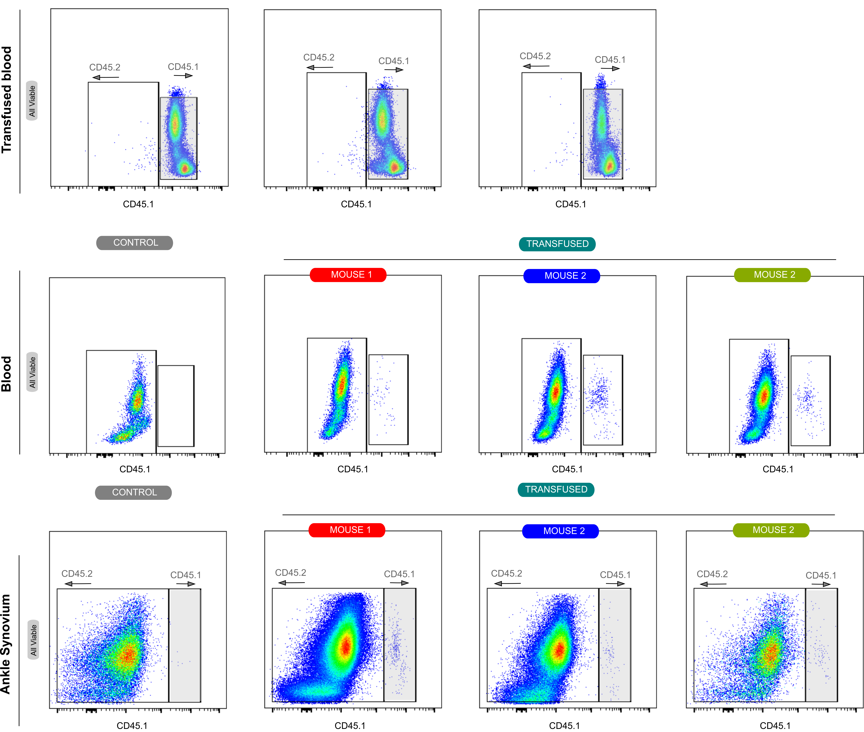
Supplementary Figure 18 | CD45.1 cells in autologous cell transfusion experiment in CIA model. Flow cytometric detection of CD45.1 cells retrieved in harvested blood of CIA CD45.1 (A) as wells as blood and in ankle synovium of CIA CD45.2, 4 hours after autologous transfusion.

Flow cytometry scatter plots of CD45.1 cells retrieved in respectively CIA CD45.1 harvested blood and synovium of CIA induced CD45.2 after autologous transfusion with 12.5*10⁶ CD45.1 cells.

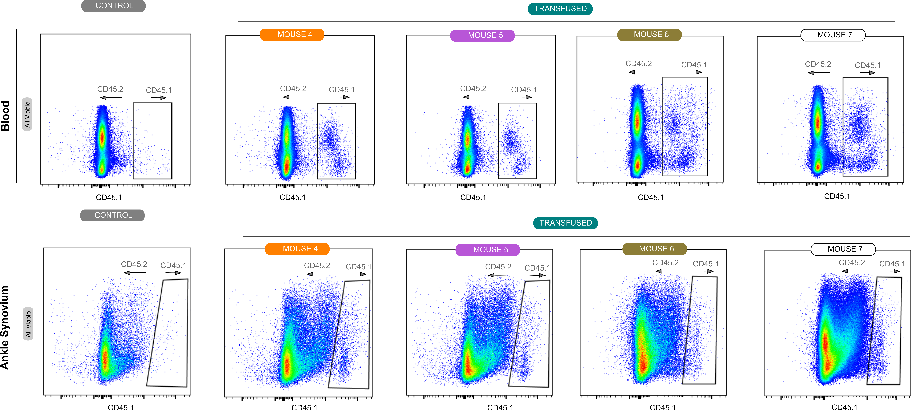
Supplementary Figure 19 | CD45.1 cells in autologous cell transfusion experiment in CIA model. Flow cytometric detection of CD45.1 cells retrieved in harvested blood of CIA CD45.1 (A) as wells as blood and in ankle synovium of CIA CD45.2, 4 hours after autologous transfusion.

Impact of selective myeloid depletion with anti-GR-1 and anti-CCR2 antibodies on myeloid cell populations retrieved in ankle synovium and blood.
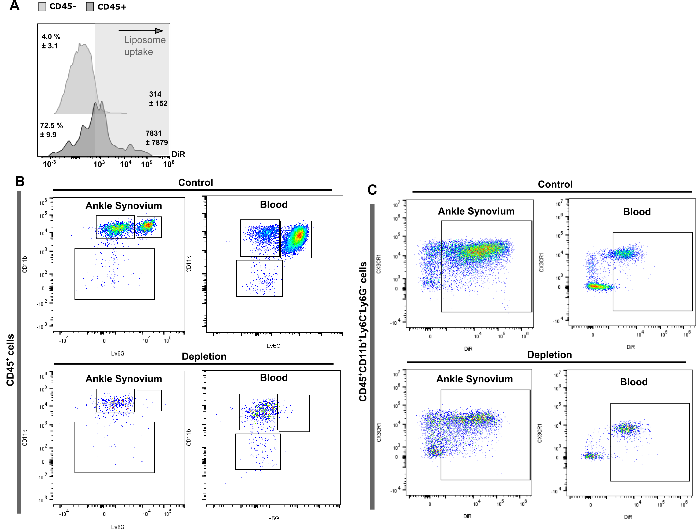
Supplementary Figure 20 | Myeloid cell depletion experiment. (A) Uptake of liposomes in non-immune cells (CD45-) and immune (CD45+) cells after myeloid depletion. (B) Quantification of the depletion of myeloid cells 48 hours after injection of depletion antibodies (anti-CCR2 and anti-GR-1) compared to control mice. (C) Liposome uptake and transport observed in myeloid CD11b⁺Ly6C⁻Ly6G⁻CX3CR1⁺ expressing cells after CCR2 and GR-1 depletion from blood into synovium.

Comparison of liposome uptake in different immune cells in blood and ankle synovium of CIA C57BL/6 mice between PEGylated liposomes and LNPs.

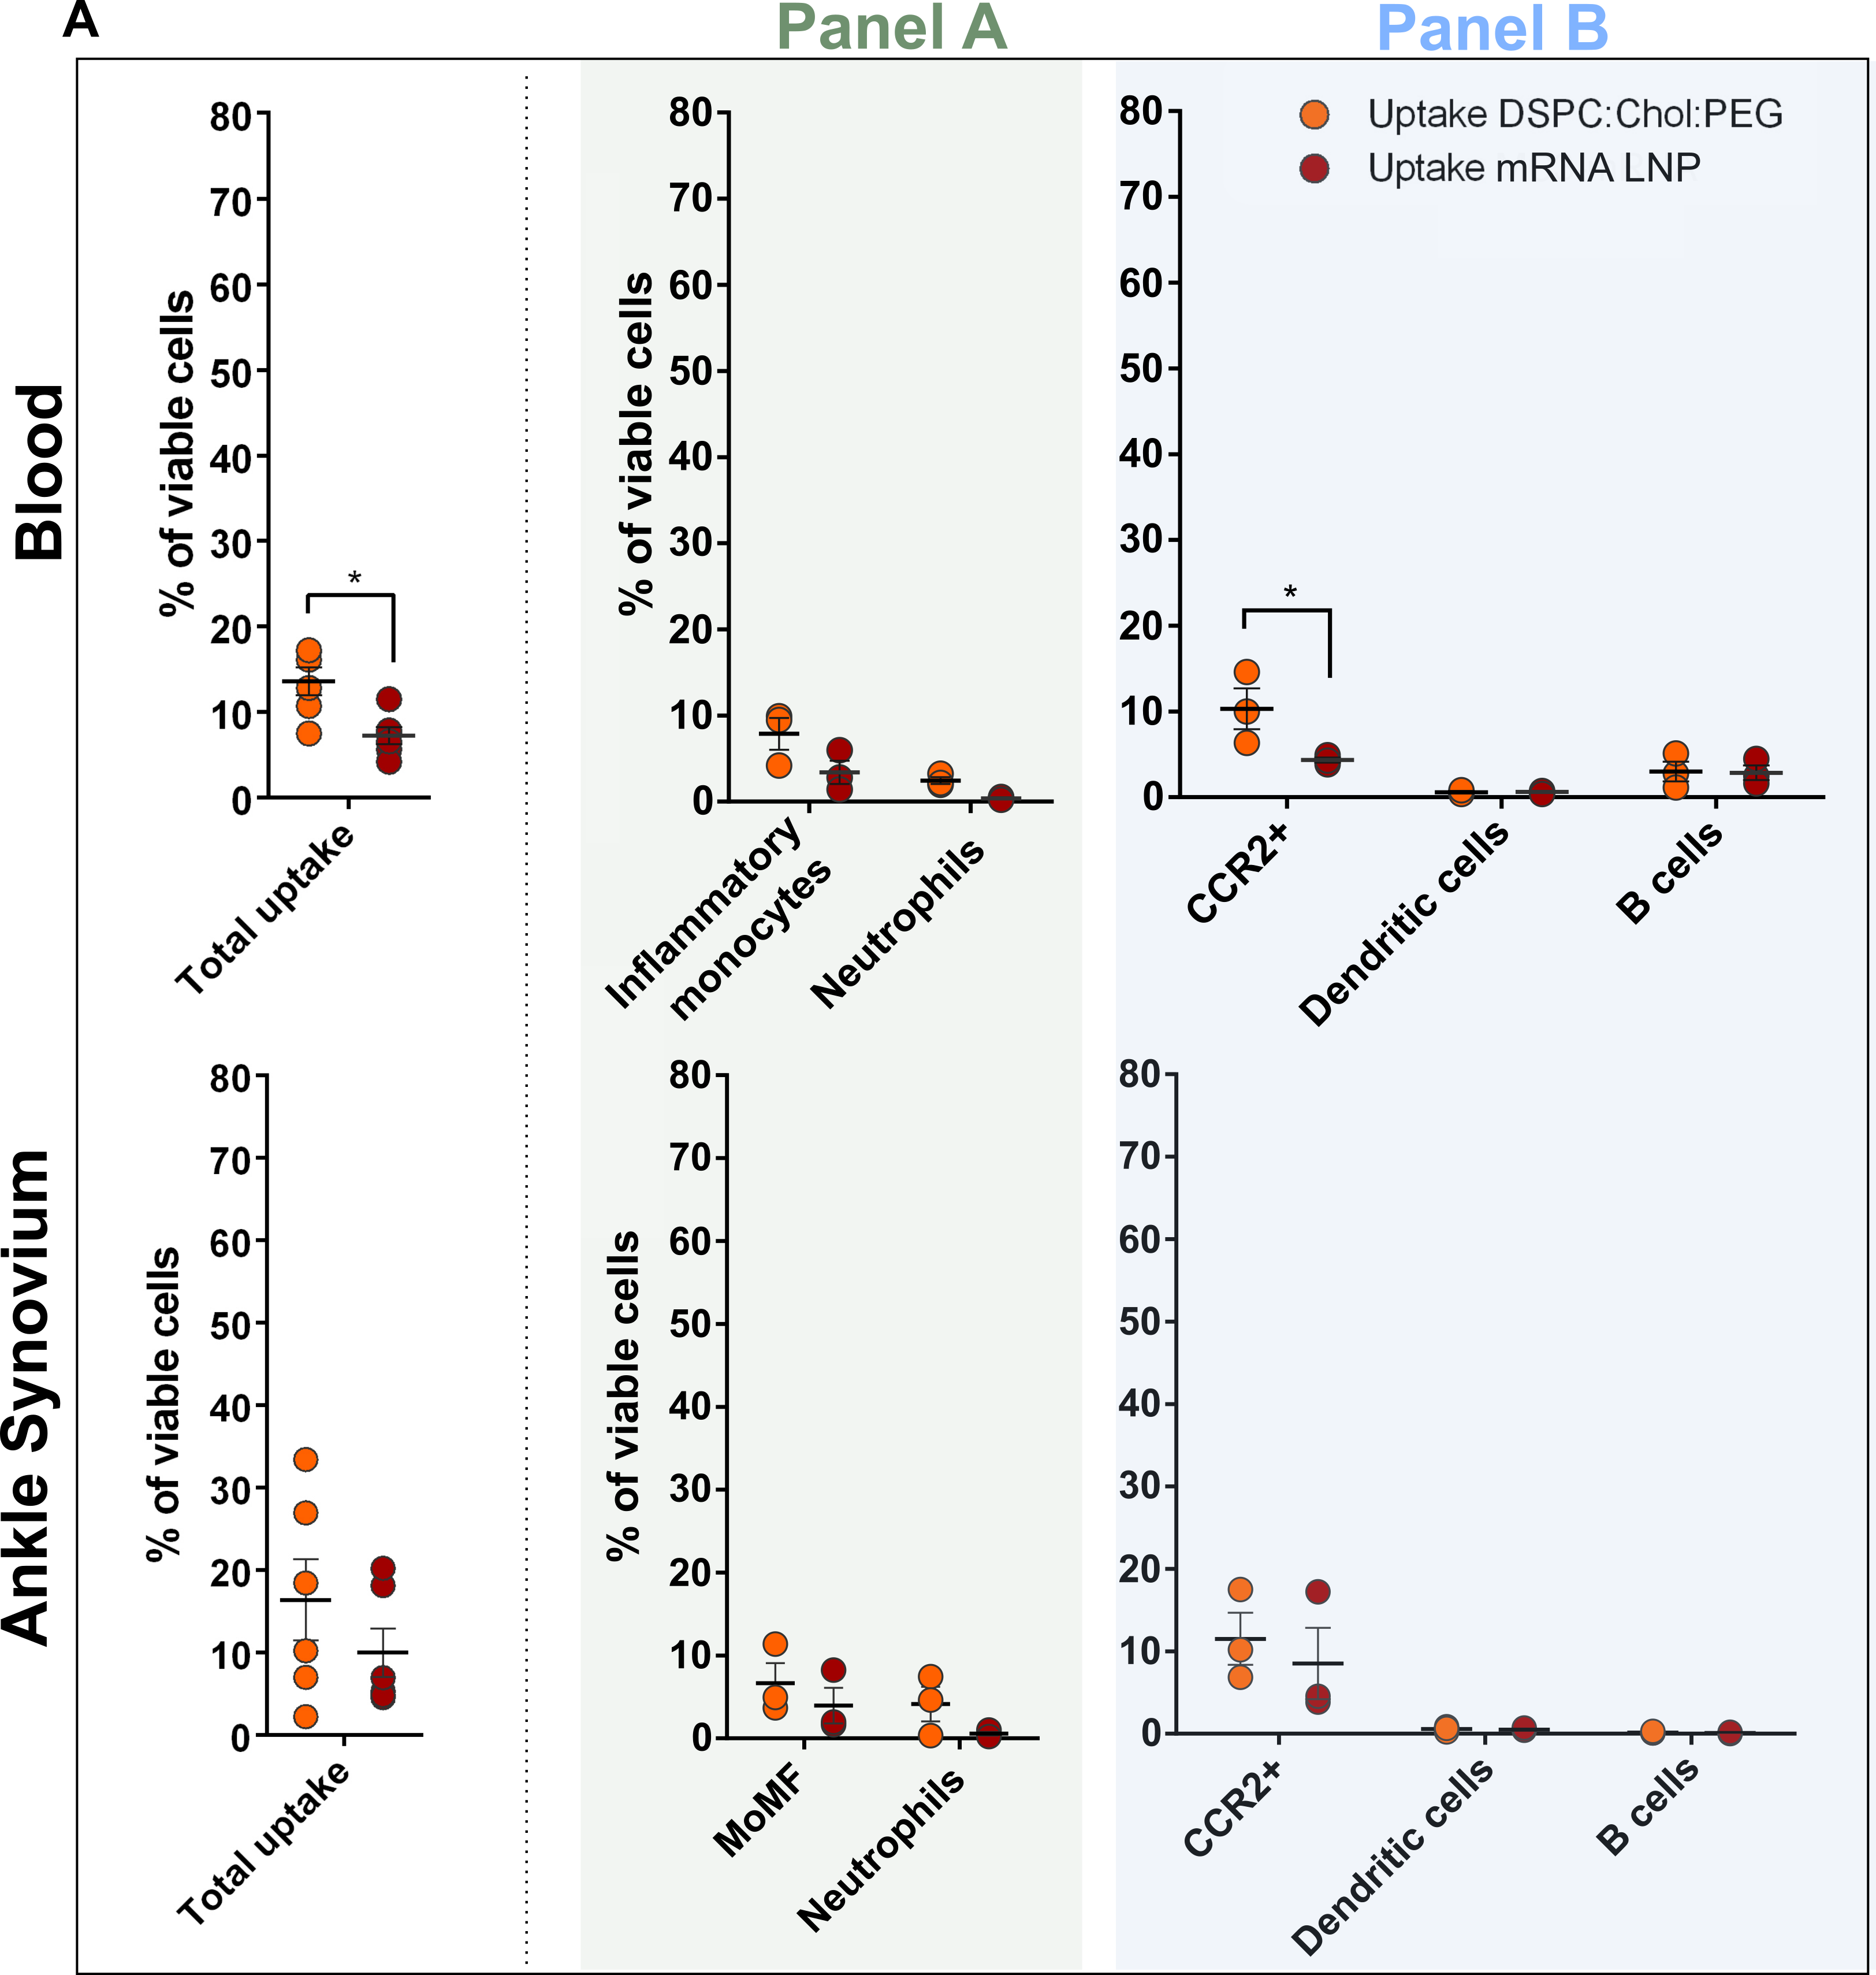
Supplementary Figure 21 | Comparison in liposome uptake in immune cells in the ankle synovium following intravenous administration of PEGylated nanocarriers: i.e. DSPC:Chol:PEG liposomes and mRNA LNPs in CIA C57BL/6 mice using exploratory panel. Left: percentage of viable immune cells in blood and ankle that engulfed DPSC:Chol:PEG liposomes (N = 3) (orange dots) and mRNA LNPs (N = 3) (red dots) at 4 hours after injection. Right: contribution of each immune cell type in total liposome uptake. Data represent mean ± SEM and were analysed by two-sided multiple t-test analysis with correction for multiple testing (Holm-Sidak). Significance levels are indicated with asterisks: *, ** and *** respectively represent adjusted p values of p < 0,05; p <0,01 and p <0.001.

In vivo biodistribution and transfection of LNPs 4 hours after i.v. injection Comparison of liposome uptake in myeloid cells in ankle synovium of CIA DBA/1 mice between PEGylated liposomes and LNPs.
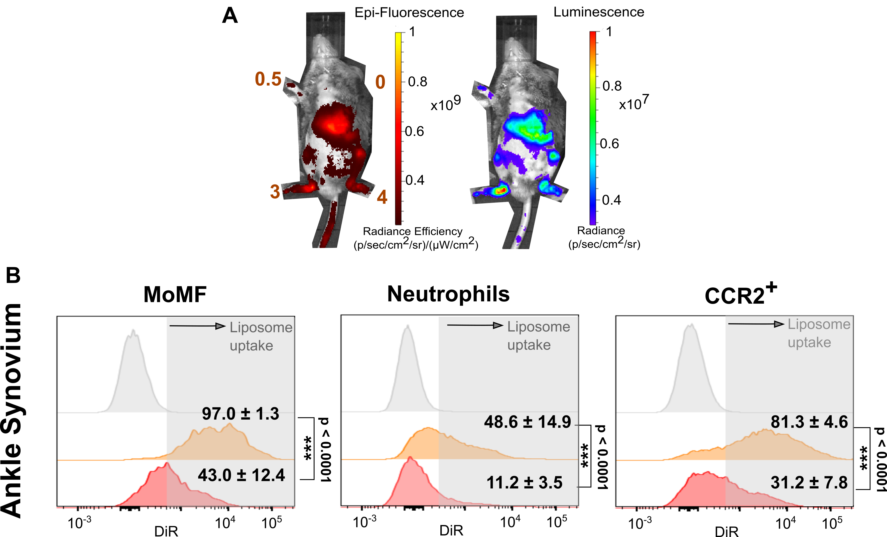
Supplementary Figure 22 | Liposome uptake of mRNA LNPs in CIA DBA/1 mice (Repeat). (A) In vivo biodistribution (left) and luciferase expression (right) 4 hours after i.v. injection in CIA DBA/1 mouse. Representative flow cytometry histograms for liposome uptake in the most relevant myeloid cells in ankle synovium (B). Data represent mean ± SD, Sample size (N=3) per condition, two-sided unpaired t-test analysis. Significance levels are indicated with asterisks: *, ** and *** respectively represent p values of p < 0,05; p <0,01 and p <0.001.

