Supplementary materials
Table S1. Results of one-way ANOVA and post-hoc Tukey’s HSD testing among-elevation variation in environmental and biotic variables. For the Tukey HSD column, elevation not sharing a letter are significantly different (p<0.05).
Variables | F | df | p | Tukey HSD (Mean)
Respiration | 2.73 | 2 | 0.067
Temperature | 127.60 | 2 | <0.001 | High (17.14)ª > Middle (13.46)^{b} > Low(10.23)^{c}
Moisture | 108.20 | 2 | <0.001 | High (17.87)^{c} < Middle (25.80)^{b} < Low (58.79)ª
Dry/Wet Weight Ratio | 103.0 | 2 | <0.001 | High (0.89)ª > Middle (0.79)^{b} > Low (0.60)^{c}
C/N Ratio | 8.57 | 2 | <0.001 | High (12.88)^{b} , Middle (12.42)^{b} < Low (14.05)ª
pH | 0.062 | 2 | 0.94
Coverage
Rock | 22.63 | 2 | <0.001 | High (15.43)ª > Middle (9.60)^{b} > Low (4.72)^{c}
Cryptogram | 12.69 | 2 | <0.001 | High (40.13)ª > Middle (29.77)^{b} , Low (24.95)^{b}
Sediment | 30.59 | 2 | <0.001 | High (33.25)ª > Middle (20.63)^{b} > Low(8.24)^{c}
Vascular Plant | 186.00 | 2 | <0.001 | High (18.32)^{c} < Middle(45.80)^{b} < Low (70.47)ª

Table S2. Environmental fitness of environmental parameters correlated with DCA ordinations of Generalists, Common taxa, and Specialists (Fig. 1).
 | Generalists |  |  |  | Common taxa |  |  |  | Specialists
 | DCA1 | DCA2 | r² | P | DCA1 | DCA2 | r² | P | DCA1 | DCA2 | r² | P
Respiration | 0.83 | -0.55 | 0.01 | 0.532 | 0.82 | 0.58 | 0 | 0.807 | -0.87 | 0.49 | 0 | 0.95
Temperature | -0.94 | -0.35 | 0.11 | 0.001 | -1.00 | 0.01 | 0.10 | 0.001 | -0.87 | 0.49 | 0.14 | 0.001
Moisture | 0.84 | 0.54 | 0.05 | 0.003 | 0.96 | -0.28 | 0.06 | 0.001 | 0.88 | -0.47 | 0.10 | 0.001
C/N Ratio | -0.98 | -0.22 | 0.10 | 0.001 | -0.94 | 0.34 | 0.17 | 0.001 | -0.98 | 0.21 | 0.18 | 0.001
pH | 0.94 | -0.34 | 0.05 | 0.003 | 0.89 | 0.46 | 0.07 | 0.001 | 0.84 | 0.54 | 0.11 | 0.001
Ec | 0.98 | 0.20 | 0.06 | 0.002 | 0.98 | 0.18 | 0.07 | 0.001 | 0.98 | -0.20 | 0.09 | 0.001
Elevation | -0.93 | -0.38 | 0.26 | 0.001 | -0.99 | 0.16 | 0.25 | 0.001 | -0.93 | 0.38 | 0.29 | 0.001
Coverage
Rock | -0.97 | -0.23 | 0.03 | 0.036 | -0.97 | -0.23 | 0.03 | 0.064 | -0.90 | -0.43 | 0.02 | 0.164
Cryptogram | 0.39 | -0.92 | 0.01 | 0.489 | 0.56 | 0.83 | 0 | 0.584 | 0.16 | -0.99 | 0.01 | 0.625
Sediment | -0.71 | -0.71 | 0.02 | 0.148 | -0.78 | 0.62 | 0.01 | 0.303 | -0.57 | 0.82 | 0.03 | 0.042
Vascular Plant | 0.74 | 0.67 | 0.09 | 0.001 | 0.80 | -0.60 | 0.07 | 0.001 | 0.88 | -0.47 | 0.08 | 0.001

Table S3. Module hubs and connectors in Total network and their topological characteristics and taxonomical features
ASV.no | Role | Niche breadth | C.score | Z.score | Node degree | Betweenness | Assigned module ID | Phylum | Class | Order
ASV00009 | Connector | Generalist | 0.7 | -0.8 | 3 | 807.029 | T_Module IV | Acidobacteriota | Acidobacteriae | Acidobacteriae Subgroup 2
ASV00072 | Connector | Generalist | 0.7 | -0.7 | 6 | 1108.236 | T_Module IV | Actinobacteriota | Thermoleophilia | Gaiellales
ASV00225 | Connector | Generalist | 0.6 | 0.7 | 22 | 10581.9 | T_Module IV | Proteobacteria | Alphaproteobacteria | Rhizobiales
ASV00383 | Connector | Common taxa | 0.7 | -0.7 | 6 | 9569.996 | T_Module V | Chloroflexi | Ktedonobacteria | Ktedonobacterales
ASV00800 | Connector | Common taxa | 0.7 | -0.5 | 7 | 1271.356 | T_Module III | Chloroflexi | Ktedonobacteria | Ktedonobacterales
ASV00559 | Connector | Common taxa | 0.6 | -0.6 | 4 | 1437.69 | T_Module III | Acidobacteriota | Vicinamibacteria | Vicinamibacterales
ASV00147 | Module hub | Generalist | 0.1 | 2.6 | 109 | 11690.94 | T_Module I | Acidobacteriota | Holophagae | Holophagae Subgroup 7
ASV00038 | Module hub | Generalist | 0.5 | 3.7 | 62 | 25285.63 | T_Module IV | Proteobacteria | Alphaproteobacteria | Rhizobiales
ASV00008 | Module hub | Generalist | 0.1 | 3.0 | 38 | 45877.65 | T_Module V | Proteobacteria | Gammaproteobacteria | WD260
ASV00110 | Module hub | Common taxa | 0.2 | 4.1 | 52 | 28366.95 | T_Module V | Proteobacteria | Alphaproteobacteria | Acetobacterales
ASV00130 | Module hub | Common taxa | 0.4 | 3.4 | 54 | 7421.026 | T_Module V | Acidobacteriota | Acidobacteriae | Acidobacteriae Subgroup 2
ASV00142 | Module hub | Common taxa | 0.1 | 2.5 | 109 | 8929.401 | T_Module II | Acidobacteriota | Acidobacteriae | Acidobacteriales
ASV00255 | Module hub | Common taxa | 0.4 | 3.4 | 59 | 8637.462 | T_Module VI | Acidobacteriota | Acidobacteriae | Bryobacterales
ASV00344 | Module hub | Common taxa | 0.1 | 3.0 | 121 | 14192.44 | T_Module I | Acidobacteriota | Acidobacteriae | Bryobacterales
ASV00191 | Module hub | Common taxa | 0.1 | 2.6 | 107 | 14569.8 | T_Module I | Proteobacteria | Gammaproteobacteria | Burkholderiales
ASV00928 | Module hub | Common taxa | 0.1 | 2.9 | 114 | 7761.666 | T_Module I | Proteobacteria | Alphaproteobacteria | Caulobacterales
ASV00259 | Module hub | Common taxa | 0.0 | 2.8 | 37 | 9506.318 | T_Module III | Bacteroidota | Bacteroidia | Chitinophagales
ASV00751 | Module hub | Common taxa | 0.0 | 2.8 | 37 | 3640.511 | T_Module III | Bacteroidota | Bacteroidia | Chitinophagales
ASV00213 | Module hub | Common taxa | 0.5 | 3.0 | 80 | 13643.65 | T_Module VI | Verrucomicrobiota | Verrucomicrobiae | Chthoniobacterales
ASV00240 | Module hub | Common taxa | 0.5 | 4.6 | 54 | 35495.63 | T_Module IV | Verrucomicrobiota | Verrucomicrobiae | Chthoniobacterales
ASV00551 | Module hub | Common taxa | 0.0 | 2.8 | 37 | 13788.13 | T_Module III | Verrucomicrobiota | Verrucomicrobiae | Chthoniobacterales
ASV00115 | Module hub | Common taxa | 0.4 | 4.4 | 63 | 18667.25 | T_Module V | Actinobacteriota | Actinobacteria | Frankiales
ASV00153 | Module hub | Common taxa | 0.0 | 3.0 | 118 | 7856.094 | T_Module II | Actinobacteriota | Actinobacteria | Frankiales
ASV00465 | Module hub | Common taxa | 0.1 | 3.9 | 50 | 11495.19 | T_Module III | Proteobacteria | Gammaproteobacteria | Gammaproteobacteria Incertae Sedis
ASV00601 | Module hub | Common taxa | 0.0 | 3.3 | 124 | 14771.11 | T_Module I | Gemmatimonadota | Gemmatimonadetes | Gemmatimonadales
ASV00632 | Module hub | Common taxa | 0.4 | 4.5 | 74 | 40610.88 | T_Module III | Proteobacteria | Gammaproteobacteria | JG36-TzT-191
ASV00148 | Module hub | Common taxa | 0.1 | 2.6 | 25 | 17313.46 | T_Module IV | Chloroflexi | Ktedonobacteria | Ktedonobacterales
ASV00216 | Module hub | Common taxa | 0.0 | 2.6 | 23 | 3420.31 | T_Module IV | Chloroflexi | Ktedonobacteria | Ktedonobacterales
ASV00234 | Module hub | Common taxa | 0.0 | 3.1 | 120 | 6411.158 | T_Module II | Chloroflexi | Ktedonobacteria | Ktedonobacterales
ASV00256 | Module hub | Common taxa | 0.0 | 2.7 | 108 | 3552.733 | T_Module II | Chloroflexi | Ktedonobacteria | Ktedonobacterales
ASV00070 | Module hub | Common taxa | 0.0 | 4.5 | 159 | 29082.51 | T_Module I | Actinobacteriota | Acidimicrobiia | Microtrichales
ASV00041 | Module hub | Common taxa | 0.5 | 2.9 | 62 | 64912.5 | T_Module V | Proteobacteria | Alphaproteobacteria | Rhizobiales
ASV00251 | Module hub | Common taxa | 0.2 | 3.7 | 47 | 14075.61 | T_Module V | Proteobacteria | Alphaproteobacteria | Rhizobiales
ASV00287 | Module hub | Common taxa | 0.5 | 2.7 | 41 | 13295.99 | T_Module IV | Proteobacteria | Alphaproteobacteria | Rhizobiales
ASV00292 | Module hub | Common taxa | 0.0 | 3.9 | 141 | 17162.91 | T_Module I | Proteobacteria | Alphaproteobacteria | Rhizobiales
ASV00326 | Module hub | Common taxa | 0.1 | 2.7 | 39 | 26386.5 | T_Module III | Proteobacteria | Alphaproteobacteria | Rhizobiales
ASV00367 | Module hub | Common taxa | 0.0 | 2.6 | 107 | 5554.266 | T_Module II | Proteobacteria | Alphaproteobacteria | Rhizobiales
ASV00626 | Module hub | Common taxa | 0.1 | 2.5 | 103 | 9771.259 | T_Module I | Proteobacteria | Alphaproteobacteria | Rhizobiales
ASV00829 | Module hub | Common taxa | 0.4 | 2.6 | 30 | 7938.818 | T_Module IV | Proteobacteria | Alphaproteobacteria | Rhizobiales
ASV00166 | Module hub | Common taxa | 0.2 | 3.5 | 48 | 132101.8 | T_Module III | Planctomycetota | Phycisphaerae | Tepidisphaerales
ASV01652 | Module hub | Common taxa | 0.0 | 3.9 | 48 | 29742.9 | T_Module III | Planctomycetota | Phycisphaerae | Tepidisphaerales
ASV01918 | Module hub | Common taxa | 0.1 | 3.0 | 42 | 6017.626 | T_Module III | Planctomycetota | Phycisphaerae | Tepidisphaerales
ASV00616 | Module hub | Common taxa | 0.3 | 2.9 | 31 | 8710.969 | T_Module IV | Chloroflexi | Gitt-GS-136 | unclassified Gitt-GS-136
ASV00218 | Module hub | Common taxa | 0.5 | 4.0 | 76 | 24719.29 | T_Module VI | Chloroflexi | TK10 | unclassified TK10
ASV00446 | Module hub | Common taxa | 0.2 | 5.4 | 72 | 26855.36 | T_Module III | Acidobacteriota | Vicinamibacteria | Vicinamibacterales
ASV00138 | Module hub | Specialist | 0.5 | 2.6 | 60 | 8631.699 | T_Module VI | Chloroflexi | Ktedonobacteria | Ktedonobacterales
ASV00922 | Module hub | Specialist | 0.1 | 2.6 | 24 | 2422.926 | T_Module IV | Chloroflexi | Ktedonobacteria | Ktedonobacterales
ASV00903 | Module hub | Specialist | 0.1 | 3.2 | 29 | 5285.609 | T_Module IV | Chloroflexi | AD3 | unclassified AD3

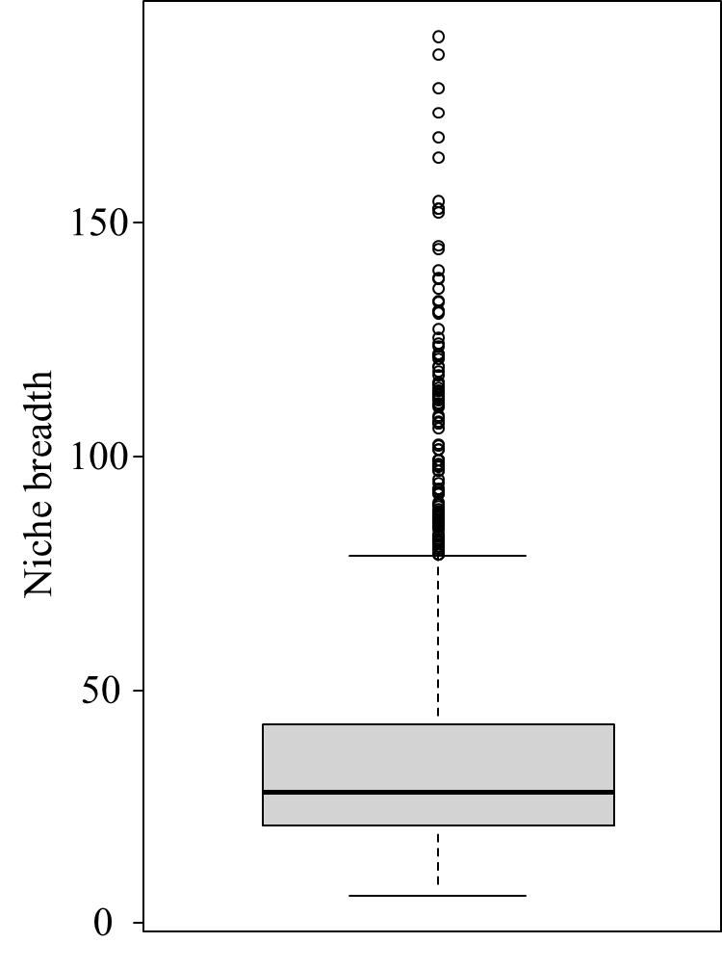
Figure S1 The distribution of the niche breadth (B) values of the ASVs. A B-value of >78 was chosen as a criterion for generalists as this value lies within the outlier area of the B-value distribution, while ASVs with B-values of <22 were regarded as specialists (lower quartile).

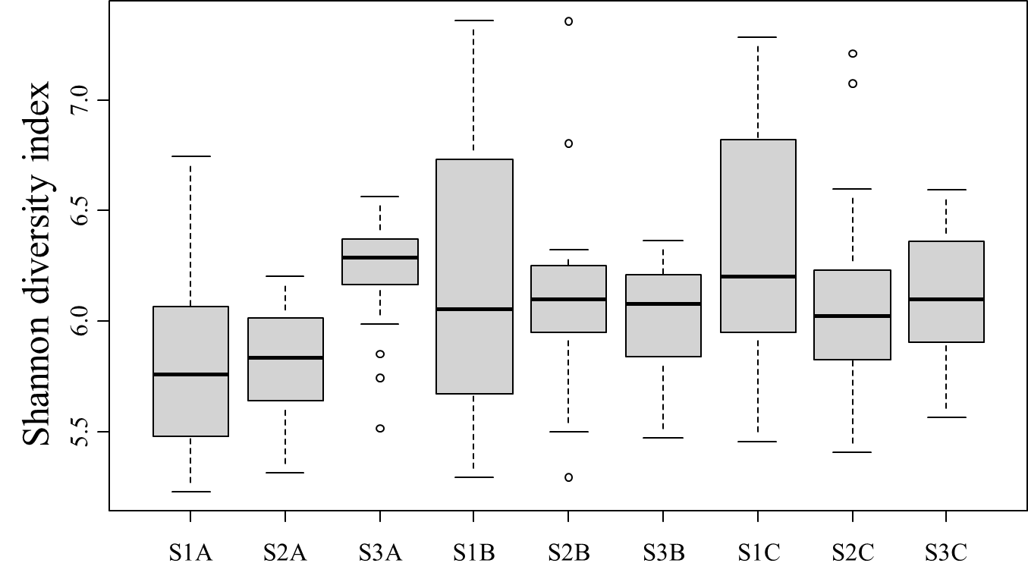
Figure S2 Shannon diversity index of the nine different sampling sites in Salluit, Nunavik.

Figure S3 (A) The relative abundance of Generalist, Common taxa, and Specialist modules in the total network module. (B) Composition of major modules.

Figure S4. Spearman's rank correlation matrix between the variables including the distribution patterns of individual modules and environmental parameters. The colors of the scale bar represent Spearman's correlation coefficient (ρ).

