Fig. S1.
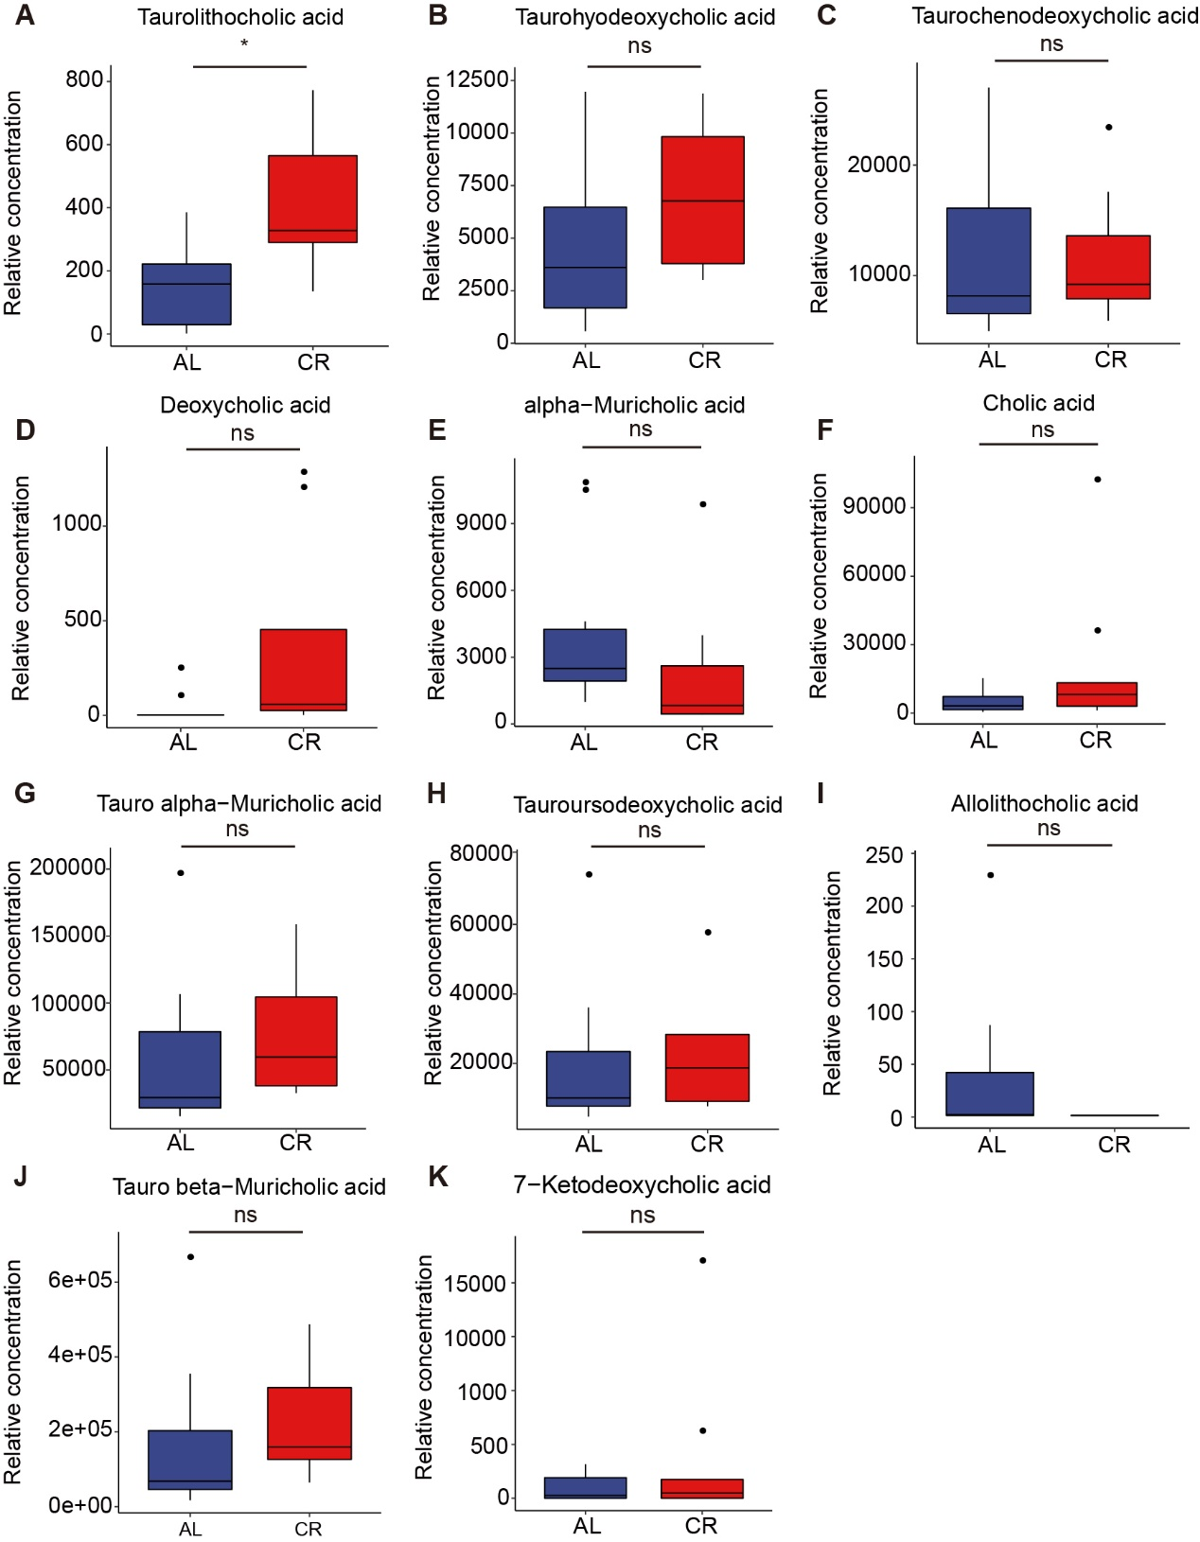
Relative concentrations of identified bile acids in AL and CR groups. (A) Relative concentration of taurolithocholic acid in AL and CR group (n=9-10 per group). (B) Relative concentration of allolithocholic acid in AL and CR group (n=9-10 per group). (C) Relative concentration of 7-Ketodeoxycholic acid in AL and CR group (n=9-10 per group). (D) Relative concentration of alpha-Muricholic acid in AL and CR group (n=9-10 per group). (E) Relative concentration of cholic acid in AL and CR group (n=9-10 per group). (F) Relative concentration of deoxycholic acid in AL and CR group (n=9-10 per group). (G) Relative concentration of tauro alpha-Muricholic acid in AL and CR group (n=9-10 per group). (H) Relative concentration of tauroursodeoxycholic acid in AL and CR group (n=9-10 per group). (I) Relative concentration of taurohyodeoxycholic acid in AL and CR group (n=9-10 per group). (J) Relative concentration of tauro beta-Muricholic acid in AL and CR group (n=9-10 per group). (K) Relative concentration of taurochenodeoxycholic acid in AL and CR group (n=9-10 per group). Multiple testing correction was calculated. * FDR < 0.1, ** FDR < 0.05, *** FDR < 0.01 and **** FDR < 0.001 were determined statistically significant.
Fig. S2.
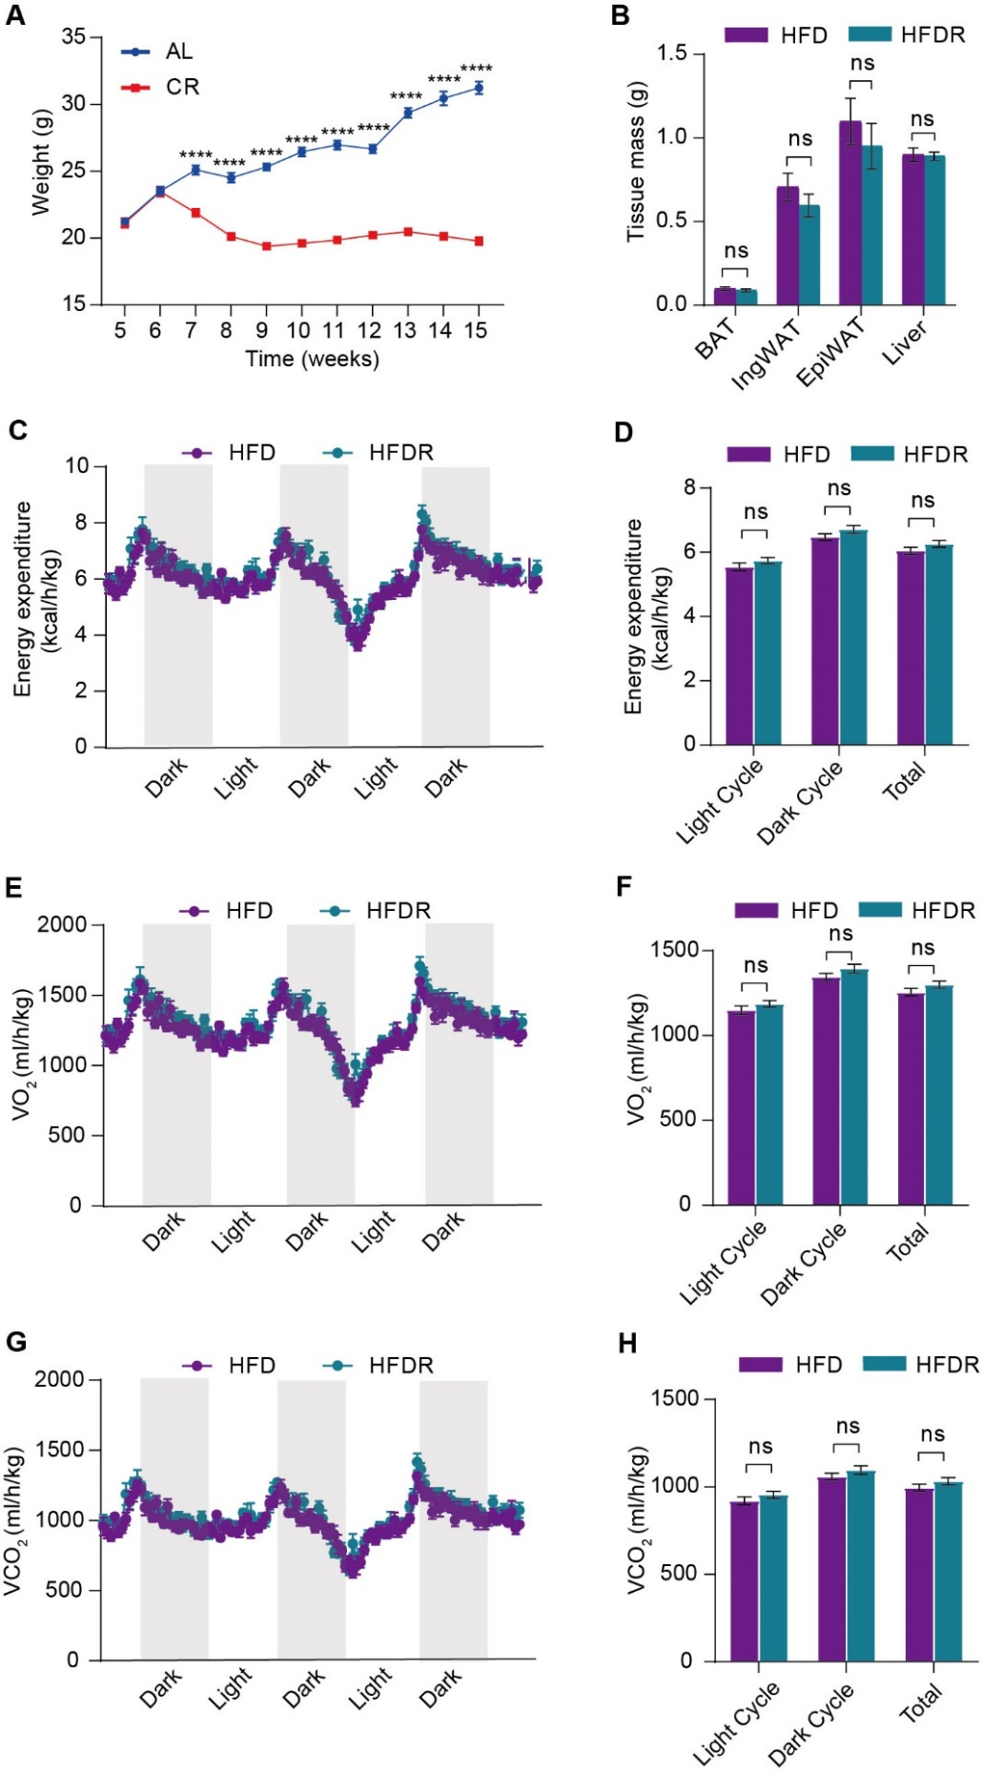
The phenotypes of HFD male mice after CR gut microbiota transplantation. (A) Body weight of male mice after AL or CR treatment (n=10 per group). (B) Brown adipose tissue (BAT), inguinal adipose tissue (IngWAT), epididymal adipose tissue (EpiWAT), and liver mass of male mice in HFD or HFDR groups (n= 8-10 per group). (C-H) TSE phenoMaster cages analysis of oxygen energy expenditure (EE), consumption rate (VO₂), and carbon dioxide production (VCO₂), of male mice in the HFD or HFDR groups (n=6 per group). Significance was calculated using non-paired two-tailed Student’s t test. ∗p < 0.05, ∗∗p < 0.01, ∗∗∗p < 0.001, ∗∗∗∗p < 0.0001.
Fig. S3.
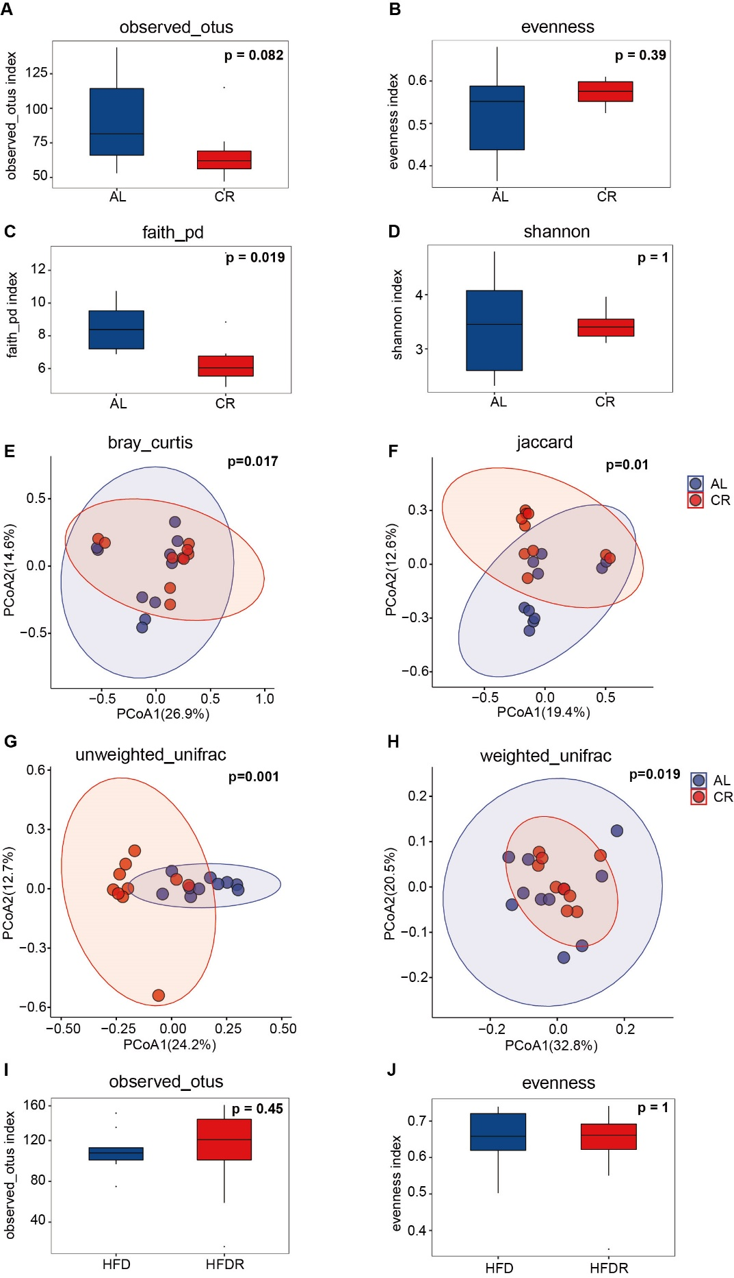
Cecal gut microbiota composition alterations in donor groups and recipient groups. (A-D) Indexes of observed_otus, evenness, faith_pd, Shannon of cecal samples from AL or CR group at 15-week (n=10 per group). (E-H) Principal coordinate analysis (PCoA) of the bray-curtis and weighted_unifrac distances of cecal samples from AL or CR group at 15-week (n=10 per group). (I-J) Indexes of observed_otus and evenness of cecal samples from HFD or HFDR group at 15-week (n=9-10 per group). Significance was calculated using Kruskal-Wallis test (alpha diversity) and permutational multivariate analysis of variance test (beta diversity). ∗p < 0.05, ∗∗p < 0.01, ∗∗∗p < 0.001, ∗∗∗∗p < 0.0001.
Fig. S4.

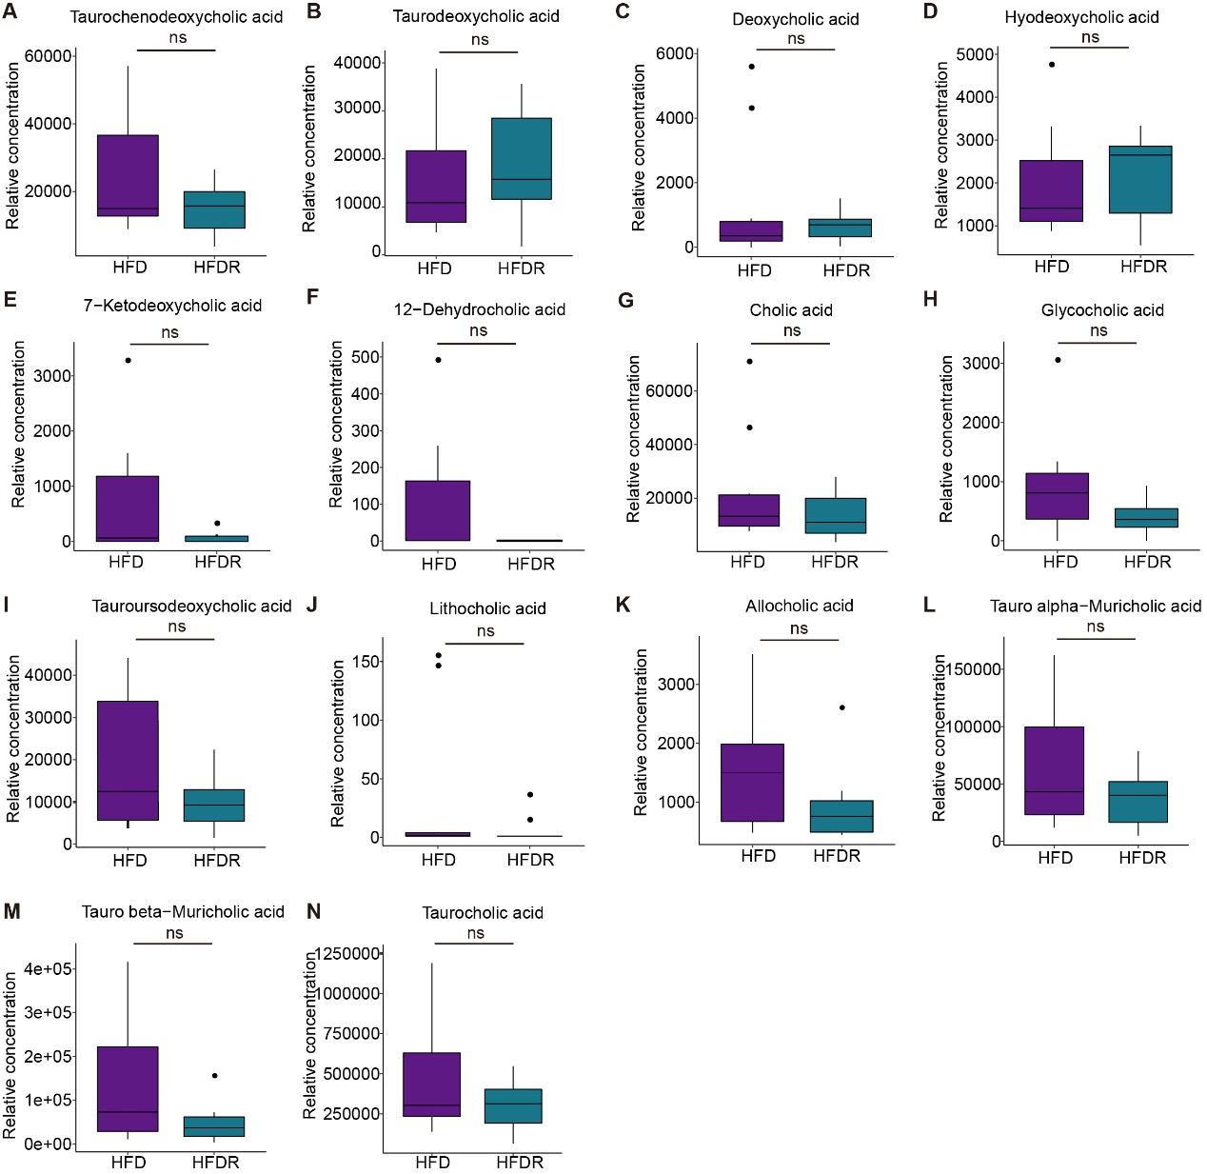
Relative concentrations of identified bile acids in HFD and HFDR groups. (A) Relative concentration of taurochenodeoxycholic acid in HFD and HFDR groups (n=9-10 per group). (B) Relative concentration of taurodeoxycholic acid in HFD and HFDR groups (n=9-10 per group). (C) Relative concentration of deoxycholic acid in HFD and HFDR groups (n=9-10 per group). (D) Relative concentration of hyodeoxycholic acid in HFD and HFDR groups (n=9-10 per group). (E) Relative concentration of 7-ketodeoxycholic acid in HFD and HFDR groups (n=9-10 per group). (F) Relative concentration of 12-dehydrocholic acid in HFD and HFDR groups (n=9-10 per group). (G) Relative concentration of cholic acid in HFD and HFDR groups (n=9-10 per group). (H) Relative concentration of glycocholic acid in HFD and HFDR groups (n=9-10 per group). (I) Relative concentration of tauroursodeoxycholic acid in HFD and HFDR groups (n=9-10 per group). (J) Relative concentration of lithocholic acid in HFD and HFDR groups (n=9-10 per group). (K) Relative concentration of allocholic acid in HFD and HFDR groups (n=9-10 per group). (L) Relative concentration of tauro alpha-Muricholic acid in HFD and HFDR groups (n=9-10 per group). (M) Relative concentration of tauro beta-Muricholic acid in HFD and HFDR groups (n=9-10 per group). (N) Relative concentration of taurocholic acid in HFD and HFDR groups (n=9-10 per group). Multiple testing correction was calculated. * FDR < 0.1, ** FDR < 0.05, *** FDR < 0.01 and **** FDR < 0.001 were determined statistically significant.

Table S1: The caloric consumption in the study.
Group# | Control Group |  | CR Group
 | gm (%) | Kcal (%) | gm (%) | Kcal (%)
Protein | 19.2 | 20 | 31.3 * 0.6 = 18.8 | 33 * 0.6 = 19.8
Carbohydrate | 67.3 | 70 | 46.9 * 0.6 = 28.1 | 50 * 0.6 = 30
Fat | 4.3 | 10 | 6.9 * 0.6 = 4.1 | 17 * 0.6 = 11.2
Total |  | 100 |  | 100 * 0.6 = 60
kcal/gm | 3.85 |  | 3.75 | kcal/gm

Table S2: The components of the diets used in the study.
Product# | Control Diet |  | Caloric Restriction Diet
 | gm (%) | Kcal (%) | gm (%) | Kcal (%)
Protein | 19.2 | 20 | 31.3 | 33
Carbohydrate | 67.3 | 70 | 46.9 | 50
Fat | 4.3 | 10 | 6.9 | 17
Total |  | 100 |  | 100
Ingredient | gm | kcal | gm | kcal
Casein, 80 Mesh | 200 | 800 | 200 | 800
L-Cystine | 3 | 12 | 3 | 12
Corm Starch | 315 | 1260 | 110 | 440
Maltodextrin 10 | 35 | 140 | 35 | 140
Sucrose | 350 | 1400 | 149.3 | 597
Cellulose, BW200 | 50 | 0 | 50 | 0
Soybean Oil | 25 | 225 | 25 | 225
Lard | 20 | 180 | 20 | 180
Mineral Mix S10026 | 10 | 0 | 10 | 0
DiCalcium Phosphate | 13 | 0 | 13 | 0
Calcium Carbonate | 5.5 | 0 | 5.5 | 0
Potassium Citrate, 1 H2O | 16.5 | 0 | 16.5 | 0
Vitamin Mix V10001 | 10 | 40 | 10 | 40
Choline Bitartrate | 2 | 0 | 2 | 0
Total | 1055.05 | 4057 | 649.35 | 2434
kcal/gm | 3.85 |  | 3.75

Table S3: Primary antibodies used in this study
Name | Host | Manufacturer | Catalog number | Dilution
H3K27ac | rabbit | Abcam, Cambridge, U.K. | ab4729 | 1:100
H3K4me1 | rabbit | Abcam, Cambridge, U.K. | Ab8895 | 1:100
HNF4α | mouse | Abcam, Cambridge, U.K. | ab41898 | 1:100

Table S4: Sequences of primers for RT‐qPCR.
Gene | Forward Sequence | Reverse Sequence
Ucp1 | AGGCTTCCAGTACCATTAGGT | CTGAGTGAGGCAAAGCTGATTT
Pgc1α(Ppargc1a) | TATGGAGTGACATAGAGTGTGCT | CCACTTCAATCCACCCAGAAAG
Dio2 | AATTATGCCTCGGAGAAGACCG | GGCAGTTGCCTAGTGAAAGGT
Cidea | TGACATTCATGGGATTGCAGAC | GGCCAGTTGTGATGACTAAGAC
CD11b | ATGGACGCTGATGGCAATACC | TCCCCATTCACGTCTCCCA
Ccl2 | TTAAAAACCTGGATCGGAACCAA | GCATTAGCTTCAGATTTACGGGT
Cxcl9 | GGAGTTCGAGGAACCCTAGTG | GGGATTTGTAGTGGATCGTGC
IL-10 | GCTCTTACTGACTGGCATGAG | CGCAGCTCTAGGAGCATGTG
CD68 | TGTCTGATCTTGCTAGGACCG | GAGAGTAACGGCCTTTTTGTGA
CD80 | ACCCCCAACATAACTGAGTCT | TTCCAACCAAGAGAAGCGAGG
F4/80 | TGACTCACCTTGTGGTCCTAA | CTTCCCAGAATCCAGTCTTTCC
CD163 | ATGGGTGGACACAGAATGGTT | CAGGAGCGTTAGTGACAGCAG
CD206 | CTCTGTTCAGCTATTGGACGC | CGGAATTTCTGGGATTCAGCTTC
Cyp7a1 | GGGATTGCTGTGGTAGTGAGC | GGTATGGAATCAACCCGTTGTC
Cyp7b1 | GGAGCCACGACCCTAGATG | TGCCAAGATAAGGAAGCCAAC
Cyp8b1 | CCTCTGGACAAGGGTTTTGTG | GCACCGTGAAGACATCCCC
CYP27a1 | CCAGGCACAGGAGAGTACG | GGGCAAGTGCAGCACATAG
PPARα | AGAGCCCCATCTGTCCTCTC | ACTGGTAGTCTGCAAAACCAAA
Hnf4α | CACGCGGAGGTCAAGCTAC | CCCAGAGATGGGAGAGGTGAT
Gapdh | AGGTCGGTGTGAACGGATTTG | TGTAGACCATGTAGTTGAGGTCA

Table S5: Sequences of primers for ChIP‐qPCR.
Gene | Forward Sequence | Reverse Sequence
Cyp8b1 | CTCCTAGCACTGTACACCAC | GCCTCTGAGCAAAGTCCAAG
Input | ATGTACCTGCGTCTTCTCCA | CACTGAGTGCTGGGATTACA

