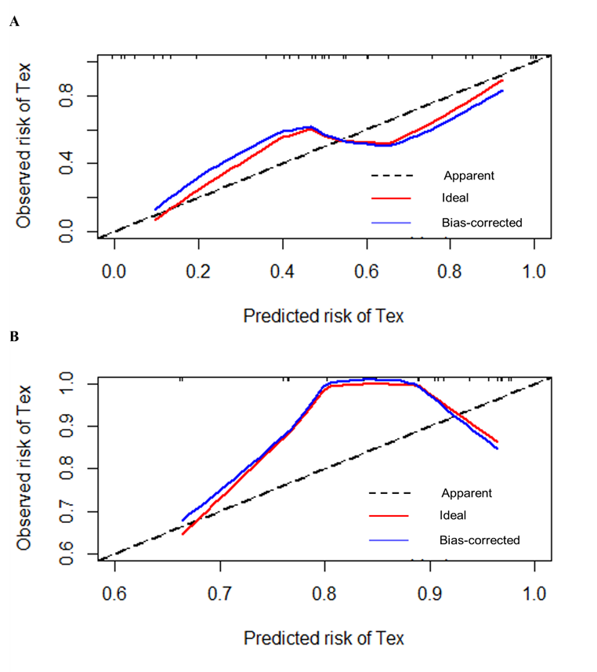
Fig S2. Calibration curves of radiomics model.
- Calibration curve of ICI group (training set).
- Calibration curve of RT group (validation set).

