Additional file Information
ROMS. The model used in this study (ROMS) is a widely-used, community supported model that is run both operationally at the University of Hawaii and also in hindcast mode. The latter, used in this study, assimilates all known observations including satellite-based sea surface temperatures from MODIS, AVHRR, or OSTIA; satellite-based sea surface height from AVISO; surface currents from PacIOOS high-frequency radios (HFR); and in-situ water temperature and salinity profiles from ARGO floats and ocean glider autonomous underwater vehicles (AUV) when these are available. The model has been shown to well represent flow in the Hawaii region (Partridge, D., T. Friedrich, and B. S. Powell, 2019: Reanalysis of the PacIOOS Hawaiian Island Ocean Forecast System, an implementation of the Regional Ocean Modeling System v3.6. Geosci. Model Devel. 12 (1): 195–213. https://doi.org/https://doi.org/10.5194/gmd-12-195-2019; Souza, J., and B. S. Powell 2018: Different approaches to model the nearshore circulation in the south shore of Oahu, Hawaii. Ocean Science 13: 31–46. https://doi.org/10.5194/os-13-31-2017; Powell, B. S. 2017: Quantifying How Observations Inform a Numerical Reanalysis of Hawaii. J. Geophys. Res. 122 (11): 8,427–28,444. https://doi.org/10.1002/2017JC012854; Janekovic, I., B. S. Powell, D. Matthews, M. A. McManus, and J. Sevadjian, 2013: 4D-Var Data Assimilation in a Nested, Coastal Ocean Model: A Hawaiian Case Study. J. Geophys. Res. 118: 1–14. https://doi.org/10.1002/jgrc.20389; and Matthews, D., B. S. Powell, and I. Janekovic 2012: Analysis of Four-dimensional Variational State Estimation of the Hawaiian Waters. J. Geophys. Res. 117 (C03013). https://doi.org/10.1029/2011JC007575).

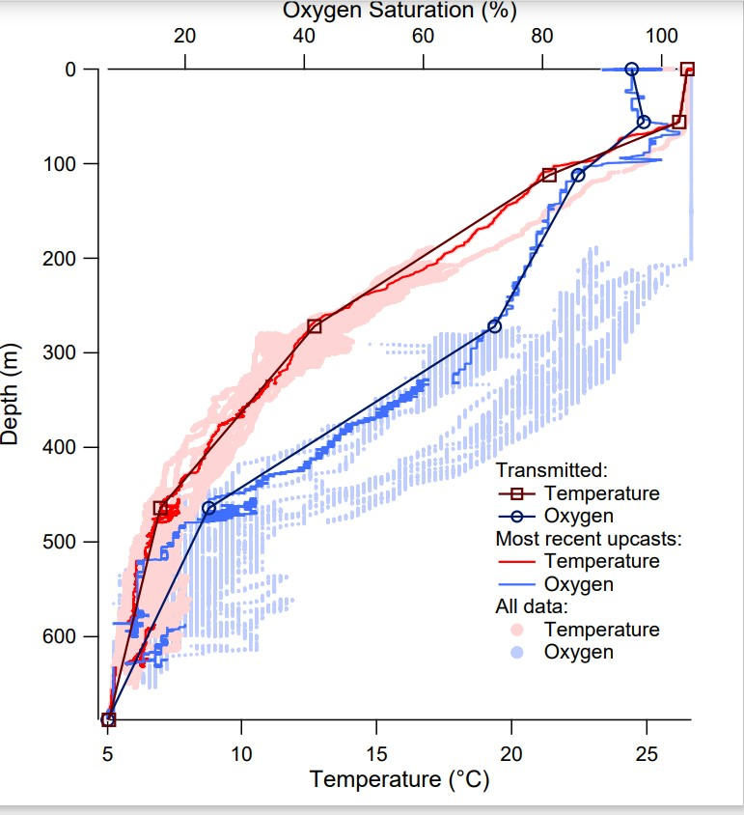

SI Figure 1. Broken Stick algorithm applied to archived depth/temperature and depth/oxygen curves. The broken stick algorithm (“transmitted”) used in the current SCOUT tag implementation is overlaid on the most recent archived profiles of oxygen saturation and temperature from a recovered pop-up tag. In this case, the broken stick curve was fitted with six points as opposed to eleven used in the case reported here.

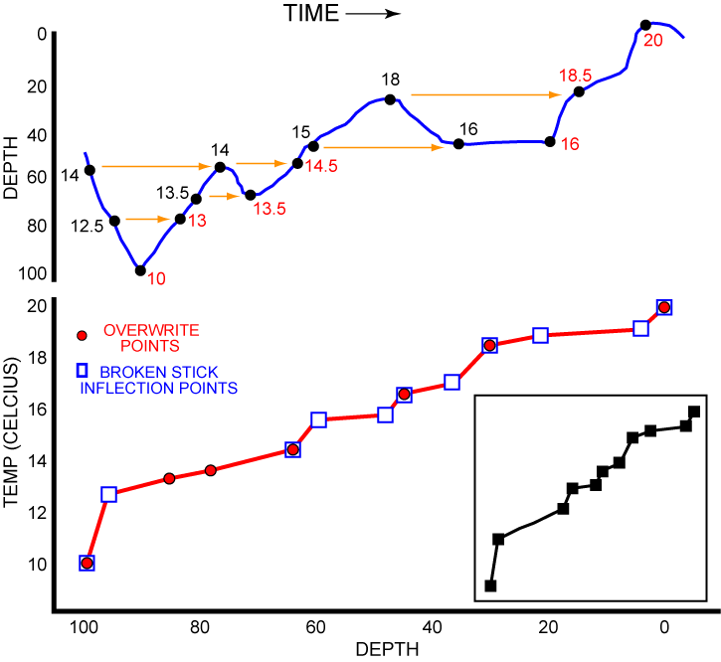
SI Figure 2. Conceptual rendering of translation of dive behavior into a broken stick temperature profile. In this stylized dive and surfacing event (blue line) temperatures at the same depth (yellow arrows) are overwritten until the last values stored (red numbers) are used to create the virtual upcast temperature profile (red line). Values imported here from the top panel (red dots) are among many hundreds comprising a typical upcast profile. Inflection points on the upcast (blue squares) are used to construct the eleven-point transmitted broken stick profile (black squares, inset).

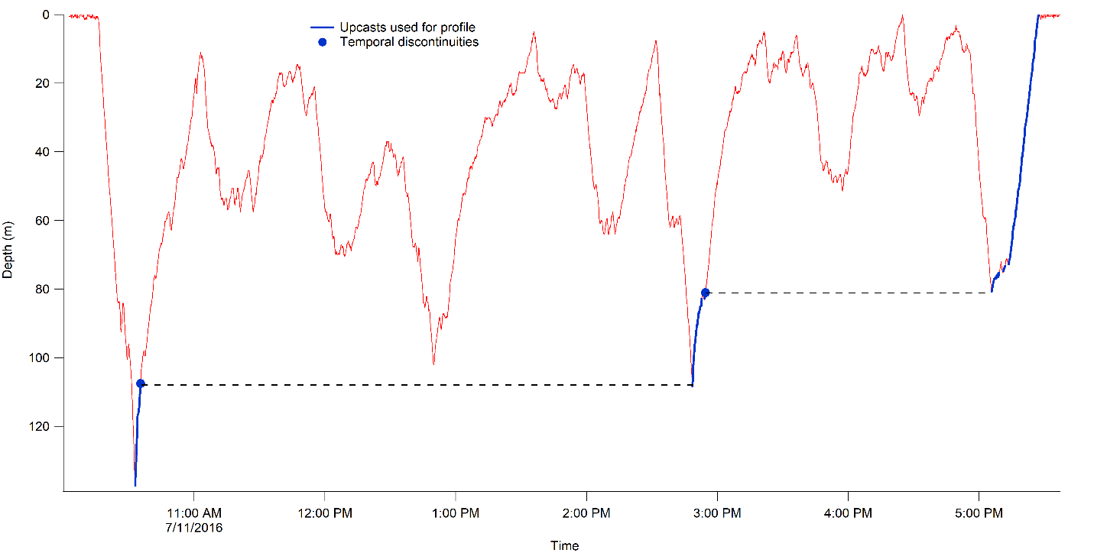
SI Figure 3. Upcast creation and time discontinuities. Temperatures are recorded every second throughout the dive but only the values in blue are used to create the virtual upcast. Dashed line shows temporal discontinuities. In the current study, any discontinuity greater than 1 h resulted in a ‘discontinuity flag’ appearing in the broken stick profile.

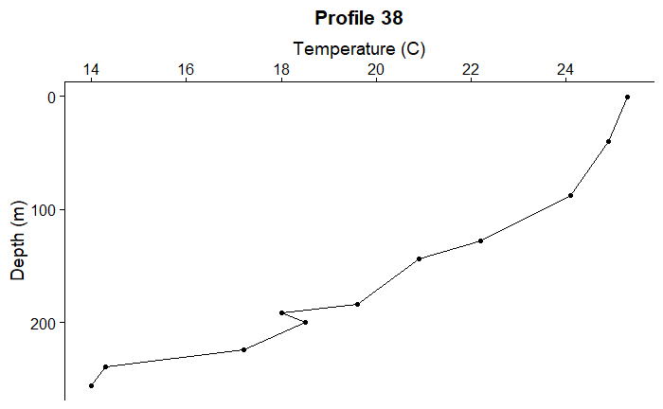
SI Figure 4. Profile 38 was constructed between 0746 and 0801 (i.e., 15 min + 15 min) on 5/12/21 and transmitted from a Fastloc-derived location approximately 1.6 km south of Kewalo Basin, Oahu. The profile originated at 256 m. Assuming the slowest ascent rate (30 min), average ascent rate = 8.5 m/min (2.9 body lengths/min).

