Table S1
Variables used in propensity score estimations
Demographic
Female
Age
BMI <30 and ≥30
Opium
Current cigarette smoker
Medical history
Diabetes
Hypertension
COPD
Cerebrovascular accident
Pre surgery PCI
Positive family history
Preoperative lab test
GFR
Cardiac status
Graft number
Ejection fraction
LM stenosis
Previous myocardial infarction (No history, ≤7 days, 8-21 days, >21days)
Surgical decision
Urgent operation

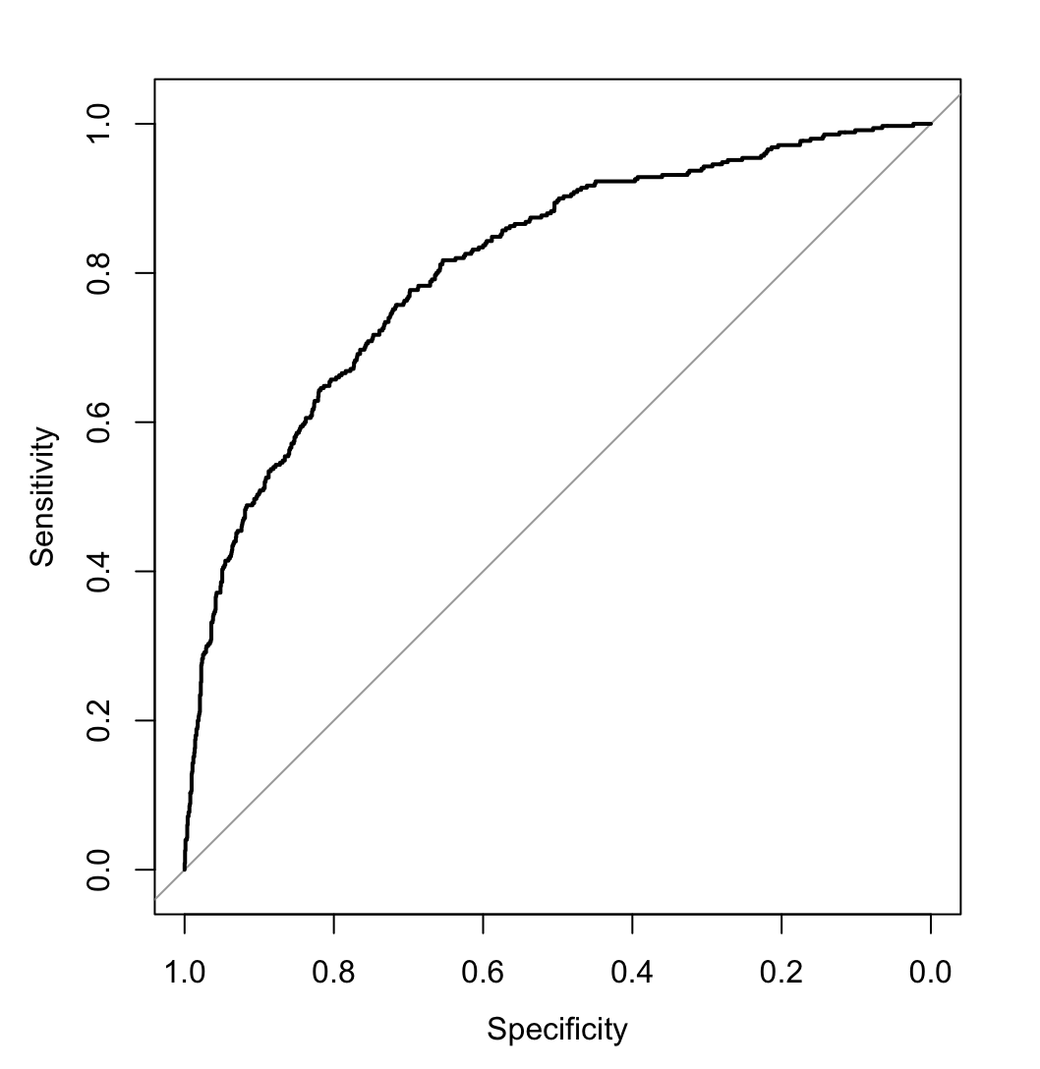
Fig. S1. C-statistic for propensity score modeling

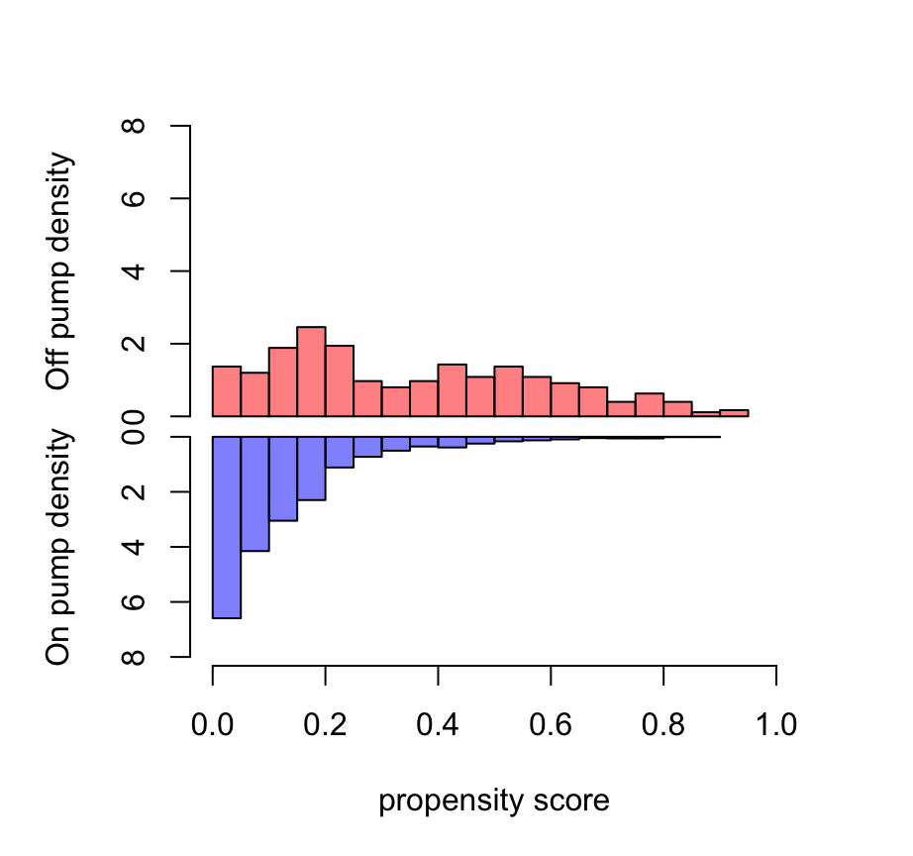
Fig. S2. Estimated Propensity scores

Table S2. Standardized mean differences (SMD) percentage of characteristic variables
 | Unadjusted | IPW
eGFR | 0.041 | 0.088
Age | 0.148 | 0.055
Gender | 0.015 | 0.015
Dyslipidemia | 0.127 | 0.054
Diabetes | 0.045 | 0.033
Hypertension | 0.180 | 0.044
Positive Family History | 0.049 | 0.012
Opium | 0.051 | 0.044
Current cigarette smoker | 0.077 | 0.011
EF | 0.181 | 0.041
Left main stenosis | 0.007 | 0.012
Pre surgery PCI | 0.189 | 0.005
BMI | 0.014 | 0.006
Urgent operation | 0.031 | 0.120
COPD | 0.081 | 0.038
Cerebrovascular Accident | 0.018 | 0.037
Previous myocardial infarction (≤7 days) | 0.109 | 0.012
Previous myocardial infarction (8-21 days) | 0.122 | 0.075
Previous myocardial infarction (>21days) | 0.011 | 0
Graft number | 0.907 | 0.128

