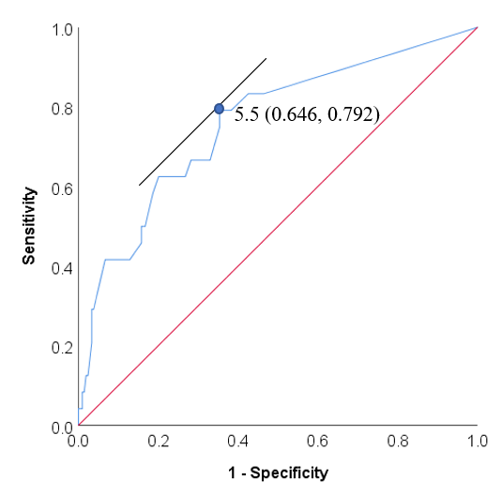
Figure S1. Receiver operating curve analysis evaluating the predictive value of radiotherapy delay for elevation in the EBV DNA load. The optimal cutoff value of radiotherapy delay was 5.5 days, with a specificity of 0.646 and a sensitivity of 0.792.
Radiotherapy delay (days) | Odds ratio (95% CI) | P value
>1 vs <1 | 5.77 (1.91, 17.47) | 0.002
>2 vs <2 | 5.89 (1.95, 17.81) | 0.002
>3 vs <3 | 6.24 (2.06, 18.88) | 0.001
>4 vs <4 | 6.74 (2.23, 20.42) | 0.001
>5 vs <5 | 6.13 (2.20, 17.06) | 0.001
>6 vs <6 | 6.93 (2.49, 19.32) | <0.001
>7 vs <7 | 5.47 (2.08, 14.39) | 0.001
>8 vs <8 | 4.06 (1.66, 9.94) | 0.002
>9 vs <9 | 4.74 (1.93, 11.65) | 0.001
>10 vs <10 | 5.09 (2.07, 12.51) | <0.001
>11 vs <11 | 4.55 (1.89, 10.99) | 0.001
>12 vs <12 | 5.44 (2.24, 13.20) | <0.001
>13 vs <13 | 5.75 (2.36, 13.96) | <0.001
>14 vs <14 | 6.63 (2.71, 16.19) | <0.001
>15 vs <15 | 6.10 (2.52, 14.76) | <0.001
Table S1. Association of radiotherapy delay with elevation in the EBV DNA load.

