Supplementary
Table of contents
Figure S1. Study design 2
Figure S2. Tumor response of patients in the dose-escalation and dose-expansion phase. 3
Figure S3. Percentage change from baseline in target lesion tumour burden over time in patients with select tumors at the recommended dose (30 mg/kg q3w) 5
Figure S4. Receiver operating characteristic curve analysis of pSmad2 level in tumor cells for ORR per RECIST v1.1. 6
Table S1. Pharmacokinetic parameters following a single infusion 7
Table S2 Summary of treatment-related adverse events and tumor response by dose in the dose-escalation and dose-expansion phase 8
Table S3. Characteristics of patients in clinical expansion cohorts by tumor types 10
Table S4. Serious treatment-related adverse events 12
Table S5 Tumor response by PD-L1 expression in all clinical expansion cohorts and in gastric cancer cohort 13
Table S6. Associations between tumor response and pSMAD2 level in clinical expansion cohorts 14

Figure S1. Study design
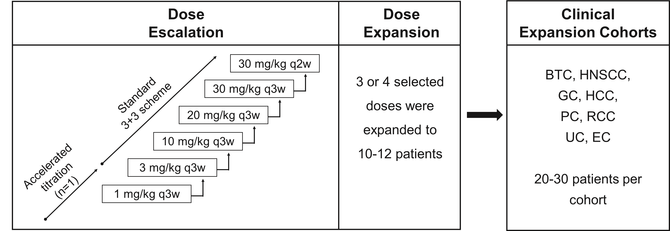
This was a multicenter, open-label, first-in-human phase I trial of SHR-1701 composed of a dose-escalation phase and dose-expansion phase in advanced solid tumors, followed by clinical expansion cohorts of selected tumor types (ClinicalTrials.gov, NCT03710265).
BTC, biliary tract cancer; HNSCC, head and neck squamous cell carcinoma; GC, gastric cancer; HCC, hepatocellular carcinoma; PC, pancreatic cancer; RCC, renal cell carcinoma; UC, urothelial carcinoma; EC, esophageal cancer.

Figure S2. Tumor response of patients in the dose-escalation and dose-expansion phase.
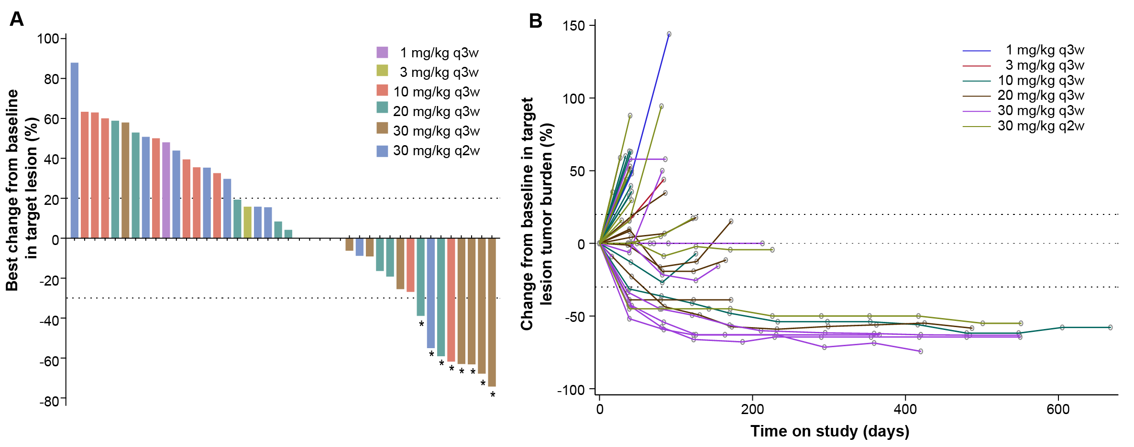
A. Waterfall plots of best overall response.
* represent patients with partial reasponse, including 2 patients with non-small cell lung cancer, 1 pancreatic acinar cell carcinoma, 1 oesophageal squamous cell carcinoma, 1 hepatocellular carcinoma, 1 dMMR colorectal cancer, 1 renal caner, and 1 epiglottis cancer.
B. Percentage change from baseline in target lesion tumor burden over time.

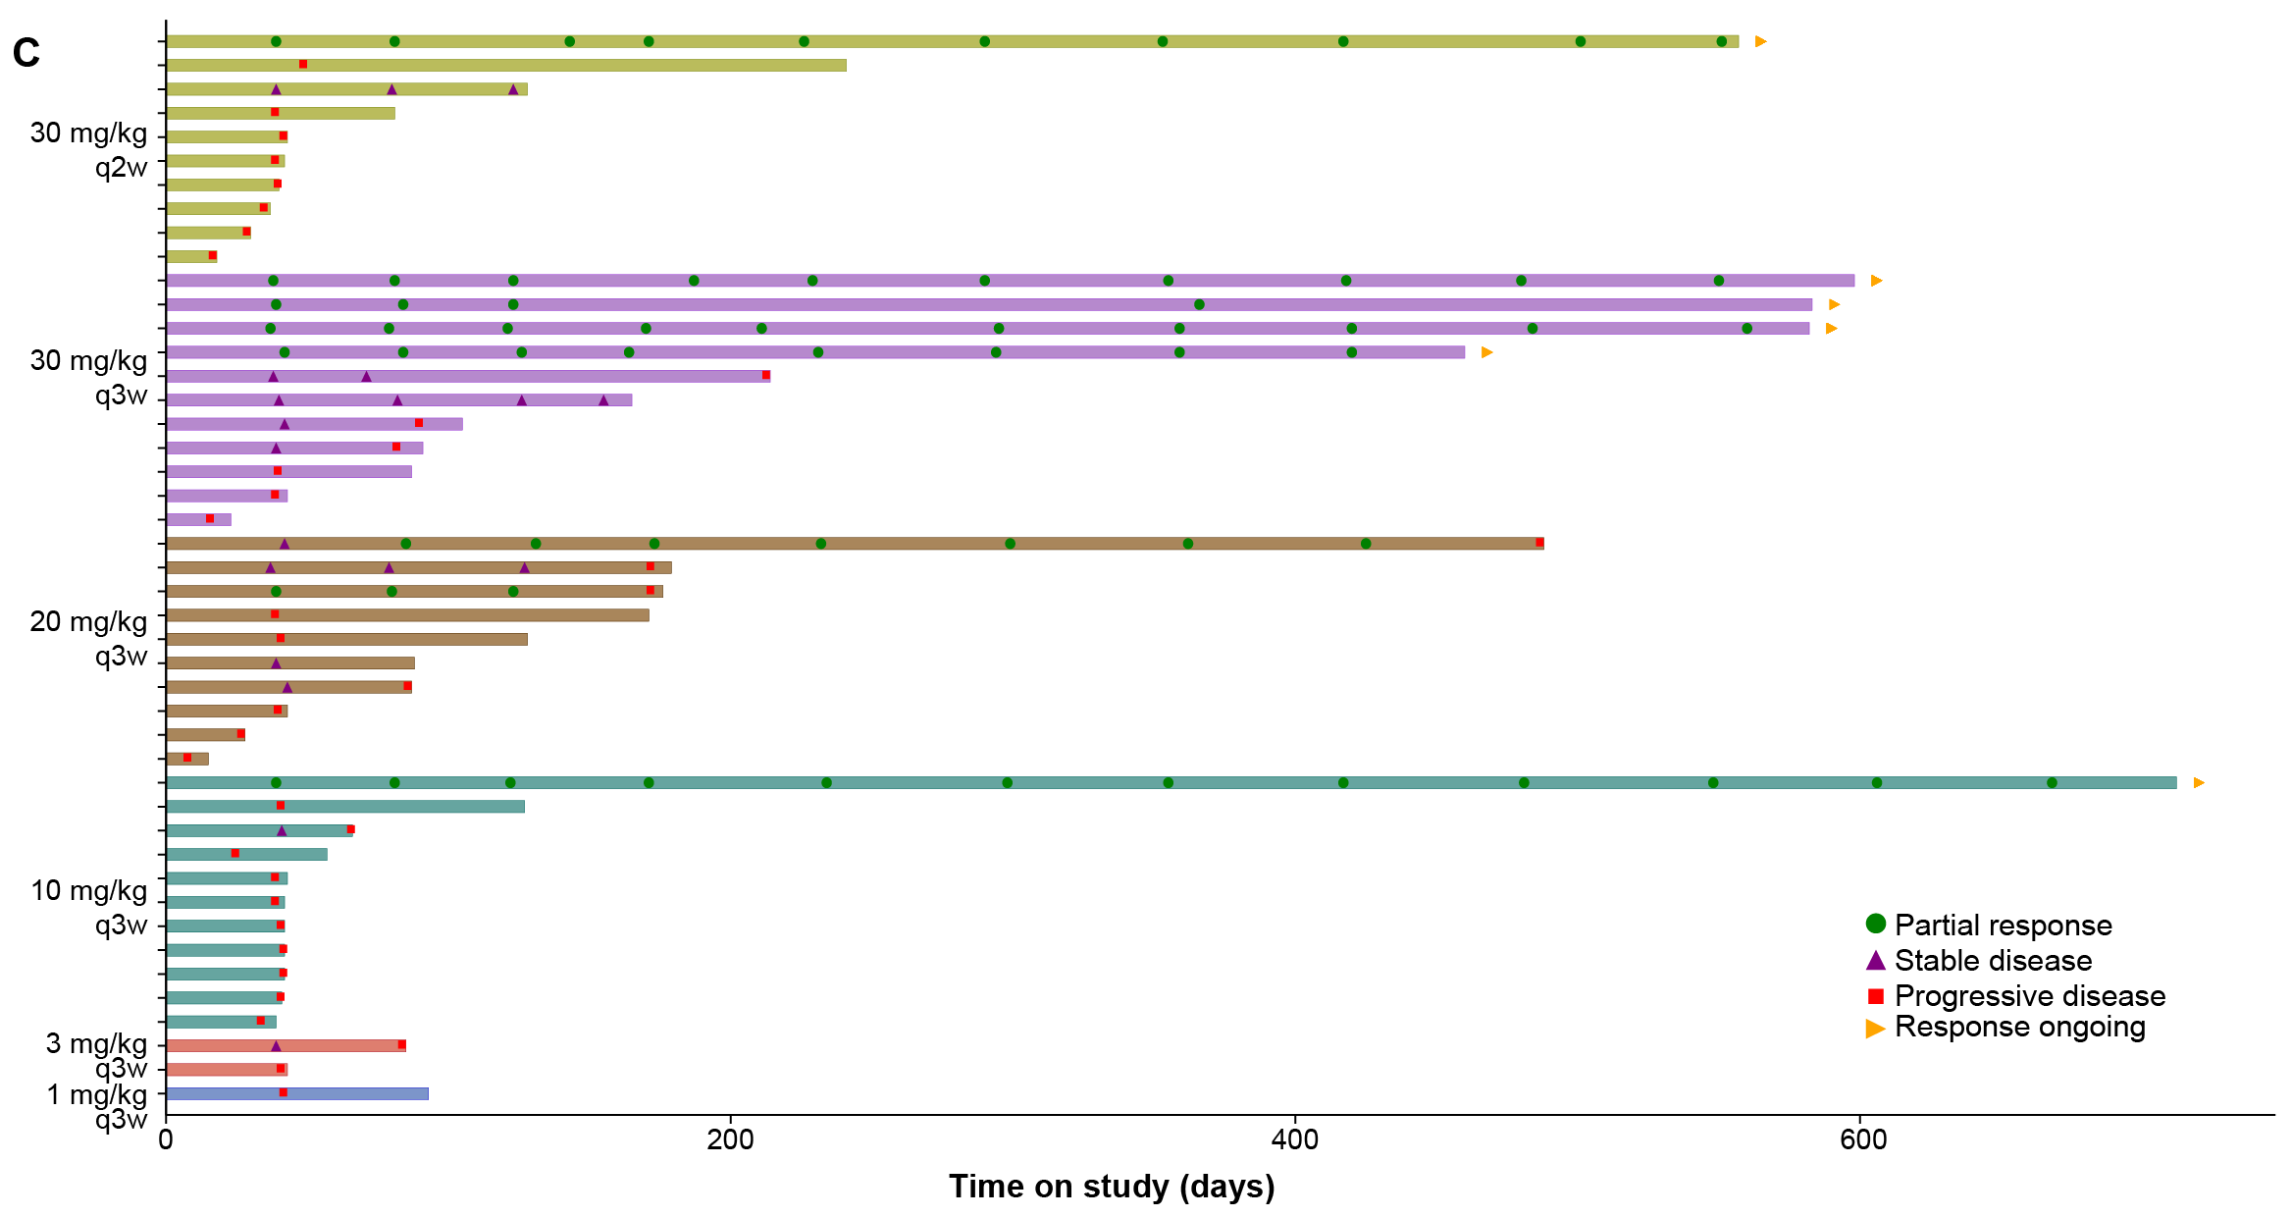
C. Tumor responses over time.

Figure S3. Percentage change from baseline in target lesion tumour burden over time in patients with select tumors at the recommended dose (30 mg/kg q3w)
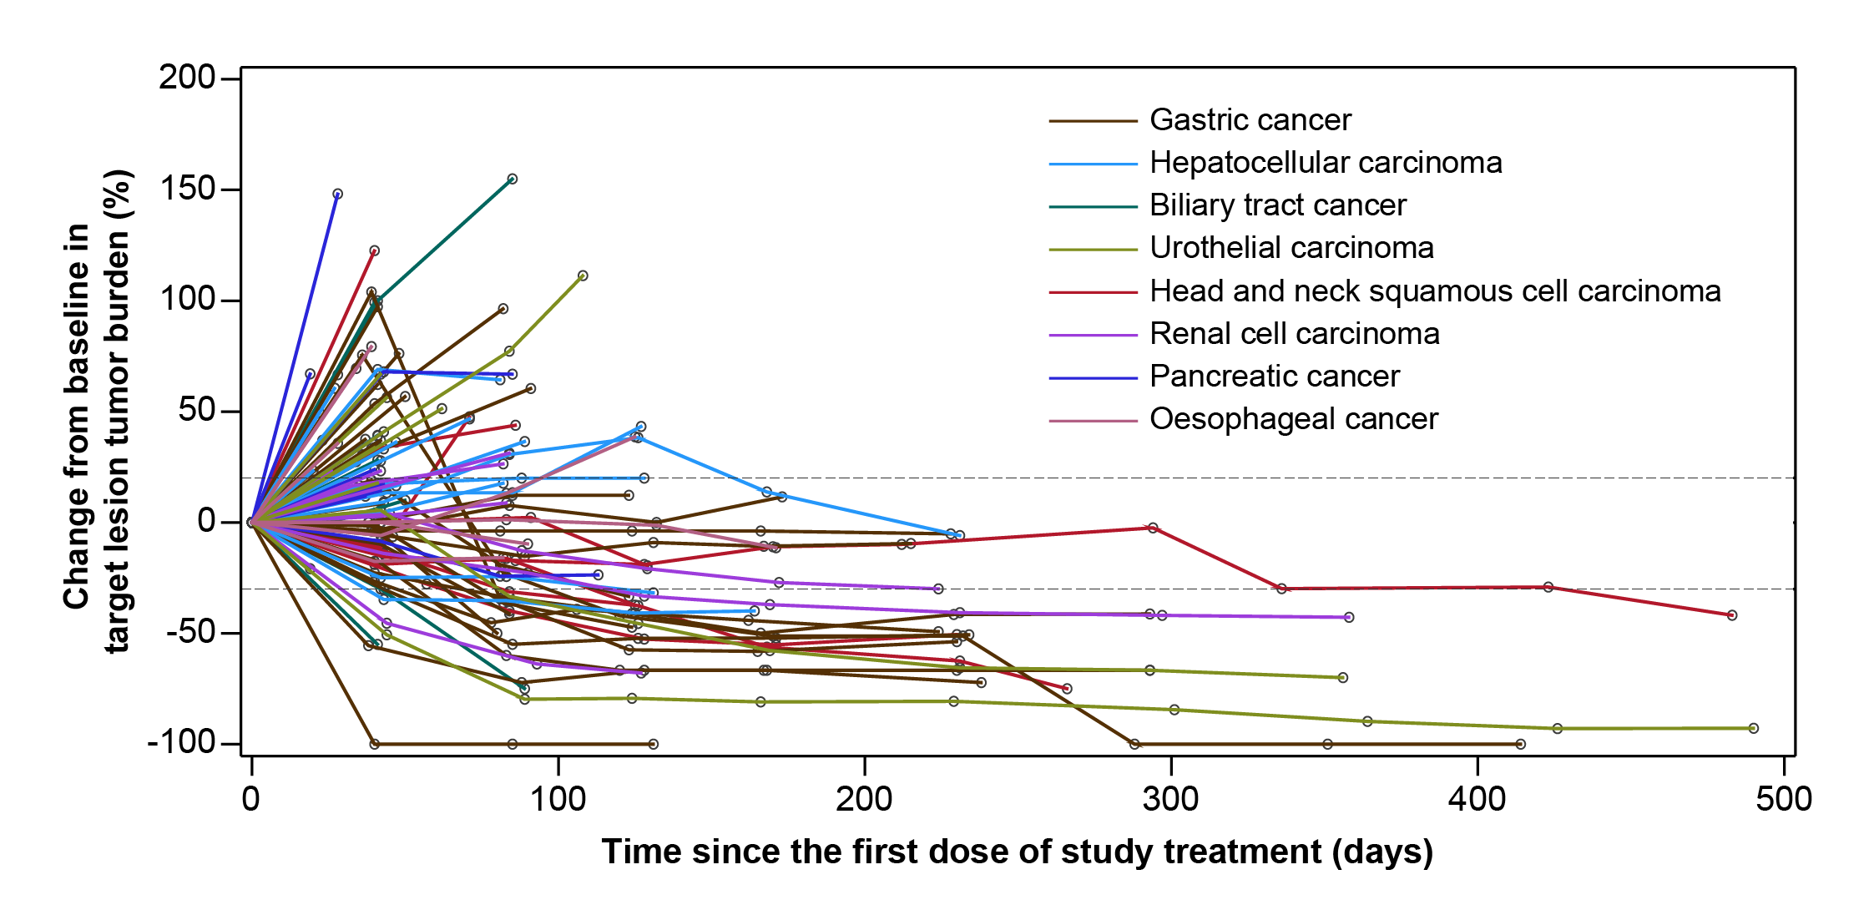

Figure S4. Receiver operating characteristic curve analysis of pSmad2 level in tumor cells for ORR per RECIST v1.1.
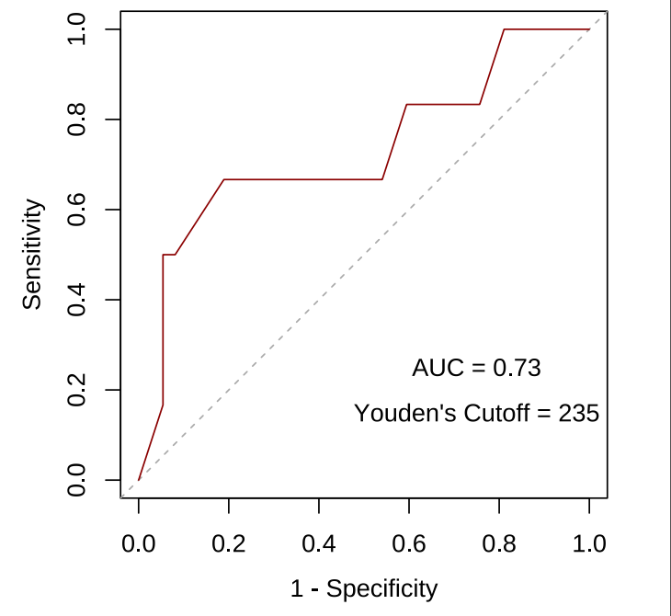
AUC, area under the curve; ORR, objective response rate.

Table S1. Pharmacokinetic parameters following a single infusion
 | 1 mg/kg q3w  (n=1) | 3 mg/kg q3w  (n=3) | 10 mg/kg q3w  (n=11) | 20 mg/kg q3w  (n=12) | 30 mg/kg q3w  (n=13) | 30 mg/kg q2w  (n=10)
C_{max}, geomean (%CVb), μg/mL | 24 | 90 (11.4) | 240 (19.3) | 409 (31.4) | 786 (37.1) | 846 (26.1)
T_{max}, median (range), h | 2.00 | 2.97  (1.12-6.87) | 2.98  (1.18-48.53) | 1.68  (0.92-2.98) | 1.93  (0.75-24.07) | 1.83  (0.92-24.83)
AUC_{inf}, geomean (%CVb), h·μg/mL | 3610 | 10200 (36.2) | 43100 (19.2) | 82500 (31.0) | 175000 (27.7) | 156000 (23.9)
AUC_{last}, geomean (%CVb), h·μg/mL | 3330 | 9550 (30.6) | 39800 (18.4) | 59200 (60.8) | 110000 (65.4) | 110000 (24.2)
t_{1/2}, geomean (%CVb), d | 6.0 | 4.6 (52.0) | 6.5 (17.7) | 7.2 (35.3) | 8.4 (16.7) | 6.3 (26.8)
CL, geomean (%CVb), mL/h | 15.8 | 17.0 (28.6) | 14.1 (20.1) | 14.3 (29.7) | 10.8 (26.0) | 12.0 (27.5)
Vss, geomean (%CVb), L | 3.25 | 2.70 (22.7) | 3.21 (15.7) | 3.67 (42.0) | 3.11 (22.3) | 2.61 (17.9)
Geomean, geometric mean; CVb, coefficient of variation of Bowen ratio; C_{max}, maximum serum concentration; T_{max}, time to reach maximum serum concentration; AUC_{inf}, area under the curve from time zero to the infinity; AUC_{last}, AUC from time zero to the last concentration measurement; t_{1/2}, half-life; CL, clearance; Vss, volume of distribution.

Table S2 Summary of treatment-related adverse events and tumor response by dose in the dose-escalation and dose-expansion phase
 | 1 mg/kg q3w  (n=1) | 3 mg/kg q3w  (n=3) | 10 mg/kg q3w  (n=11) | 20 mg/kg q3w  (n=12) | 30 mg/kg q3w  (n=13) | 30 mg/kg q2w  (n=10) | All patients  (N=50)
Safety, n (%)
Any grade | 1 (100.0) | 3 (100.0) | 8 (72.7) | 11 (91.7) | 10 (76.9) | 8 (80.0) | 41 (82.0)
Grade ≥3 | 0 | 0 | 1 (9.1) | 3 (25.0) | 4 (30.8) | 3 (30.0) | 11 (22.0)
Serious | 0 | 1 (33.3) | 2 (18.2) | 3 (25.0) | 1 (7.7) | 2 (20.0) | 9 (18.0)
Leading to treatment interruption | 0 | 1 (33.3) | 3 (27.3) | 1 (8.3) | 4 (30.8) | 3 (30.0) | 12 (24.0)
Leading to treatment discontinuation | 0 | 0 | 0 | 0 | 1 (7.7) | 1 (10.0) | 2 (4.0)
Efficacy
BOR, n (%)
Partial response | 0 | 0 | 1 (9.1) | 2 (16.7) | 4 (30.8) | 1 (10.0) | 8 (16.0)
Stable disease | 0 | 1 (33.3) | 1 (9.1) | 3 (25.0) | 4 (30.8) | 1 (10.0) | 10 (20.0)
Progressive disease | 1 (100) | 1 (33.3) | 9 (81.8) | 5 (41.7) | 3 (23.1) | 8 (80.0) | 27 (54.0)
Not evaluable | 0 | 1 (33.3) | 0 | 2 (16.7) | 2 (15.4) | 0 | 5 (10.0)
ORR, % (95% CI) | 0  (0-97.5) | 0  (0-70.8) | 9.1  (0.2-41.3) | 16.7  (2.1-48.4) | 30.8  (9.1-61.4) | 10.0  (0.3-44.5) | 16.0  (7.2-29.1)
DCR, % (95% CI) | 0  (0-97.5) | 33.3  (0.8-90.6) | 18.2  (2.3-51.8) | 41.7  (15.2-72.3) | 61.5  (31.6-86.1) | 20.0  (2.5-55.6) | 36.0  (22.9-50.8)
BOR, best overall response; ORR, objective response rate; DCR, disease control rate.

Table S3. Characteristics of patients in clinical expansion cohorts by tumor types
 | Clinical Expansion Cohorts
 | Gastric cancer  (n=35) | Hepatocellular carcinoma  (n=21) | Biliary tract cancer  (n=13) | Urothelial carcinoma  (n=12) | Head and neck squamous cell carcinoma  (n=10) | Renal cell carcinoma  (n=10) | Pancreatic cancer  (n=10) | Oesophageal cancer  (n=10)
Age, median (range), years | 61 (31-74) | 51 (21-68) | 55 (31-73) | 55 (46-72) | 58 (39-69) | 57 (22-71) | 58 (42-69) | 64 (47-74)
Sex, n (%)
Male | 28 (80.0) | 19 (90.5) | 9 (69.2) | 11 (91.7) | 9 (90.0) | 8 (80.0) | 6 (60.0) | 8 (80.0)
Female | 7 (20.0) | 2 (9.5) | 4 (30.8) | 1 (8.3) | 1 (10.0) | 2 (20.0) | 4 (40.0) | 2 (20.0)
ECOG performance status, n (%)
0 | 4 (11.4) | 7 (33.3) | 2 (15.4) | 2 (16.7) | 2 (20.0) | 2 (20.0) | 3 (30.0) | 1 (10.0)
1 | 31 (88.6) | 14 (66.7) | 11 (84.6) | 10 (83.3) | 8 (80.0) | 8 (80.0) | 7 (70.0) | 9 (90.0)
No. of organs of metastases, n (%)
0 | 0 | 2 (9.5) | 0 | 0 | 3 (30.0) | 0 | 0 | 1 (10.0)
1 | 14 (40.0) | 8 (38.1) | 5 (38.5) | 3 (25.0) | 0 | 1 (10.0) | 3 (30.0) | 4 (40.0)
2 | 13 (37.1) | 5 (23.8) | 4 (30.8) | 2 (16.7) | 2 (20.0) | 1 (10.0) | 4 (40.0) | 4 (40.0)
3 | 5 (14.3) | 5 (23.8) | 2 (15.4) | 1 (8.3) | 5 (50.0) | 2 (20.0) | 0 | 1 (10.0)
4 or more | 3 (8.6) | 1 (4.8) | 2 (15.4) | 6 (50.0) | 0 | 6 (60.0) | 3 (30.0) | 0
Lines of prior anticancer therapies, n (%)
0 | 0 | 0 | 0 | 1 (8.3) | 1 (10.0) | 1 (10.0) | 0 | 0
1 | 16 (45.7) | 17 (81.0) | 11 (84.6) | 10 (83.3) | 5 (50.0) | 7 (70.0) | 3 (30.0) | 9 (90.0)
2 | 19 (54.3) | 4 (19.0) | 2 (15.4) | 1 (8.3) | 4 (40.0) | 2 (20.0) | 7 (70.0) | 1 (10.0)
Prior therapy, n (%)
Chemotherapy | 35 (100) | 6 (28.6) | 13 (100) | 11 (91.7) | 9 (90.0) | 1 (10.0) | 10 (100) | 10 (100)
Targeted therapy | 10 (28.6) | 17 (81.0) | 1 (7.7) | 1 (8.3) | 2 (20.0) | 8 (80.0) | 1 (10.0) | 2 (20.0)
Immunotherapy | 0 | 0 | 0 | 0 | 0 | 1 (10.0) | 0 | 0
Others | 0 | 2 (9.5) | 0 | 1 (8.3) | 0 | 0 | 1 (10.0) | 1 (10.0)
ECOG, Eastern Cooperative Oncology Group.

Table S4. Serious treatment-related adverse events
 | All Patients (N=171)
 | Any Grade | Grade 3-5
Any | 25 (14.6) | 13 (7.6)
Unknown death | 2 (1.2) | 2 (1.2)
Pneumonia | 2 (1.2) | 1 (0.6)
Vomiting | 2 (1.2) | 0
Immune-mediated lung disease | 2 (1.2) | 0
T1DM | 1 (0.6) | 1 (0.6)
Hyponatremia | 1 (0.6) | 1 (0.6)
Hypercalcemia | 1 (0.6) | 1 (0.6)
Asthenia | 1 (0.6) | 1 (0.6)
Blood creatinine increased | 1 (0.6) | 1 (0.6)
Lipase increased | 1 (0.6) | 1 (0.6)
Nausea | 1 (0.6) | 1 (0.6)
Gastrointestinal hemorrhage | 1 (0.6) | 1 (0.6)
Immune-mediated hepatic disorder | 1 (0.6) | 1 (0.6)
Anemia | 1 (0.6) | 1 (0.6)
Pyrexia | 1 (0.6) | 0
Alanine aminotransferase increased | 1 (0.6) | 0
Platelet count decreased | 1 (0.6) | 0
Diarrhea | 1 (0.6) | 0
Immune-mediated enterocolitis | 1 (0.6) | 0
Hepatic function abnormal | 1 (0.6) | 0
Pneumonitis | 1 (0.6) | 0
Interstitial lung disease | 1 (0.6) | 0

Table S5 Tumor response by PD-L1 expression in all clinical expansion cohorts and in gastric cancer cohort
 | All clinical expansion cohorts | Gastric cancer cohort
PD-L1 CPS
≥1 vs <1 | 20.8% (15/72, 12.2-32.0) vs 7.5% (3/40, 1.6-20.4), P=0.105 | 21.7% (5/23, 7.5-43.7) vs 12.5% (1/8, 0.3-52.7), P=1.0
≥5 vs <5 | 34.1% (14/41, 20.1-50.6) vs 5.6% (4/71, 1.6-13.8), P<0.001 | 45.5% (5/11, 16.7-76.6) vs 5.0% (1/20, 0.1-24.9), P=0.013
≥10 vs <10 | 40.6% (13/32, 23.7-59.4) vs 6.3% (5/80, 2.1-14.0), P<0.001 | 55.6% (5/9, 21.2-86.3) vs 4.5% (1/22, 0.1-22.8), P<0.001
ORR are shown in % (n/N, 95% CI). Tumor responses were assessed per RECIST v1.1.
ORR, objective response rate; PD-L1, programmed death ligand 1; CPS, combined positive score; CI, confidence interval.

Table S6. Associations between tumor response and pSMAD2 level in clinical expansion cohorts
pSMAD2 level in immune cells
AUC | 0.48
H-score ≥65 vs <65 | 16.7% (3/18) vs 12.0% (3/25); P=0.683
pSMAD2 level in tumor cells
AUC | 0.73
H-score ≥235 vs <235 | 36.4% (4/11) vs 6.3% (2/32); P=0.029
ORR are shown in % (n/N); P. Tumor responses were assessed per RECIST v1.1.
AUC, area under the curve; ORR, objective response rate; H-score, histochemical score.

