Supplemental data
Tab. S1 The sequences of primers used in the qRT-PCR assay
Gene name | Sequences of primer (5’-3’)
miR-92a-2-5p | Stem-loop: CTCAACTGGTGTCGTGGAGTCGGCAATTCAGTTGAGTCCACCCC  Forward: ACACTCCAGCTGGGCATTACCGTGATTAGG
miR-9-5p | Stem-loop: CTCAACTGGTGTCGTGGAGTCGGCAATTCAGTTGAGTCATACAG  Forward: ACACTCCAGCTGGGTCTTTGGTTATCTAGCT
miR-21-5p | Stem-loop: CTCAACTGGTGTCGTGGAGTCGGCAATTCAGTTGAGTCAACATC  Forward: ACACTCCAGCTGGGTAGCTTATCAGACTGA
miR-128-3p | Stem-loop: CTCAACTGGTGTCGTGGAGTCGGCAATTCAGTTGAGAAAGAGAC  Forward: ACACTCCAGCTGGGTCACAGTGAACCGGT
miR-141 | Stem-loop: CTCAACTGGTGTCGTGGAGTCGGCAATTCAGTTGAGCCATCTTT  Forward: ACACTCCAGCTGGGTAACACTGTCTGGTAA
miR-144 | Stem-loop: CTCAACTGGTGTCGTGGAGTCGGCAATTCAGTTGAGAGTACATC  Forward: ACACTCCAGCTGGGTACAGTATAGATGA
miR-146a | Stem-loop: CTCAACTGGTGTCGTGGAGTCGGCAATTCAGTTGAGAACCCATG  Forward: ACACTCCAGCTGGGTGAGAACTGAATTCCA
miR-153 | Stem-loop: CTCAACTGGTGTCGTGGAGTCGGCAATTCAGTTGAGGATCACTT  Forward: ACACTCCAGCTGGGTTGCATAGTCACAAAA
miR-155 | Stem-loop: CTCAACTGGTGTCGTGGAGTCGGCAATTCAGTTGAGACCCCTAT  Forward: ACACTCCAGCTGGGTTAATGCTAATCGTGAT
miR-200a | Stem-loop: CTCAACTGGTGTCGTGGAGTCGGCAATTCAGTTGAGACATCGTT  Forward: ACACTCCAGCTGGGTAACACTGTCTGGTAA
universal reverse primer | CTCAACTGGTGTCGTGGAGT

Tab. S2 The application information of antibodies used in the experiments
Name | Description | Company information | Application information
Anti-MKNK2 | Rabbit polyclonal | Proteintech, Wuhan, China | 1:500 dilution in WB;  1:200 dilution in IHC
Anti-8-OHdG | Mouse monoclonal | Santa Cruz, CA, USA | 1:100 dilution in IHC
Anti-p38 | Rabbit monoclonal | Abcam, Cambridge, UK | 1:1000 dilution in WB
Anti-p-p38 | Rabbit polyclonal | Abcam, Cambridge, UK | 1:1000 dilution in WB
Anti-β-actin | Mouse monoclonal | Abcam, Cambridge, UK | 1:2000 dilution in WB

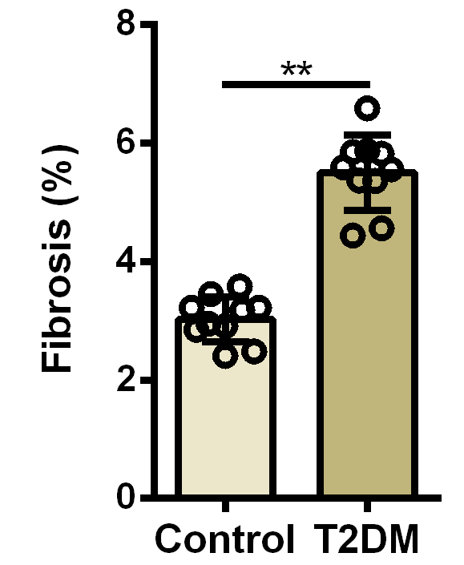
Figure S1 Quantification of fibrotic areas in DCM hearts. Fibrotic area in the section of heart tissue was quantified by ImageJ software. n=10 in each group.

Figure S2 TUNEL- and DAPI-staining of cardiomyocytes under high glucose stimulation. TUNEL signals are green, DAPI signals are blue. HG, high glucose (33 mmol/L).

Figure S3 TUNEL- and DAPI-staining of cardiomyocytes with miR-92a-2-5p overexpression or inhibition under high glucose stimulation. TUNEL signals are green, DAPI signals are blue.
Figure S4 TUNEL- and DAPI-staining of cardiomyocytes with miR-92a-2-5p/MKNK2 expression under high glucose stimulation. TUNEL signals are green, DAPI signals are blue.

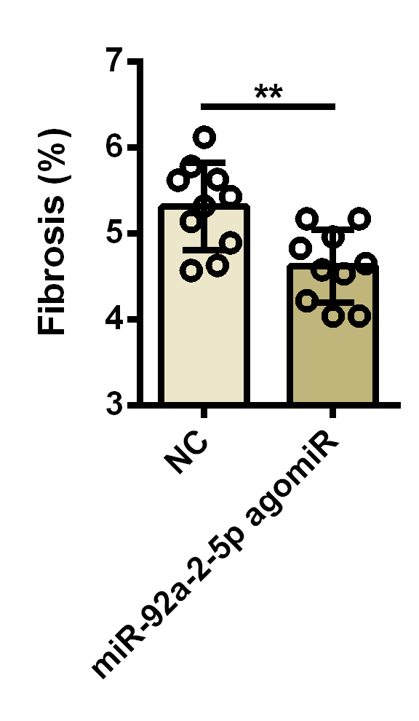
Figure S5 Quantification of fibrotic areas in DCM hearts with miR-92a-2-5p agomiR treatment. Fibrotic area in the section of heart tissue was quantified by ImageJ software. n=10 in each group.

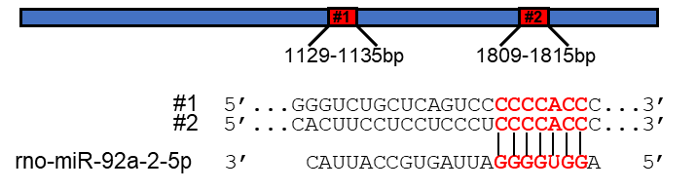
Fig. S6 The schematic of full-length 3’UTR information of human MKNK2a isoform. #1-#2, the potential binding sites of miR-92a-2-5p.

