Supplementary Materials

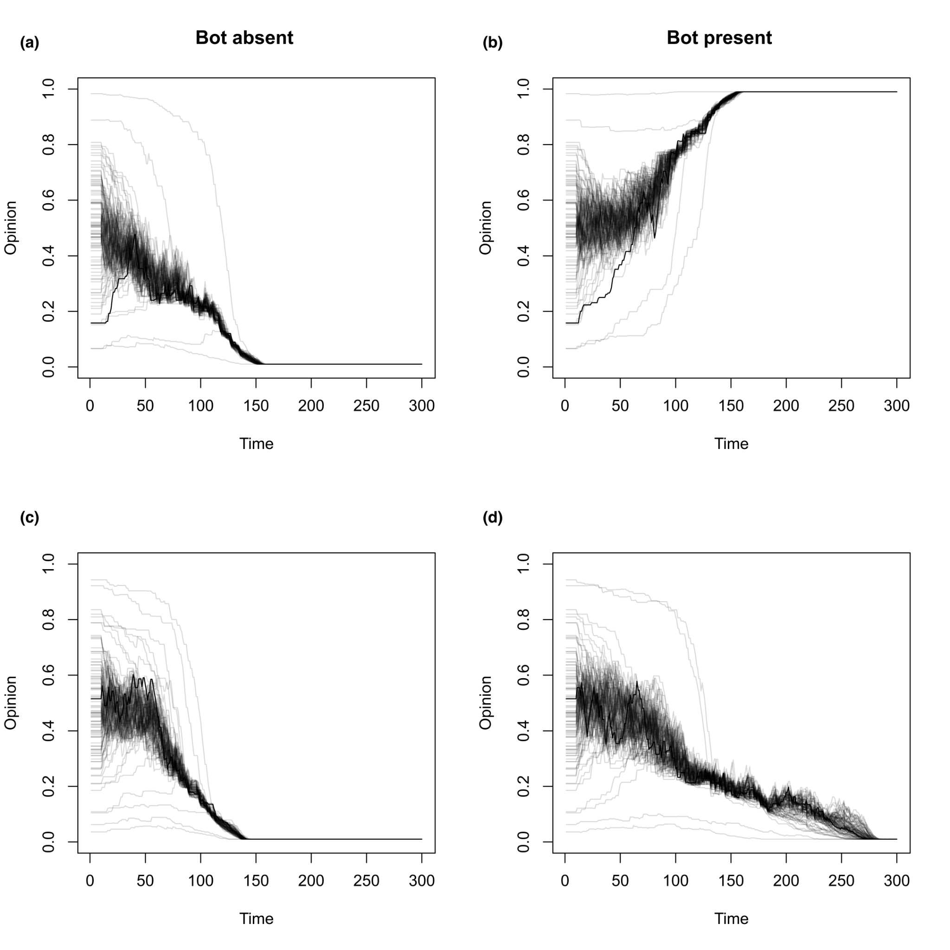
Figure S1. Individual opinion dynamics. (a) and (c) Individual opinion dynamics in the control condition (bot is absent). (b) and (d) Individual opinion dynamics in the treatment condition (bot is present). When the bot is present, consensus is faster when it is reached on the side of the bot (>0.5) than when it is on the opposite side (<0.5).

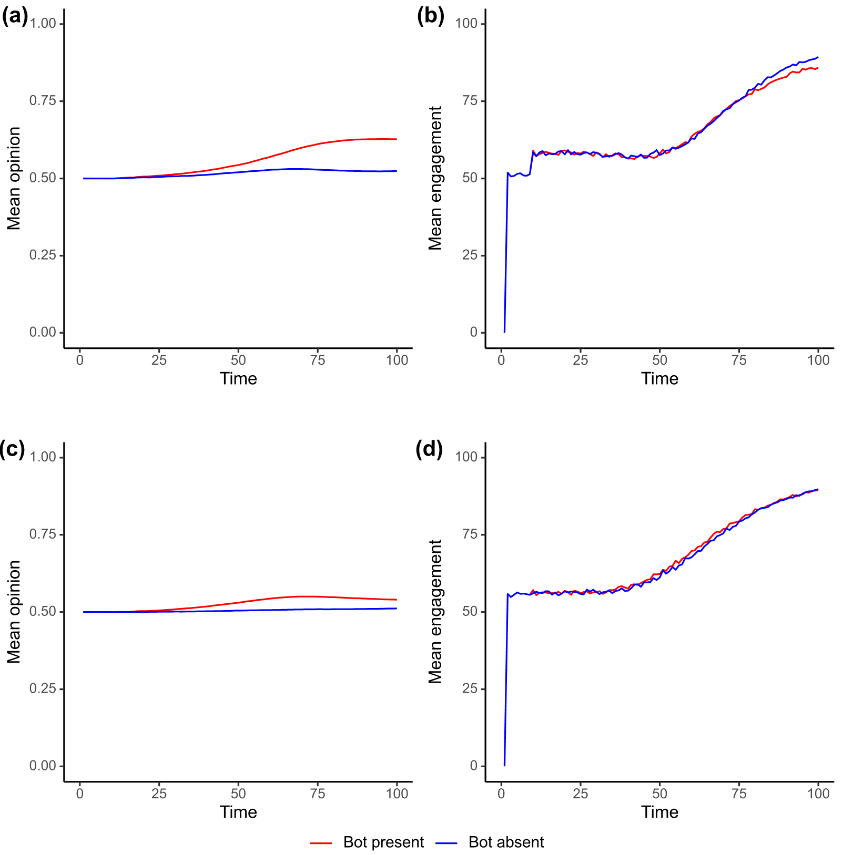
Figure S2. Variations on the engagement function. We progressively increase the similarity bias weight. This makes agents more likely to engage with similar opinions. (a) Population’s mean opinion with alpha=0.4. (b) Population’s mean engagement with alpha=0.4. (c) Population’s mean opinion with alpha=0.5. (d) agents’ mean engagement with alpha=0.5. Notice the gradual reduction of the bot’s effect as we increase the weight of the similarity bias. This effect is because, in this simulation, the bot’s opinion (0.8) was distant from the agents’ average opinions (0.5).

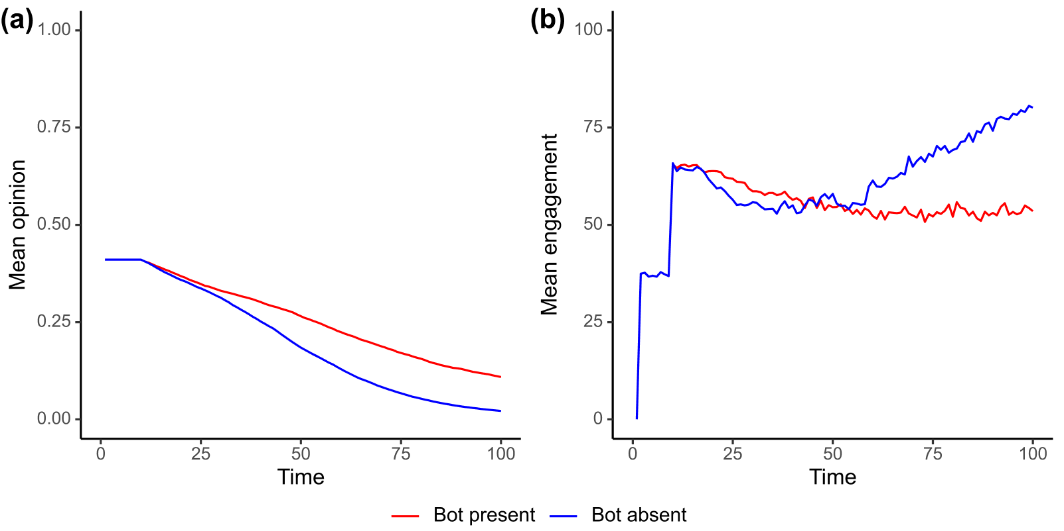

Figure S3. Variations on the average population’s opinion. (a) In this simulation, we set alpha=0 and set the population’s average opinion to 0.4. The bot’s presence slows down the convergence process. (b) In the first half of the simulation (t<50), the bot’s presence increases engagement compared to the control condition, likely because the bot holds the most extreme opinion in the population. In the second half, average engagement is higher in the bot-absent condition, likely due to the agents' convergence to one end of the opinion continuum driving up engagement (Figure S1).

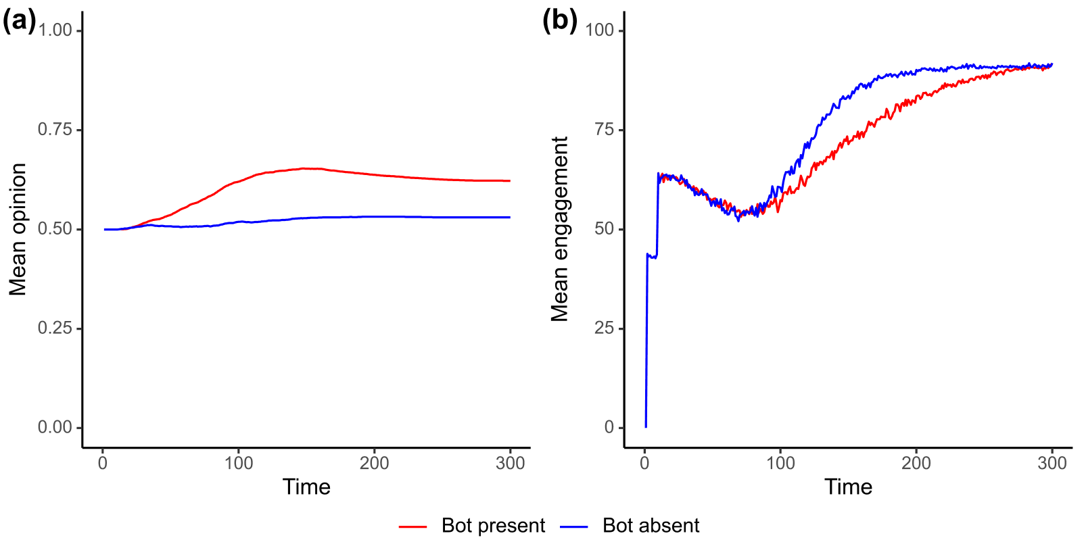
Figure S4. Longer time evolution. (a) Population’s average opinion in the control (bot absent) and treatment (bot present) conditions. In this simulation, we let the same model reproduced in Figure 2 run for longer. (b) Average engagement dynamics over 300 timesteps. Notice that after the initial 100 steps (as reproduced in the main text), the bot’s presence seems to reduce the population’s average engagement compared to the control condition.

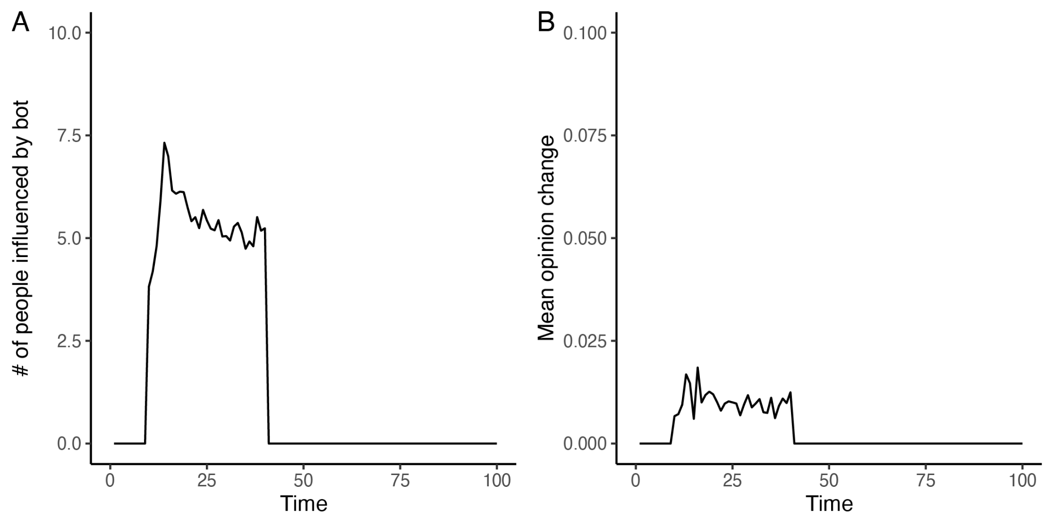

Figure S5. Direct bot influence. (a) In this simulation, the bot was removed after 40 timesteps. A sudden drop in the number of people directly influenced by the bot is observed when the bot is removed. (b) After the bot is removed from the network, a drop in average opinion change is observed.

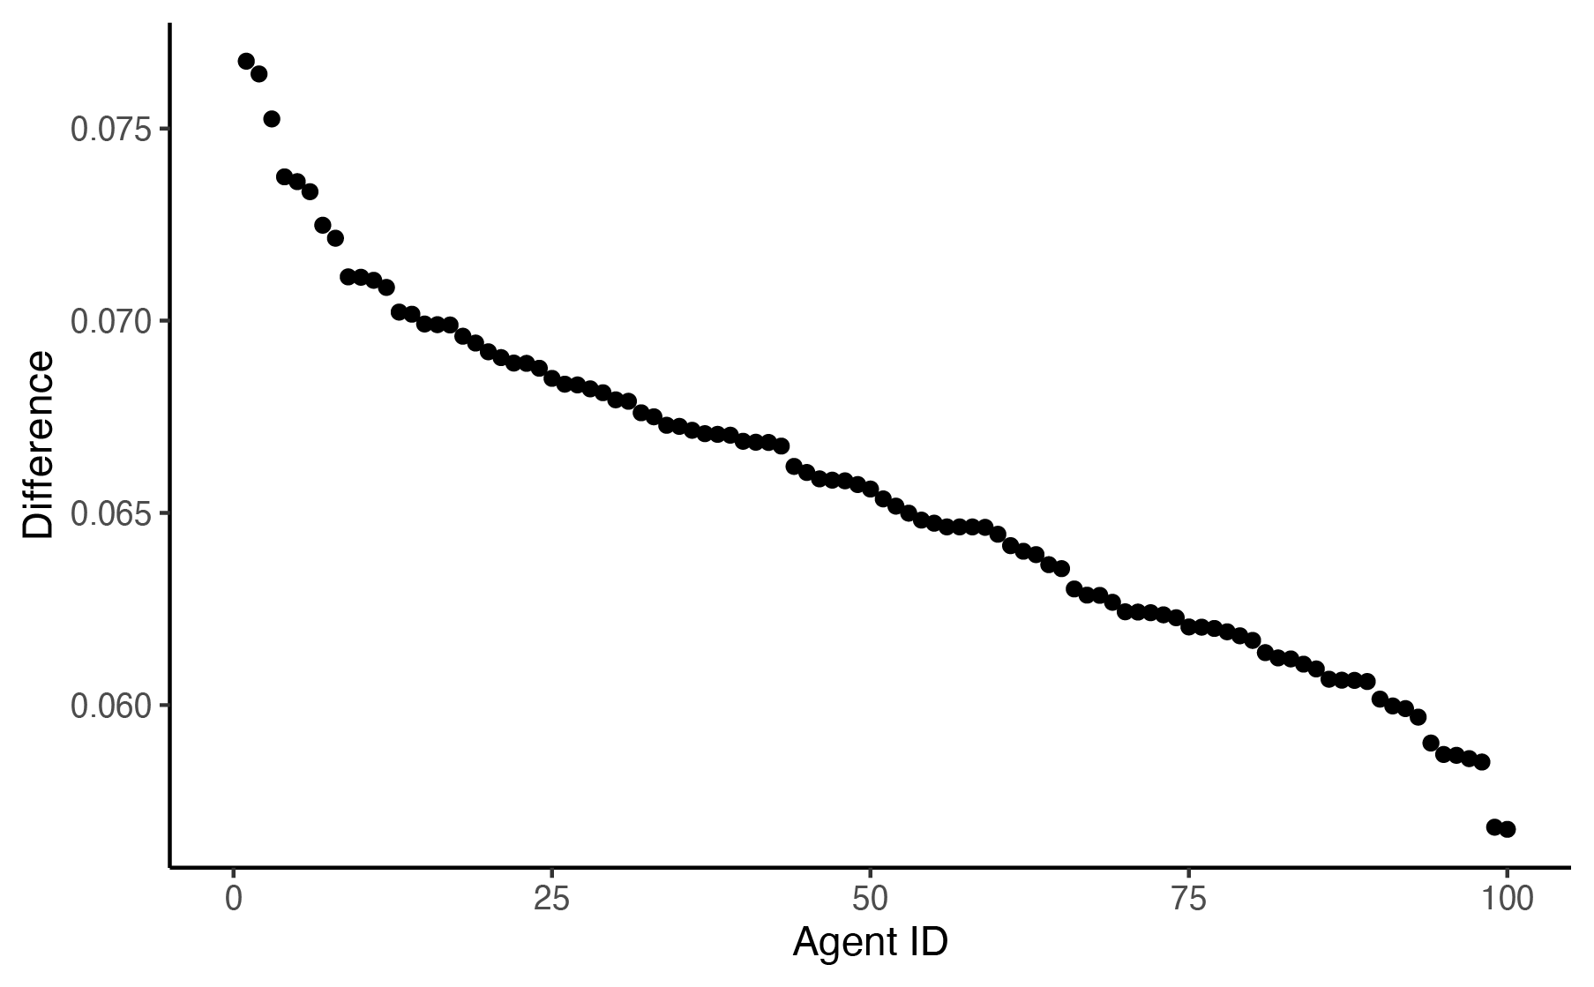

Figure S6. Within-node bot effect across the two simulations. The absolute within-node opinion distance between the bot and no-bot conditions in the final step of the simulation, in a simulation when the bot is removed after the first 40 steps. The bot presence during the first 40 trials still affects within-node opinion differences. However, this difference's magnitude is significantly reduced: it ranges from 5% to 7.5% (compared to 11-15% in Figure 4).

