Additional File 1: Supplementary tables and figures

Figure S1. Chinese vertical governmental and administrative model and the three-level hospitals in the CAMI registry.

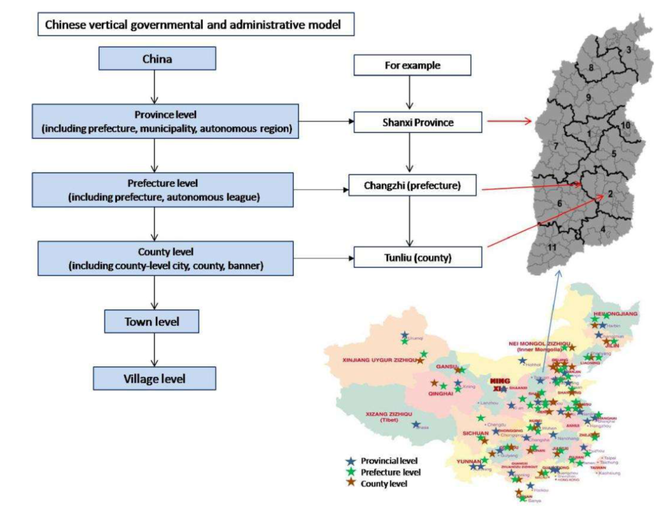
Figure S2. Flow-chart of patients included in this study. STEMI, ST-elevation myocardial infarction; CAD, coronary artery disease; MI, myocardial infarction; PCI, percutaneous coronary intervention; CABG, coronary artery bypass graft.

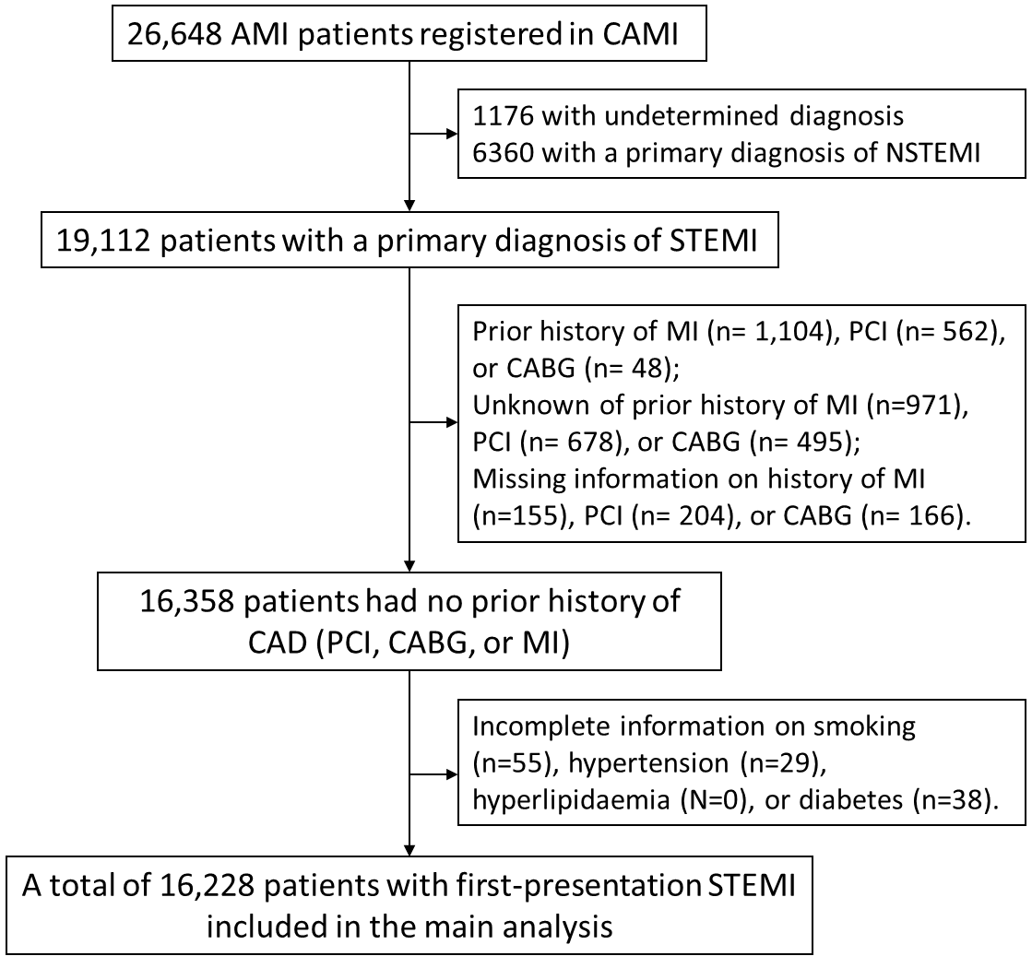

Figure S3. Reasons for No Reperfusion Therapy among the Eligible STEMI Patients

Figure S4. Landmark analysis of association of SMuRF status with all-cause mortality to 2 years. The top and bottom panel shows cumulative incident rate of all-cause mortality to 2 years among the overall patients and patients surviving at 30 days, respectively. SMuRF=standard modifiable cardiovascular risk factor.

Table S1. Definition of study variables
Variables | Definition | Continuous/  Categorical/ Binary | Completeness (%)
Admission characteristics
Age* | Years after birth | Continuous | 99.3
Sex* | Female/Male | Binary | 100
Education* | Education level; Illiterate/Primary or secondary/High/unknown | Categorical | 100
Hospital class* | Province-level/Prefecture-level/County-level | Categorical | 100
Smoking status | Current smoking was defined as smoking regularly within the past month before admission; current/former/never | Binary | 100
Hypertension | Self-reported hypertension or using antihypertensive medications before admission | Binary | 100
Diabetes | Self-reported diabetes, a glucose concentration of 11.1 mmol/L or higher, or a glycated haemoglobinA1c of 6.5% or higher. | Binary | 100
Hyperlipidemia | Self-reported hyperlipidaemia, using lipid-lowering medications before admission, an LDL-C concentration of 3.37 mmol/L or higher, or a total cholesterol concentration of 5.18 mmol/L or higher during hospitalization | Binary | 100
Body-mass index, kg/m² | Body mass index calculated during hospitalization, kg/m² | Continuous | 96.3
Medical history
Family history of coronary artery disease* | Family members (parents, siblings, and children) has ever been diagnosed with angina, acute myocardial infarction, sudden cardiac death without obvious cause, coronary artery bypass grafting, or percutaneous coronary intervention before 55 years for male and 50 years for female. Yes; No; Unknown | Categorical | 100
Heart failure | Previous history of heart failure | Binary | 99.9
Stroke* | Previous history of stroke | Binary | 99.9
Peripheral arterial disease | Previous history of peripheral vascular disease (includes upper and lower extremity, renal, mesenteric, and abdominal aortic systems) | Binary | 99.9
Chronic renal failure | Previous history of chronic renal failure | Binary | 99.7
Chronic obstructive pulmonary disease* | Previous history of chronic obstructive pulmonary disease | Binary | 99.4
Pre-hospital pharmacotherapy
Aspirin | Aspirin use in the past week before symptom onset | Binary | 99.4
P₂Y₁₂ inhibitor | Use of any kinds of P2Y₁₂ inhibitors in the past week before symptom onset | Binary | 99.2
Statin | Use of any kinds of statins in the past week before symptom onset | Binary | 97.9
β-blocker | Use of any kinds of β-blockers in the past week before symptom onset | Binary | 98.7
ACEI/ARB | Use of any kinds of ACEIs/ARBs in the past week before symptom onset | Binary | 98.5
Presentation characteristics
Means of transport | Ambulance; self or family; transferring in; in hospital. | Categorical | 99.7
Onset-to-arrival time* | Time from symptom onset to arriving hospital | Categorical; <3, 3-12, 12-24, >24h | 99.2
Time for symptoms to first medical contact, minute | Time from symptom onset to first contact with medical system (EMS system or arriving at hospitals) | Continuous | 80
GRACE risk score | Evaluated on admission |  | 95.1
Systolic blood pressure, mmHg | SBP measured on admission | Continuous | 99.2
Heart rate, beats/min | Heart rate measured on admission | Continuous | 99.4
Cardiac arrest at presentation | Cardiac arrest before admitting to hospitals or during the process of transport. |  | 100
Killip class | Evaluated on admission | Categorical | 99.6
LVEF | The first measurement of LVEF after hospitalization | Continuous | 77.7
Anterior myocardial infarction | Evaluated on admission | Categorical | 99.7
Three-vessel coronary artery disease | Evaluated using coronary angiography on admission. | Categorical | 93.7
Laboratory variables
Creatinine, mmol/L | The first measurement of creation after hospitalization | Continuous | 96.7
Glucose, mmol/L | The first measurement of glucose after hospitalization | Continuous | 96.1
Glycated haemoglobin A1c, % | The first measurement of HbA1C after hospitalization | Continuous | 34.6
Total cholesterol, mmol/L | Admission TC measured within 24 hours of hospitalization | Continuous | 90.6
Triglycerides, mmol/L | Admission TG measured within 24 hours of hospitalization | Continuous | 91.6
LDL cholesterol, mmol/L | Admission LDL-C measured within 24 hours of hospitalization | Continuous | 89.6
HDL cholesterol, mmol/L | Admission HDL-C measured within 24 hours of hospitalization | Continuous | 89.6
In-hospital management
Reperfusion therapy* | Reperfusion strategy on admission, No reperfusion/Fibrinolysis/Primary PCI | Categorical | 99
Door-to-balloon time, minute | Time between the arrival in the emergency room until the time that a balloon is inflated in the occluded, culprit coronary artery | Continuous | 29.5
Door-to needle time, minute | Time between the arrival in the emergency room until the time that the (bolus of) rtPA was given | Continuous | 53.6
Any PCI | Patients receiving any PCI during hospitalization | Binary | 100
Any CABG | Patients receiving any CABG during hospitalization | Binary | 100
Intra-aortic balloon pump use | Use of IABP during hospitalization | Binary | 98.7
Medication during hospitalization
Aspirin* | Use of aspirin during hospitalization | Binary | 99.6
P₂Y₁₂-receptor inhibitor* | Use of any kinds of P2Y₁₂ inhibitors in the past 2 weeks before symptom onset | Binary | 99
Statin* | Use of any kinds of statins during hospitalization | Binary | 99.3
β-blocker* | Use of any kinds of β-blocker during hospitalization | Binary | 98.8
ACEI/ARB* | Use of any kinds of ACEI/ARB during hospitalization | Binary | 98.7
Heparin | Use of heparin during hospitalization (not including during the process of PCI) | Binary | 97.3
Glucoprotein IIb or IIIa inhibitor | Use of glucoprotein IIb or IIIa inhibitor during hospitalization | Binary | 96.3
In-hospital outcome
Death | Any death during hospitalization | Binary | 100
Cardiac arrest | Indicate if the patient experienced an episode of cardiac arrest in the facility. | Binary | 98.9
Heart failure | Indicate if there is physician documentation or report of either new onset or acute reoccurrence of heart failure. | Binary | 99
Re-infarction | Indicate if there are clinical signs and symptoms of a new infarction or repeat infarction. | Binary | 98.9
Cerebrovascular accident or stroke | Defined as loss of neurological function caused by an ischemic or hemorrhagic  event with residual symptoms at least 24 hours after onset or leading to death. | Binary | 98.9
Severe arrhythmia | Indicate if the patient has a new episode or acute recurrence of arrhythmia in your facility documented by 1 of the following: Arial fibrillation/flutter; Supraventricular tachycardia requiring treatment (supraventricular tachycardia that requires cardioversion, drug therapy, or is sustained for greater than 1 minute); Ventricular tachycardia or ventricular fibrillation; Sinus pause or bradycardia; second-degree, or high-degree, or third-degree atrioventricular (AV) block | Binary | 99
Length of stay, day | Time from admission to discharge | Continuous | 96.4
Medication at discharge
Aspirin | Prescription of aspirin at discharge | Binary | 99.9
Clopidogrel | Prescription of clopidogrel at discharge | Binary | 99.8
Statin | Prescription of any kinds of statin at discharge | Binary | 99.8
β-blocker | Prescription of any kinds of β-blocker at discharge | Binary | 99.7
ACEI/ARB | Prescription of any kinds of ACEIs/ARBs at discharge | Binary | 99.7
*Included as covariates in the multivariate analysis.

Table S2. Baseline information stratified by the number of standard modifiable risk factors
Variables | Total (N=16228) | 0  (N=1918) | 1  (N=5852) | 2  (N=5651) | 3  (N=2411) | 4  (N=396) | P Value
Admission characteristics
Age | 61.7±12.5 | 64.9±13.0 | 62.3±12.9 | 61.3±12.2 | 59.6±11.6 | 57.4±10.2 | <0.0001
<55 | 4834 (30.0) | 436 (22.9) | 1697 (29.2) | 1690 (30.2) | 850 (35.5) | 161 (41.1)
55-74 | 8659 (53.8) | 1004 (52.6) | 3043 (52.4) | 3108 (55.5) | 1296 (54.1) | 208 (53.1)
≥75 | 2614 (16.2) | 467 (24.5) | 1069 (18.4) | 804 (14.4) | 251 (10.5) | 23 (5.9)
Male | 12381 (76.3) | 1318 (68.7) | 4492 (76.8) | 4307 (76.2) | 1901 (78.8) | 363 (91.7) | <0.0001
Education |  |  |  |  |  |  | <0.0001
Illiterate | 1293 (8.0) | 232 (12.1) | 544 (9.3) | 409 (7.2) | 100 (4.1) | 8 (2.0)
Primary or secondary | 9073 (55.9) | 1052 (54.8) | 3350 (57.2) | 3121 (55.2) | 1347 (55.9) | 203 (51.3)
High | 1348 (8.3) | 112 (5.8) | 436 (7.5) | 519 (9.2) | 229 (9.5) | 52 (13.1)
Unknown | 4514 (27.8) | 522 (27.2) | 1522 (26.0) | 1602 (28.3) | 735 (30.5) | 133 (33.6)
Hospital class |  |  |  |  |  |  | <0.0001
Province-level | 5256 (32.4) | 496 (25.9) | 1808 (30.9) | 1891 (33.5) | 889 (36.9) | 172 (43.4)
Prefecture-level | 8808 (54.3) | 1098 (57.2) | 3215 (54.9) | 3060 (54.1) | 1245 (51.6) | 190 (48.0)
County-level | 2164 (13.3) | 324 (16.9) | 829 (14.2) | 700 (12.4) | 277 (11.5) | 34 (8.6)
Smoking status |  |  |  |  |  |  | <0.0001
Never | 7062 (43.5) | 1582 (82.5) | 2824 (48.3) | 2061 (36.5) | 595 (24.7) | 0 (0)
Former | 1454 (9.0) | 336 (17.5) | 618 (10.6) | 402 (7.1) | 98 (4.1) | 0 (0)
Current | 7712 (47.5) | 0 (0) | 2410 (41.2) | 3188 (56.4) | 1718 (71.3) | 396 (100)
Hypertension | 7887 (48.6) | 0 (0) | 1822 (31.1) | 3604 (63.8) | 2065 (85.7) | 396 (100) | <0.0001
Diabetes | 4312 (26.6) | 0 (0) | 624 (10.7) | 1768 (31.3) | 1524 (63.2) | 396 (100) | <0.0001
Hyperlipidemia | 6060 (37.4) | 0 (0) | 996 (17.0) | 2742 (48.5) | 1926 (79.88) | 396 (100) | <0.0001
Weight, kg | 68.1±10.9 | 64.4±10.5 | 67.0±10.7 | 68.8±10.6 | 70.8±11.3 | 74.1±10.3 | <0.0001
Body-mass index, kg/m² | 24.1±3.1 | 23.2±3.0 | 23.8±3.1 | 24.3±3.0 | 24.9±3.3 | 25.5±3.2 | <0.0001
Medical history
Family history of coronary artery disease | 562 (3.5) | 34 (1.8) | 157 (2.7) | 213 (3.8) | 131 (5.4) | 27 (6.8) | <0.0001
Heart failure | 114 (0.7) | 11 (0.6) | 39 (0.7) | 43 (0.8) | 20 (0.8) | 1 (0.3) | 0.63
Stroke | 1399 (8.6) | 95 (5.0) | 457 (7.8) | 565 (10.0) | 230 (9.6) | 52 (13.1) | <0.0001
Peripheral arterial disease | 61 (0.4) | 5 (0.3) | 12 (0.2) | 29 (0.5) | 11 (0.5) | 4 (1.0) | 0.01
Chronic renal failure | 112 (0.7) | 8 (0.4) | 28 (0.5) | 55 (1.0) | 20 (0.8) | 1 (0.3) | 0.006
Chronic obstructive pulmonary disease | 271 (1.7) | 45 (2.4) | 105 (1.8) | 82 (1.5) | 32 (1.3) | 7 (1.8) | 0.055
Pre-hospital pharmacotherapy
Aspirin | 937 (5.8) | 38 (2.0) | 223 (3.8) | 371 (6.6) | 251 (10.4) | 54 (13.7) | <0.0001
P₂Y₁₂ inhibitor | 318 (2.0) | 15 (0.8) | 68 (1.2) | 127 (2.3) | 96 (4.0) | 12 (3.0) | <0.0001
Statin | 942 (5.9) | 0 (0) | 105 (1.8) | 417 (7.5) | 355 (14.9) | 65 (16.8) | <0.0001
β-blocker | 518 (3.2) | 0 (0) | 71 (1.2) | 232 (4.2) | 179 (7.5) | 36 (9.3) | <0.0001
ACEI/ARB | 763 (4.8) | 0 (0) | 139 (2.4) | 331 (5.9) | 238 (10.0) | 55 (14.2) | <0.0001
Presentation characteristics
Emergency medical system | 1736 (10.7) | 186 (9.7) | 597 (10.2) | 607 (10.8) | 297 (12.4) | 49 (12.5) | 0.003
Onset-to-arrival time |  |  |  |  |  |  | <0.0001
<3h | 3844 (23.9) | 392 (20.7) | 1298 (22.4) | 1383 (24.6) | 651 (27.2) | 120 (30.5)
3-12h | 6974 (43.3) | 811 (42.9) | 2522 (43.4) | 2443 (43.5) | 1021 (42.6) | 177 (44.9)
12-24h | 1665 (10.3) | 197 (10.4) | 619 (10.7) | 571 (10.2) | 238 (9.9) | 40 (10.2)
1-7d | 3619 (22.5) | 491 (26.0) | 1368 (23.6) | 1216 (21.7) | 487 (20.3) | 57 (14.5)
Time for symptoms to first medical contact, minute | 328 (139-1124) | 370 (165-1441) | 330 (141-1200) | 310 (137-1060) | 300 (120-1020) | 265 (120-827) | 0.0001
GRACE risk score | 148.4±35.4 | 156.1±35.7 | 150.2±35.0 | 146.7±34.7 | 143.8±37.1 | 138.9±32.6 | <0.0001
Systolic blood pressure, mmHg | 127.3±24.9 | 120.5±22.1 | 125.3±23.9 | 129.0±25.1 | 132.9±26.7 | 134.0±28.7 | <0.0001
Heart rate, beats/min | 77.4±18.1 | 76.8±18.0 | 76.9±18.1 | 77.4±17.9 | 78.8±18.6 | 79.6±18.3 | <0.0001
Cardiac arrest at presentation | 207 (1.3) | 24 (1.3) | 69 (1.2) | 75 (1.3) | 38 (1.6) | 1 (0.3) | 0.23
Killip class |  |  |  |  |  |  | 0.51
I | 12466 (77.2) | 1484 (77.7) | 4498 (77.2) | 4348 (77.2) | 1834 (76.4) | 302 (76.5)
II | 2510 (15.5) | 276 (14.5) | 899 (15.4) | 906 (16.1) | 369 (15.4) | 60 (15.2)
III | 566 (3.5) | 68 (3.6) | 200 (3.4) | 185 (3.3) | 97 (4.0) | 16 (4.1)
IV | 615 (3.8) | 81 (4.2) | 226 (3.9) | 190 (3.4) | 101 (4.2) | 17 (4.3)
LVEF |  |  |  |  |  |  | 0.058
Normal,>50% | 8633 (68.5) | 899 (66.2) | 3093 (68.5) | 3079 (68.8) | 1333 (69.6) | 229 (66.6)
Slightly,40-49% | 3050 (24.2) | 340 (25.0) | 1109 (24.6) | 1084 (24.2) | 433 (22.6) | 84 (24.4)
Moderately,30-39% | 797 (6.3) | 99 (7.3) | 276 (6.1) | 270 (6.0) | 123 (6.4) | 29 (8.4)
Severely,<30% | 132 (1.0) | 21 (1.5) | 38 (0.8) | 45 (1.0) | 26 (1.4) | 2 (0.6)
Anterior myocardial infarction | 9091 (56.2) | 1121 (58.6) | 3303 (56.6) | 3128 (55.5) | 1309 (54.5) | 230 (58.1) | 0.048
Three-vessel coronary artery disease * | 3762 (36.4) | 300 (29.2) | 1159 (32.4) | 1465 (39.1) | 703 (41.2) | 135 (45.5) | <0.0001
Laboratory variables
Creatinine, mmol/L | 74.0 (61.7-90.0) | 71.0 (59.0-87.0) | 73.6 (61.5-89.2) | 74.6 (62.0-90.0) | 75.6 (62.0-91.1) | 74.5 (62.6-89.0) | <0.0001
Glucose, mmol/L | 7.0 (5.7-9.1) | 6.4 (5.4-7.6) | 6.6 (5.5-8.0) | 7.2 (5.8-9.7) | 8.8 (6.6-12.4) | 11.3 (8.5-14.1) | <0.0001
Glycated haemoglobin A1c, % | 6.0 (5.5-7.0) | 5.6 (5.3-6.0) | 5.7 (5.4-6.1) | 6.0 (5.5-7.2) | 6.8 (5.9-8.2) | 7.4 (6.7-8.5) | <0.0001
Total cholesterol, mmol/L | 4.5 (3.8-5.3) | 4.1 (3.6-4.6) | 4.3 (3.7-4.8) | 4.7 (4.0-5.5) | 5.2 (4.4-5.8) | 5.4 (4.9-6.1) | <0.0001
Triglycerides, mmol/L | 1.4 (1.0-2.0) | 1.1 (0.8-1.6) | 1.3 (0.9-1.8) | 1.5 (1.0-2.2) | 1.7 (1.2-2.5) | 2.0 (1.4-3.0) | <0.0001
LDL cholesterol, mmol/L | 2.8 (2.2-3.4) | 2.4 (2.0-2.8) | 2.6 (2.1-3.1) | 2.9 (2.3-3.6) | 3.3 (2.6-3.9) | 3.5 (2.8-3.8) | <0.0001
HDL cholesterol, mmol/L | 1.1 (0.9-1.3) | 1.1 (0.9-1.3) | 1.1 (0.9-1.3) | 1.1 (0.9-1.3) | 1.1 (0.9-1.3) | 1.0 (0.9-1.2)
In-hospital management
Reperfusion therapy
Among all the patients |  |  |  |  |  |  | <0.0001
No reperfusion | 7430 (46.2) | 1000 (52.8) | 2818 (48.6) | 2505 (44.8) | 955 (40.0) | 152 (38.5)
Fibrinolysis | 1618 (10.1) | 172 (9.1) | 584 (10.1) | 589 (10.5) | 236 (9.9) | 37 (9.4)
Primary PCI | 7017 (43.7) | 722 (38.1) | 2399 (41.4) | 2495 (44.6) | 1195 (50.1) | 206 (52.2)
Among patients admitted within 12 hours from onset |  |  |  |  |  |  | <0.0001
No reperfusion | 2953 (27.6) | 394 (33.2) | 1103 (29.1) | 1015 (26.8) | 365 (22.1) | 76 (25.7)
Fibrinolysis | 1552 (14.5) | 163 (13.7) | 560 (1.8) | 562 (14.8) | 231 (14.0) | 36 (12.2)
Primary PCI | 6210 (58.0) | 631 (53.1) | 2125 (56.1) | 2211 (58.4) | 1059 (64.0) | 184 (62.2)
Door-to-balloon time, minute | 107 (75-159) | 110 (63-200) | 105 (70-150) | 110 (80-163) | 105 (75-150) | 110 (90-152) | 0.29
Door-to needle time, minute | 53 (30-90) | 50 (29-79.5) | 50 (30-90) | 56.5 (30-90) | 52.5 (30-103) | 45 (29-68) | 0.49
Any PCI | 10361 (63.8) | 1041 (54.3) | 3602 (61.6) | 3740 (66.2) | 1686 (69.9) | 292 (73.7) | <0.0001
Any CABG | 98 (0.6) | 9 (0.5) | 29 (0.5) | 36 (0.6) | 19 (0.8) | 5 (1.3) | 0.20
Intra-aortic balloon pump use | 547 (3.4) | 50 (2.6) | 186 (3.2) | 188 (3.4) | 106 (4.4) | 17 (4.4) | 0.01
Medication during hospitalization
Aspirin | 15697 (97.1) | 1840 (96.6) | 5641 (96.8) | 5478 (97.3) | 2349 (97.8) | 389 (98.2) | 0.04
P₂Y₁₂-receptor inhibitor | 15669 (97.5) | 1811 (95.7) | 5662 (97.7) | 5466 (97.6) | 2340 (98.0) | 390 (99.0) | <0.0001
Statin | 15598 (96.8) | 1807 (95.6) | 5620 (96.8) | 5456 (97.0) | 2327 (97.0) | 388 (98.0) | 0.02
β-blocker | 11227 (70.0) | 1270 (67.2) | 4033 (69.5) | 3902 (69.8) | 1718 (72.7) | 304 (77.9) | <0.0001
ACEI/ARB | 9404 (58.7) | 914 (48.5) | 3240 (55.9) | 3379 (60.6) | 1593 (67.4) | 278 (71.1) | <0.0001
Heparin | 14449 (91.5) | 1642 (88.8) | 5228 (91.6) | 5060 (91.9) | 2161 (92.0) | 358 (93.5) | 0.0003
Glucoprotein IIb or IIIa inhibitor | 5511 (35.3) | 549 (30.0) | 1920 (34.1) | 2000 (36.6) | 892 (38.3) | 150 (39.5) | <0.0001
In-hospital outcome
Death | 1015 (6.3) | 157 (8.2) | 360 (6.2) | 342 (6.1) | 147 (6.1) | 9 (2.3) | 0.0001
Cardiac arrest | 567 (3.5) | 90 (4.8) | 202 (3.5) | 192 (3.4) | 77 (3.2) | 6 (1.5) | 0.008
Heart failure | 2501 (15.6) | 311 (16.5) | 884 (15.3) | 894 (16.0) | 371 (15.5) | 41 (10.5) | 0.04
Re-infarction | 88 (0.5) | 8 (0.4) | 30 (0.5) | 32 (0.6) | 18 (0.8) | 0 (0) | 0.32
Cerebrovascular accident or stroke | 127 (0.8) | 12 (0.6) | 44 (0.8) | 48 (0.9) | 22 (0.9) | 1 (0.3) | 0.57
Severe arrhythmia | 1372 (8.5) | 161 (8.5) | 521 (9.0) | 484 (8.6) | 180 (7.5) | 26 (6.6) | 0.17
Length of stay, day | 10 (7-13) | 10 (7-14) | 10 (7-13) | 10 (7-13) | 9 (7-13) | 10 (7-13) | 0.10
Medication at discharge
Aspirin | 15066 (99.2) | 1726 (98.3) | 5440 (99.2) | 5266 (99.3) | 2249 (99.3) | 385 (99.5) | <0.0001
Clopidogrel | 14868 (98.0) | 1701 (97.1) | 5365 (97.9) | 5202 (98.2) | 2218 (98.1) | 382 (98.7) | 0.08
Statin | 14993 (98.7) | 1709 (97.5) | 5415 (98.8) | 5249 (99.0) | 2236 (98.8) | 384 (99.2) | <0.0001
β-blocker | 11725 (77.3) | 1319 (75.2) | 4170 (76.1) | 4109 (77.6) | 1805 (80.0) | 322 (83.6) | <0.0001
ACEI/ARB | 10135 (66.8) | 1014 (57.9) | 3479 (63.5) | 3652 (69.0) | 1689 (74.8) | 301 (78.2) | <0.0001
SMuRF=standard modifiable cardiovascular risk factor; ACEI=angiotensin-converting enzyme inhibitor; ARB=angiotensin receptor blocker; LVEF=left ventricular ejection fraction; PCI, percutaneous coronary intervention; CABG, coronary artery bypass graft.
Table S3. Adjusted Proportions of Evidence-based Medication Use among Patients with First ST-segment Elevation Myocardial Infarction by Number of Cardiovascular Risk Factors
 | Without SMuRFs | 1-2 SMuRFs | 3-4 SMuRFs | P_{trend}
Medication during hospitalization
Aspirin | 97.2 (95.2-98.4) | 96.7 (94.8-97.9) | 97.2 (95.4-98.3) | 0.9065
P₂Y₁₂-receptor inhibitor | 96.4 (93.8-97.9) | 97.5 (95.9-98.5) | 97.7 (96.0-98.6) | 0.0286
Statin | 94.6 (91.6-96.6) | 95.3 (93.2-96.8) | 95.1 (92.6-96.8) | 0.6566
β-blocker | 64.4 (59.1-69.4) | 63.3 (58.6-67.8) | 64.0 (59.1-68.7) | 0.9333
ACEI/ARB | 55.6 (50.3-60.8) | 61.5 (56.9-65.9) | 67.9 (63.4-72.0) | <0.0001
Medication at discharge
Aspirin | 99.3 (97.7-99.8) | 99.6 (98.8-99.9) | 99.6 (98.6-99.9) | 0.1218
Clopidogrel | 98.6 (96.0-99.5) | 98.9 (96.9-99.6) | 99.1 (97.3-99.7) | 0.102
Statin | 98.0 (94.9-99.2) | 98.8 (97.2-99.5) | 98.5 (96.3-99.4) | 0.4257
β-blocker | 76.8 (71.5-81.3) | 76.5 (71.8-80.6) | 77.7 (73.0-81.9) | 0.4299
ACEI/ARB | 71.0 (65.7-75.8) | 75.4 (71.0-79.3) | 80.7 (76.8-84.1) | <0.0001

Models were adjusted for age, sex, education level, hospital class, pre-hospital aspirin, systolic blood pressure, heart rate, creatinine, Killip class, cardiac arrest, onset-to-arrival time, anterior myocardial infarction, and reperfusion therapy.

Table S4. Association of SMuRF status with in-hospital, 30-day, and 2-year mortality
 |  | 30-day mortality |  | 2-year mortality |  | In-hospital mortality
Factors | Reference | OR (95% CI) | P value | HR (95% CI) | P value | HR (95% CI) | P value
Unadjusted model
1-2 SMuRFs | No SMuRFs | 0.73 (0.61-0.87) | 0.0006 | 0.75 (0.64-0.88) | 0.0004 | 0.79 (0.7-0.9) | 0.0005
3-4 SMuRFs | No SMuRFs | 0.66 (0.53-0.83) | 0.0004 | 0.63 (0.52-0.78) | <0.0001 | 0.68 (0.58-0.8) | <0.0001
Adjusted model
1-2 SMuRFs | No SMuRFs | 1.15 (0.96-1.39) | 0.14 | 1.19 (1.02-1.39) | 0.02 | 1.22 (0.95-1.55) | 0.12
3-4 SMuRFs | No SMuRFs | 1.31 (1.02-1.68) | 0.03 | 1.39 (1.14-1.69) | 0.001 | 1.55 (1.14-2.12) | 0.006
Baseline characteristics
Age |  | 1.04 (1.04-1.05) | <0.0001 | 1.05 (1.05-1.06) | <0.0001 | 1.06 (1.05-1.06) | <0.0001
Male | Female | 0.66 (0.57-0.75) | <0.0001 | 0.76 (0.68-0.85) | <0.0001 | 0.59 (0.49-0.7) | <0.0001
Education
Primary or secondary | Illiteracy | 1.02 (0.84-1.23) | 0.86 | 0.98 (0.84-1.14) | 0.78 | 0.95 (0.75-1.22) | 0.71
High | Illiteracy | 0.88 (0.62-1.25) | 0.47 | 0.77 (0.58-1.02) | 0.07 | 0.78 (0.49-1.23) | 0.28
Unknown | Illiteracy | 1.11 (0.89-1.37) | 0.36 | 1.01 (0.85-1.2) | 0.88 | 1.09 (0.82-1.43) | 0.56
Hospital class
Prefecture-level | Province-level | 1.30 (1.09-1.54) | 0.003 | 1.29 (1.13-1.47) | 0.0002 | 1.32 (1.07-1.63) | 0.01
County-level | Province-level | 1.79 (1.44-2.22) | <0.0001 | 1.64 (1.38-1.95) | <0.0001 | 1.89 (1.44-2.49) | <.0001
BMI |  | 0.99 (0.97-1.01) | 0.15 | 0.99 (0.97-1) | 0.09 | 0.99 (0.96-1.01) | 0.29
Pre-hospital aspirin - Yes | No | 0.96 (0.73-1.25) | 0.75 | 0.94 (0.77-1.16) | 0.57 | 1.06 (0.76-1.48) | 0.72
Family history of CAD
Yes | No | 0.92 (0.57-1.47) | 0.71 | 0.73 (0.49-1.1) | 0.13 | 0.88 (0.49-1.58) | 0.67
Unknown | No | 1.27 (1.08-1.50) | 0.004 | 1.17 (1.02-1.34) | 0.02 | 1.31 (1.05-1.62) | 0.01
Prior history of stroke - Yes | No | 1.55 (1.30-1.84) | <0.0001 | 1.55 (1.35-1.78) | <0.0001 | 1.46 (1.16-1.84) | 0.001
Prior history of COPD - Yes | No | 1.14 (0.84-1.56) | 0.41 | 1.22 (0.96-1.56) | 0.11 | 1.21 (0.78-1.87) | 0.39
Presenting characteristics
Systolic blood pressure (per 10 mmHg) |  | 0.89 (0.87-0.92) | <0.0001 | 0.92 (0.9-0.94) | <0.0001 | 0.86 (0.83-0.89) | <.0001
Creatinine (per 10 mmHg) |  | 1.03 (1.02-1.04) | <0.0001 | 1.03 (1.02-1.03) | <0.0001 | 1.04 (1.03-1.06) | <.0001
Heart rate (per 10 beats/min) |  | 1.18 (1.14-1.21) | <0.0001 | 1.16 (1.14-1.19) | <0.0001 | 1.23 (1.18-1.28) | <.0001
Killip class
II | I | 1.38 (1.17-1.64) | 0.0002 | 1.38 (1.21-1.57) | <0.0001 | 1.33 (1.07-1.64) | 0.009
III | I | 1.78 (1.42-2.24) | <0.0001 | 1.84 (1.54-2.21) | <0.0001 | 1.92 (1.42-2.58) | <.0001
IV | I | 2.56 (2.09-3.15) | <0.0001 | 2.51 (2.11-2.98) | <0.0001 | 3.64 (2.78-4.78) | <.0001
Cardiac arrest - Yes | No | 2.06 (1.47-2.89) | <0.0001 | 1.69 (1.24-2.31) | 0.001 | 2.38 (1.48-3.85) | 0.0004
Anterior myocardial infarction - Yes | No | 1.44 (1.25-1.66) | <0.0001 | 1.37 (1.23-1.53) | <0.0001 | 1.74 (1.45-2.08) | <.0001
Onset-to-arrival time
3-12 h | <3 h | 1.25 (1.03-1.51) | 0.0209 | 1.24 (1.07-1.43) | 0.005 | 1.27 (1.01-1.61) | 0.04
12-24 h | <3 h | 1.36 (1.07-1.74) | 0.01 | 1.23 (1.01-1.49) | 0.04 | 1.34 (0.98-1.83) | 0.06
1-7 d | <3 h | 1.01 (0.81-1.25) | 0.95 | 0.96 (0.81-1.14) | 0.67 | 0.99 (0.75-1.3) | 0.93
In-hospital management
Reperfusion therapy
Thrombolysis | No reperfusion | 0.98 (0.77-1.24) | 0.87 | 0.92 (0.76-1.11) | 0.39 | 1.15 (0.86-1.54) | 0.34
Primary PCI | No reperfusion | 0.57 (0.48-0.69) | <0.0001 | 0.58 (0.5-0.66) | <0.0001 | 0.54 (0.43-0.67) | <.0001
Aspirin – Yes | No | 0.71 (0.55-0.92) | 0.01 | 0.7 (0.56-0.86) | 0.001 | 0.6 (0.42-0.87) | 0.007
P2Y12 – Yes | No | 0.91 (0.68-1.2) | 0.49 | 0.85 (0.68-1.07) | 0.16 | 0.78 (0.53-1.16) | 0.22
Statin – Yes | No | 0.47 (0.37-0.59) | <0.0001 | 0.49 (0.4-0.6) | <0.0001 | 0.33 (0.24-0.46) | <.0001
β-blocker – Yes | No | 0.53 (0.46-0.61) | <0.0001 | 0.63 (0.56-0.71) | <0.0001 | 0.47 (0.39-0.56) | <.0001
ACEI/ARB – Yes | No | 0.61 (0.53-0.71) | <0.0001 | 0.69 (0.61-0.77) | <0.0001 | 0.51 (0.43-0.61) | <.0001

OR, odds ratio; CI, confidence interval; HR, hazard ratio; SMuRF, standard modifiable cardiovascular risk factor; PCI, percutaneous coronary intervention; ACEI/ARB, angiotensin-converting enzyme inhibitor or angiotensin receptor blocker.

Table S5. Sensitivity analysis for the association of SMuRF status with all-cause mortality at 30 days
 | Without SMuRFs | 1-2 SMuRFs | 3-4 SMuRFs | P_{trend}
Main analysis
Unadjusted (n=16,228) | 1 (Ref) | 0.75 (0.64-0.88) | 0.63 (0.52-0.78) | <0.0001
Adjusted (n=14,319) | 1 (Ref) | 1.15 (0.95-1.39) | 1.31 (1.02-1.68) | 0.03
SA1: excluding patients without lipid and glucose measurements at admission
Unadjusted (n=14,154) | 1 (Ref) | 0.81 (0.66-1.00) | 0.80 (0.63-1.03) | 0.13
Adjusted (n=12,904) | 1 (Ref) | 1.15 (0.92-1.44) | 1.45 (1.10-1.91) | 0.009
SA2: removing patients occurring death with the first 24 hours
Unadjusted (n=15,804) | 1 (Ref) | 0.86 (0.70-1.06) | 0.74 (0.57-0.96) | 0.02
Adjusted (n=14,027) | 1 (Ref) | 1.19 (0.95-1.50) | 1.31 (0.97-1.76) | 0.08
SA3: excluding patients transferring out
Unadjusted (n=15,403) | 1 (Ref) | 0.74 (0.63-0.87) | 0.62 (0.50-0.76) | <0.0001
Adjusted (n=13,633) | 1 (Ref) | 1.13 (0.94-1.37) | 1.29 (1.00-1.65) | 0.048
SA3: excluding patients occurring death with the first 24 hours and transferring out
Unadjusted (n=14,987) | 1 (Ref) | 0.83 (0.68-1.03) | 0.71 (0.54-0.92) | 0.01
Adjusted (n=13,346) | 1 (Ref) | 1.18 (0.93-1.48) | 1.28 (0.94 -1.73) | 0.11

Models were adjusted for Model 3 was adjusted for age, sex, education, hospital levels, BMI, family history of CAD, prior history of stroke, prior history of COPD, pre-admission aspirin, onset-to-arrival time, pre-admission cardiac arrest, heart rate, systolic blood pressure, plasma creatinine, Killip class, anterior myocardial infarction, reperfusion strategies, and evidence-based medications (aspirin, P2Y12-receptor inhibitor, statin, ACEi/ARB, and β-blocker). HR, hazard ratio; CI, confidence interval; SMuRF, standard modifiable cardiovascular risk factor; CAD, coronary artery disease; COPD, chronic obstructive pulmonary disease; ACEI, angiotensin-converting enzyme inhibitor; ARB, angiotensin receptor blocker.

