Supplementary Materials

Supplementary figures
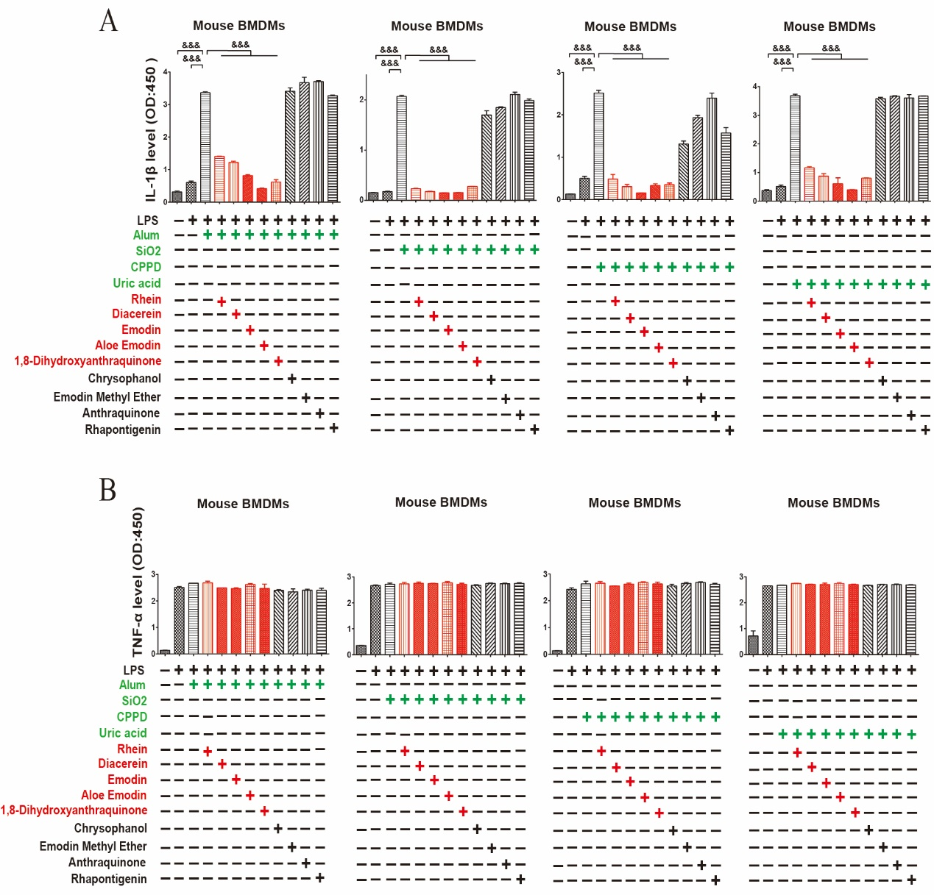

Additional file 1: Fig S 1. RFAs inhibited NLRP3 inflammasome induced by uric acid, alum, SiO₂ and CPPD.
Moue BMDMs were pretreated with RFAs (40μM rhein / 40μM diacerein, 40μM emodin, 40μM aloe emodin, 40μM 1,8-dihydroxyanthraquinone, 20μM chrysophanol, 4μM emodin methyl ether, 4μM anthraquinone) for 30 minutes and then stimulated with LPS (100ng / ml) for 4 hours. uric acid (100μg / ml), alum (100μg / ml), SiO₂ (100μg / ml) and CPPD (100μg / ml) were added for 12 hours. IL-1β (A) and TNF-α (B) in cell culture supernatant were detected by ELISA (n=3 / group). Data are presented as mean ± SEM. For multiple comparisons, one-way ANOVA coupled with LSD’s post hoc testing was performed. &: P<0.05; &&: p<0.01; &&&: p<0.001. ANOVA, analysis of variance; BMDMs, bone marrow-derived macrophages; CPPD, calcium pyrophosphate; ELISA, enzyme linked immunosorbent assay; IL-1β, interleukin-1 beta; LPS, lipopolysaccharide; SiO₂, silicon dioxide; TNF-α, tumor necrosis factor-alpha.
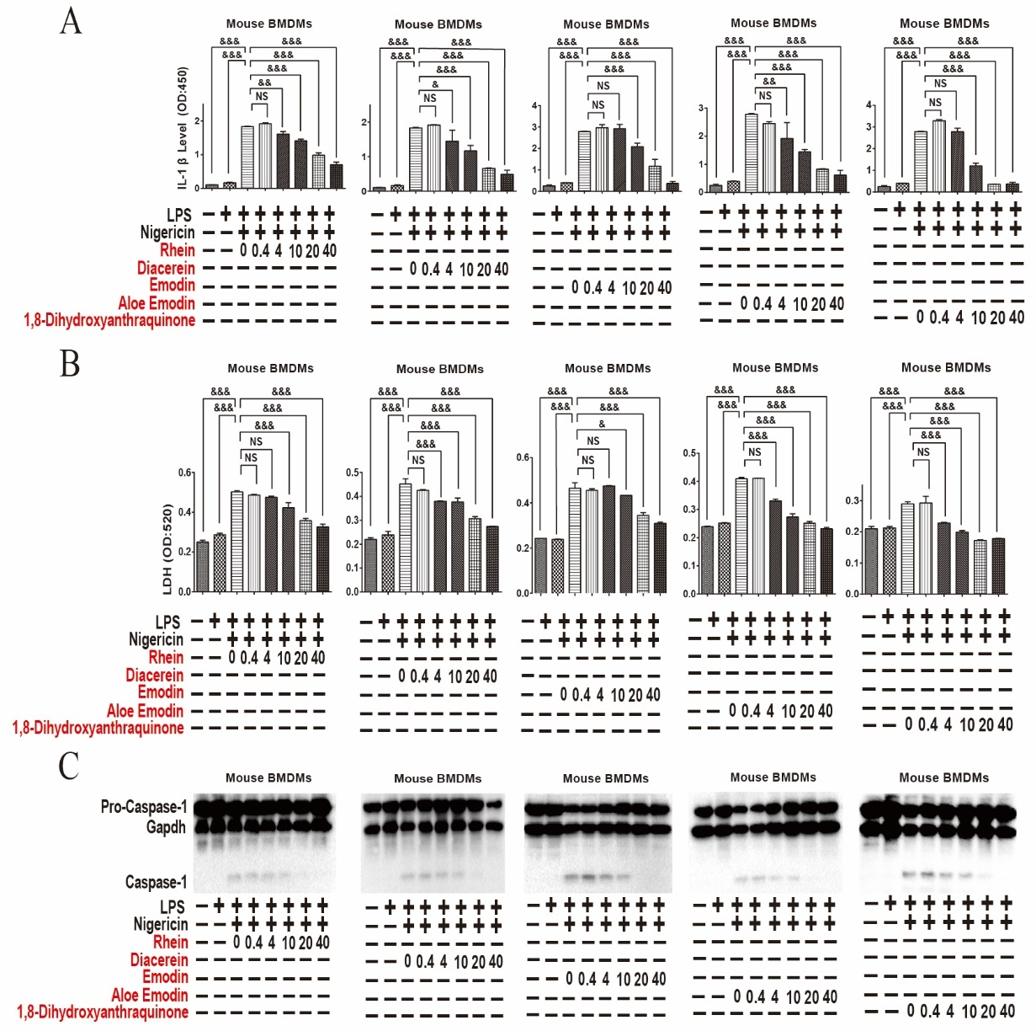

Additional file 1: Fig S 2. RFAs inhibited NLRP3 inflammasome in a dose dependent manner.
Mouse BMDMs were pretreated by rhein, diacerein, emodin, aloe emodin and 1,8-dihydroxyanthraquinone with the concentration of 40μM, 20μM, 10μM, 4μM and 0.4μM for 30 minutes, and then stimulated with LPS (100ng / ml) for 4 hours. Nigericin (2.5μM) was added for 2 hours. IL-1β (A) in cell culture supernatant were detected by ELISA (n=3 / group), LDH (B) in cell culture supernatant were detected by biochemical kit (n=3 / group), The cleavage of pro-caspase-1 (C) was detected by western blot. Data are presented as mean ± SEM. For multiple comparisons, one-way ANOVA coupled with LSD’s post hoc testing was performed. &: P<0.05; &&: p<0.01; &&&: p<0.001. ANOVA, analysis of variance; BMDMs, bone marrow-derived macrophages; ELISA, enzyme linked immunosorbent assay; IL-1β, interleukin-1 beta; LDH, lactate dehydrogenase; LPS, lipopolysaccharide; NS, no significance; TNF-α, tumor necrosis factor-alpha.
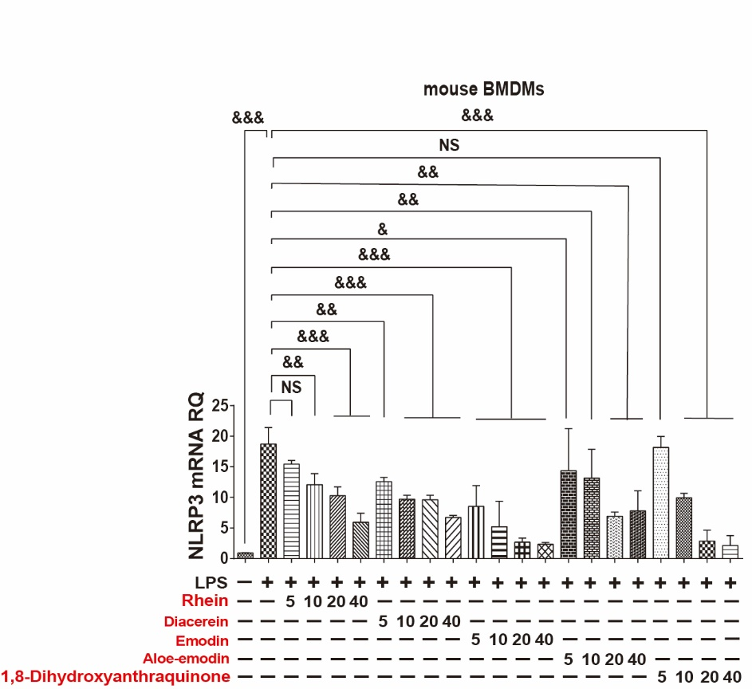

Additional file 1: Fig S 3. RFAs inhibited the transcription of NLRP3 in a dose dependent manner.
Mouse BMDMs were pretreated by rhein, diacerein, emodin, aloe emodin and 1,8-dihydroxyanthraquinone with the concentration of 40μM, 20μM, 10μM and 5μM for 30min and then stimulated with 100ng / ml LPS for 1 hours. NLRP3 mRNA were detected by RT-qPCR (n=3 / group). Data are presented as mean ± SEM. For multiple comparisons, one-way ANOVA coupled with LSD’s post hoc testing was performed. &: P<0.05; &&: p<0.01; &&&: p<0.001. ANOVA, analysis of variance; BMDMs, bone marrow-derived macrophages; LPS, lipopolysaccharide; NS, no significance; RT-qPCR, quantitative reverse transcription polymerase chain reaction.

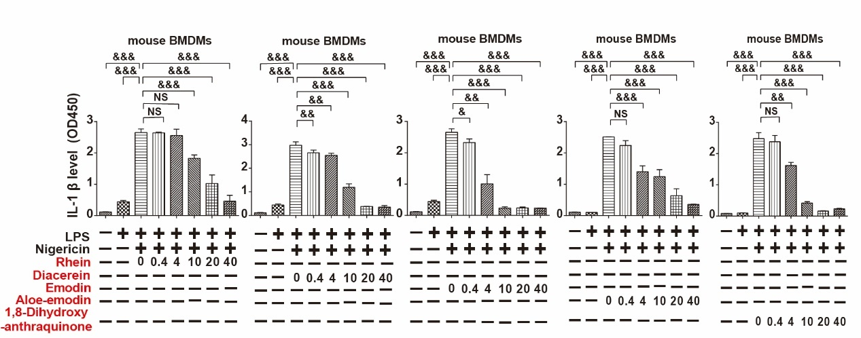

Additional file 1: Fig S 4. RFAs inhibited the assembly of NLRP3 inflammasome in a dose dependent manner.
Mouse BMDMs were stimulated by LPS (100ng / ml) for 4 hours before the media was changed. Rhein, diacerein, emodin, aloe emodin and 1,8-dihydroxyanthraquinone with the concentrations of 40μM, 20μM, 10μM, 4μM and 0.4μM were added for 30 minutes and then stimulated with nigericin (2.5μM) for 2 hours. IL-1β in cell culture supernatant was detected by ELISA (n=3 / group). Data are presented as mean ± SEM. For multiple comparisons, one-way ANOVA coupled with LSD’s post hoc testing was performed. &: P<0.05; &&: p<0.01; &&&: p<0.001. ANOVA, analysis of variance; BMDMs, bone marrow-derived macrophages; ELISA, enzyme linked immunosorbent assay; IL-1β, interleukin-1 beta; LPS, lipopolysaccharide, NS, no significance.
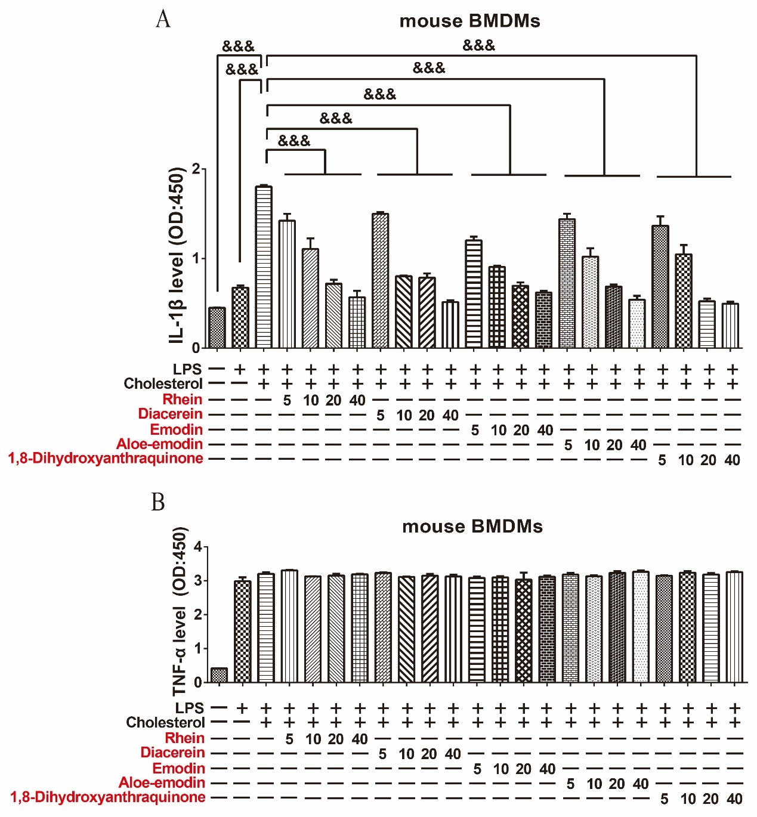

Additional file 1: Fig S 5. RFAs inhibited cholesterol induced NLRP3 inflammasome in mouse BMDMs in a dose dependent manner.
Mouse BMDMs were pretreated by RFAs (Rhein, diacerein, emodin, aloe emodin and 1,8-dihydroxyanthraquinone with the concentrations of 40μM, 20μM, 10μM and 5μM) for 30 minutes and then stimulated with LPS (100ng/ml) for 4 hours and cholesterol (100μg / ml) for 12 hours. IL-1β (A) and TNF-α (B) in cell culture supernatant were detected by ELISA (n=3 / group). Data are presented as mean ± SEM. For multiple comparisons, one-way ANOVA coupled with LSD’s post hoc testing was performed. &: P<0.05; &&: p<0.01; &&&: p<0.001. ANOVA, analysis of variance; BMDMs, bone marrow-derived macrophages; ELISA, enzyme linked immunosorbent assay; IL-1β, interleukin-1 beta; LPS, lipopolysaccharide; TNF-α, tumor necrosis factor-alpha.
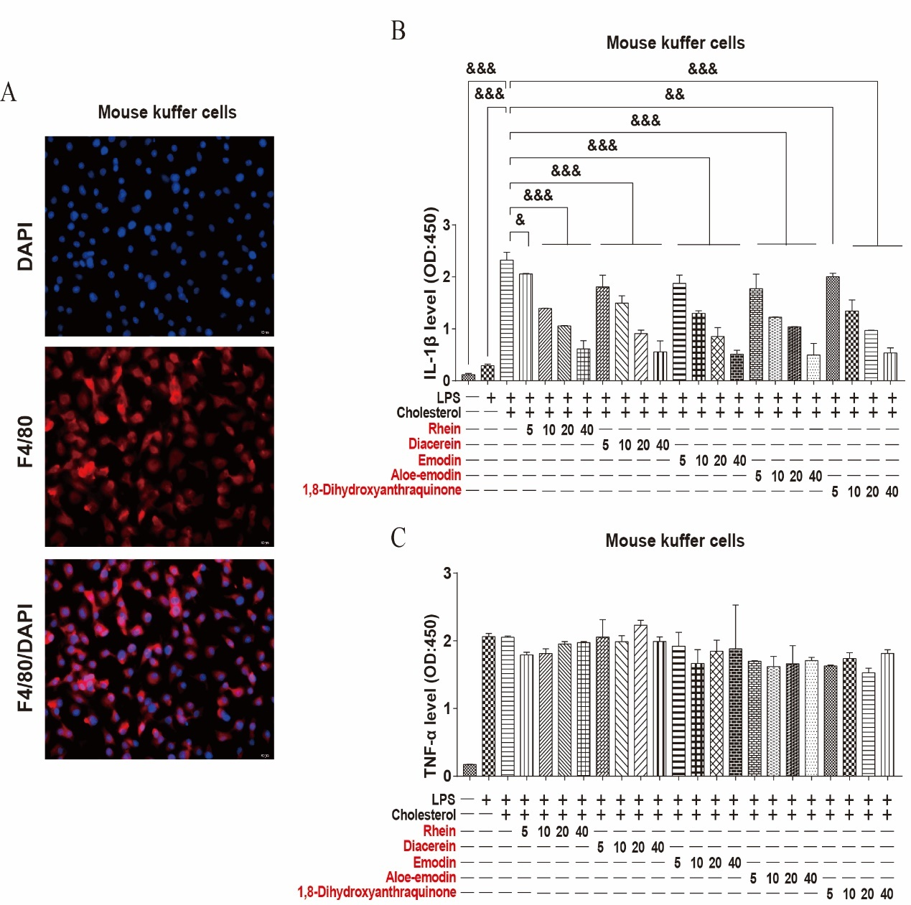

Additional file 1: Fig S 6. RFAs inhibited cholesterol induced NLRP3 inflammasome in mouse Kuffer cells.
Mouse Kuffer cells were identified by immunofluorescence through detecting F4/80 (A). Mouse Kuffer cells were pretreated by RFAs (Rhein, diacerein, emodin, aloe emodin and 1,8-dihydroxyanthraquinone with the concentrations of 40μM, 20μM, 10μM and 5μM) for 30 minutes and then stimulated with LPS (100ng / ml) for 4 hours and cholesterol (100μg / ml) for 12 hours. IL-1β (B) and TNF-α (C) in cell culture supernatant were detected by ELISA (n=3 / group). Data are presented as mean ± SEM. For multiple comparisons, one-way ANOVA coupled with LSD’s post hoc testing was performed. &: P<0.05; &&: p<0.01; &&&: p<0.001. ANOVA, analysis of variance; DAPI, 4',6-diamidino-2-phenylindole; ELISA, enzyme linked immunosorbent assay; IL-1β, interleukin-1 beta; LPS, lipopolysaccharide; TNF-α, tumor necrosis factor-alpha.
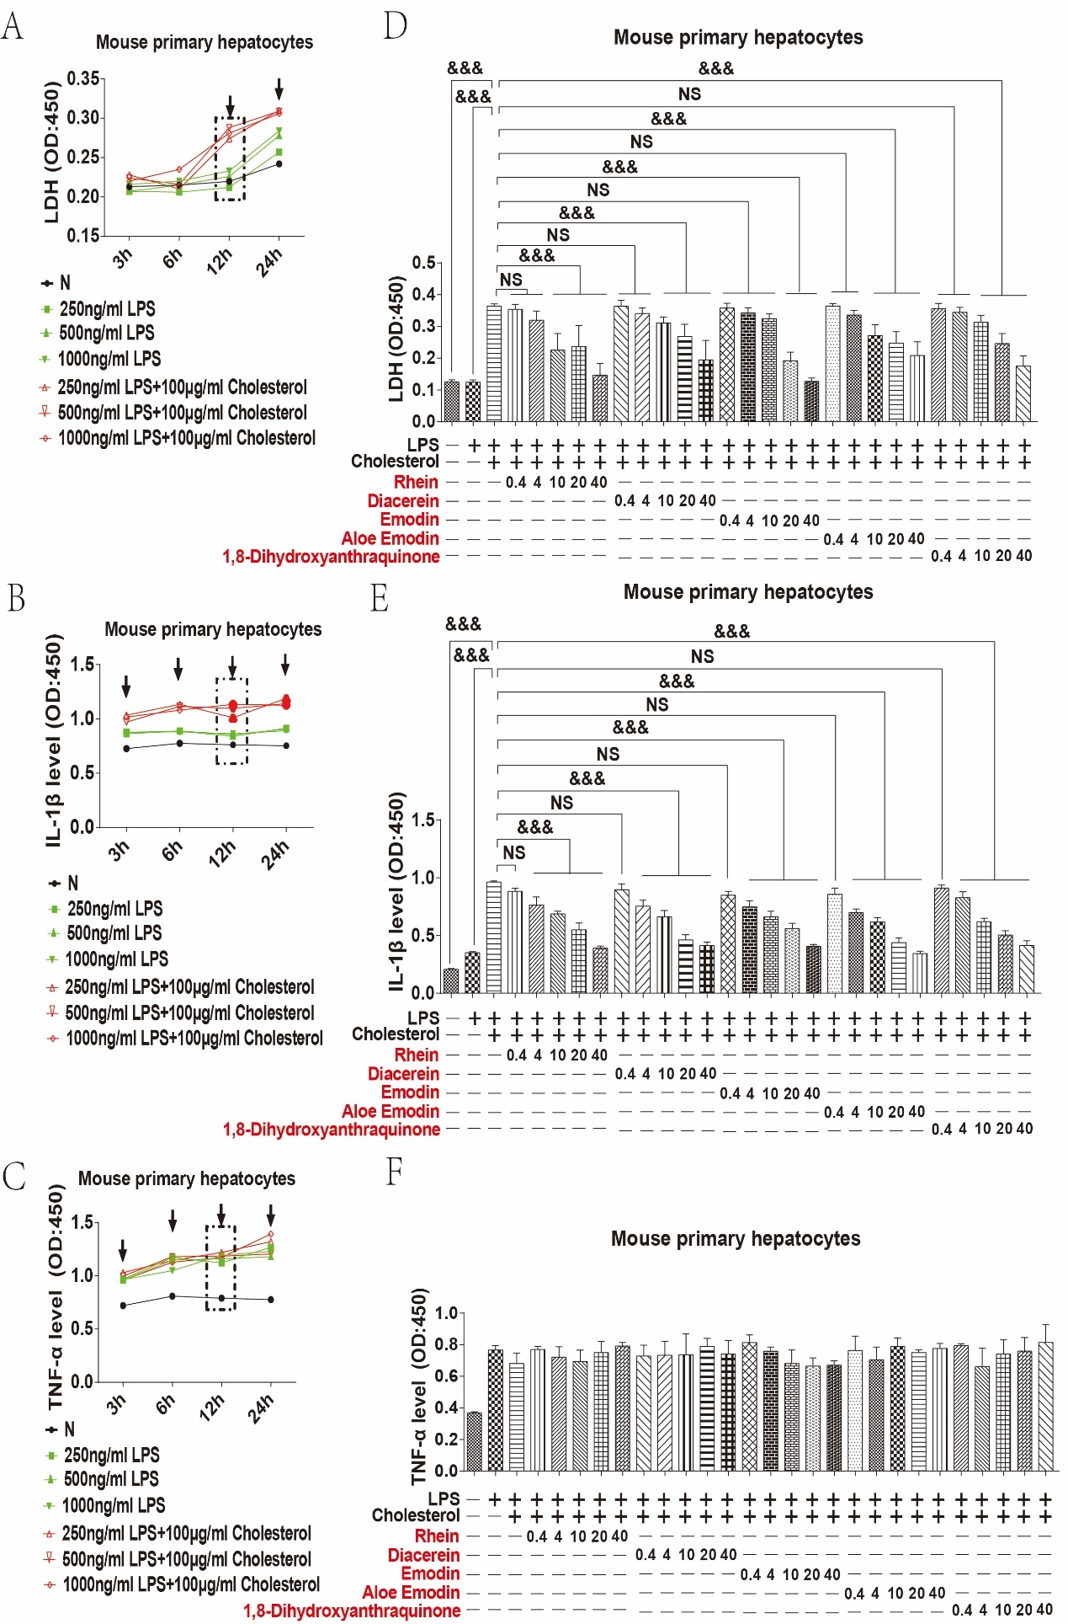

Additional file 1: Fig S 7. RFAs inhibited cholesterol induced NLRP3 inflammasome in mouse primary hepatocytes.
Mouse primary hepatocytes were stimulated by LPS (250ng / ml, 500ng / ml and 1000ng / ml) for 4 hours and then stimulated by cholesterol (100μg / ml) for 12 hours, LDH (A) were detected by LDH kits (n=1 / group); IL-1β (B) and TNF-α (C) were detected by ELISA (n=1 / group). Mouse primary hepatocytes were pretreated by RFAs (Rhein, diacerein, emodin, aloe emodin and 1,8-dihydroxyanthraquinone with the concentrations of 40μM, 20μM, 10μM and 5μM) for 30 minutes and then stimulated with LPS (1000ng / ml) for 4 hours and cholesterol (100μg / ml) for 12 hours. LDH were detected by LDH kits (D) (n=3 / group); IL-1β (E) and TNF-α (F) were detected by ELISA (n=3 / group). Data are presented as mean ± SEM. For multiple comparisons, one-way ANOVA coupled with LSD’s post hoc testing was performed. &: P<0.05; &&: p<0.01; &&&: p<0.001. ANOVA, analysis of variance; ELISA, enzyme linked immunosorbent assay; IL-1β, interleukin-1 beta; LDH, lactate dehydrogenase; LPS, lipopolysaccharide; NS, no significance; TNF-α, tumor necrosis factor-alpha.
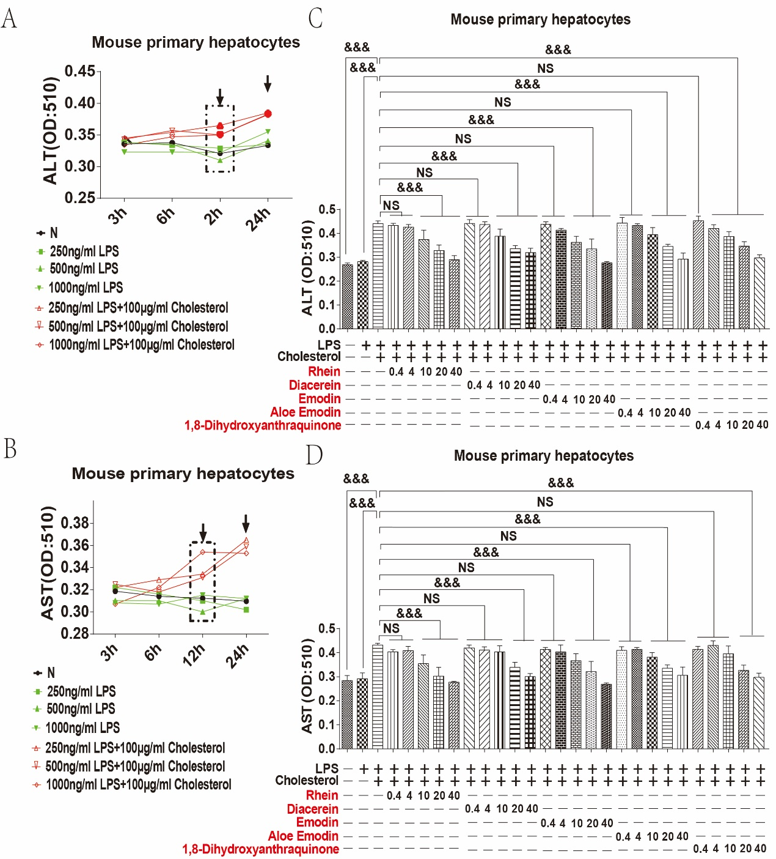

Additional file 1: Fig S 8. RFAs inhibited ALT and AST in mouse primary hepatocytes stimulated by LPS + cholesterol.
Mouse primary hepatocytes were stimulated by LPS (250ng / ml, 500ng / ml and 1000ng / ml) for 4 hours and then stimulated by cholesterol (100μg / ml) for 12 hours, ALT (A) and AST (B) were detected by ALT / AST kits (n=1 / group). Mouse primary hepatocytes were pretreated by RFAs (Rhein, diacerein, emodin, aloe emodin and 1,8-dihydroxyanthraquinone with the concentrations of 40μM, 20μM, 10μM and 5μM) for 30 minutes and then stimulated with LPS (1000ng / ml) for 4 hours and cholesterol (100μg / ml) for 12 hours. ALT (C) and AST (D) were detected by ALT / AST kits (n=3 / group). Data are presented as mean ± SEM. For multiple comparisons, one-way ANOVA coupled with LSD’s post hoc testing was performed. &: P<0.05; &&: p<0.01; &&&: p<0.001. ALT, alanine aminotransferase; ANOVA, analysis of variance; AST, aspartate aminotransferase; ELISA, enzyme linked immunosorbent assay; IL-1β, interleukin-1 beta; LDH, lactate dehydrogenase; LPS, lipopolysaccharide; NS, no significance; TNF-α, tumor necrosis factor-alpha.
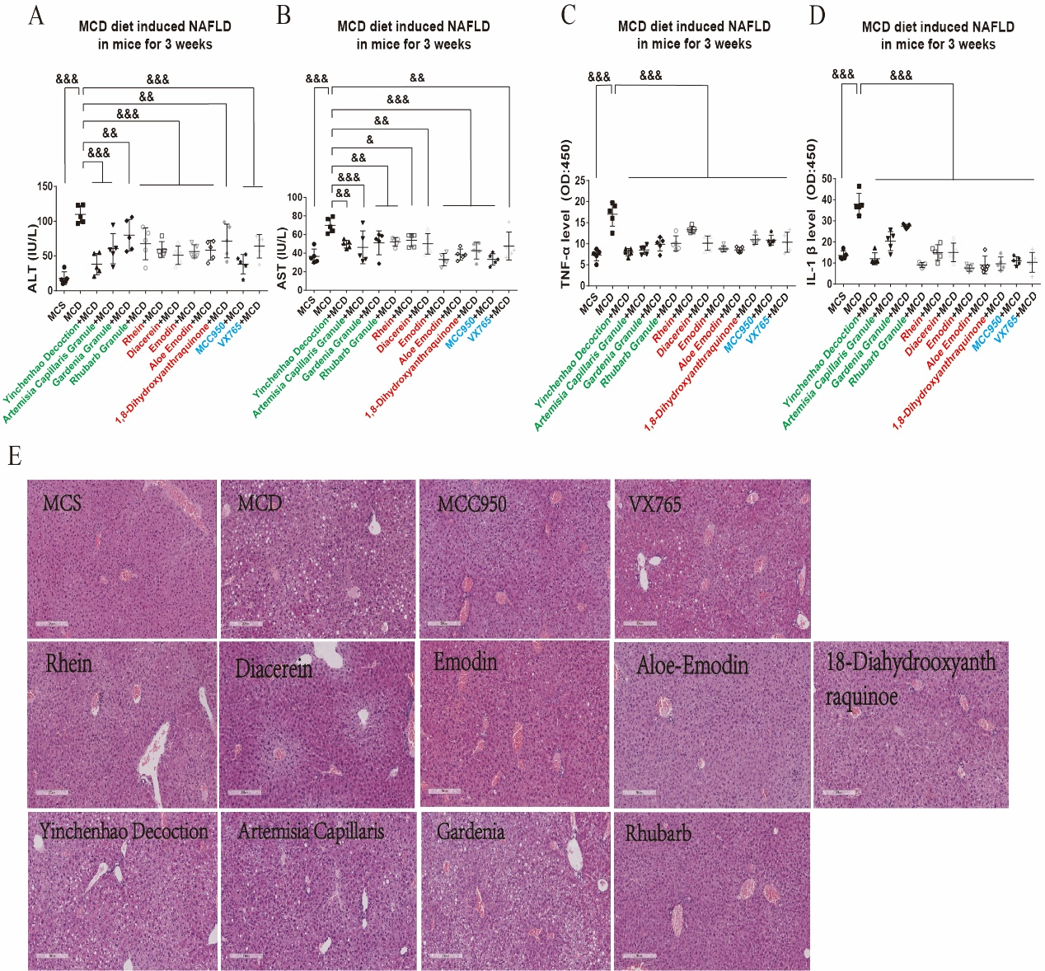

Additional file 1: Fig S 9. RFAs improved MCD diet induced mice NAFLD by inhibiting NLRP3 inflammasome in the third week.
C57 BL/6 mice were fed by MCD diet for 3 weeks. RFAs (rhein / diacerein, emodin, aloe emodin, 1,8-dihydroxyanthraquinone), rhubarb and yinchenhao decoction as well as inflammasome inhibitors MCC950 and VX765 were given by gavage every 2 days when MCD diet treatment started. Serum ALT (A) and AST (B) were detected by ALT / AST kit, serum IL-1β (C) and TNF-α (D) were detected by ELISA. H&E stain and sirius red staining were also detected (E). Control group was fed by MCS diet (n=5 / group); Model group was fed by MCD diet (n=5 / group); Intervention groups were fed by MCD diet and different drugs (n=5 / group). For multiple comparisons, one-way ANOVA coupled with LSD’s post hoc testing was performed. &: P<0.05; &&: p<0.01; &&&: p<0.001. ALT, alanine aminotransferase; ANOVA, analysis of variance; AST, aspartate aminotransferase; ELISA, enzyme linked immunosorbent assay; H&E, hematoxylin and eosin; IL-1β, interleukin-1 beta; MCD, methionine and choline deficiency; MCS, methionine-choline-supplemented; TNF-α, tumor necrosis factor-alpha.

Additional table

Table S1 Main materials
REAGENT | SOURCE | IDENTIFIER
Biochemical reagents & solutions
Alum | Invivogen | 21645-51-2
BSA | Sengon biotech | ST025
CPPD | Sengon biotech | 7790-76-3
DAPI | Beyotime | C1002
LPS | Sigma | L2630
Nigericin | Sigma | 481990
SiO2 | Sengon biotech | 238-878-4
4% paraformaldehyde fix solution | Sengon biotech | E672002
Lipofectamine 2000 | Invitrogen | 2030864
Opti-MEM | Gibico | 2048098
Protein A+G agrarose | Beyotime | P2055
Durgs
Rhubarb | Tianjiang Pharmaceutical Co., Ltd | 18037004
Rhein (Rhubarb) | Ronghe Pharmaceutical Technology Development Co., Ltd | 171019/171109
Aloe Emodin (Rhubarb) | Ronghe Pharmaceutical Technology Development Co., Ltd | 190307/171216
Anthraquinone (Rhubarb) | Ronghe Pharmaceutical Technology Development Co., Ltd | 170820
Chrysophanol (Rhubarb) | Ronghe Pharmaceutical Technology Development Co., Ltd | 180309
Diacerin (Rhubarb) | Ronghe Pharmaceutical Technology Development Co., Ltd | 171107/171224
Emodin (Rhubarb) | Ronghe Pharmaceutical Technology Development Co., Ltd | 190120/180106
Emodin methyl ether (Rhubarb) | Ronghe Pharmaceutical Technology Development Co., Ltd | 180905
1,8-dihydroxyanthraquinone (Rhubarb) | Ronghe Pharmaceutical Technology Development Co., Ltd | 170716/180325
Artemisia Capillaris | Tianjiang Pharmaceutical Co., Ltd | 18086954
Artemisinin (Artemisia Capillaris) | Ronghe Pharmaceutical Technology Development Co., Ltd | 190420
Caffeic acid (Artemisia Capillaris) | Ronghe Pharmaceutical Technology Development Co., Ltd | 190425
Chlorogenic acid (Artemisia Capillaris) | Ronghe Pharmaceutical Technology Development Co., Ltd | 190327
Crocin I (Artemisia Capillaris) | Ronghe Pharmaceutical Technology Development Co., Ltd | 190124
Crocin II (Artemisia Capillaris) | Ronghe Pharmaceutical Technology Development Co., Ltd | 190305
Ferulic acid (Artemisia Capillaris) | Ronghe Pharmaceutical Technology Development Co., Ltd | 181109
Hyperoside (Artemisia Capillaris) | Ronghe Pharmaceutical Technology Development Co., Ltd | 190402
Quercetin (Artemisia Capillaris) | Ronghe Pharmaceutical Technology Development Co., Ltd | 190331
Scopolactone (Artemisia Capillaris) | Ronghe Pharmaceutical Technology Development Co., Ltd | 190316
6-hydroxy-7-methoxycoumarin (Artemisia Capillaris) | Ronghe Pharmaceutical Technology Development Co., Ltd | 190103
Gardenia | Tianjiang Pharmaceutical Co., Ltd | 1807664
Genipin (Gardenia) | Ronghe Pharmaceutical Technology Development Co., Ltd | 181229
Geniposide (Gardenia) | Ronghe Pharmaceutical Technology Development Co., Ltd | 181205
Geniposidic acid (Gardenia) | Ronghe Pharmaceutical Technology Development Co., Ltd | 181227
Genipin-1-β-gentibioside (Gardenia) | Ronghe Pharmaceutical Technology Development Co., Ltd | 190223
Inhibitors:
MCC950 | Selleck Biotechnology Co., Ltd | S8930
VX765 | Selleck Biotechnology Co., Ltd | S2228
RNA isolation, reverse and amplification kits
RNAfast200 kit | Fastagen | 220011
Reverse transcriptionand kit | TAKARA | RR036
Amplification kit | Toyobo | 857100
Primers
Mouse β-actin primers | Genewiz | N/S
Mouse IL-1β primers | Genewiz | N/S
Mouse TNF-α primers | Genewiz | N/S
Mouse NLRP3 primers | Genewiz | N/S
Antibody
p-P65/P65 | CST | 3033/6956
p-ERK/ERK | CST | 4730/4695
p-JNK/JNK | CST | 4668/9252
p-P38/P38 | CST | 4511/9212
NLRP3 | Adipogen | AG-20B-0014
Caspase-1 | Adipogen | AG-20B-0048
ASC | CST | 67824
GAPDH | Proteinteck | 60004-l-lg
β-actin | Proteinteck | 66009-l-lg
β-actin | CST | 4970
α-tubulin | Proteinteck | 66031-l-lg
Anti-rabbit IgG-Cy3 | Abcam | ab6939
Critical commercial Assays
ALT kit | Nanjing Jiancheng bioengineering institute | C009-2-1
AST kit | Nanjing Jiancheng bioengineering institute | C010-2-1
LDH kit | Nanjing Jiancheng bioengineering institute | A020-2-2
IL-1β ELISA kits | Thermo Fisher | 88-7013
TNF-α ELISA kits | Thermo Fisher | 88-7324

