Supplemental material

Figure S1. Trend in the age- and sex- standardized population rate of suicide attempt-related ED visits from 2016 to 2019
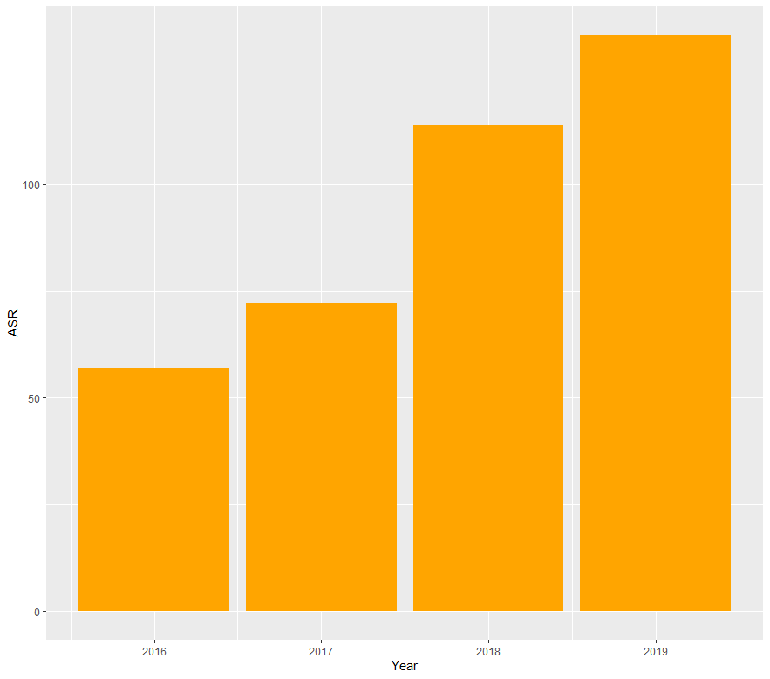
Note: ASR, age- and sex-standardized incidence rates of suicide attempt-related ED visits per 100,000 persons (with the 2020 census population as the standard population).

Figure S2. Trends in suicide attempt-related ED visits among adolescents based on disposition
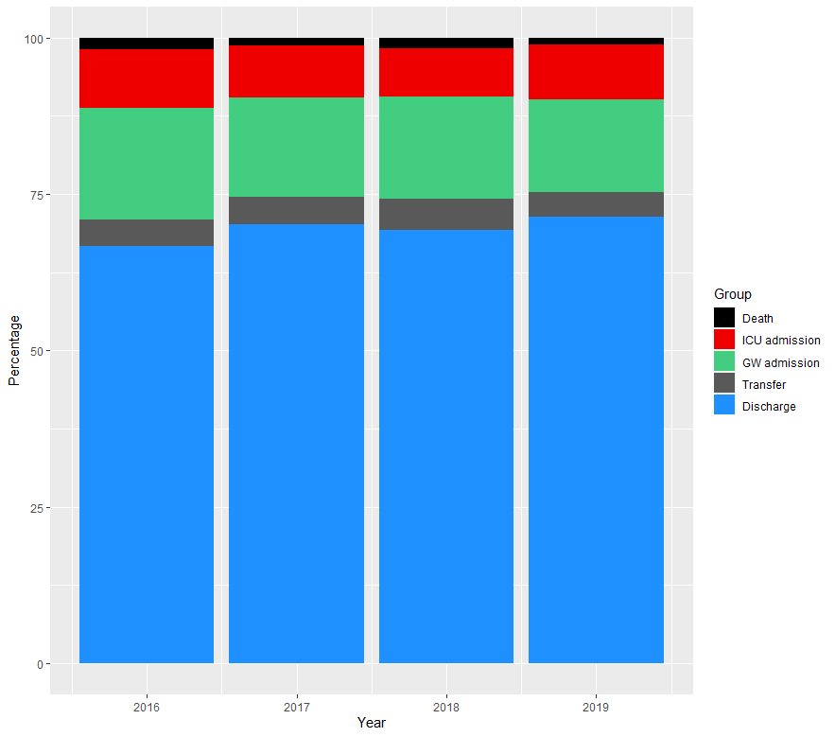
Note: ED, emergency department; ICU, intensive care unit; GW, general ward

Figure S3. Detailed trends in suicide attempt-related ED visits among adolescents based on disposition
- Death group | 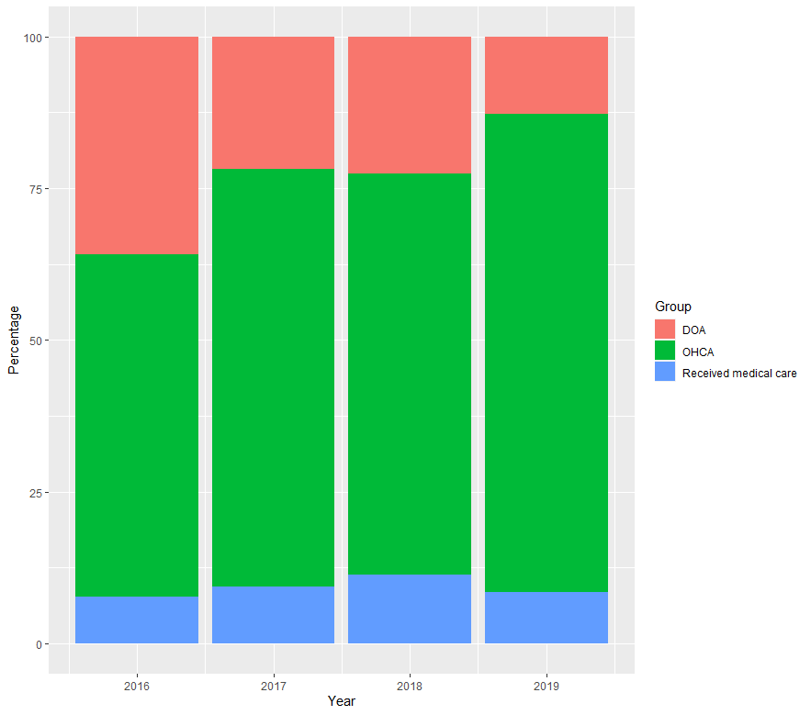
(b) Transfer group | 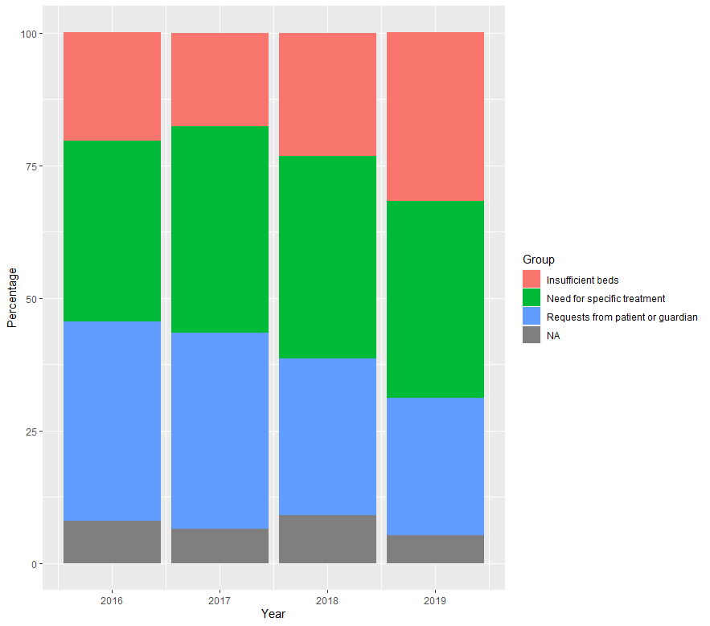
(c) Discharge group | 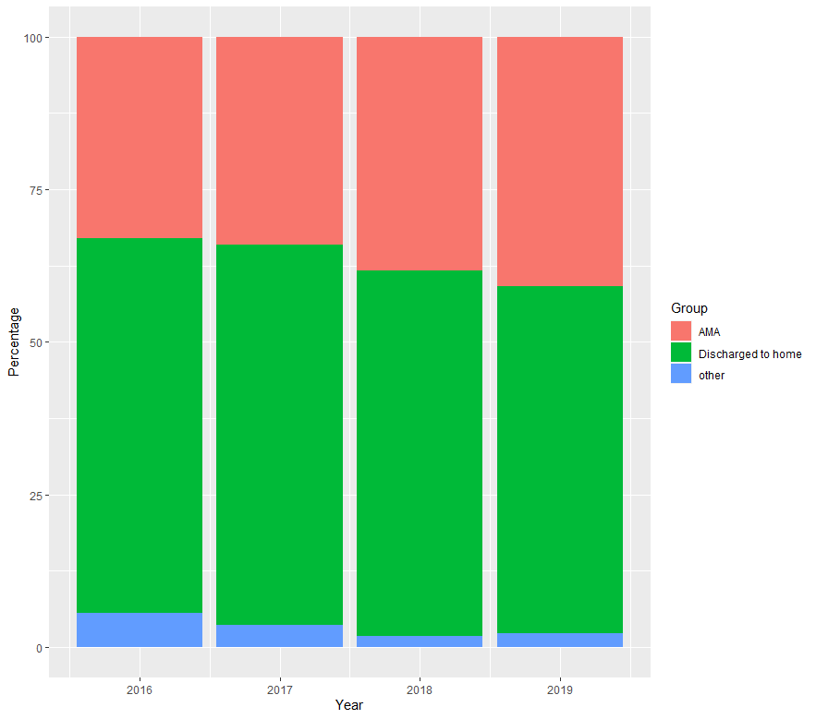
Note: DOA, dead on arrival; OHCA, out of hospital cardiac arrest; NA, others; AMA, against medical advice.

Table S1. The ten most common diagnoses by disposition
No. | Total  (n=11,462) |  | Discharge group  (n=8,456) |  | General ward admissions subgroup  (n=1,958) |  | Intensive care unit admissions subgroup (n=1,048)
1 | S61 | 1,994 (17.3) | S61 | 1,855 (21.9) | T50 | 364 (18.5) | T50 | 276 (26.3)
2 | T50 | 1,373 (11.9) | S51 | 787 (9.3) | T39 | 272 (13.8) | T42 | 100 (9.5)
3 | S51 | 845 (7.3) | T50 | 733 (8.6) | S61 | 135 (6.8) | T39 | 97 (9.2)
4 | T39 | 604 (5.2) | F32 | 438 (5.1) | F32 | 113 (5.7) | T65 | 89 (8.4)
5 | F32 | 558 (4.8) | S60 | 433 (5.1) | T42 | 108 (5.5) | F19 | 69 (6.5)
6 | T42 | 501 (4.3) | T42 | 293 (3.4) | F19 | 90 (4.5) | T43 | 59 (5.6)
7 | F19 | 441 (3.8) | F19 | 282 (3.3) | T65 | 87 (4.4) | S32 | 30 (2.8)
8 | S60 | 441 (3.8) | R45 | 270 (3.1) | S66 | 60 (3.0) | F13 | 21 (2.0)
9 | T65 | 382 (3.3) | T39 | 235 (2.7) | S51 | 57 (2.9) | T58 | 20 (1.9)
10 | R45 | 301 (2.6) | Z91 | 230 (2.7) | T43 | 57 (2.9) | I46 | 18 (1.7)
Note: S61, Open wound of wrist and hand; T50, Poisoning by diuretics or other unspecified drugs; S51, Open wound of forearm; T39, Poisoning by non-opioid analgesics; F32, Depressive episode; T42, Poisoning by antiepileptic; F19, Misuse of drugs NOS; S60, Superficial injury of wrist and hand; T65, Toxic effect of other and unspecified substances; R45, Symptoms and signs involving emotional state; Z91, Personal history of risk factors; S66, Injury of muscle and tendon at wrist and hand level; T43, Poisoning by psychotropic drugs; S32, Fracture of lumbar spine and pelvis; F13, Mental and behavioral disorders due to use of sedatives or hypnotics; T58, Toxic effect of carbon monoxide; I46, Cardiac arrest

