Additional File 9: Rt estimates

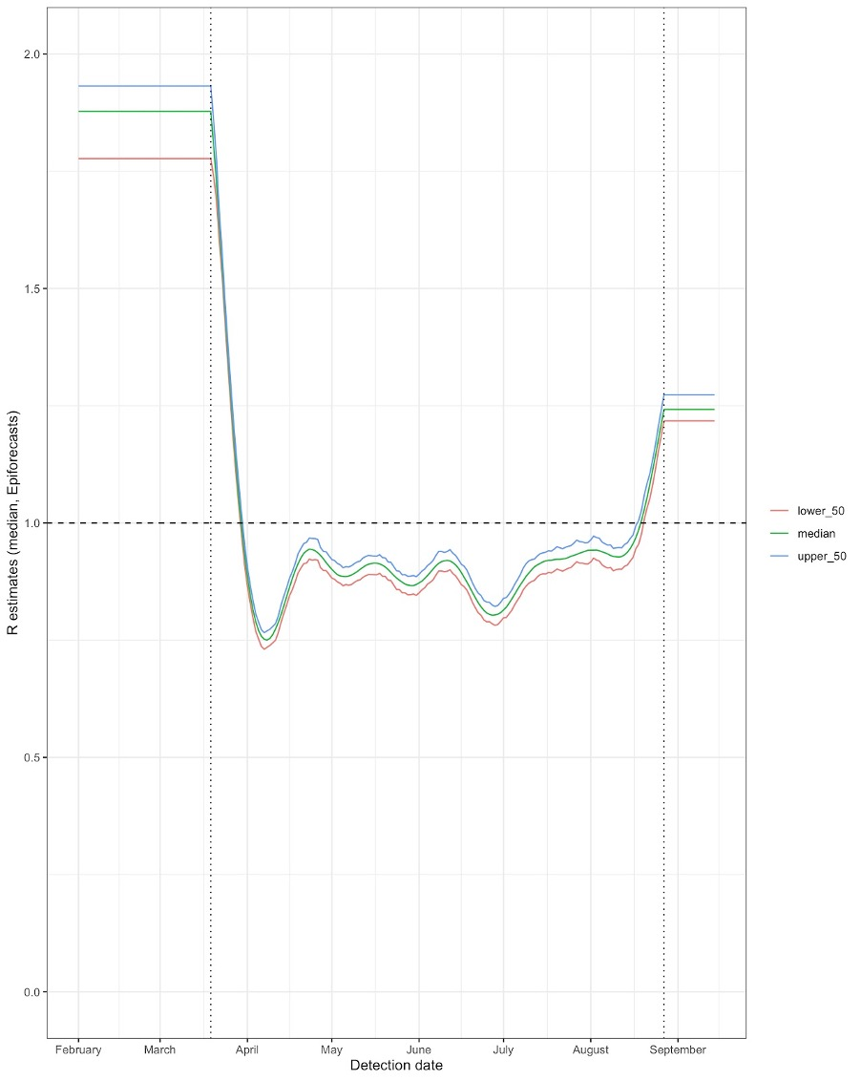
Figure S8: Time varying estimate of Rt taken from EpiForecast team : median estimated using hospitalised cases (1) with upper and lower bounds of the 50% credible intervals.

Uncertainty in the simulations was generated by taking the mean and 95% ranges for onward transmission infections and case numbers are presented as over the 600 simulations generated from 200 simulations on each R value (estimate, upper and lower bound).

References
1. Abbott S, Hellewell J, Thompson RN, Sherratt K, Gibbs HP, Bosse NI, et al. Estimating the time-varying reproduction number of SARS-CoV-2 using national and subnational case counts. Wellcome Open Res. 2020 Dec 8;5:112.

