Additional File 11: Additional results
- Figure 5 additional analysis
- Table S3: Additional reported results
- Table S4: Estimated percentage of “community onset, community acquired” infections that would be re-classified as “community onset, hospital acquired” infections
- Table S5: Estimated number of community onset, hospital-linked cases
- Figure S13: Impact of 1 vs 5 day discharge before associated identified hospital case
- Figure S14: Impact of R value variation over time (not just aggregated)

Figure 5 additional analysis
- Of all hospital patients who had a SARS-CoV-2 infection some time during their stay, 29.6% (28.9%, 30.5%) were hospital-acquired (E/(A+D), Figure 5).
- With the addition of hospital-linked infections, out of all hospital patients with a SARS-CoV-2 infection, 31.5% (30.6%, 32.4%) were estimated to have acquired their infection in hospitals or were hospital-linked ((E+F)/(A+D), Figure 5).

Estimate | Cutoff
 | 7 | 14 | 4 | Details
“hospital-onset, hospital-acquired” identified cases across acute English Trusts up to the 31st July 2020 | 6,640 | 4,440 | 7,830 | From adjusted CO-CIN
unidentified hospital-acquired infections | 20,000 (19,200, 21,100) | 29,000 (28,400, 29,600) | 17,500 (16,000, 19,300) | mean; 95% range over 200 simulations
Percentage of “community-onset, community-acquired” that should be classified as “community-onset, hospital-acquired” | 2.1% (1.7%, 2.6%) | 2.6% (2.1%, 3.1%) | 2.1% (1.7%, 2.6%) | mean; 95% range over 200 simulations:
“community-onset, hospital-linked” cases | 1,600 (1,600, 1,700) | 2,100 (2,000, 2,200) | 1,600 (1,400, 1,700) | For the time varying R value mean; 95% range over 600 simulations

Table S3: Estimated additional main results for 14 and 4 day cut-offs in line with 7 day values in main text
Table S4: Estimated mean and 95% quantile range over 200 simulations of the percentage of “community onset, community acquired” infections that would be re-classified as “community onset, hospital acquired” infections under different R values, hospital-acquired (HA) definition cutoffs (if symptom onset starts this many days from admission), discharge times from associated hospital-acquired case for unidentified hospital-acquired infection and scenarios for symptom onset to hospitalisation.
R value (0.8, 1.2, rt) | HA definition cutoff (5,8,15) | Discharge time for unidentified hospital-acquired infection  (1 or 5) | Symptom onset to hospitalisation scenario  (1-3) | Mean | 95% quantile range
0.8 | 5 | 5 | 1 | 2.1 | 1.6 | 2.5
0.8 | 5 | 5 | 2 | 2.1 | 1.6 | 2.5
0.8 | 5 | 5 | 3 | 2.1 | 1.6 | 2.5
0.8 | 8 | 5 | 1 | 2.1 | 1.7 | 2.6
0.8 | 8 | 5 | 2 | 2.1 | 1.7 | 2.6
0.8 | 8 | 5 | 3 | 2.1 | 1.7 | 2.6
0.8 | 15 | 5 | 1 | 2.6 | 2.1 | 3.1
0.8 | 15 | 5 | 2 | 2.6 | 2.1 | 3.1
0.8 | 15 | 5 | 3 | 2.6 | 2.1 | 3.1
1.2 | 5 | 5 | 1 | 2.1 | 1.6 | 2.5
1.2 | 5 | 5 | 2 | 2.1 | 1.6 | 2.5
1.2 | 5 | 5 | 3 | 2.1 | 1.6 | 2.5
1.2 | 8 | 5 | 1 | 2.1 | 1.7 | 2.6
1.2 | 8 | 5 | 2 | 2.1 | 1.7 | 2.6
1.2 | 8 | 5 | 3 | 2.1 | 1.7 | 2.6
1.2 | 15 | 5 | 1 | 2.6 | 2.1 | 3.1
1.2 | 15 | 5 | 2 | 2.6 | 2.1 | 3.1
1.2 | 15 | 5 | 3 | 2.6 | 2.1 | 3.1
rt | 5 | 5 | 1 | 2.1 | 1.6 | 2.6
rt | 5 | 5 | 2 | 2.1 | 1.6 | 2.5
rt | 5 | 5 | 3 | 2.1 | 1.6 | 2.6
rt | 8 | 5 | 1 | 2.1 | 1.7 | 2.6
rt | 8 | 5 | 2 | 2.1 | 1.7 | 2.6
rt | 8 | 5 | 3 | 2.1 | 1.7 | 2.6
rt | 15 | 5 | 1 | 2.6 | 2.1 | 3.1
rt | 15 | 5 | 2 | 2.6 | 2.1 | 3.1
rt | 15 | 5 | 3 | 2.6 | 2.1 | 3.1
0.8 | 5 | 1 | 1 | 2.1 | 1.6 | 2.5
0.8 | 5 | 1 | 2 | 2.1 | 1.6 | 2.5
0.8 | 5 | 1 | 3 | 2.1 | 1.6 | 2.5
0.8 | 8 | 1 | 1 | 2.1 | 1.7 | 2.6
0.8 | 8 | 1 | 2 | 2.1 | 1.7 | 2.6
0.8 | 8 | 1 | 3 | 2.1 | 1.7 | 2.6
0.8 | 15 | 1 | 1 | 2.6 | 2.1 | 3.1
0.8 | 15 | 1 | 2 | 2.6 | 2.1 | 3.1
0.8 | 15 | 1 | 3 | 2.6 | 2.1 | 3.1
1.2 | 5 | 1 | 1 | 2.1 | 1.6 | 2.6
1.2 | 5 | 1 | 2 | 2.1 | 1.6 | 2.5
1.2 | 5 | 1 | 3 | 2.1 | 1.6 | 2.5
1.2 | 8 | 1 | 1 | 2.1 | 1.7 | 2.6
1.2 | 8 | 1 | 2 | 2.1 | 1.7 | 2.6
1.2 | 8 | 1 | 3 | 2.1 | 1.7 | 2.6
1.2 | 15 | 1 | 1 | 2.6 | 2.1 | 3.1
1.2 | 15 | 1 | 2 | 2.6 | 2.1 | 3.1
1.2 | 15 | 1 | 3 | 2.6 | 2.1 | 3.1
rt | 5 | 1 | 1 | 2.1 | 1.6 | 2.5
rt | 5 | 1 | 2 | 2.1 | 1.6 | 2.5
rt | 5 | 1 | 3 | 2.1 | 1.6 | 2.5
rt | 8 | 1 | 1 | 2.1 | 1.7 | 2.6
rt | 8 | 1 | 2 | 2.1 | 1.7 | 2.6
rt | 8 | 1 | 3 | 2.1 | 1.7 | 2.6
rt | 15 | 1 | 1 | 2.6 | 2.1 | 3.1
rt | 15 | 1 | 2 | 2.6 | 2.1 | 3.1
rt | 15 | 1 | 3 | 2.6 | 2.1 | 3.1

Table S5: Estimated mean and 95% quantile range over 200 simulations number and percentage contribution of “community onset, hospital linked cases” under different R values, hospital-acquired (HA) definition cutoffs (if symptom onset starts this many days from admission), discharge times from associated hospital-acquired case for unidentified hospital-acquired infection and scenarios for symptom onset to hospitalisation.
 |  |  |  | Number of infections |  |  | Proportion of community onset community acquired cases
R value  (0.8, 1.2, rt) | HA definition cutoff  (5,8,15) | Discharge time for unidentified hospital-acquired infection  (1 or 5) | Symptom onset to hospitalisation scenario  (1-3) | Mean | 95% quantile range |  | Mean | 95% quantile range
0.8 | 5 | 5 | 1 | 1000 | 800 | 1100 | 1.3 | 1.2 | 1.5
0.8 | 5 | 5 | 2 | 1000 | 800 | 1100 | 1.3 | 1.2 | 1.6
0.8 | 5 | 5 | 3 | 1000 | 800 | 1100 | 1.3 | 1.2 | 1.5
0.8 | 8 | 5 | 1 | 1000 | 900 | 1100 | 1.4 | 1.2 | 1.5
0.8 | 8 | 5 | 2 | 1000 | 900 | 1100 | 1.4 | 1.3 | 1.5
0.8 | 8 | 5 | 3 | 1000 | 900 | 1100 | 1.4 | 1.2 | 1.5
0.8 | 15 | 5 | 1 | 1300 | 1200 | 1400 | 1.7 | 1.6 | 1.8
0.8 | 15 | 5 | 2 | 1300 | 1200 | 1400 | 1.7 | 1.6 | 1.8
0.8 | 15 | 5 | 3 | 1300 | 1200 | 1400 | 1.7 | 1.6 | 1.8
1.2 | 5 | 5 | 1 | 2600 | 2300 | 2900 | 3.6 | 3.2 | 4.1
1.2 | 5 | 5 | 2 | 2600 | 2300 | 2900 | 3.6 | 3.3 | 4.1
1.2 | 5 | 5 | 3 | 2600 | 2300 | 3000 | 3.7 | 3.3 | 4.2
1.2 | 8 | 5 | 1 | 2700 | 2500 | 3000 | 3.8 | 3.5 | 4.1
1.2 | 8 | 5 | 2 | 2700 | 2500 | 3000 | 3.8 | 3.5 | 4.1
1.2 | 8 | 5 | 3 | 2700 | 2500 | 3000 | 3.8 | 3.5 | 4.1
1.2 | 15 | 5 | 1 | 3400 | 3200 | 3700 | 4.6 | 4.3 | 4.9
1.2 | 15 | 5 | 2 | 3400 | 3300 | 3700 | 4.6 | 4.4 | 4.9
1.2 | 15 | 5 | 3 | 3500 | 3200 | 3700 | 4.6 | 4.3 | 5
rt | 5 | 5 | 1 | 1600 | 1400 | 1700 | 2.2 | 2 | 2.4
rt | 5 | 5 | 2 | 1600 | 1400 | 1700 | 2.2 | 2 | 2.4
rt | 5 | 5 | 3 | 1600 | 1400 | 1700 | 2.2 | 2 | 2.4
rt | 8 | 5 | 1 | 1600 | 1600 | 1700 | 2.3 | 2.1 | 2.4
rt | 8 | 5 | 2 | 1600 | 1500 | 1700 | 2.3 | 2.1 | 2.4
rt | 8 | 5 | 3 | 1600 | 1500 | 1800 | 2.3 | 2.1 | 2.4
rt | 15 | 5 | 1 | 2100 | 2000 | 2200 | 2.8 | 2.7 | 2.9
rt | 15 | 5 | 2 | 2100 | 2000 | 2200 | 2.8 | 2.7 | 2.9
rt | 15 | 5 | 3 | 2100 | 2000 | 2200 | 2.8 | 2.7 | 2.9
0.8 | 5 | 1 | 1 | 900 | 800 | 1100 | 1.3 | 1.2 | 1.5
0.8 | 5 | 1 | 2 | 1000 | 800 | 1100 | 1.3 | 1.2 | 1.5
0.8 | 5 | 1 | 3 | 1000 | 800 | 1100 | 1.3 | 1.2 | 1.5
0.8 | 8 | 1 | 1 | 1000 | 900 | 1100 | 1.4 | 1.3 | 1.5
0.8 | 8 | 1 | 2 | 1000 | 900 | 1100 | 1.4 | 1.3 | 1.5
0.8 | 8 | 1 | 3 | 1000 | 900 | 1100 | 1.4 | 1.3 | 1.5
0.8 | 15 | 1 | 1 | 1300 | 1200 | 1400 | 1.7 | 1.6 | 1.8
0.8 | 15 | 1 | 2 | 1300 | 1200 | 1400 | 1.7 | 1.6 | 1.8
0.8 | 15 | 1 | 3 | 1300 | 1200 | 1400 | 1.7 | 1.6 | 1.8
1.2 | 5 | 1 | 1 | 2600 | 2300 | 2900 | 3.6 | 3.2 | 4.1
1.2 | 5 | 1 | 2 | 2600 | 2300 | 2900 | 3.6 | 3.2 | 4.1
1.2 | 5 | 1 | 3 | 2600 | 2300 | 2900 | 3.6 | 3.3 | 4.1
1.2 | 8 | 1 | 1 | 2700 | 2500 | 2900 | 3.8 | 3.5 | 4.1
1.2 | 8 | 1 | 2 | 2700 | 2500 | 3000 | 3.8 | 3.5 | 4.1
1.2 | 8 | 1 | 3 | 2700 | 2500 | 3000 | 3.8 | 3.5 | 4.1
1.2 | 15 | 1 | 1 | 3400 | 3200 | 3700 | 4.6 | 4.3 | 4.9
1.2 | 15 | 1 | 2 | 3400 | 3200 | 3700 | 4.6 | 4.3 | 4.9
1.2 | 15 | 1 | 3 | 3400 | 3200 | 3700 | 4.6 | 4.3 | 4.9
rt | 5 | 1 | 1 | 1300 | 1200 | 1500 | 1.9 | 1.7 | 2.1
rt | 5 | 1 | 2 | 1300 | 1200 | 1500 | 1.9 | 1.7 | 2.1
rt | 5 | 1 | 3 | 1300 | 1200 | 1500 | 1.9 | 1.7 | 2.1
rt | 8 | 1 | 1 | 1400 | 1300 | 1500 | 1.9 | 1.8 | 2.1
rt | 8 | 1 | 2 | 1400 | 1300 | 1500 | 1.9 | 1.8 | 2.1
rt | 8 | 1 | 3 | 1400 | 1300 | 1500 | 1.9 | 1.8 | 2.1
rt | 15 | 1 | 1 | 1800 | 1700 | 1900 | 2.4 | 2.2 | 2.5
rt | 15 | 1 | 2 | 1800 | 1700 | 1900 | 2.4 | 2.2 | 2.5
rt | 15 | 1 | 3 | 1800 | 1700 | 1900 | 2.4 | 2.2 | 2.5

Impact of 1 - 5 day discharge

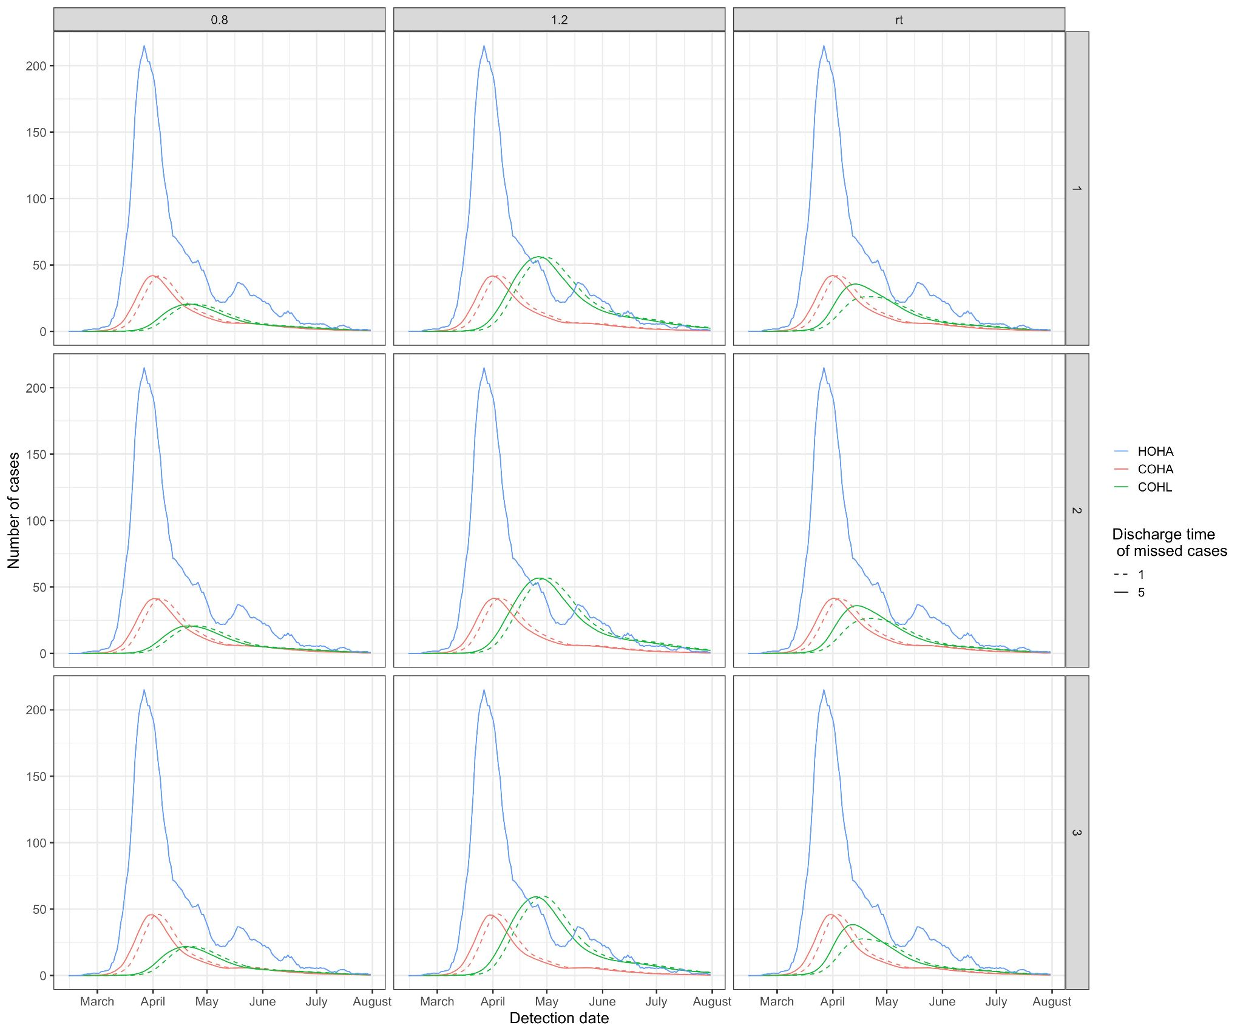
Figure S13: The impact of discharging missed cases 5 days (solid line, baseline) or 1 day (dashed line) before the associated identified hospital-acquired case at a cut-off threshold of 7 days from admission across different R values (columns) and Scenarios (rows) of symptom onset to hospitalisation. This is for “hospital-onset, hospital-acquired” (HOHA, blue), “community-onset, hospital-acquired” (COHA, red) and “community-onset, hospital-linked” (COHL, green) cases

As shown in Figure S13, there is a minimal impact of varying the day of discharge of missed cases, except for the “community-onset, hospital-linked” (COHL) cases when using the time varying R estimates (“rt”). Cumulatively, up to the end of July 2020, this results in a less than 0.001% change in the number of “community-onset, community-acquired” cases but a ~30% higher number of “community-onset, hospital-linked” cases when using the time varying R estimates (“rt”) and a 5 day discharge. This is due to a synergistic impact of the missed infections entering the community at peak R value (before early April).
Impact of R value variation

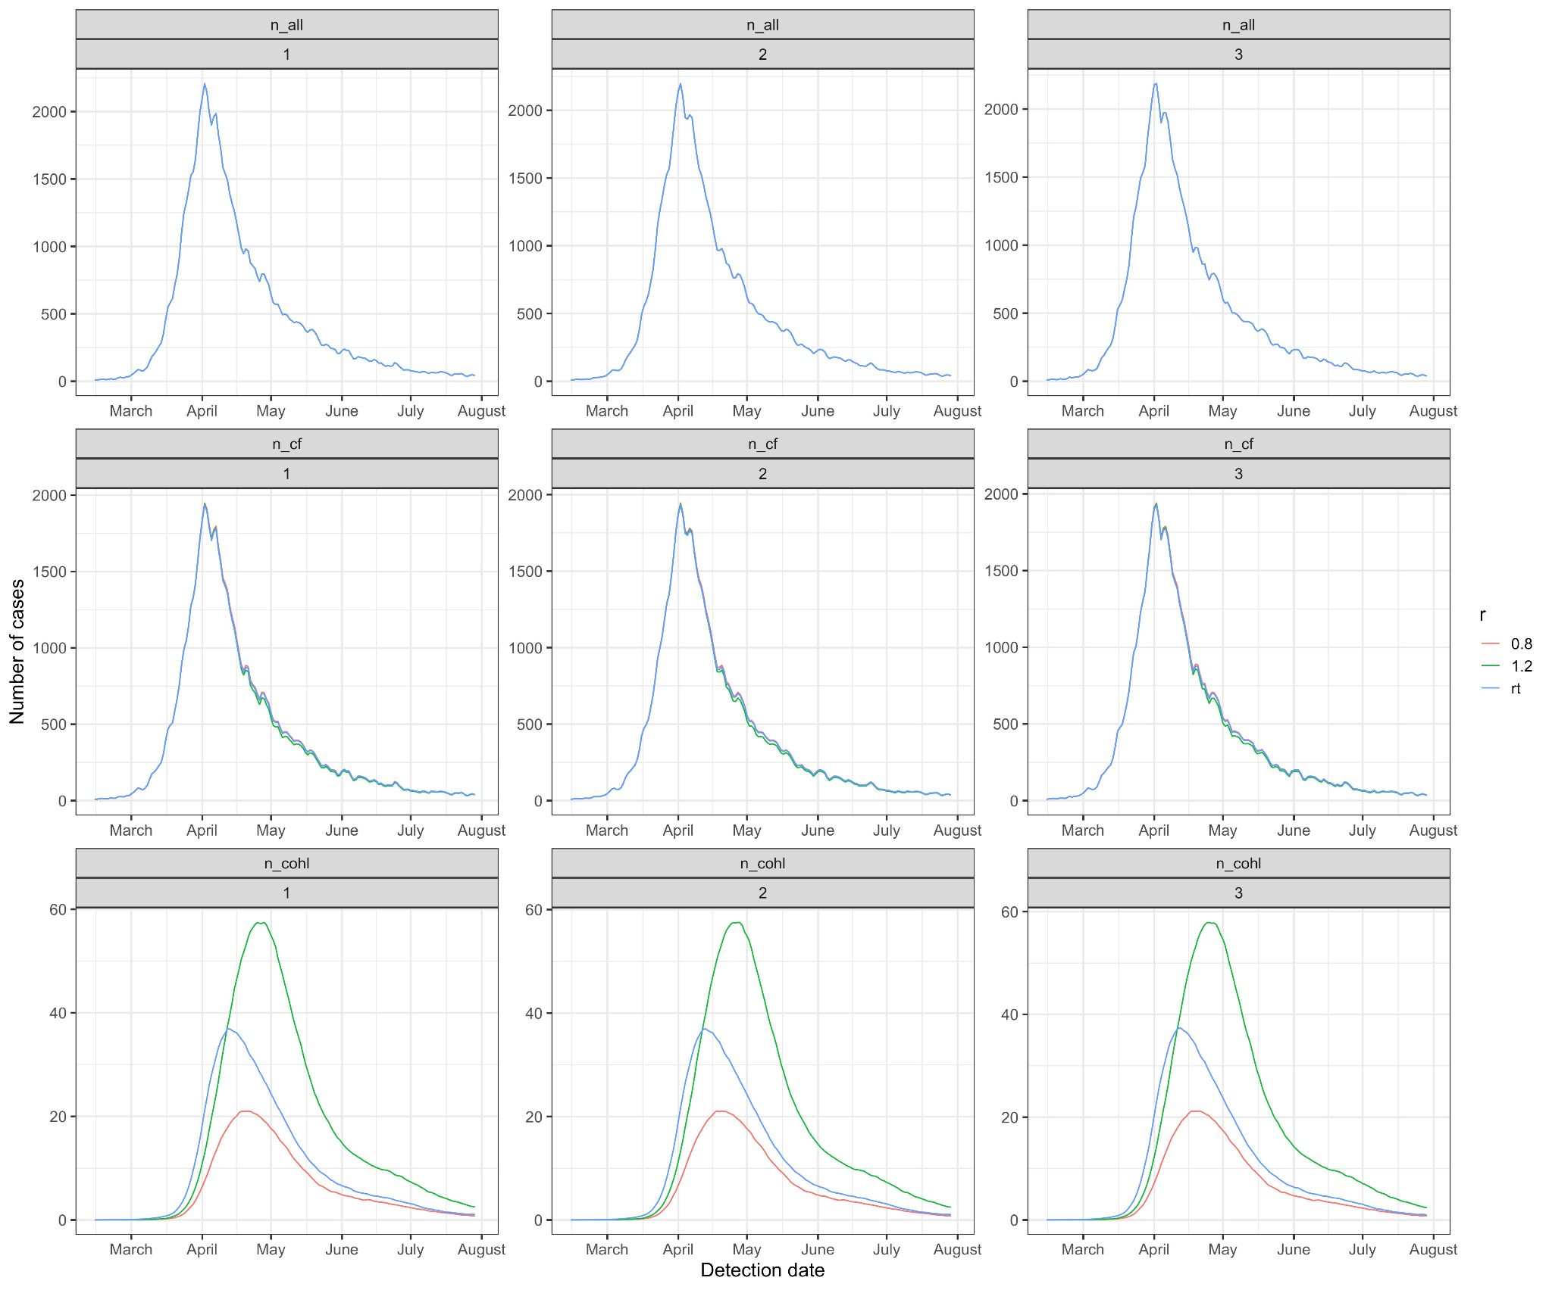
Figure S14: Time series of all hospitalised, counter-factual and community onset, hospital-linked cases under different onward transmission (R) values (median values shown here, colours). This is for a cutoff of 7 days from admission for the hospital-acquired definition and for the three scenarios (columns) for symptom onset to hospitalisation.

