Supplementary Figure S2. Neighbours improved water (A) and sanitation (B) coverage per household during 2012-2015 in Manhiça district.

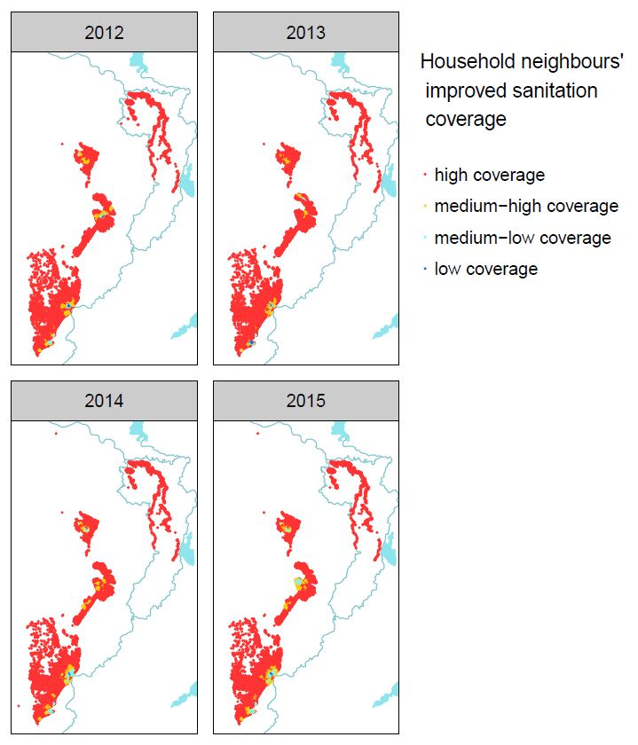
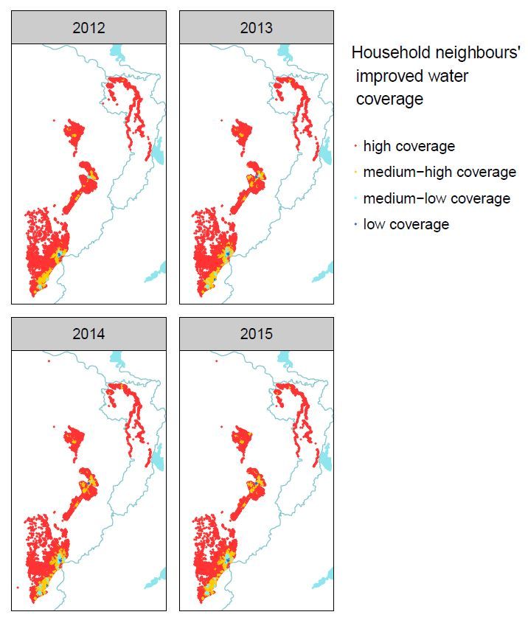
A B

