Supplementary Materials
Introduction and transmission of SARS-CoV-2 B.1.1.7 (Alpha) in Denmark
Thomas Y. Michaelsen¹, Marc Bennedbæk², Lasse E. Christiansen³, Mia Sarah Fischer Jørgensen⁴, Camilla Holten Møller⁵, Emil A. Sørensen¹, Simon Knutsson¹, Jakob Brandt¹, Thomas B. N. Jensen¹, Clarisse Chiche-Lapierre¹, Emilio F. Collados¹, Trine Sørensen¹, Celine Petersen¹, Vang Le-Quy⁶, Mantas Sereika¹, Frederik T. Hansen¹, Morten Rasmussen⁷, Jannik Fonager⁷, Søren M. Karst⁷, Rasmus L. Marvig⁸, Marc Stegger⁹, Raphael N. Sieber⁹, Robert Skov⁵, Rebecca Legarth⁴, Tyra Grove Krause⁵, Anders Fomsgaard⁷, The Danish Covid-19 Genome Consortium (DCGC)¹⁰, Mads Albertsen^{1,*}
Correspondence to: ma@bio.aau.dk

List of Danish Covid-19 Genome Consortium members
The ordering of affiliations and authors does not reflect any difference in contribution.
Kasper S. Andersen¹, Martin H. Andersen¹, Amalie Berg¹, Susanne R. Bielidt¹, Sebastian M. Dall¹, Erika Dvarionaite¹, Susan H. Hansen¹, Vibeke R. Jørgensen¹, Rasmus H. Kirkegaard¹, Wagma Saei¹, Trine B. Nicolajsen¹, Stine K. Østergaard¹, Rasmus F. Brøndum², Martin Bøgsted², Katja Hose³, Tomer Sagi³, Miroslaw Pakanec³, David Fuglsang-Damgaard⁴, Mette Mølvadgaard⁴, Henrik Krarup⁵, Christina W. Svarrer⁶, Mette T. Christiansen⁶, Anna C. Ingham⁶, Thor B. Johannesen⁶, Martín Basterrechea⁶, Berit Lilje⁶, Kirsten Ellegaard⁶, Povilas Matusevicius⁶, Lars B. Christoffersen⁶, Man-Hung E. Tang⁶, Kim L. Ng⁶, Sofie M. Edslev⁶, Sharmin Baig⁶, Ole H. Larsen⁷, Kristian A. Skipper⁷, Søren Vang⁷, Kurt J. Handberg⁸, Marc T. K. Nielsen⁸, Carl M. Kobel⁸, Camilla Andersen⁸, Irene H. Tarpgaard⁸, Svend Ellermann-Eriksen⁸, José A. S. Castruita⁹, Uffe V. Schneider⁹, Nana G. Jacobsen⁹, Christian Ø. Andersen⁹, Martin S. Pedersen¹⁰, Kristian Schønning¹⁰, Nikolai Kirkby¹⁰, Lene Nielsen¹¹, Line L. Nilsson¹¹, Martin B. Friis¹¹, Thomas Sundelin¹¹, Thomas A. Hansen¹¹, Marianne N. Skov¹², Thomas V. Sydenham¹², Xiaohui C. Nielsen¹³, Christian H. Schouw¹³, Anders Jensen¹⁴, Ea S. Marmolin¹⁴, John E. Coia¹⁵, Dorte T. Andersen¹⁵

¹ Department of Chemistry and Bioscience, Aalborg University.
² Department of Clinical Medicine, Aalborg University.
³ Department of Computer Science, Aalborg University.
⁴ Department of Clinical Microbiology, Aalborg University Hospital.
⁵ Department of Molecular Diagnostics, Aalborg University Hospital.
⁶ Statens Serum Institut.
⁷ Department of Molecular Medicine (MOMA), Aarhus University Hospital.
⁸ Department of Clinical Microbiology, Aarhus University Hospital.
⁹ Department of Clinical Microbiology, Copenhagen University Hospital.
¹⁰ Rigshospitalet, Copenhagen University Hospital.
¹¹ Department of Clinical Microbiology, Herlev Hospital.
¹² Odense University Hospital.
¹³ Zealand University Hospital.
¹⁴ Sygehus Lillebælt.
¹⁵ Department of Clinical Microbiology, Sydvestjysk sygehus.

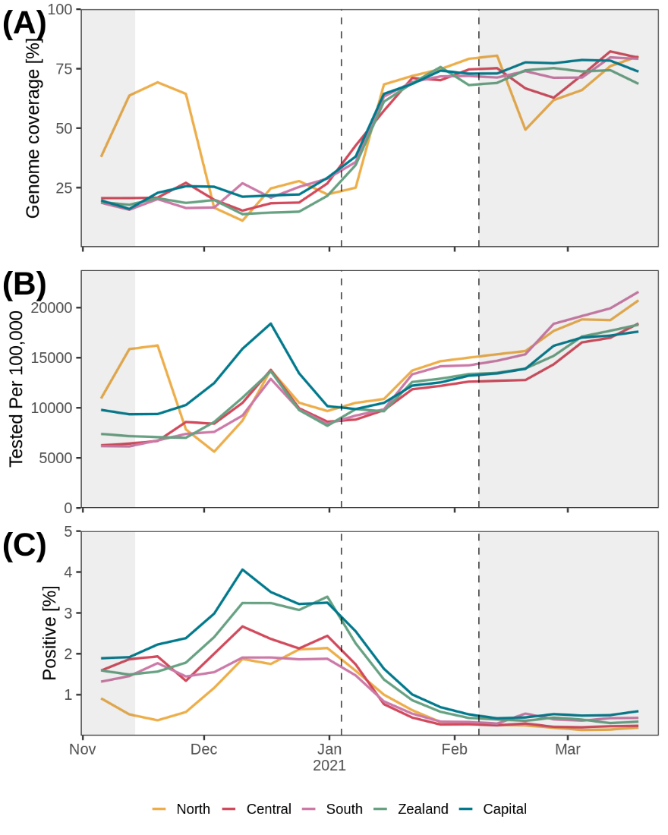
Fig. S1. Sequencing rate relative to total number of covid19 cases per week (A), relative testing effort (B), and percent positive (C) for each Danish region across time. The two vertical dashed lines indicate the beginning and end of study period used to infer B.1.1.7 transmissibility, while the non-shaded area shows the period used for phylogenetic analysis. The time outside the study are shaded in grey.
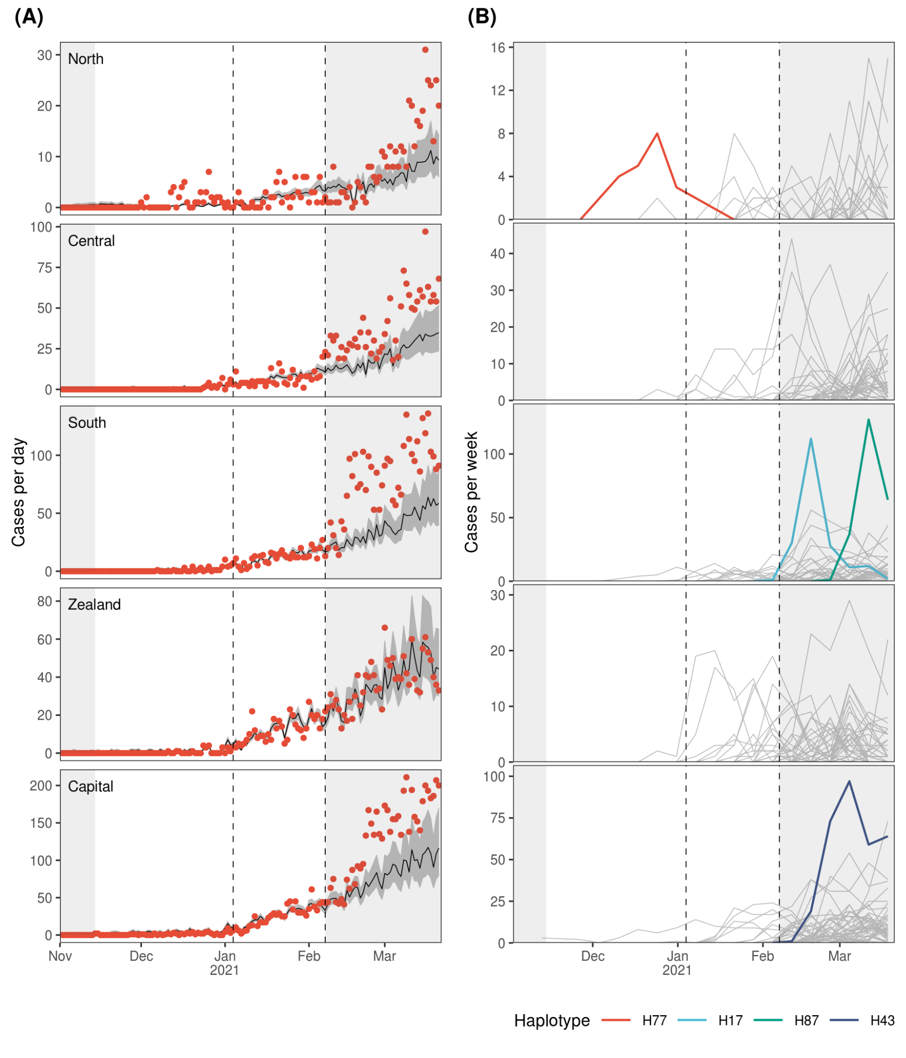
Fig. S2. The two vertical dashed lines indicate the beginning and end of study period used to infer B.1.1.7 transmissibility, while the non-shaded area shows the period used for phylogenetic analysis. The time outside the study are shaded in grey. (A) Model predictions from Poisson regression model on daily counts of B.1.1.7 for each region. Dark-grey areas represent 95% CI. (B) Frequency of unique haplotypes across time for each region. Each line represents the weekly count of a unique B.1.1.7 haplotype. The four haplotypes mentioned in the main text are highlighted.
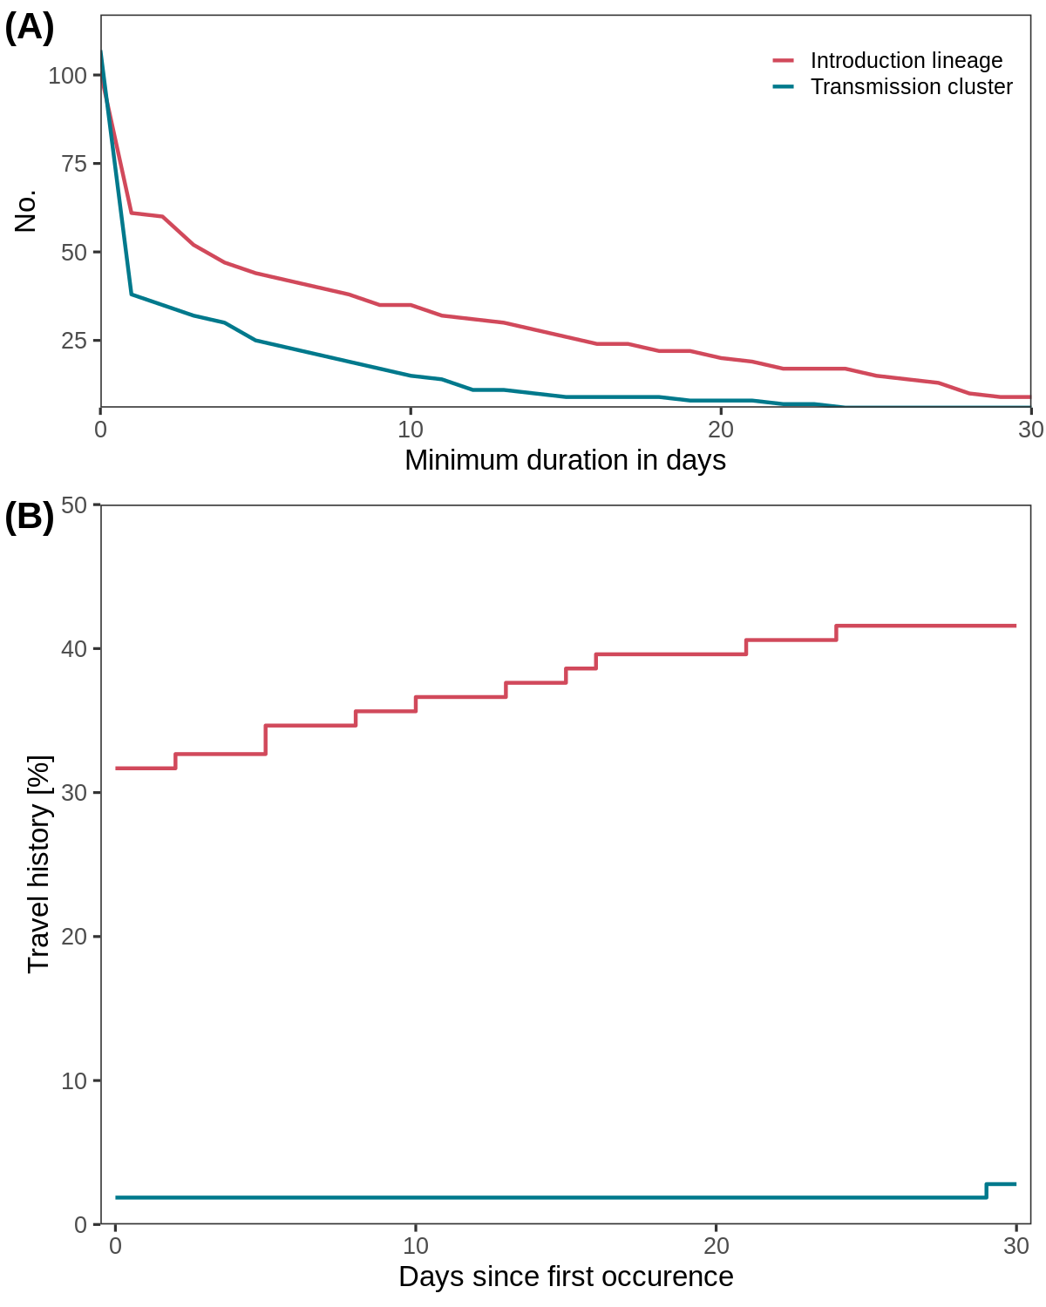
Fig. S3. Assessing robustness of inferred introductions from phylogenetic analysis using travel history. (A) and (B) are grouped into introduction lineages that are introduced from abroad and transmission clusters introduced from other Danish regions. (A) shows the number of introduction lineages and transmission clusters with a minimum duration given on the x-axis. (B) shows the percent of introduction lineages and transmission clusters with travel-associated cases before a cutoff day indicated on the x-axis. The cutoff day on x-axis is relative to the first occurrence of the introduction lineage or transmission cluster.
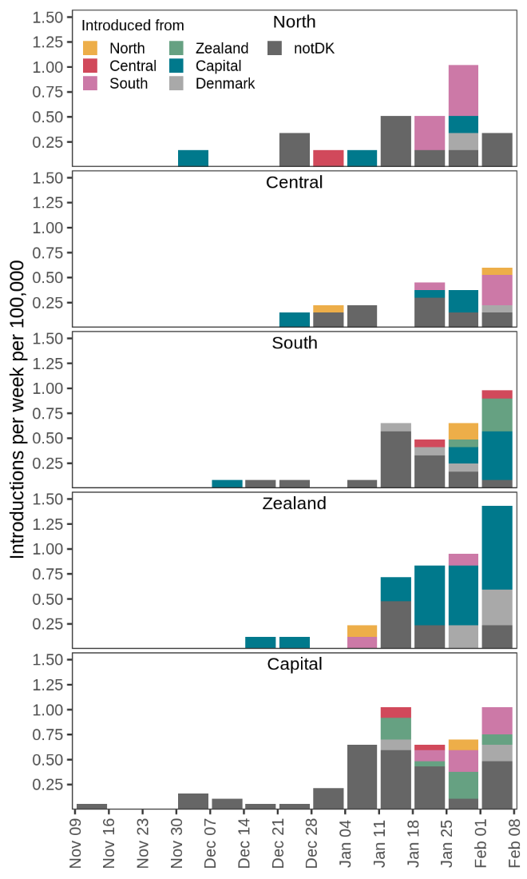
Fig. S4. Alternative version of Fig. 4D, showing the origin of introductions across time for each region. The y-axis is scaled to introductions per week per 100,000 inhabitants based on the population size for each region. If there was equal support for multiple regions as origin for an introduction Denmark was used as the origin. Label notDK indicates an introduction from outside Denmark. Only ancestral state changes with a marginal probability >95% were included in the analysis.
Haplotype | Nucleotide mutations
H43 | C241T, C913T, C3037T, C3267T, C5388A, C5986T, T6954C, C14408T, C14676T, T15096C, C15279T, T16176C, A17496G, T22016A, A23063T, C23271A, A23403G, C23604A, C23709T, T24506G, G24914C, G25785T, C27972T, G28048T, A28095T, A28111G, G28280C, A28281T, T28282A, G28881A, G28882A, G28883C, C28977T, G29764A, T11288-, C11289-, T11290-, G11291-, G11292-, T11293-, T11294-, T11295-, T11296-, A11297-, A21766-, C21767-, A21768-, T21769-, G21770-, T21771-, C21772-, T21994-, T21995-, A21996-, C21997-, A28274-
H77 | C241T, C913T, C2110T, C3037T, C3177T, C3267T, C5388A, C5986T, T6954C, C14408T, C14676T, C15279T, T16176C, A23063T, C23271A, A23403G, C23604A, C23709T, T24506G, G24914C, C27972T, G28048T, A28111G, G28280C, A28281T, T28282A, G28881A, G28882A, G28883C, C28977T, T11288-, C11289-, T11290-, G11291-, G11292-, T11293-, T11294-, T11295-, T11296-, A11297-, A21766-, C21767-, A21768-, T21769-, G21770-, T21771-, C21772-, T21994-, T21995-, A21996-, C21997-, A28274-
H87 | C241T, C913T, C2623T, C3037T, C3267T, C4009T, C5388A, T5762C, C5986T, T6954C, C14408T, C14676T, G15025T, C15279T, T16176C, A17615G, T19050C, A23063T, C23271A, A23403G, C23604A, C23638T, C23709T, T24506G, G24914C, C27972T, G28048T, A28111G, G28280C, A28281T, T28282A, G28881A, G28882A, G28883C, C28977T, T11288-, C11289-, T11290-, G11291-, G11292-, T11293-, T11294-, T11295-, T11296-, A11297-, A21766-, C21767-, A21768-, T21769-, G21770-, T21771-, C21772-, T21994-, T21995-, A21996-, C21997-, A28274-
H17 | C241T, C913T, C3037T, C3267T, C5388A, C5944T, C5986T, T6954C, A10716G, C14408T, C14676T, T15096C, C15279T, T16176C, A23063T, C23271A, A23403G, C23604A, C23709T, C23854T, T24506G, G24914C, G26951C, C27972T, G28048T, A28095T, A28111G, G28280C, A28281T, T28282A, G28881A, G28882A, G28883C, G28884C, C28977T, T11288-, C11289-, T11290-, G11291-, G11292-, T11293-, T11294-, T11295-, T11296-, A11297-, A21766-, C21767-, A21768-, T21769-, G21770-, T21771-, C21772-, T21994-, T21995-, A21996-, C21997-, A28274-
Table S1. Nucleotide mutations for each of the four haplotypes specifically mentioned in the manuscript.

